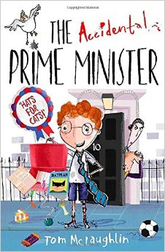
100 Books To Try And Read In Year 3/4
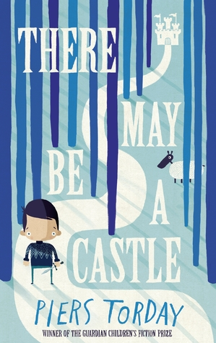
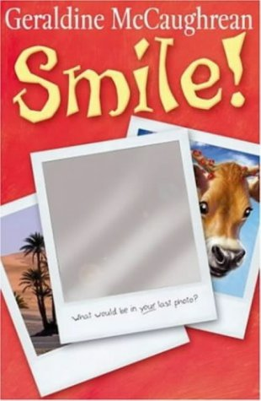
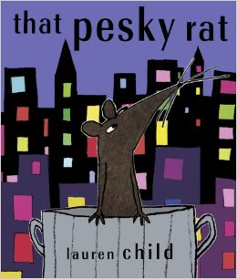
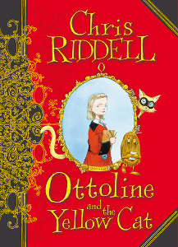
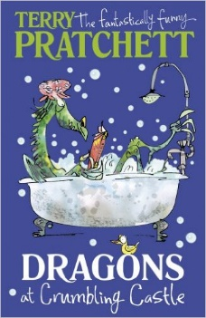
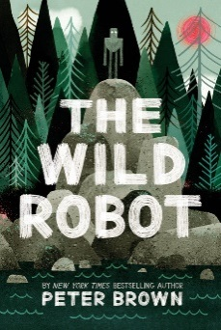
Shackleton’s Journey
William Grill
The Whisperer
Nick Butterworth
The Tale of Despereaux
Kate DiCamillo
Dragons at Crumbling Castle
Terry Pratchett
Fergus Crane
Paul Stewart and Chris Riddell
The Year of Billy Miller
Kevin Henkes

Liz Pichon
Frindle
Andrew Clements
The Shrimp
Emily Smith
The Invention of Huge Cabret
Brian Selznick
Mouse Noses on Toast
Darren Fletcher

There May Be A Castle
Piers Torday
That Pesky Rat
Lauren Child
Smile
Geraldine McCaughrean
Ottoline and the Yellow Cat
Chris Riddell
The Wild Robot
Peter Brown
The Accidental Prime Minister
Tom McLaughlin

