100 Books To Read In Year 3 and 4
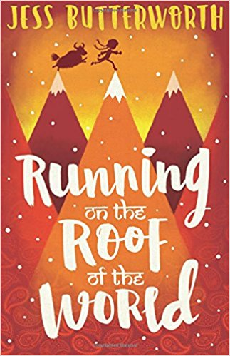
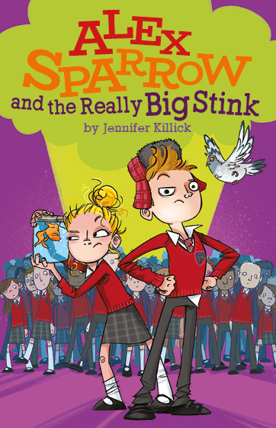
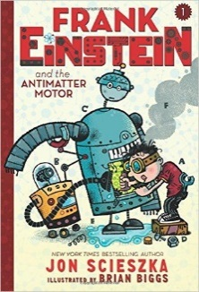
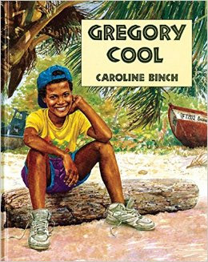
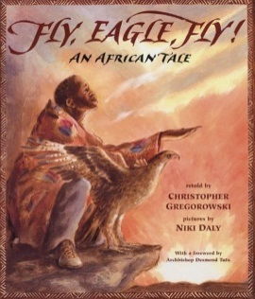
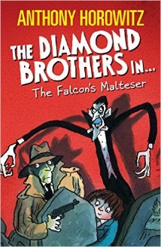
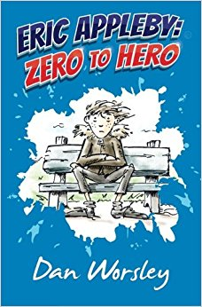
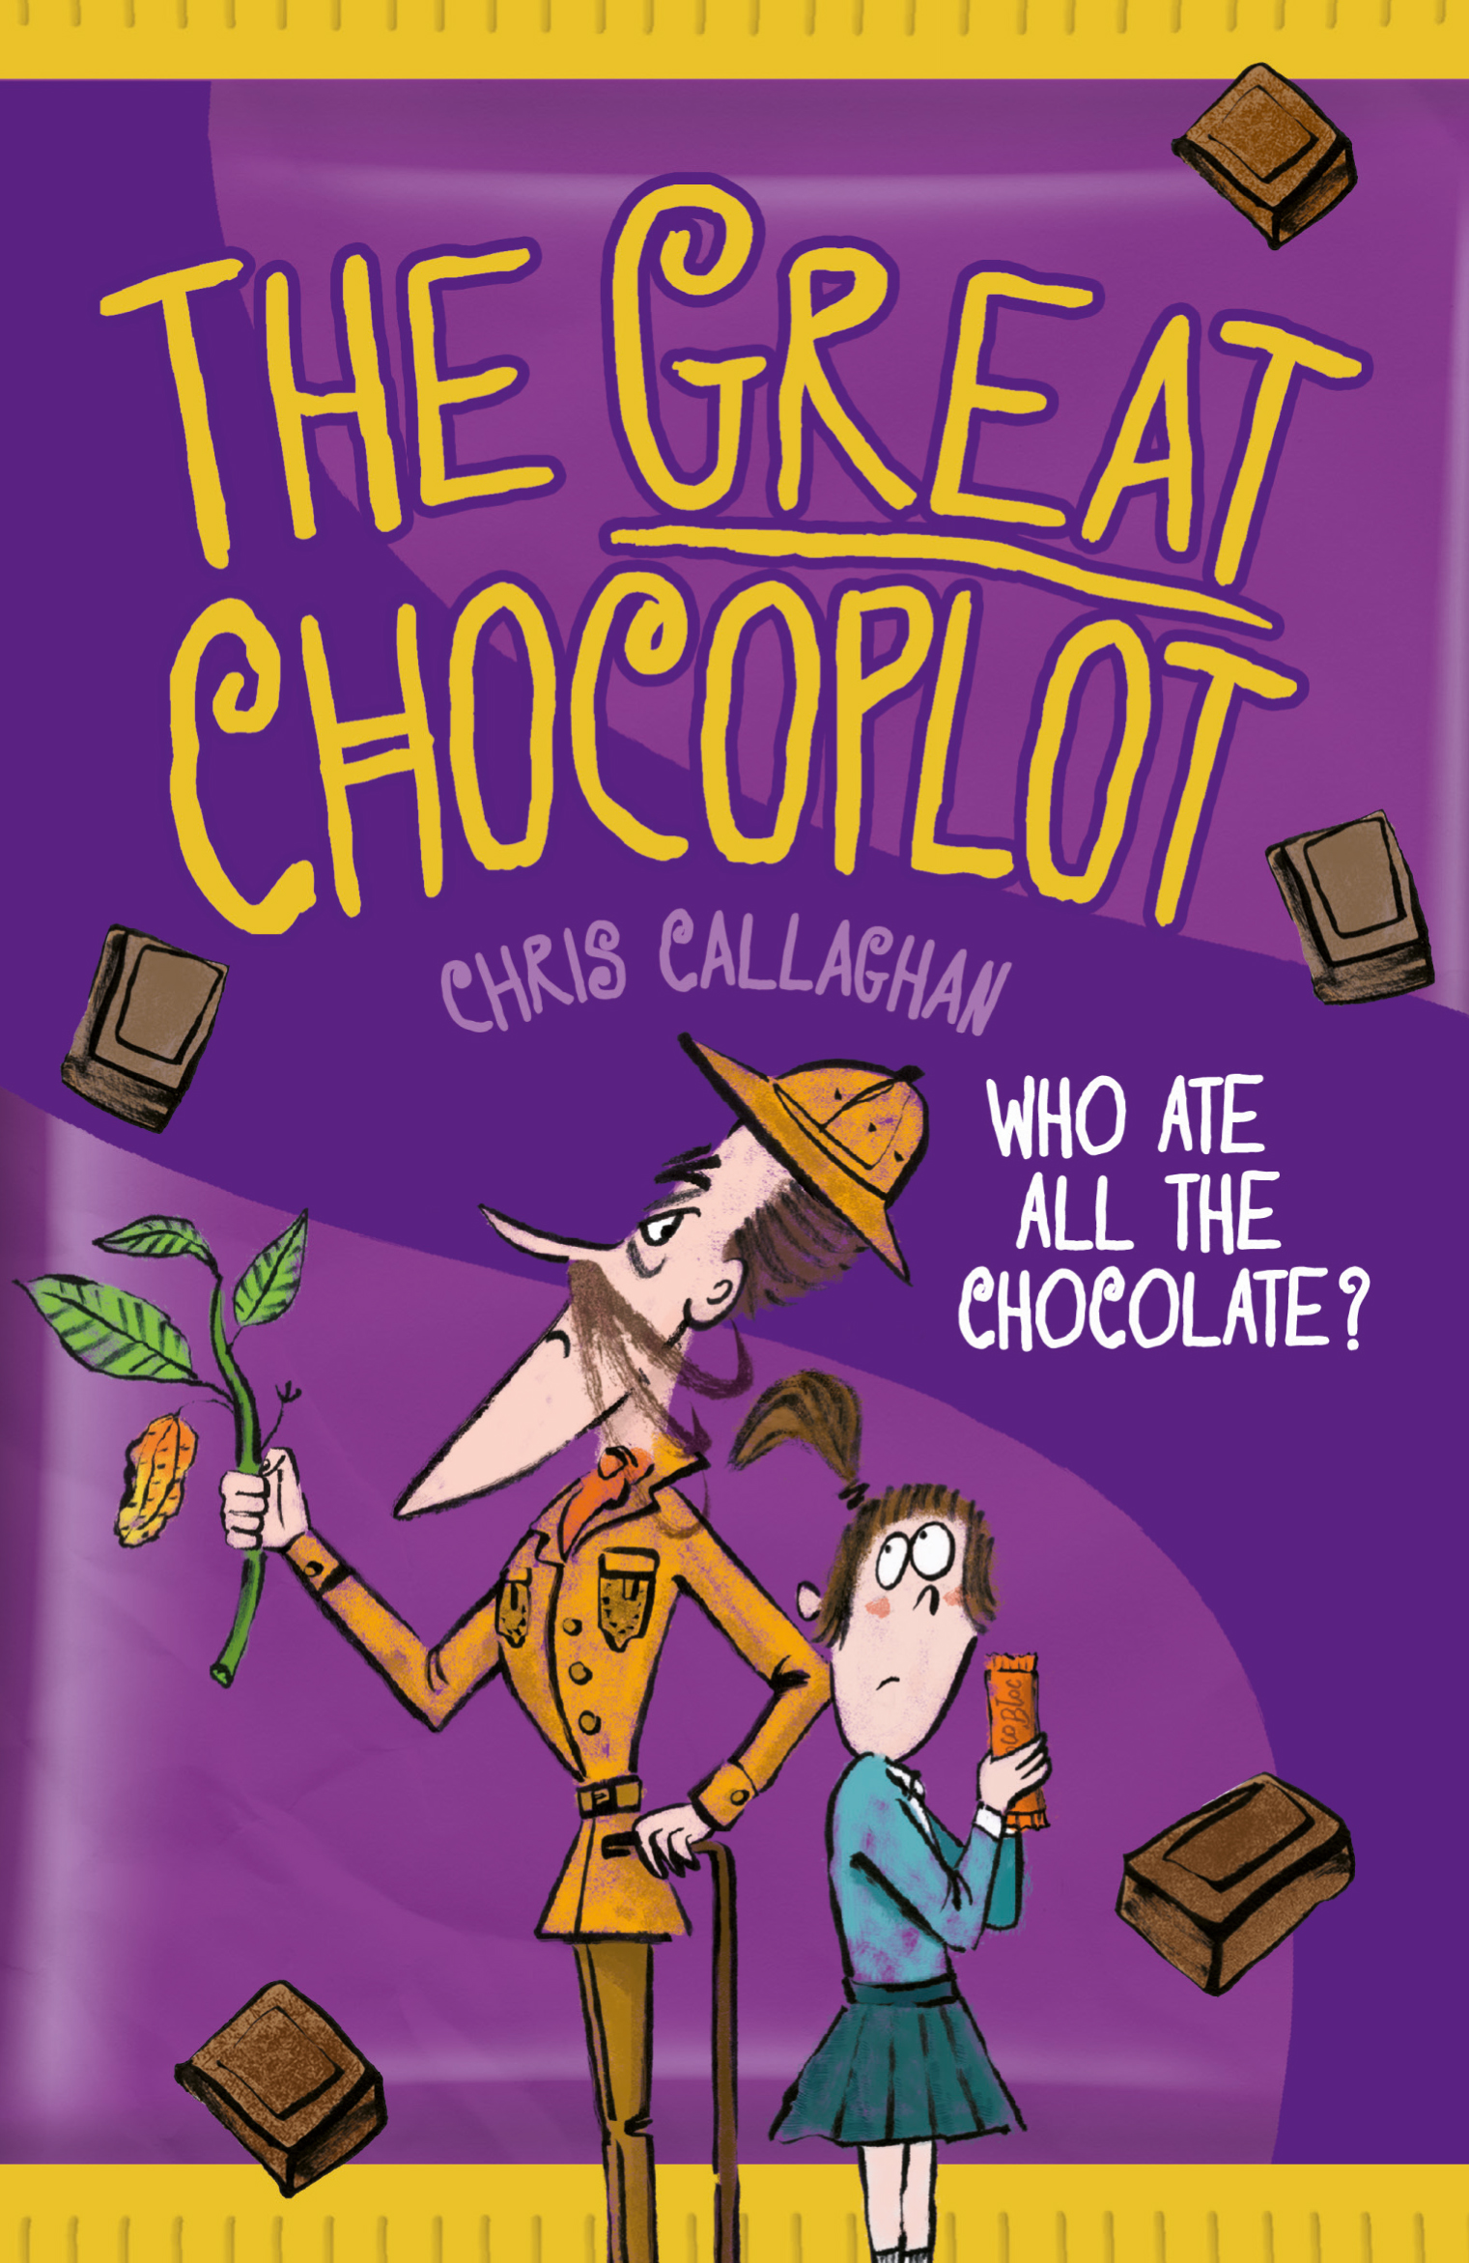
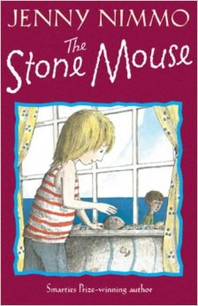
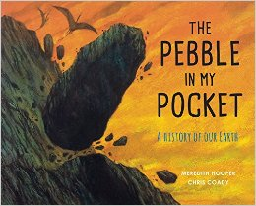
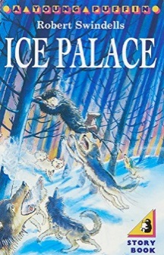
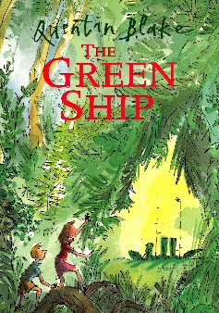
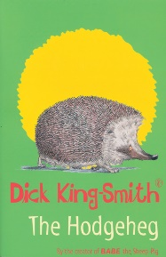
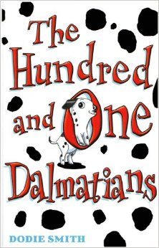
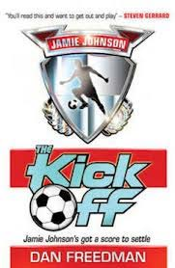
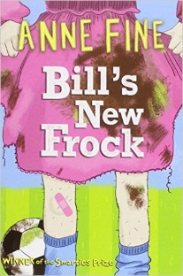
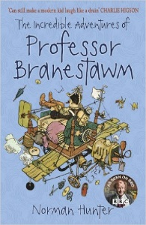
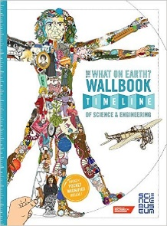
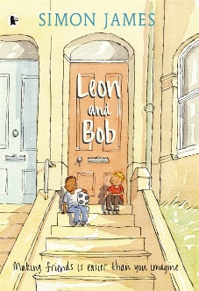
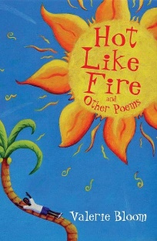
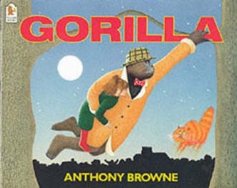
v
The What On Earth Wallbook
Christopher Lloyd
The Stone Mouse
Jenny Nimmo
The Pebble in my Pocket
Meredith Hooper
Ice Palace
Robert Swindells

The Hodgeheg
Dick King-Smith
The Green Ship
Quentin Blake
The Hundred and One Dalmatians
Dodie Smith
The Kick Off
Dan Freedman
Fly, Eagle Fly!
Christopher Gregorowski
Flour Babies
Anne Fine
The Incredible Adventures of Professor Branestawn
Norman Hunter
Eric Appleby: Zero to Hero
Dan Worsley
The Great Chocoplot
Chris Callaghan
Leon and Bob
Simon James
Hot Like Fire
Valerie Bloom
Frank Einstein and the Antimatter Motor
Jon Sciezka
Running On The Roof Of The World
Jess Butterworth
Gregory Cool
Caroline Birch
Gorilla
Anthony Browne
The Falcon’s Malteser
Anthony Horowitz
Alex Sparrow and the Really Big Stink
Jennifer Killick

