100 Books To Read In Year 3 and 4
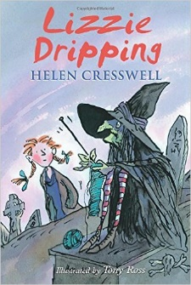
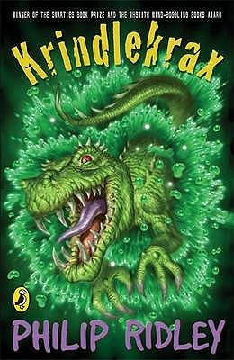
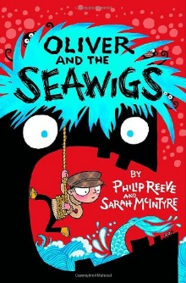
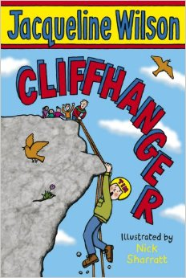
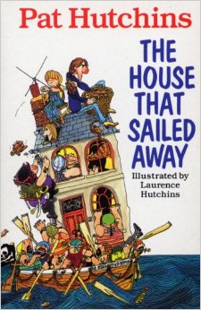
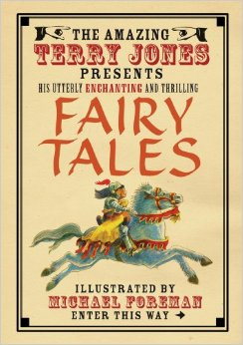
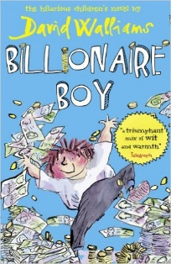
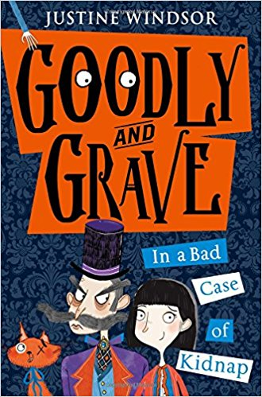
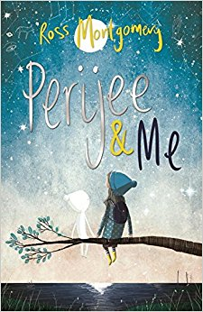
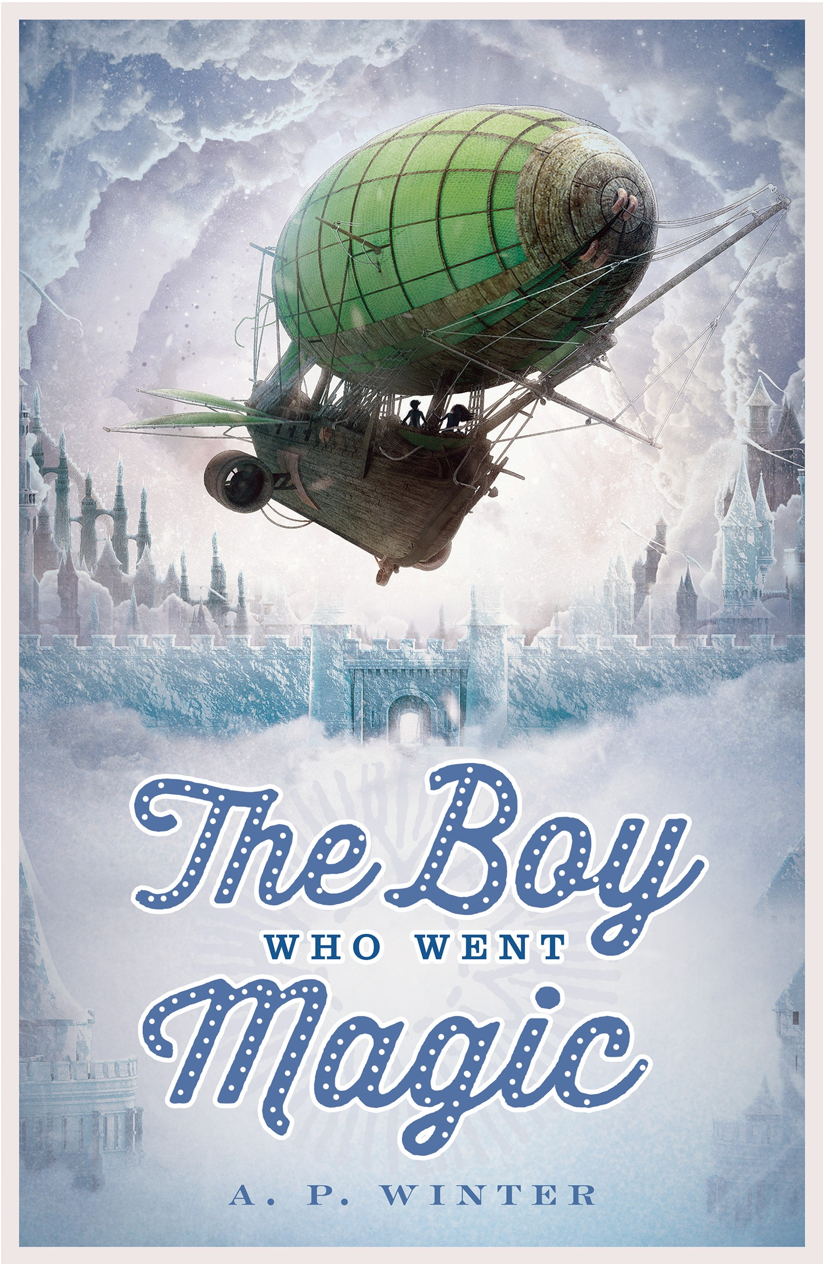
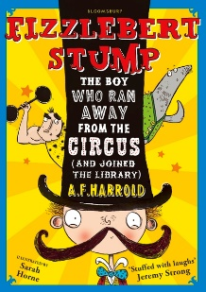
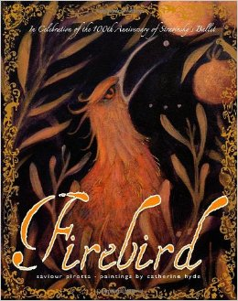
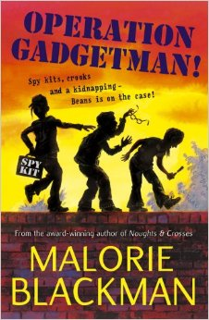

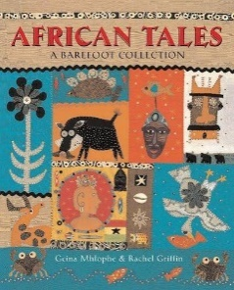
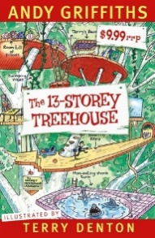
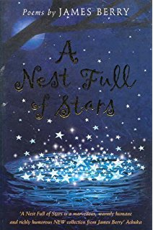
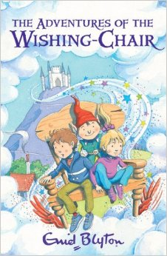
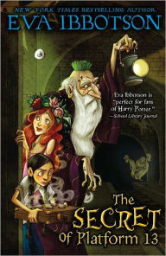
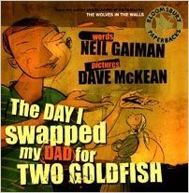
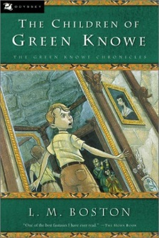
The Adventures of the Wishing-Chair
Enid Blyton
The Imaginary
A F Harold
Firebird
Saviour Pirotta
The Boy Who Went Magic
AP Winters

Operation Gadgetman!
Malorie Blackman
Belonging
Jeannie Baker
African Tales: A Barefoot Collection
GcinaMlophe
Goodly and Grave
Justine Windsor
The House That Sailed Away
Pat Hutchins
The 13-Storey Treehouse
Andry Griffiths
Perijee and Me
Ross Montgomery
A Nest Full of Stars
James Berry
The Secret of Platform 13
Eva Ibbotson
The Day I Swapped My Dad for Two Goldfish
Neiil Gaiman
The Children of Green Knowe
L.M.Boston
Lizzie Dripping
Helen Cresswel
Krindlekrax
Philip Ridley
Oliver and the Seawigs
Phillip Reeve
Cliffhanger
Jacqueline Wilson
Fairy Tales
Terry Jones
Billionaire Boy
David Walliams

