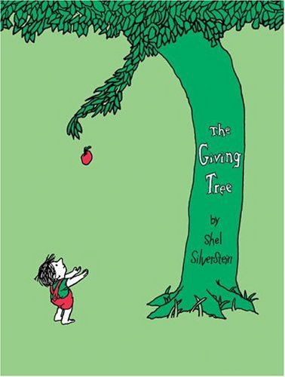
100 Books To Read In KS1
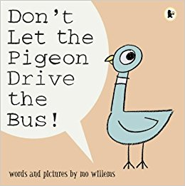
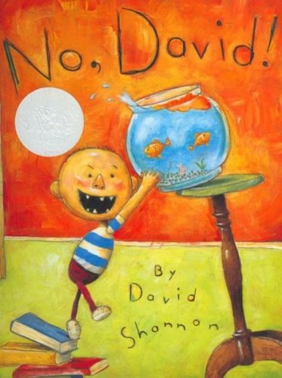
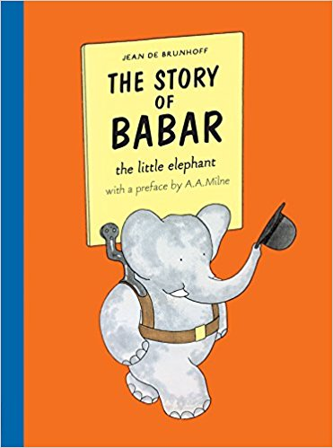
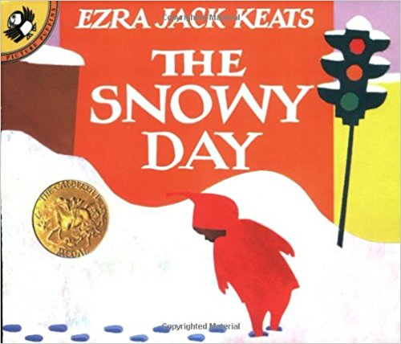
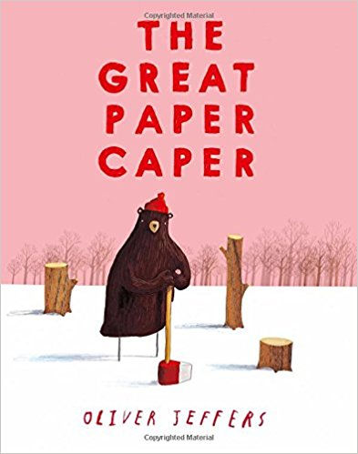
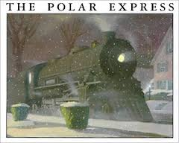
Alexander and the Terrible, Horrible, No Good, Very Bad Day
Judith Viorst
The Whisperer
Nick Butterworth
Guess How Much I Love you
Sam McBratney
The Giving Tree
Shel Silverstein
Who Sank The Boat?
Pamela Allen

Liz Pichon
Knuffle Bunny
Mo Willems
Make Way For Ducklings
Robert McCloskey
Goodnight Moon
Margaret Wise Brown

Don’t Let The Pigeon Drive The Bus
Mo Willems
No, David!
David Shannon
The Polar Express
Chris Van Allsburg
The Story of Babar
Jean De Brunhoff
The Snowy Day
Ezra Jack Keats
The Great Paper Caper
Oliver Jeffers

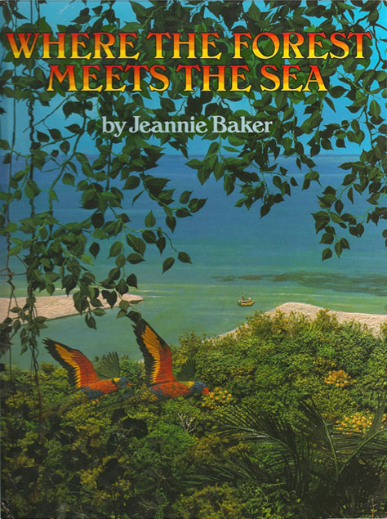
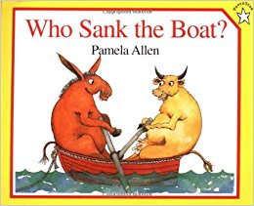
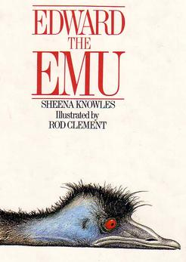
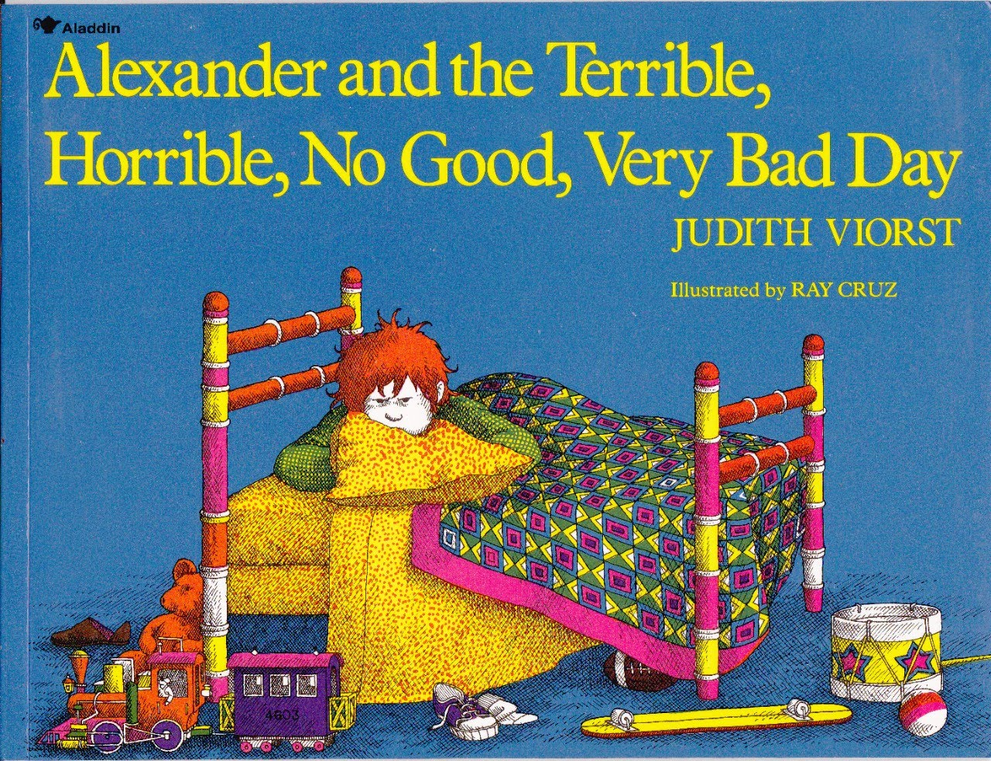
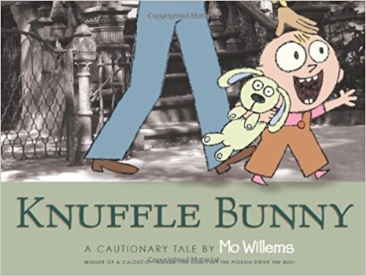
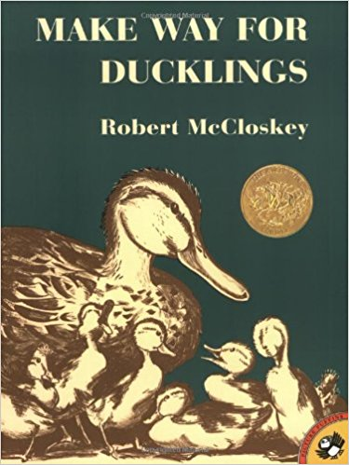
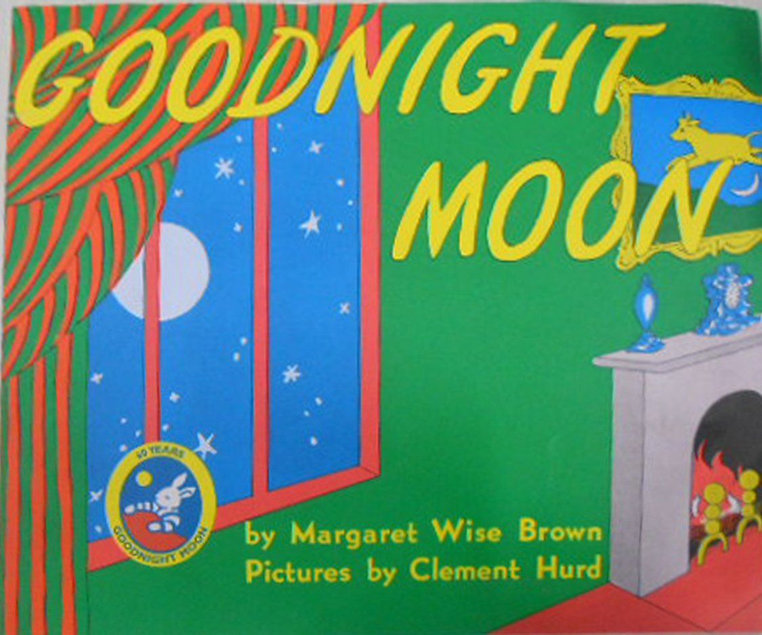

Where The Forest Meets The Sea
Jeannie Baker
Edward The Emu
Sheena Knowles

