100 Books To Read In Key Stage 1
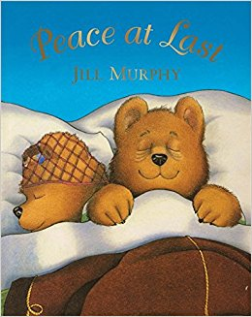
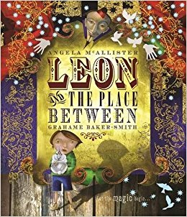
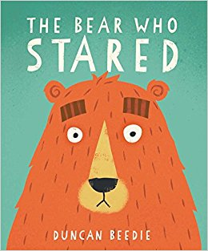
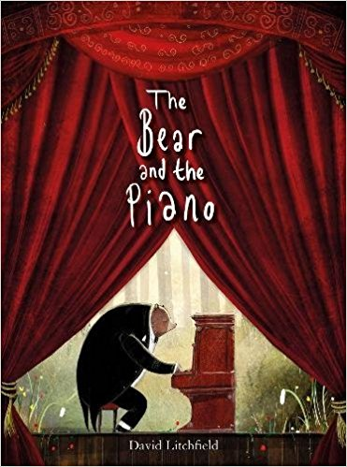
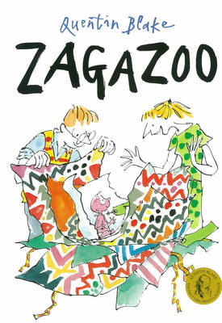
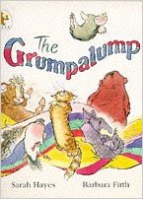
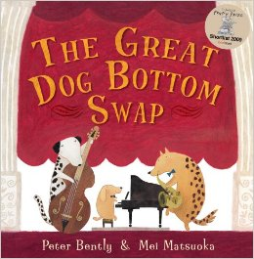
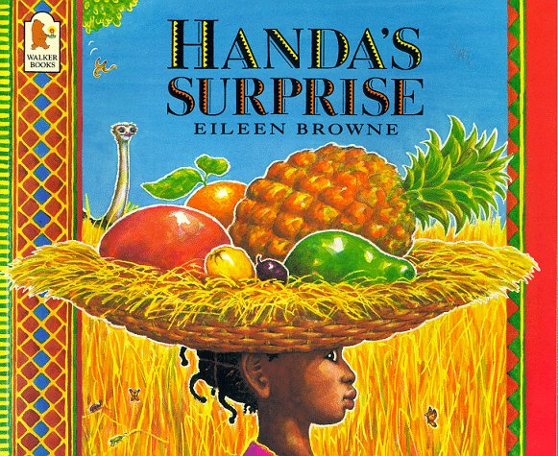
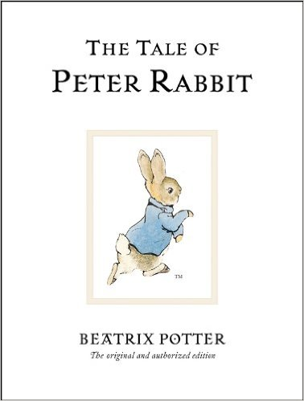
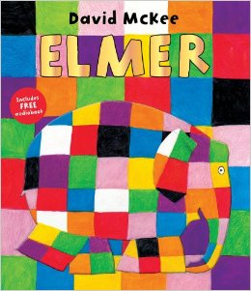
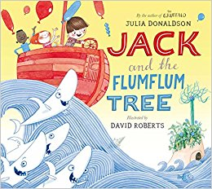
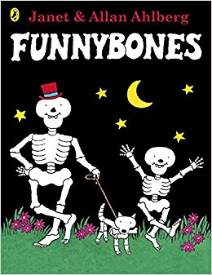
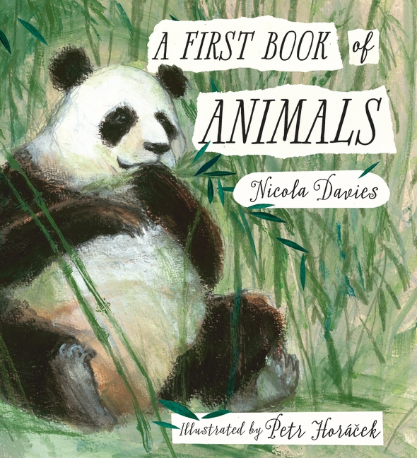
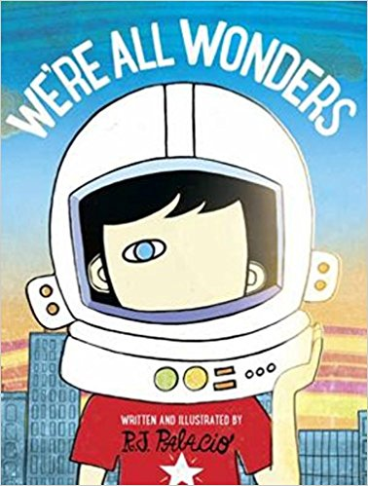
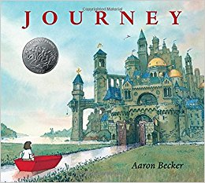
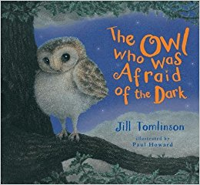
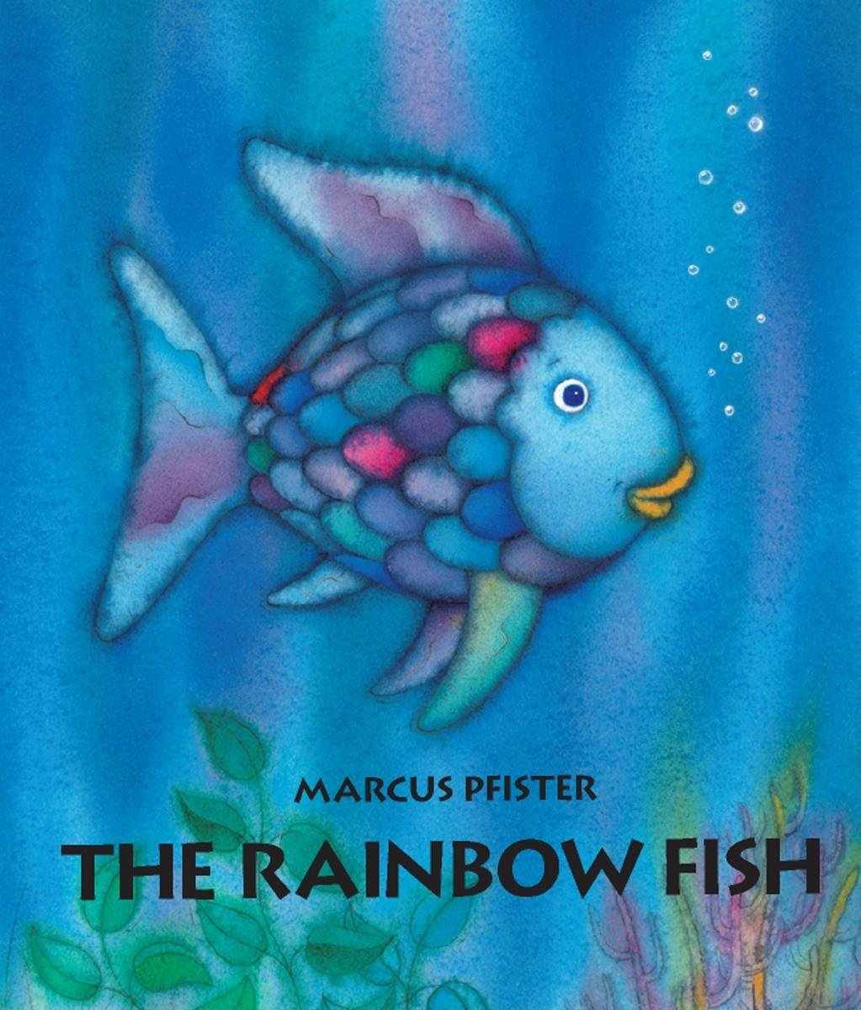
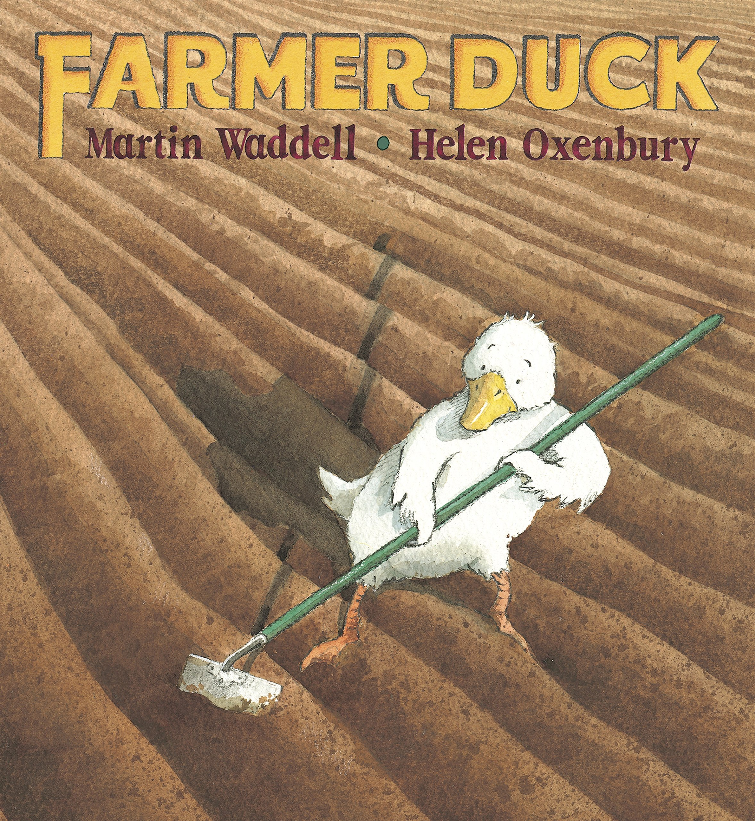
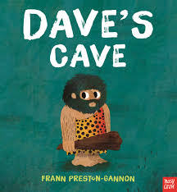
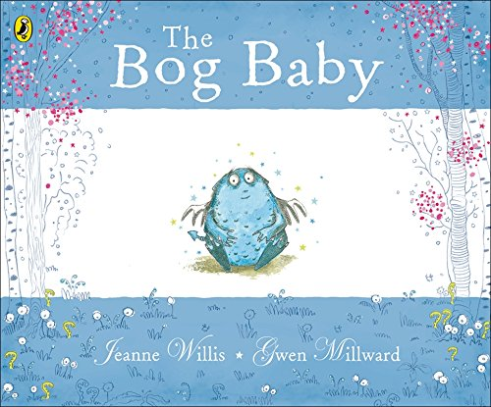
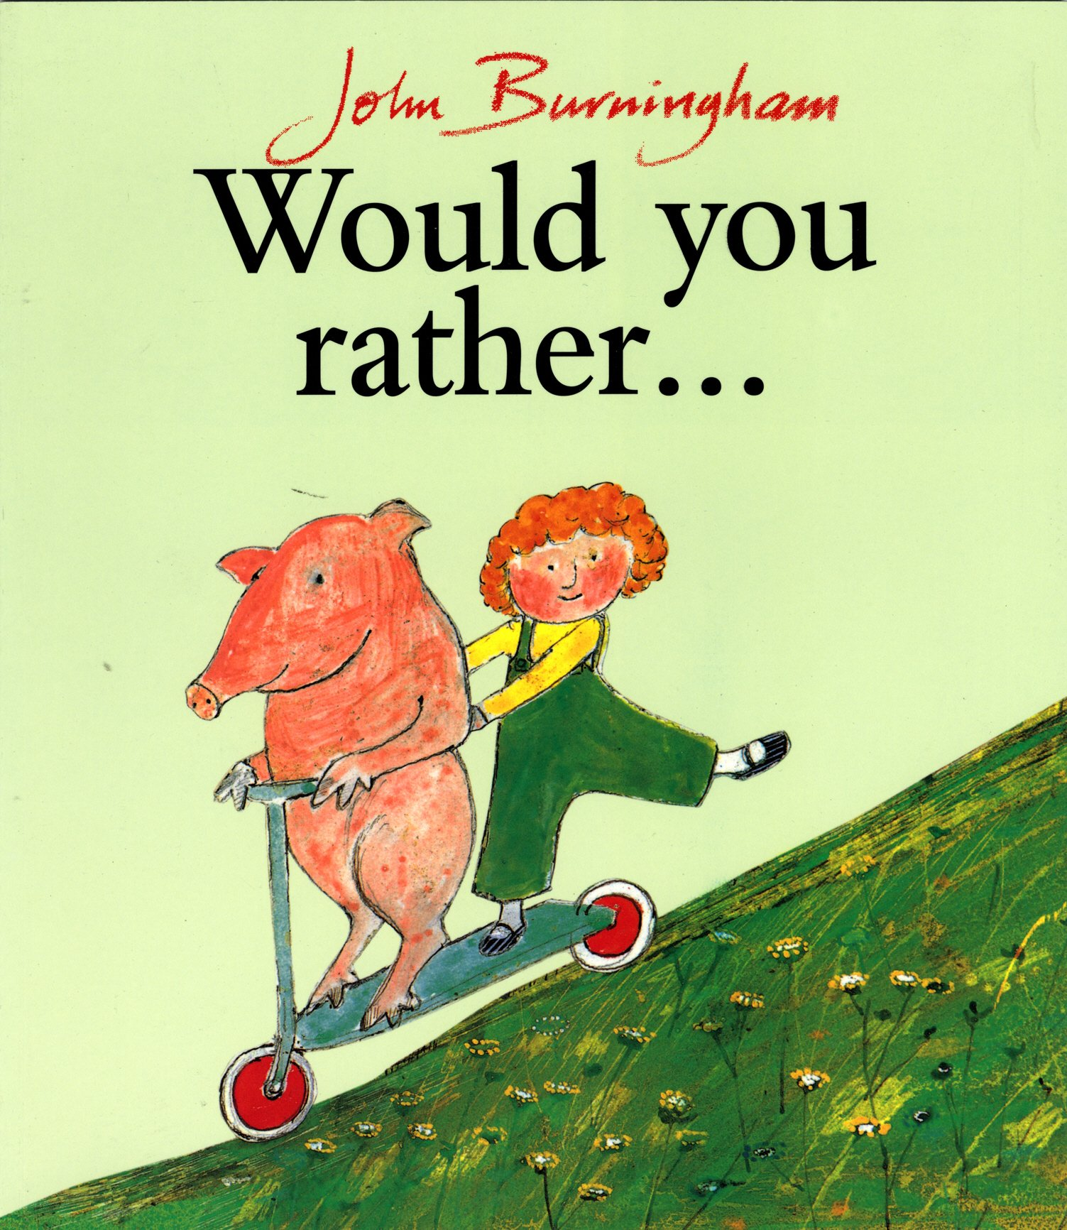
The Rainbow Fish
Marcus Pfister
The Bog Baby
Jenne Willis and Glen Millward
We’re All Wonders
RJ Palacio
Farmer Duck
Martin Waddell and Helen Oxbury
Peace At Last
Jill Murphy
Zagazoo
Quentin Blake
The Grumpalump
Sarah Hayes
The Great Dog Bottom Swap
Peter Bently and Mel Matsuoka

Handa’s Surprise
Eileen Browne
The Tale Of Peter Rabbit
Beatrix Potter
Elmer
Dacid McKee
Jack and the Flumflum Tree
Julia Donaldson
The Bear and The Piano
David Litchfield
Funnybones
Janet and Allan Ahlberg
A First Book Of Animals
Nicola Davies
Journey
Aaron Becker
The Owl Who Was Afraid Of The Dark
Jill Tomlinson
Dave’s Cave
Frann Preston-Gannon
Leon and the Place Between
Angela McAllister and Grahame Baker-Smith
The Bear Who Stared
Duncan Beedie
Would You Rather…
John Burningham

