100 Books To Read In Key Stage 1
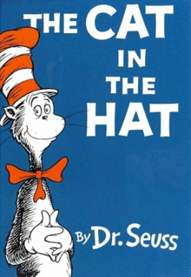
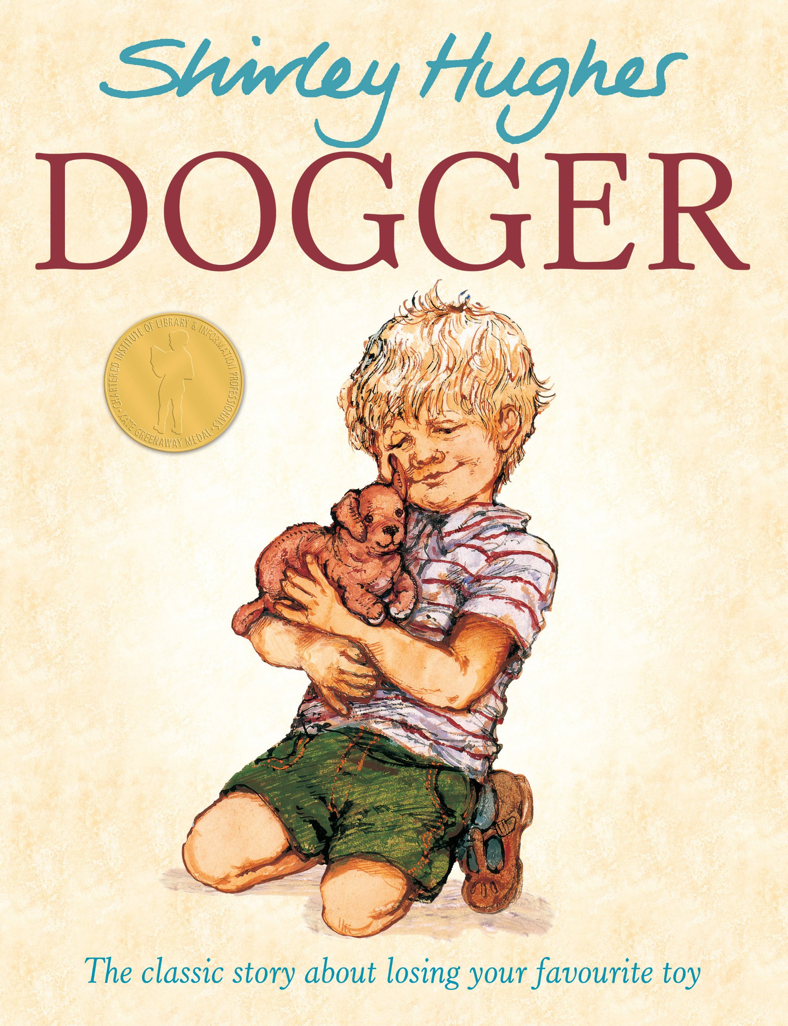
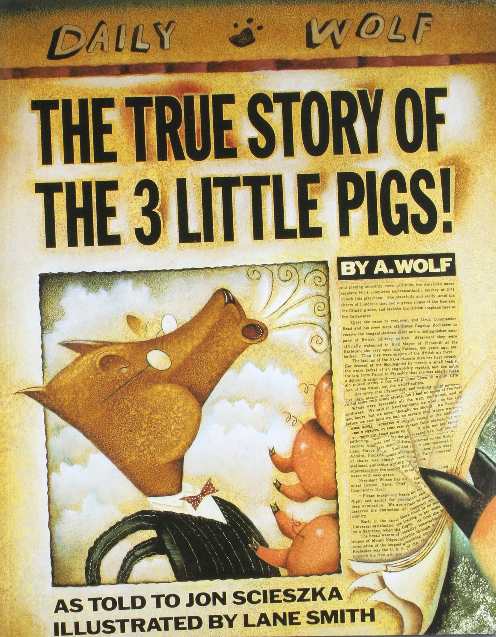
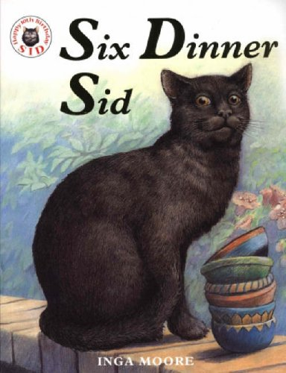
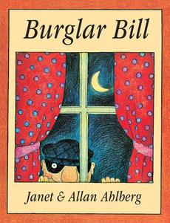
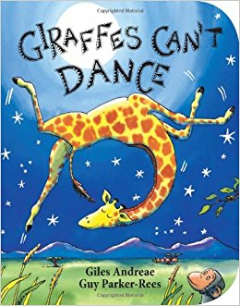
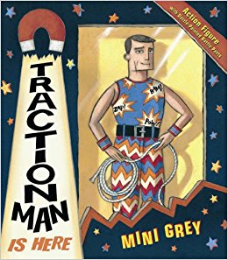
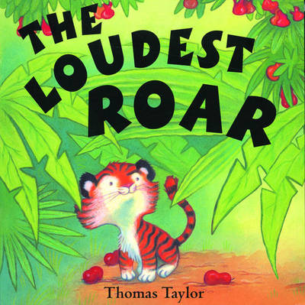
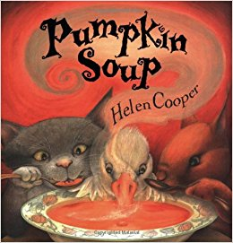
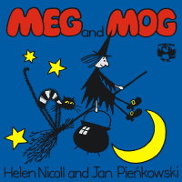
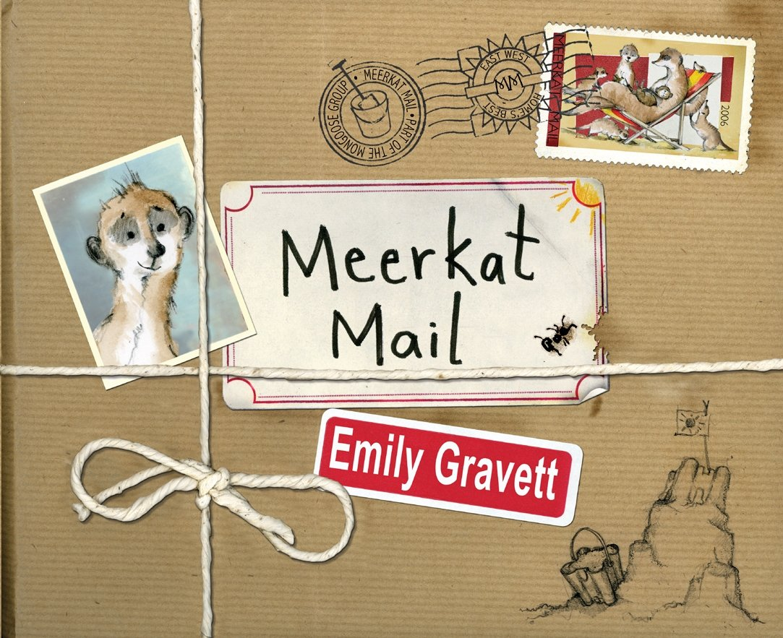
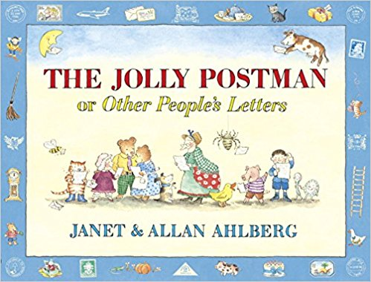
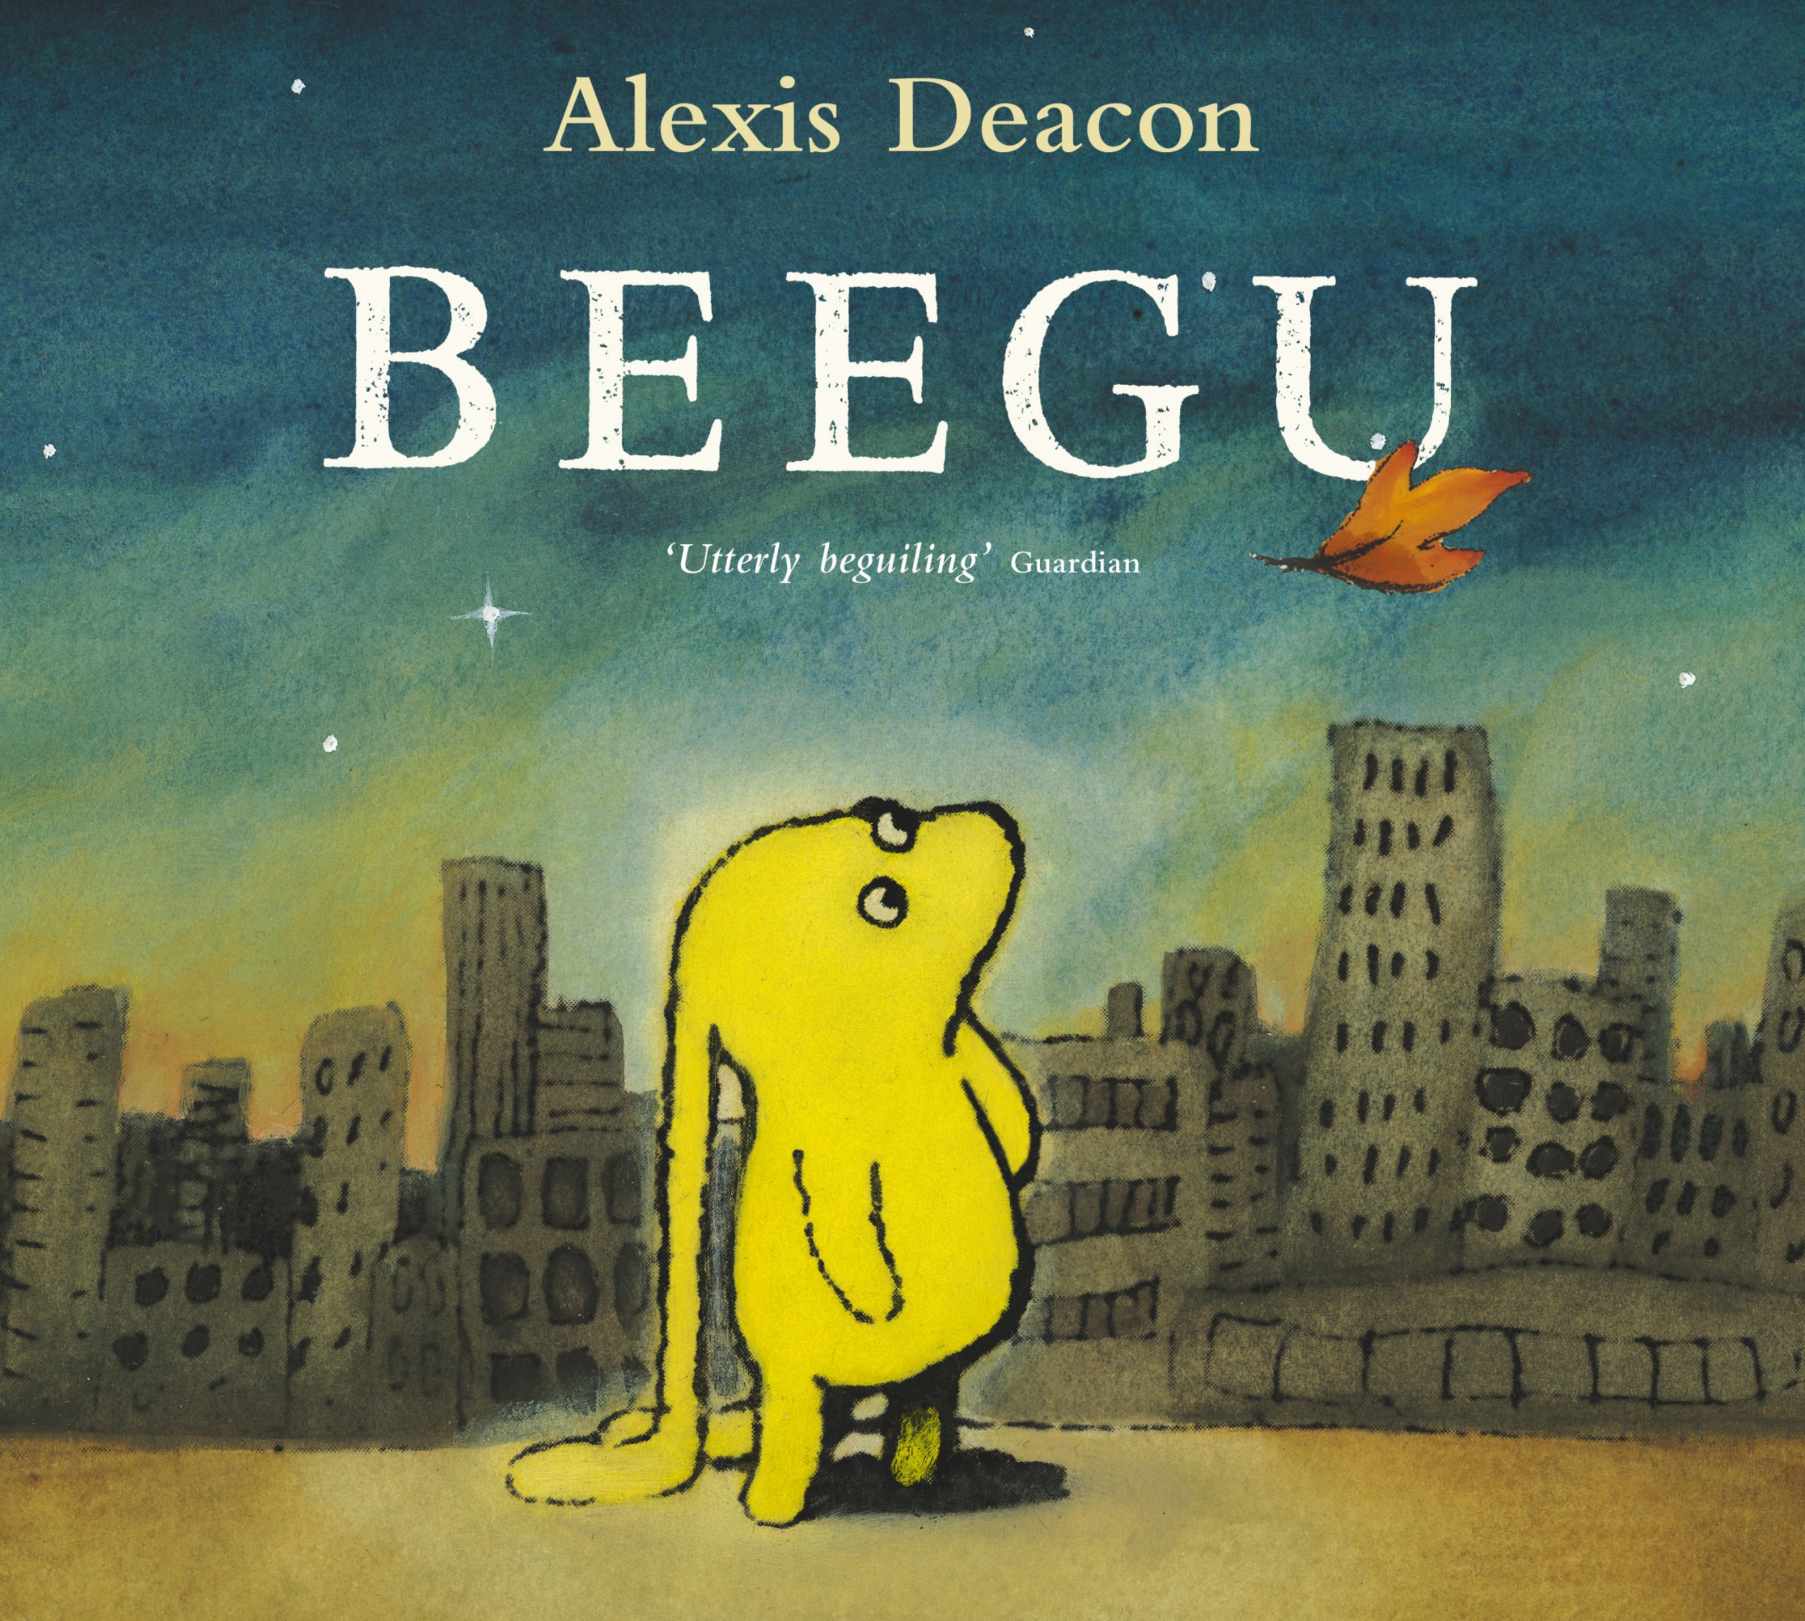
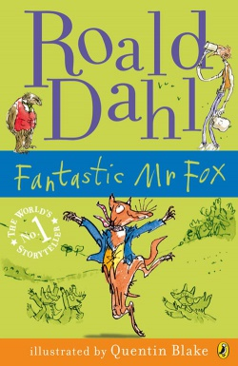
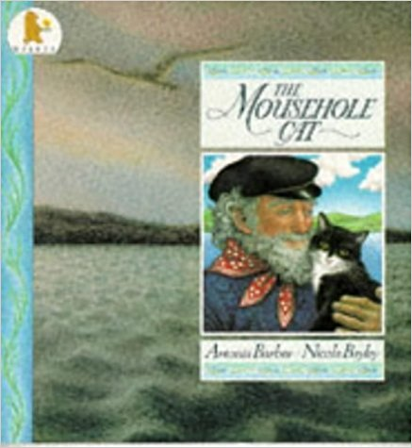
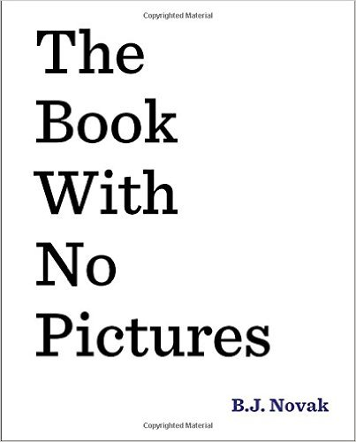
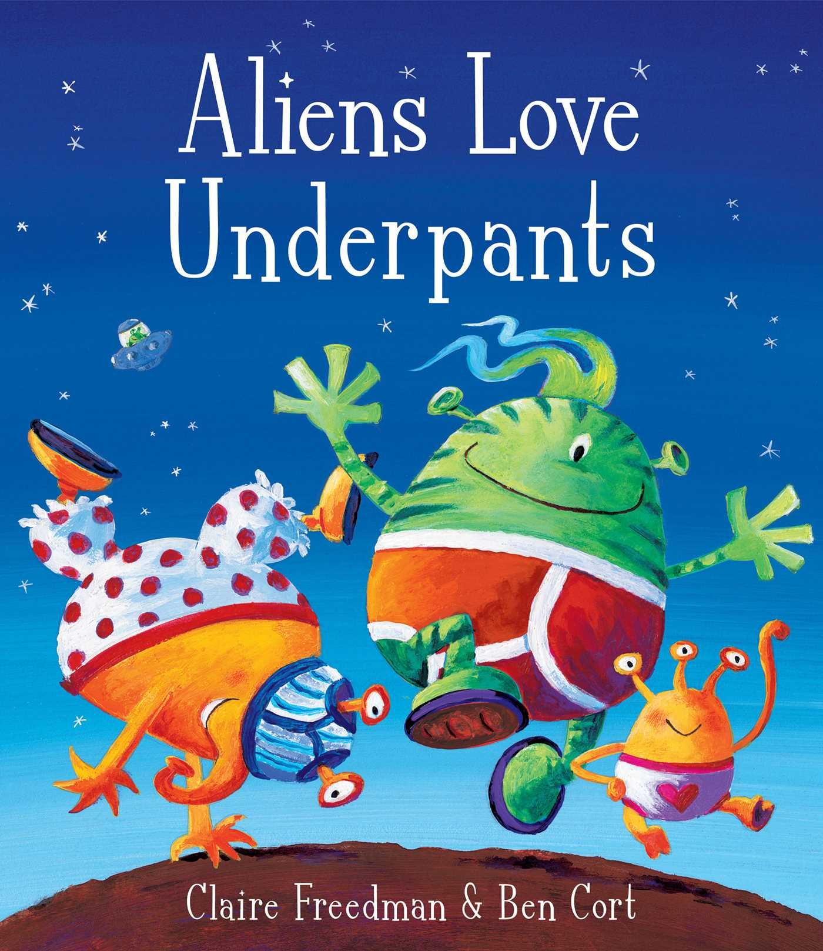
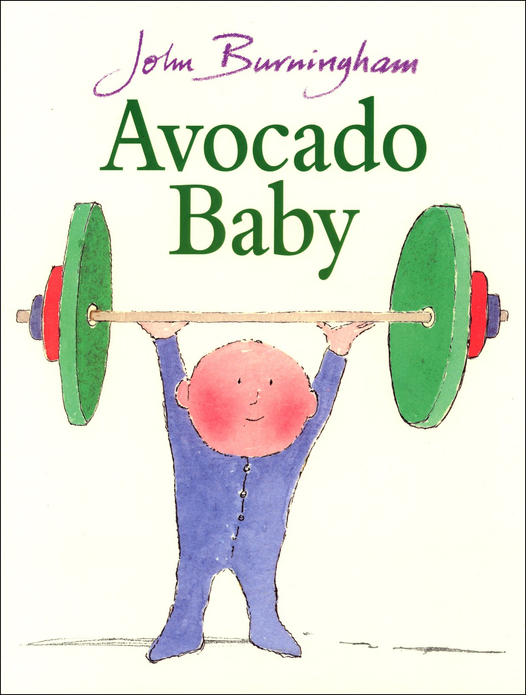
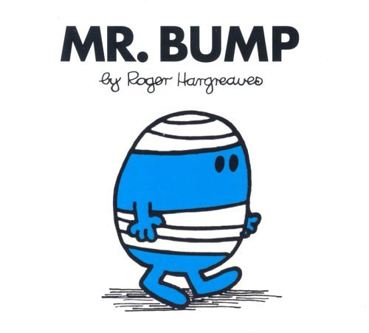
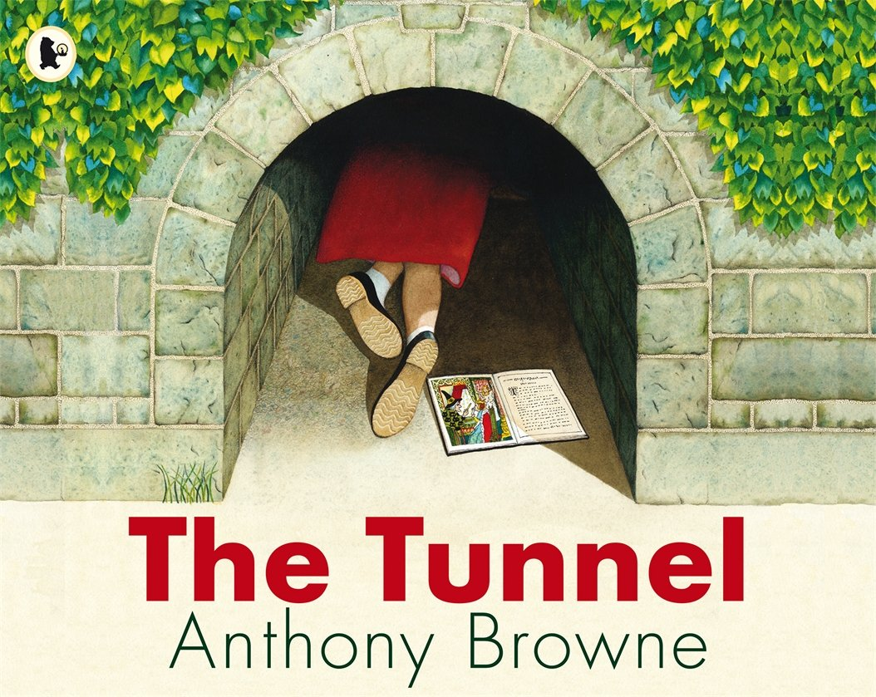
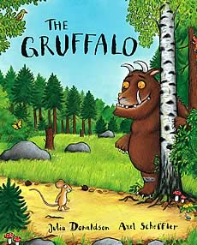
The Mousehole Cat
Antonia Barber
The Gruffalo
Julia Donaldson
The Jolly Postman
Janet and Allan Ahlberg
The Book With No Pictures
BJ Novak
The Cat In The Hat
Dr Seuss
The True Story Of The 3 Little Pigs
Jon Scieska
Six Dinner Sid
Inga Moore
Burglar Bill
Janet and Allan Ahlberg
Giraffes Can’t Dance
Giles Andrea and Guy Parker Rees
Traction Man
Mini Grey
The Loudest Roar
Thomas Taylor
Pumpkin Soup
Helen Cooper
The Tunnel
Anthony Browne
Meg and Mog
Helen Nicoll and Jan Piekowski
Meerkat Mail
Emily Gravett
Beegu
Alexis Deacon
The Fantastic Mr Fox
Roald Dahl
Aliens Love Underpants
Claire Freedman and Ben Cort
Avocado Baby
John Burningham
Mr Bump
Roger Hargreaves
Dogger
Shirley Hughes

