100 Books To Read In Key Stage 1
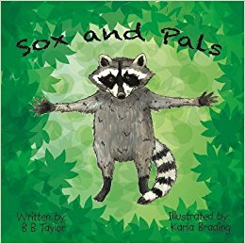
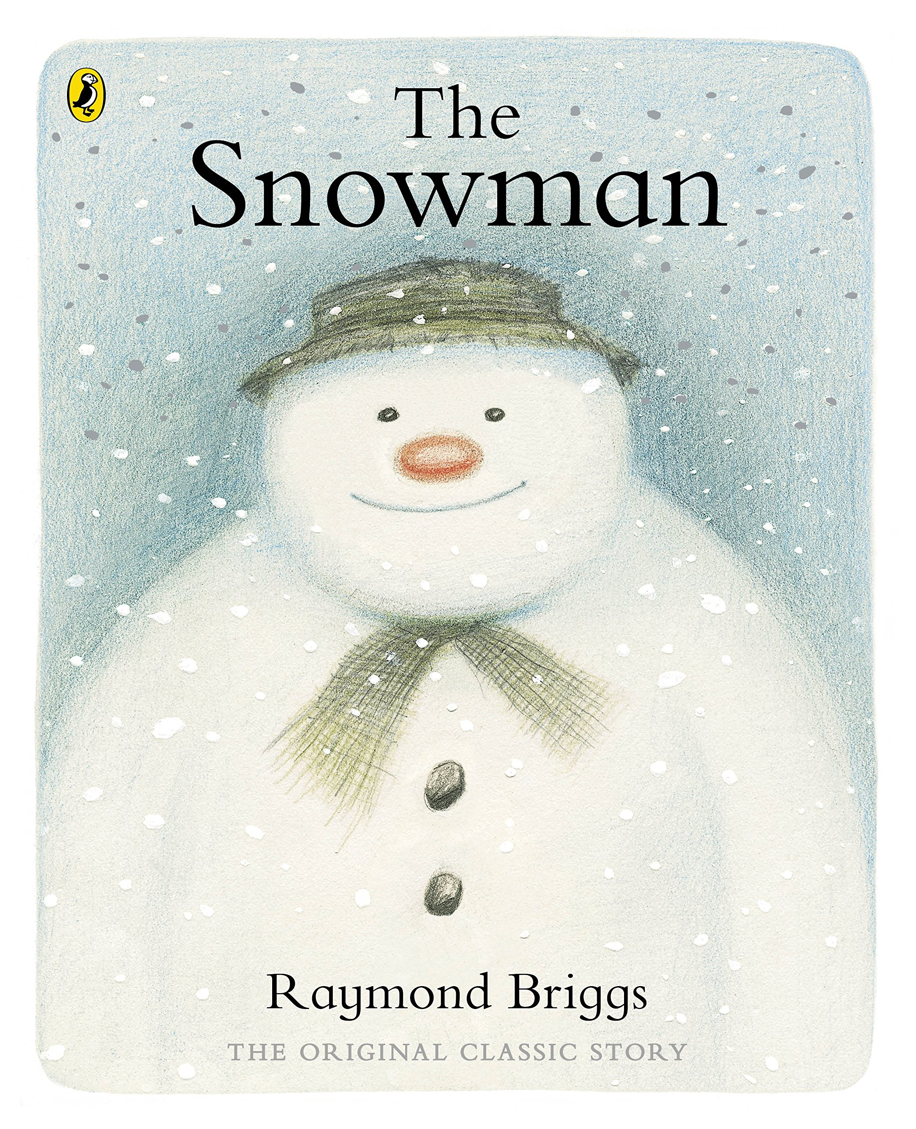
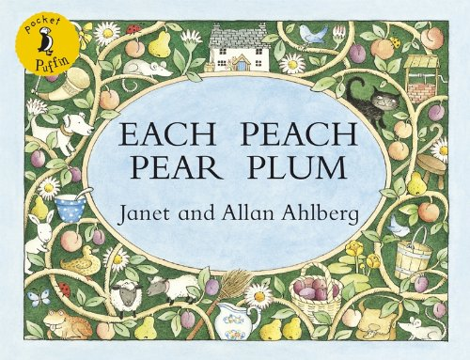
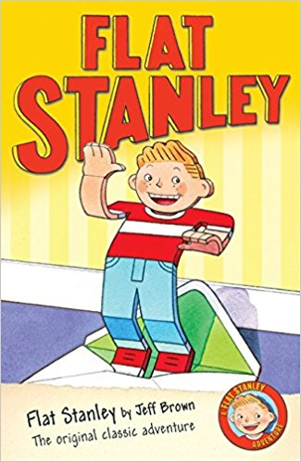
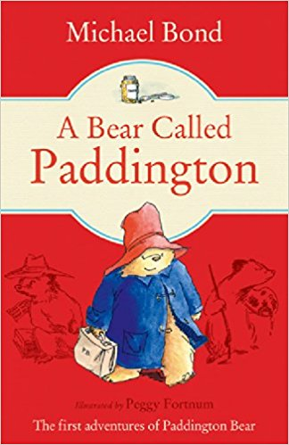
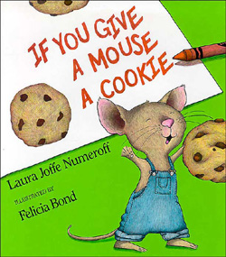
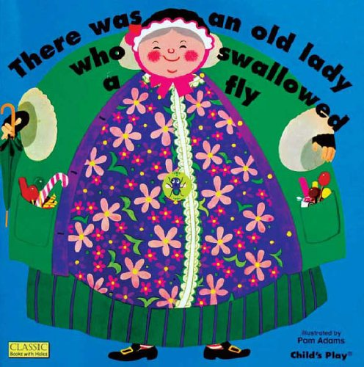
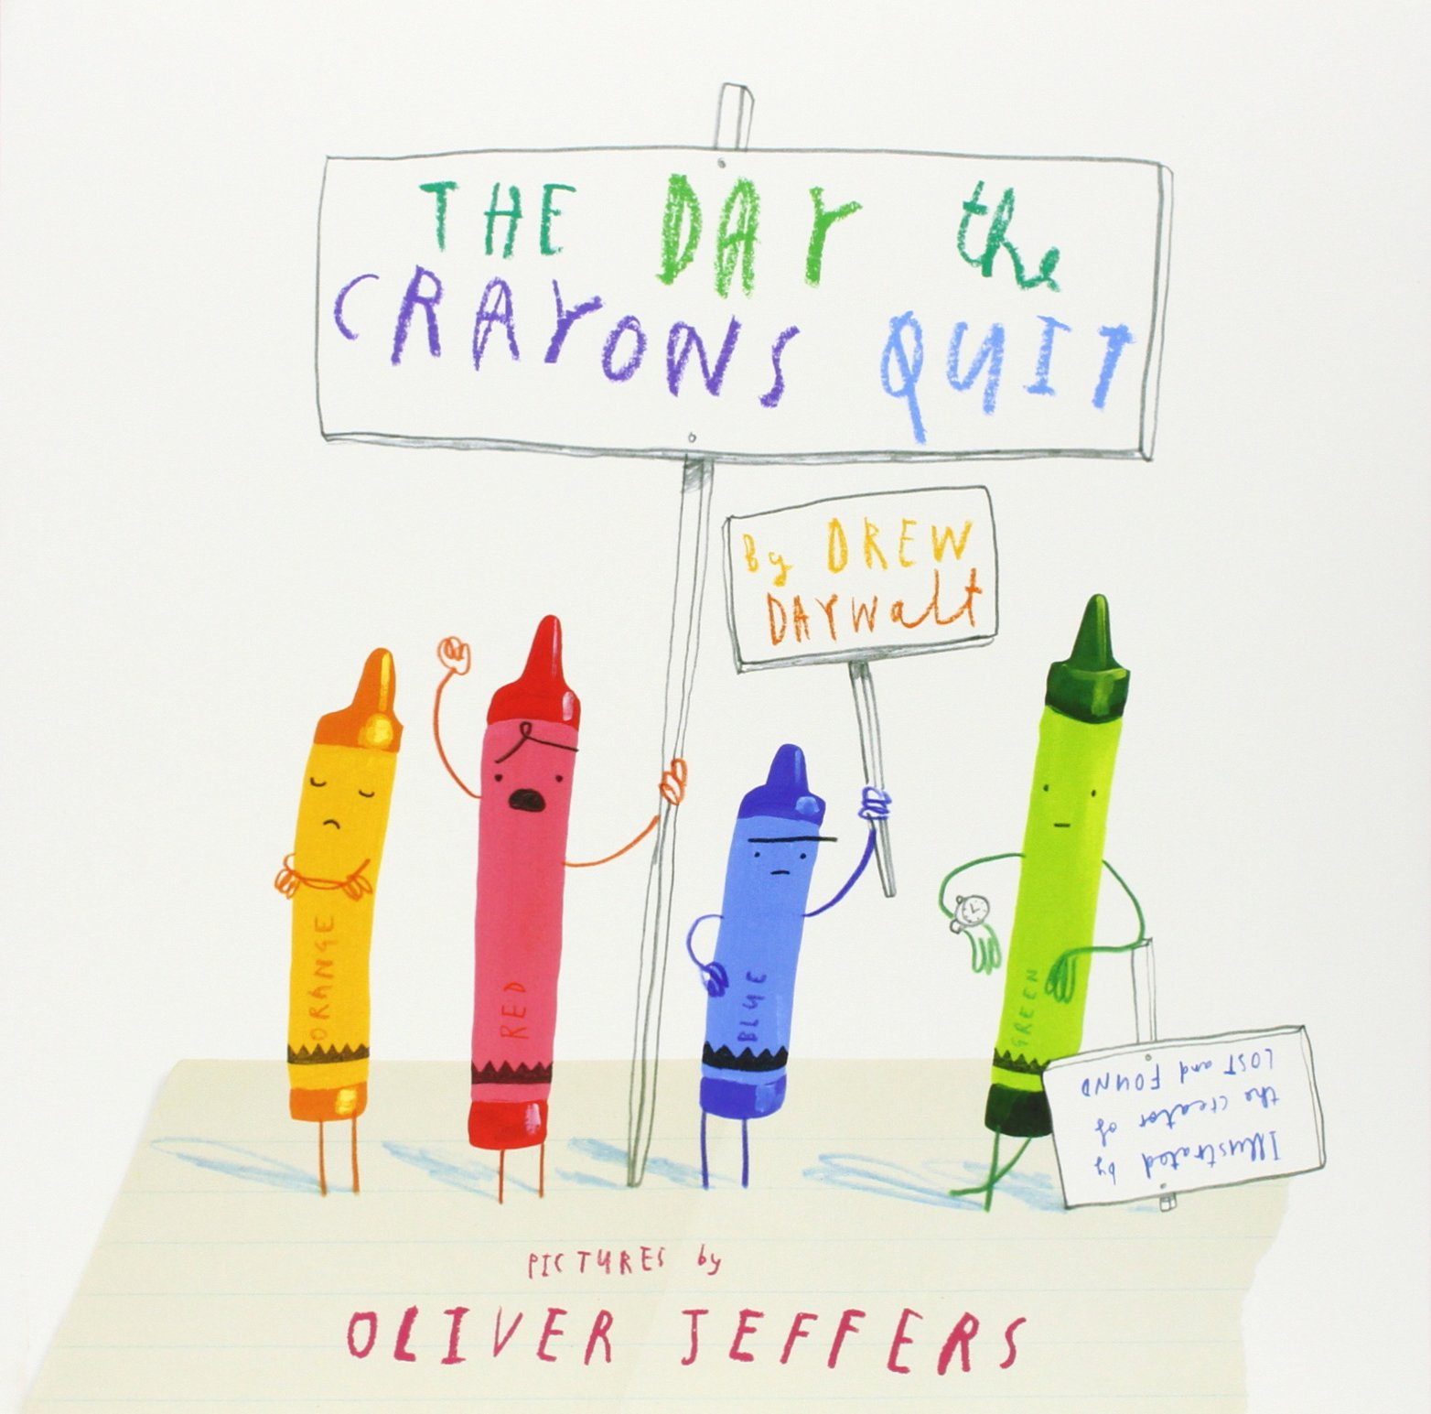
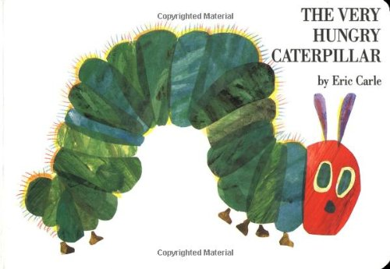
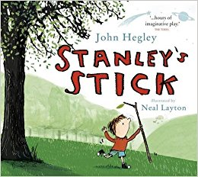
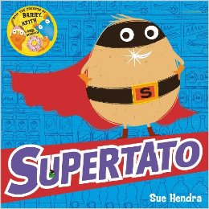
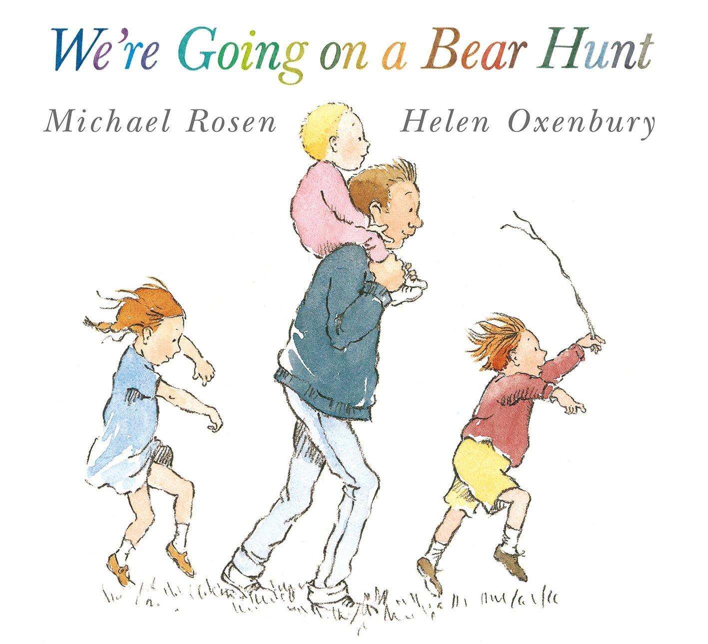
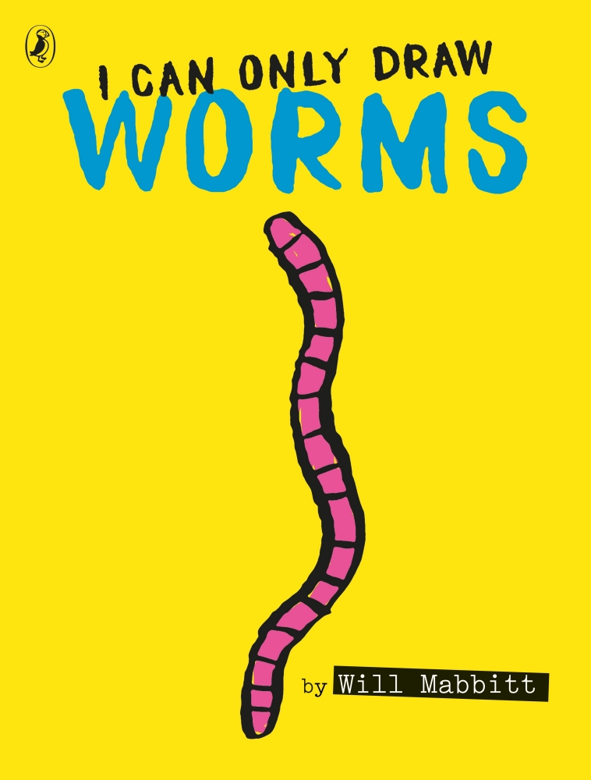
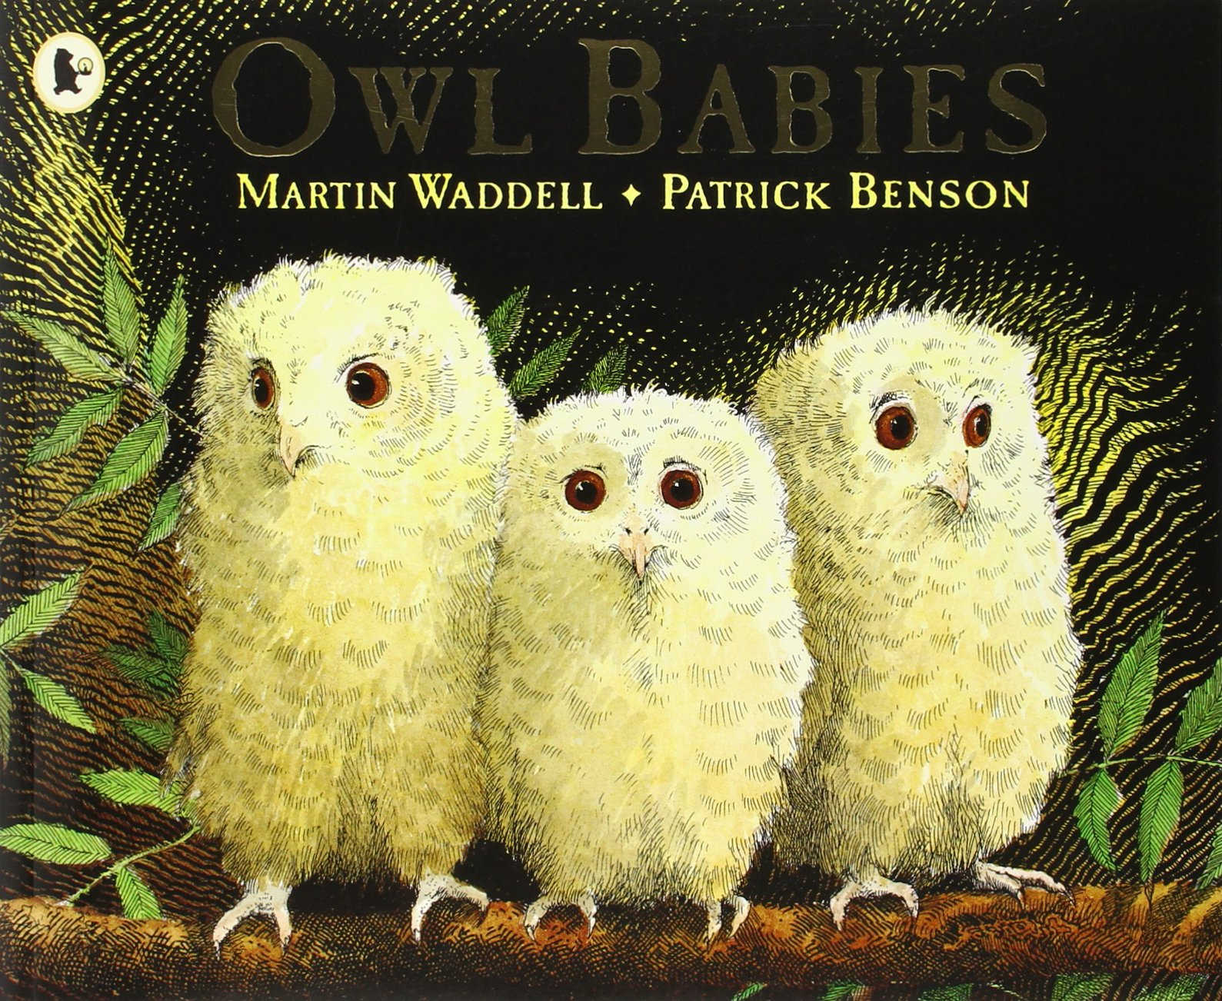
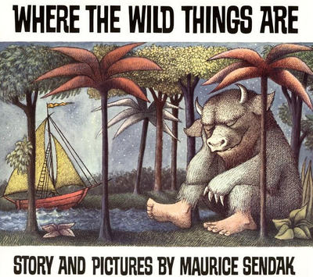
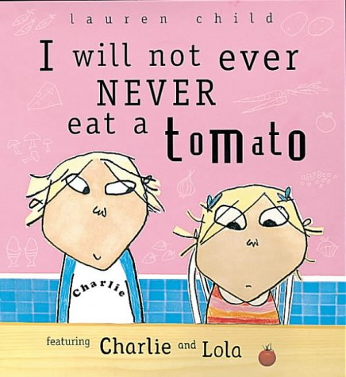
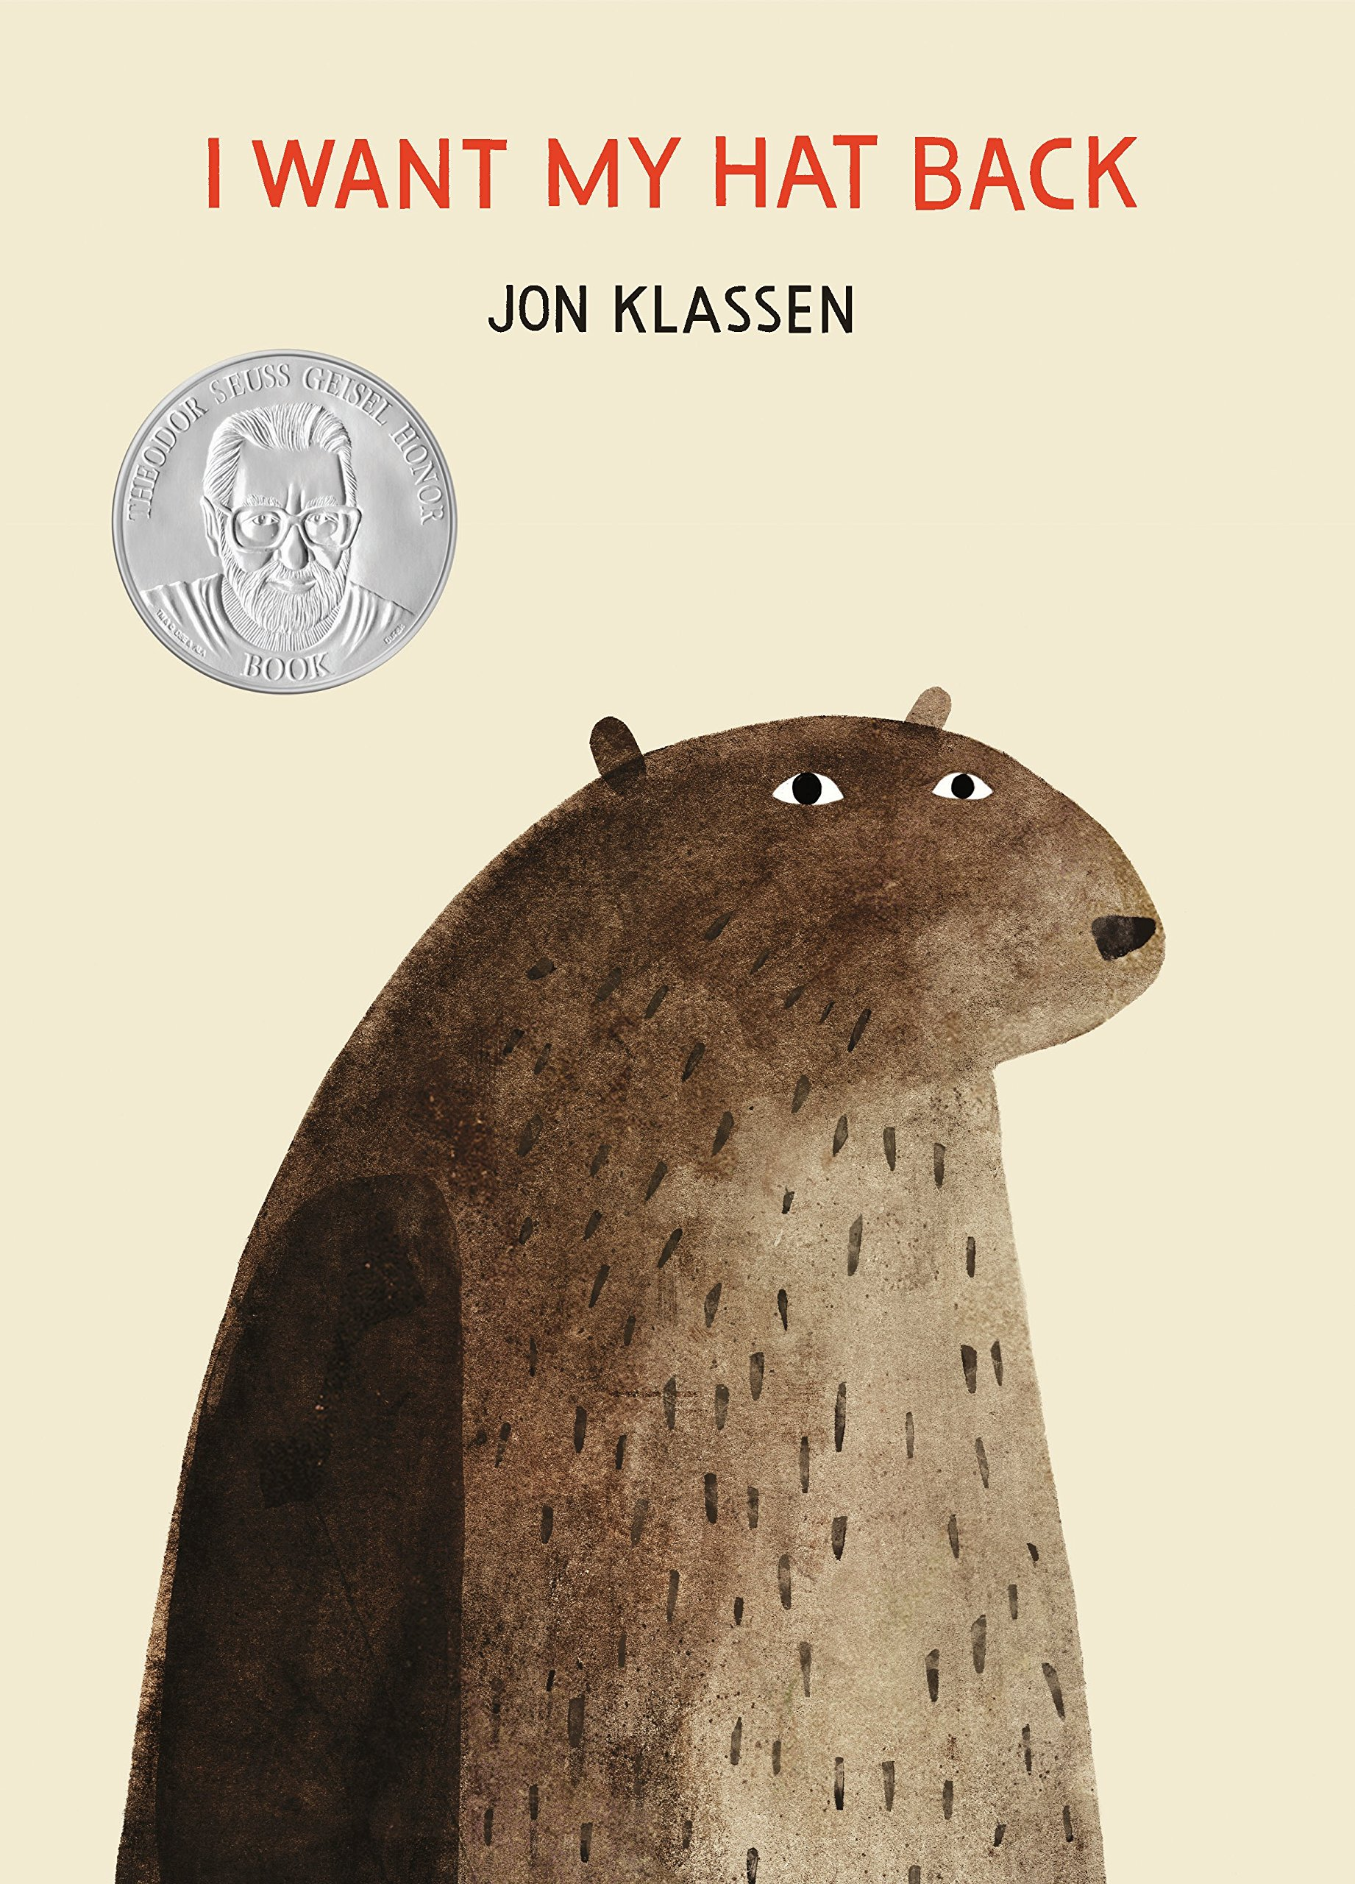
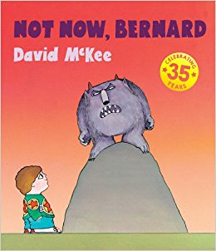
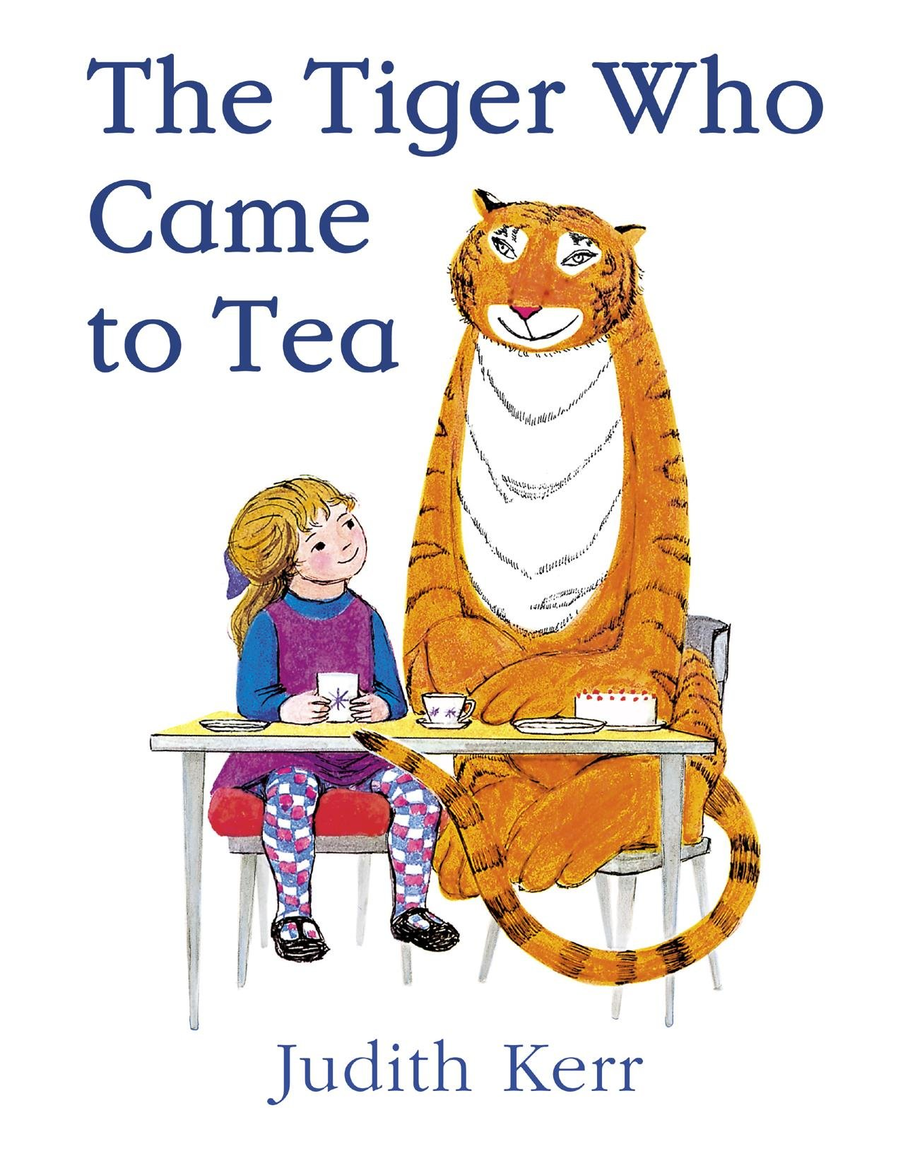
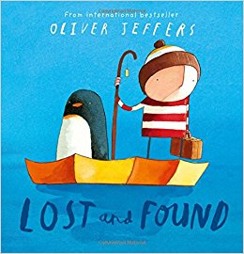
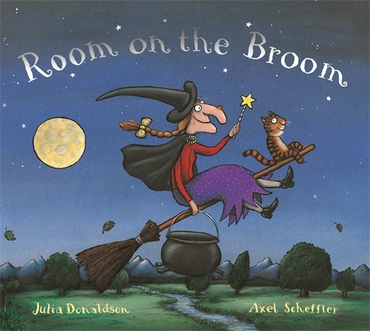
Where The Wild Things Are
Maurice Sendak
The Tiger Who Came To Tea
Judith Kerr
Sox and Pals
B B Taylor
If You Give A Mouse A Cookie
Laura Joffe Numeroff
There Was An Old Lady Who Swallowed A Fly
Pam Adams
The Day The Crayons Quit
Drew Daywalt
The Very Hungry Caterpillar
Eric Carle
Stanley’s Stick
John Hegley
Horrid Henry
Francesca Simon
We’re Going On A Bear Hunt
Michael Rosen
Each Peach Pear Plum
Janet and Allan Ahlberg
I Can Only Draw Worms
Will Mabbit
Owl Babies
Martin Waddell
I Will Never Not Eat A Tomato
Lauren Child
I Want My Hat Back
Jon Klassen
Not Now Bernard
David McKee
Lost and Found
Oliver Jeffers
Room On The Broom
Julia Donaldson and Axel Sheffler
The Snowman
Raymond Briggs
Flat Stanley
Jeff Brown
A Bear Called Paddington
Michael Bond

