Our Wellbeing Journey…

We’ve always been proud of our strong tradition of pastoral care at St Vincent’s. Our focus has been to meet the needs of our children in an ever-changing society. This is central to our school’s vision statement where we work hard to enable children to let their light shine. Follow this link to see how promoting and protecting emotional wellbeing and mental health fits in to our strategic vision. http://www.stvincents.trafford.sch.uk/uploads/120/files/st%20vincents%20strategy%20one%20page%20web.pdf

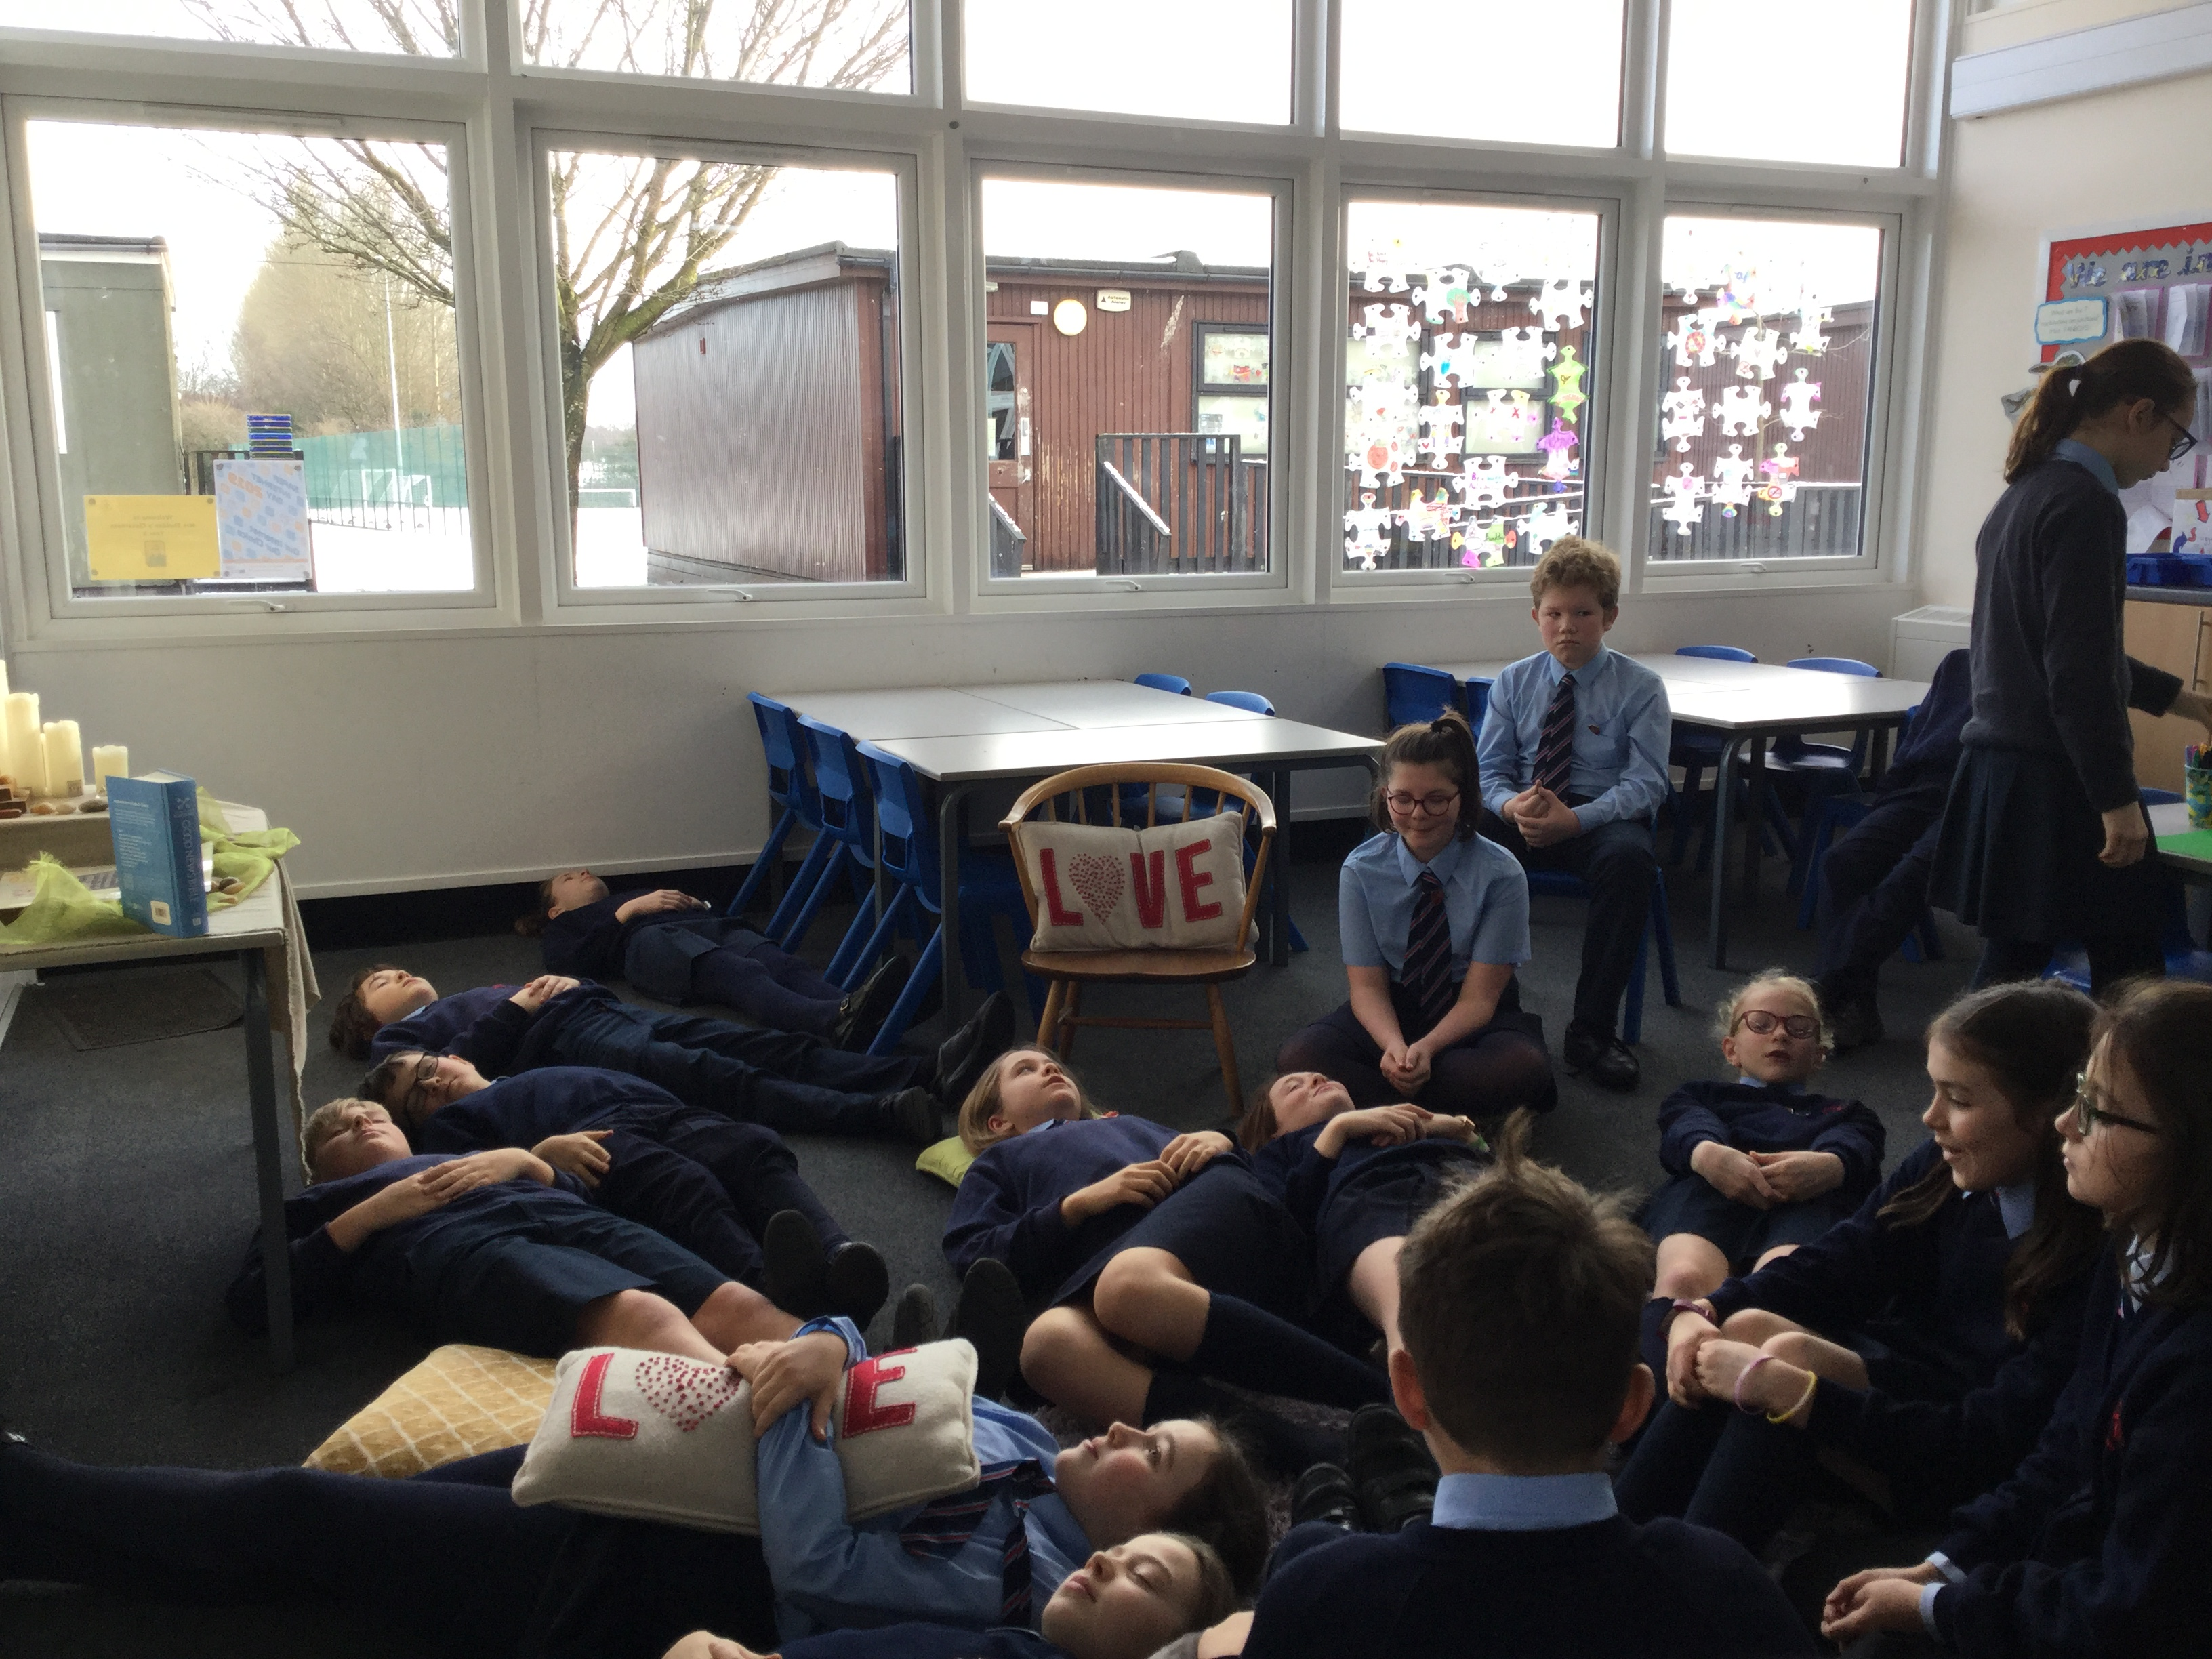
Since then, we’ve involved everyone in school…


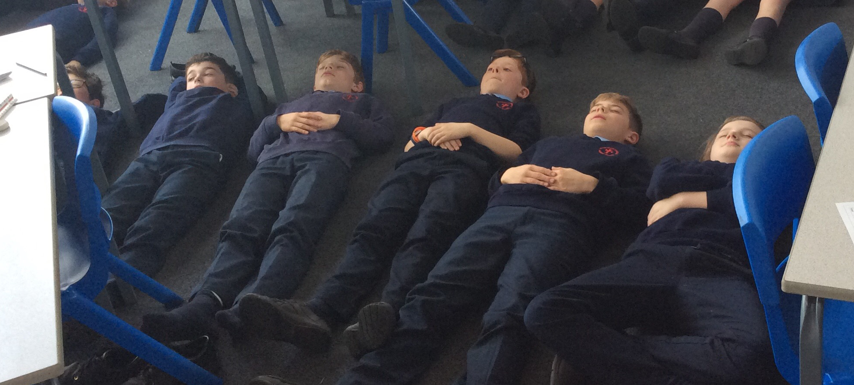

Pupils


We’ve created a new group called Wellbeing Champions who are tasked with spreading the message and with building a program of activities for pupils to enjoy. One of the highlights has been Thoughtful Thursdays, which take place at lunchtime on the last Thursday of every month on a drop-in basis offering the opportunity to take part in mindfulness, yoga and even peer massage!

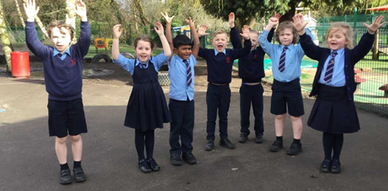

One of the biggest changes we’ve introduced in school is to bring in a new PSHE scheme of work, Jigsaw, which offers a comprehensive program of study in personal, social and health education. We believe that this is helping us to equip our children for challenges they may face and equipping them fully for the next stage of their lives.

Staff

We’ve looked at ways in which we can look after the wellbeing of staff, including mindfulness apps, shout-out boards and a focus on workload. We celebrate World Mental Health Day every year in October and a number of our staff are now Mental Health First Aiders (this in addition to a comprehensive program of professional development). We’ve added to our pastoral care team and Mrs Gee now has Mrs Robinson to work with her, giving them both much more capacity.

Governors

We have the full support of our governing body and have a designated wellbeing governor. Governors have been involved throughout the process offering support in developing our provision.

Parents

We’ve introduced a Wellbeing area on our school website so that our work can be celebrated and identified and so that any additional support required is clearly signposted. We’ve also put in a series of workshops for parents such as the Wellbeing Workshop, Building Resilience and Emotion Coaching.

All of the groups mentioned have been offered the chance to complete a survey, which has given us assurance that our message is reaching our whole school community.

Wellbeing Award for Schools

We’ve been working towards the Wellbeing Award for Schools and our inspection day was last Friday. In order to obtain the award very many different criteria need to be met and evidenced. We’re incredibly proud to announce that our school’s hard work has been clearly recognised and we’ve been awarded the award. This makes us currently the only school in Trafford to have such an accolade. The inspector had some lovely things to say about us such as:

“St Vincent’s is a very welcoming, nurturing and happy school.”

“St Vincent’s is a school, where the mental health and wellbeing of all is a foundation principle.”

“Pupils have aspirations and are clearly grateful for the support they receive. They are very proud of their school.”

“Staff feel valued for their important role of teaching and supporting pupils.”

Next Steps…

Despite having plenty to celebrate, we recognise that supporting the emotional wellbeing and mental health of our whole school community must be an ongoing priority and we’re going to continue to build on this great foundation. Look out for any new initiatives through the newsletter, twitter feed and the wellbeing area of our website.

http://www.stvincents.trafford.sch.uk/page/thought-for-the-week/49444

