No-cook Playdough recipe
On Tuesday 19th January at 1pm, I will show the children how to make their own playdough. They can join in with me making it at the same time if they have all the ingredients ready. Alternatively, they can just watch and make it later. The recipe does call for boiling water out of the kettle, so they will definitely require adult supervision.
I have provided measurements in cups or grams. Using either measure is a great way for children to start thinking about ratio and reading measures.
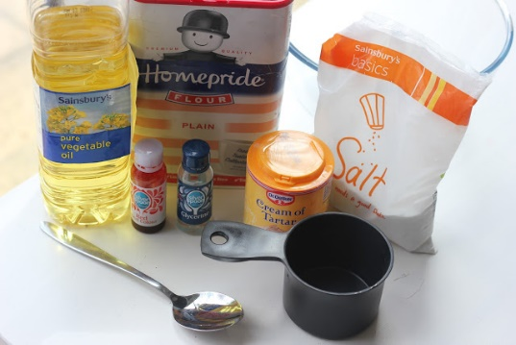
You will need ready for Tuesday:
- 2 cups (aprox 500g) plain flour
- 2 tablespoons vegetable or sunflower oil (baby oil and coconut oil work too)
- 1/2 cup (aprox 125g) salt
- 2 tablespoons cream of tartar
- 1 cups hot water (aprox 250ml) – (Adult help required)
Optional extras
- food colouring
- glitter
- few drops glycerine (secret ingredient for stretch and shine!)
- You can also add smells, such as orange oil or vanilla extract, but this makes it more tempting to eat, so be careful if you have younger children at home.

Method
- Mix the flour, salt, cream of tartar (glitter) in a large bowl.
- Add the oil to the dry ingredients and mix.
- Add the food colour (if using) to your cup/jug of water.
- Add the water to the mixture and stir. You may need to add a little extra if it seems very dry.
Mix with a spoon, then when cool enough, tip onto a board and knead with your hands for a few minutes, until you have a nice, smooth ball.
Have fun playing! This will store for a few months in an airtight box.

