Holmes Chapel Primary School


How to use Microsoft Teams
Simple guide for parents and children

This guide is to support parents and children downloading and using Microsoft Teams. MS Teams is a video and audio meeting space that children can join to talk to their teacher and class. It is also a digital platform for storing, uploading and downloading work for school.
Contents:
Page 2: Software and Login
Page 3: Teams and Channels
Page 4: Assignments
Paeg 5: Joining a Meeting

Software and Login
Before using Teams, you can download the desktop or mobile app.
Or you can use your browser online: https://www.microsoft.com/en-gb/microsoft-365/microsoft-teams/log-in
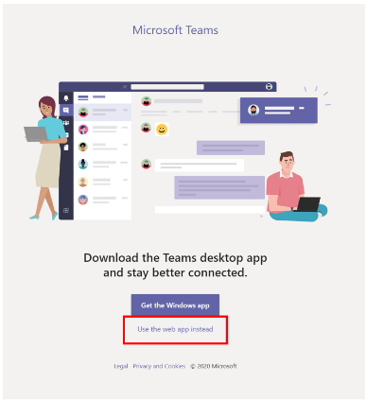

Once downloaded, type your email address and password as supplied by school.

This is in the format of firstname.surname@holmeschapelprimary.cheshire.sch.uk
e.g. joe.smith@holmeschaepelprimary.cheshire.sch.uk

Your password cannot be changed. Please keep it safe and do not share it with your friends.

Different Teams

When you are logged in you will see this screen below. Click on the icon Teams on the left hand side of the screeen and you will see the Teams you are now assigned to.
This is what Mrs Brown’s looks like but children should only be part of one Team e.g. Year 3
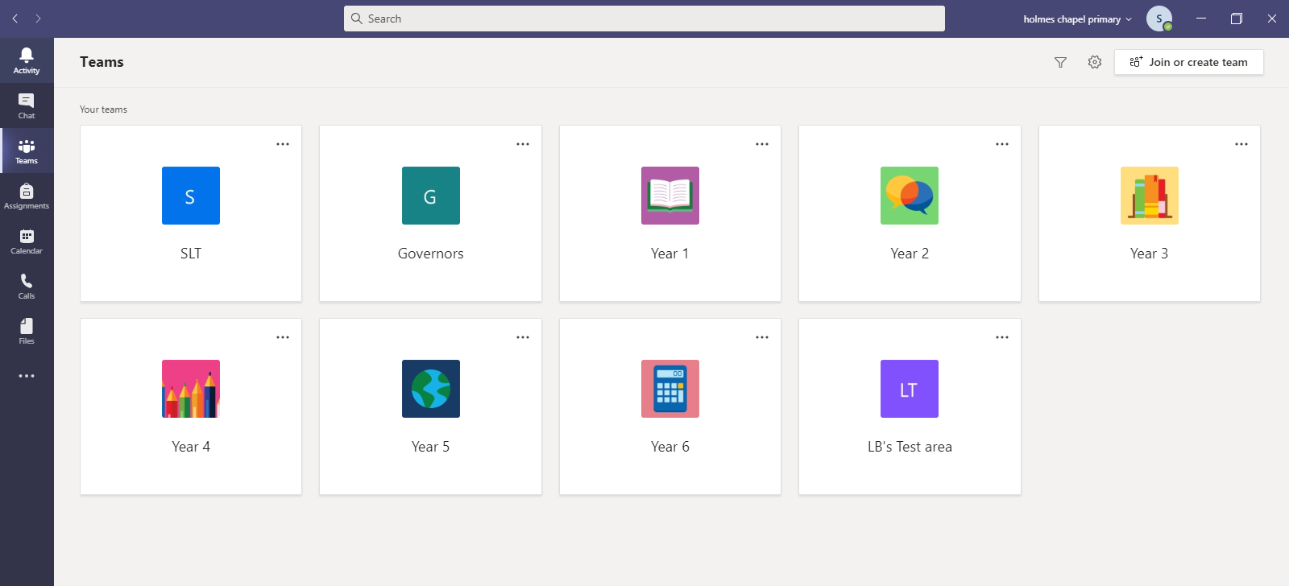

Channels in Teams
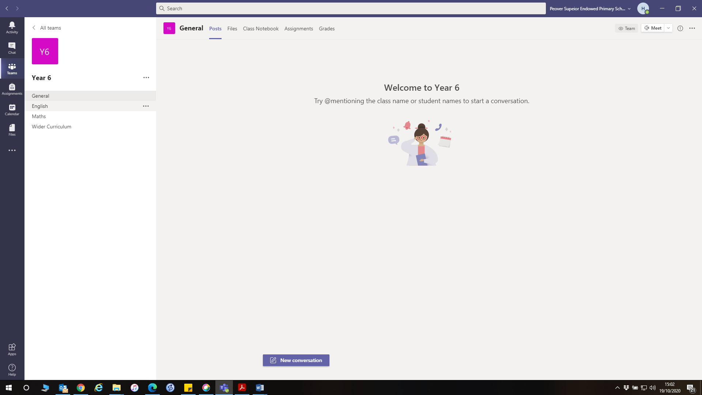

Click on your Team e.g. Year 6 to open the Team. You will see this screen (see above). On the left-hand side, there are now different channels. The chat function on Teams is not available for you to use.
If you click on the ‘Posts’ button, you can see any posts, comments and documents shared by your teacher as well as any live meetings that you can join. Only adults can post on the channel.
Assignments
At the left side of your screen there is a tab called assignments. This is where you will find some of the work set by your teachers. These can be completed on your device so you do not need to print anything out.

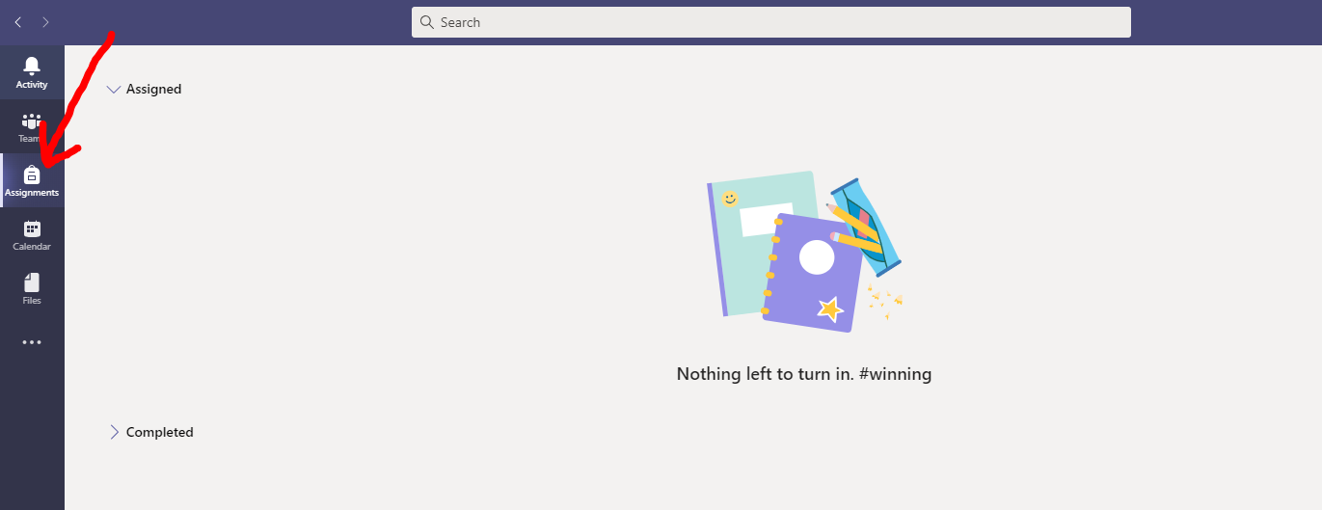

It will show you if you have any work due to be completed in the Assigned section and any work that you have Completed.
When you click on an assignment, it will give you information about what to do and when you should complete your work by.

When you have finished, click Turn in and the work will be sent directly to your teacher, where they can read it and add any comments. They can then send it back to you for you to read.

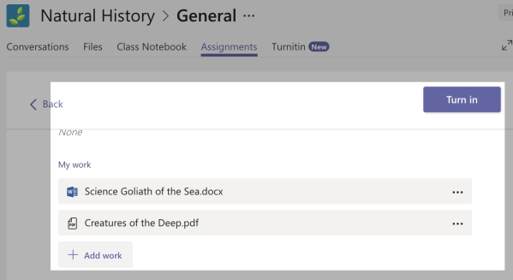
Joining a Teams ‘live’ meeting
Children cannot start a live meeting as this feature has been turned off.
When it is time to join a Teams meeting and you have been told to join by your teacher, this is what you will see in the corner of your Teams area. Click Join.

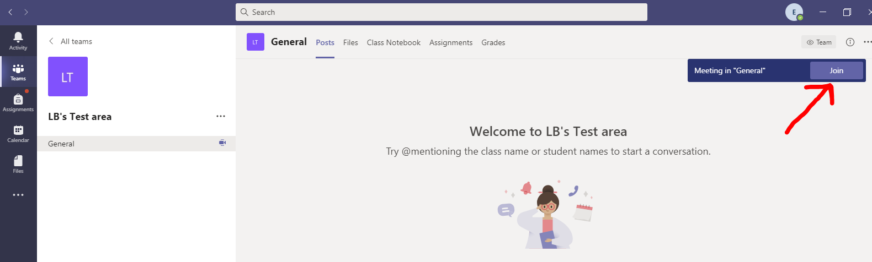

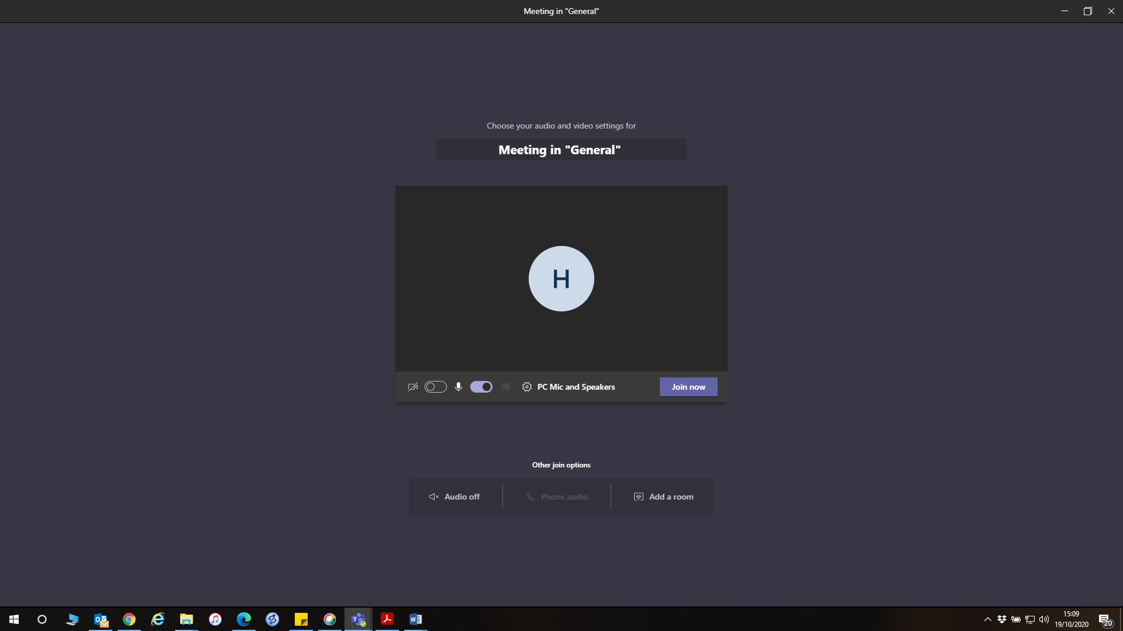

When you join a meeting, you will be added to a lobby and adult will let you in at the correct time.
When joining a Teams meeting, you can turn off your video and audio. Your teacher can also do the same. The initial’s or name of the person currently talking will be shown on the screen. Teacher’s can also share power poimts, videos etc through Teams.
If your teacher has muted you all so that they she can talk, you can also press a message icon on the screen. This is the class chat that can be used during live sessions. Please use this appropriately, as mentioned in the Code of Conduct for online sessions.

Calendar
Your teacher may use invites and the calendar to set up meetings, or they may just ask you to login at a set time and to click the Join button as shown above.
If you have a scheduled meeting, you can see this in the calendar tab at the left side of the screen. You can also join a scheduled meeting from this tab.
Children are unable to create their own New Meeting.
When you join a meeting, you will be added to a lobby and adult will let you in at the correct time.

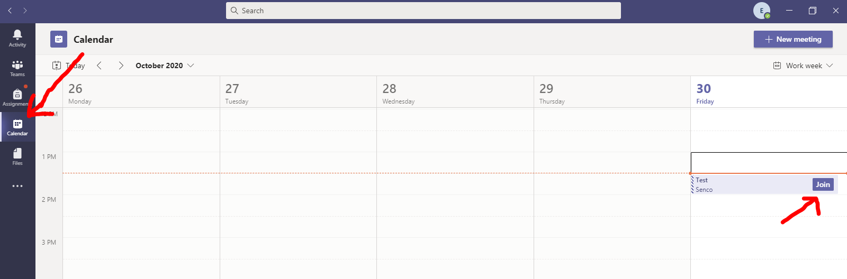

This is a basic guide to Teams. We will gradually introduce further applications within Teams and within Office 365 over the year. If you have any questions, please speak to you teacher.

