Holmes Chapel Primary School – Homework Grid – Year 3

DRY DESERTS

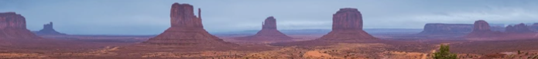
- Have some fun choosing from the following suggestions or make up a similar activity of your own.
- Please take pride in completing the work to the best of your ability.
- You should choose at least one task – or as many of them as you want!
- Please bring the work into school or send it on e-mail via Arbor in the weeks beginning Monday 19th October

Design a poster or leaflet to explain how to survive in a desert environment. | Make a fact file or PowerPoint about a desert biome of your choice. | Make a set of Top Trump cards about different deserts. | Make a traditional dish from people who live in one of the desert areas of the world. | Water is a precious resource in the desert. Record how many times you use water during a day or a week.
Find out about an animal that lives in the desert. How has it adapted to such a harsh environment? | Write a poem about the desert. | Choose a country which contains a desert biome. Find out which language is spoken there and learn some words or phrases. | Draw or paint a picture of a desert landscape. | Compare the rainfall and temperatures between Holmes Chapel and different desert locations.
Create a mini desert biome in a glass jar with a small succulent plant.  (You can find instructions online). | Make a 3D model of a desert physical feature. | Go to the library and chose a non-fiction book about deserts or a story book with a desert setting. | Invent a board game for a journey through a desert biome of your choice. | Design a building which has special features for life in a desert biome. Draw and label it.

