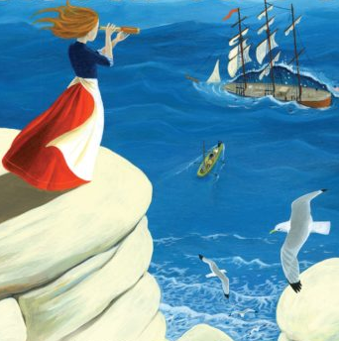
Holmes Chapel Primary School – Homework Menu – Year 4

REMEMBER to keep up with a regular diet of Times Tables and Spellings,
while cramming in as many portions of Reading for Pleasure as possible!

Captivating Coastlines

- Have some fun choosing from the following suggestions or make up a similar activity of your own.
- Please take pride in completing the work to the best of your ability and make sure it is extra tasty!
- You should choose at least one task each half term – or as many of them as you want!
- Please send them to your class e-mail by the weeks beginning Mon. 13th July. Thank you.
class4@holmeschapelprimary.cheshire.sch.uk or class4a@holmeschapelprimary.cheshire.sch.uk

Produce a fact file or a PowerPoint about a main world coastline. Include as many interesting facts as you can. | Design an animal that is adapted to live on a coastline. Would it have fur, feathers or fins? Be as creative as you like! | Create a sculpture of a coastal animal. You could use clay, salt dough, papier-mâché or whatever you like. | Investigate safety on the coast by creating a poster for the RNLI (Royal National Lifeboat Institution). | Make a model of a boat, e.g. a dinghy, barge, canoe etc. Is it strong enough to carry an apple without sinking?
Write a poem, story or cartoon about a coastal creature. | Label the countries with the longest coastlines in each continent on a map of the world. | Create a game about a coast. Don’t forget the rules and instructions! | Cook a sea-food based meal – you shall have a fishy, on a little dishy! | Investigate an artist who paints/painted coasts. Create your own version of a favourite piece.
Design a brochure or leaflet encouraging people to take a coastal holiday. | Using the tune of a well-known song, make up your own sea shanty. | Listen to the Hebrides Overture by Mendelssohn. Create your own piece of music using this as your inspiration. | Visit a coast. Make sketches of the features that you see. | Create a food chain/web for a coast. How would climate change or pollution affect it?

