Holmes Chapel Primary School – Homework Grid – Year 3

Rich Rainforests

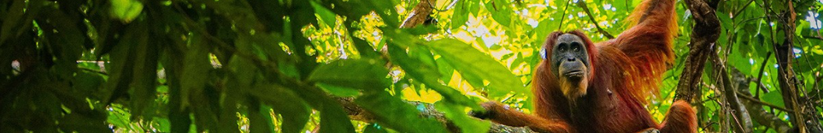
- Have some fun choosing from the following suggestions or make up a similar activity of your own.
- Please take pride in completing the work to the best of your ability.
- You should choose at least one task – or as many of them as you want!
- Please bring the work into school or send it to your class e-mail in the weeks beginning Monday 13th July
class3@holmeschapelprimary.cheshire.sch.uk or class3a@holmeschapelprimary.cheshire.sch.uk

Make an equipment list of everything you would need to take with you on a trip into a rainforest. | Make a fact file or PowerPoint about a tropical rainforest biome of your choice. | Make a set of Top Trump cards about different rainforests or rainforest creatures. | Make a dish using ingredients which are grown in or originate from a rainforest | Visit some creatures of the rainforest somewhere such as Chester Zoo or Peak Wildlife Park.
Find out about an animal that lives in the rainforest. How has it adapted to this environment? | Write a poem about the rainforest. | Choose a country which contains a rainforest biome. Find out which language is spoken there and learn some words or phrases. | Draw or paint a picture of a rainforest landscape or creature. | Compare the rainfall and temperatures between Holmes Chapel and different rainforest locations.
Create a mini rainforest biome diorama in a box showing the different layers. | Make a 3D model of a rainforest creature. | Go to the library and chose a non-fiction book about rainforests or a story book with a rainforest setting. | Invent a board game for a journey through a rainforest biome of your choice. | Write a diary entry as an explorer travelling through a rainforest.

