Good morning Year 5,
We hope that you have safe and cosy snow day. Here is an overview of your home learning for today.
Maths
Practice your column subtraction and division skills using the games on the website Maths Frame (mathsframe.co.uk/en/resources/category/22/most-popular). Choose a game, press play and then choose the topic. Once you've chosen a topic, then choose a suitable starting point (e.g. Subtract combinations of 3-digit numbers). The further down the list you go, the harder it gets. Make sure you've got a pen and paper to hand to do any working out. If you need a reminder on how to do column subtraction, then watch the following video: Subtraction Video – Corbettmaths Primary.
English
Over the next couple of weeks, we will be revisiting and practising writing dialogue. Attached on the ‘Next week in Year 5’ page is a powerpoint for you to go through and follow the activities. You can complete the activities on a lined piece of paper.

If you struggle to access it, please go to the Oak Academy page. There is a video to watch if you prefer, but it is a little slow! https://www.thenational.academy/teachers/programmes/english-primary-ks2/units/building-handwriting-fluency-through-speed-choices-and-writing-dialogue/lessons/practising-handwriting-by-writing-dialogue

Extra practice
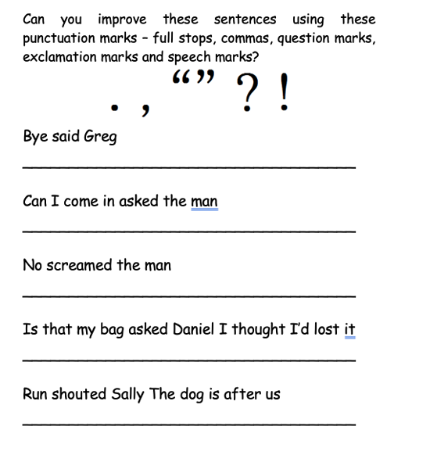

Reading-Book Hook-
Before we introduce you to our new class book, we want you to use your imagination (you may need adult support for this lesson).
Find a space where you can block out as much light as possible. Lay down and close your eyes. What thoughts and feelings do you have about being in a dark space? While you are still lying down with your eyes closed, try stretching your arms and legs and gently move your body. Do your feelings change as you change position? Which of these positions do you feel less comfortable in and why? When in complete silence (with adult support) play the following sound effects https://www.youtube.com/watch?v=kmb8RoiTPfU and relax.

Activity:
Get yourself a piece of paper and some pencil/pens to draw with. Next, draw what images came into your mind whilst listening to the sound effects. What images did you see? What did it remind you of? You may want to draw symbols or write descriptions, but please use your imagination as much as possible.
Please bring your pictures into school so we can share them with the class.

Happy New Year!
What are your New Year goals for 2026?
Colour in and complete the 2026 New Year goal worksheet (also attached. on the ‘Next week in Year 5’ page) Write down what you would like to do this year, what new books you would like to read, places you might like to visit and what new things you would like to learn. Let’s make 2026 a great year!
Other activities you might want to do:
Art - Have some fun following along with a draw with Rob video. Videos can be found on this link : #DrawWithRob — Rob Biddulph
You can always practice your times tables on TT Rockstars and spelling on Spelling Shed too.

Have a great day and stay safe!
Mrs Wall, Mrs May and Mrs Waddington

