Holmes Chapel Primary School – Homework Grid – Year 3

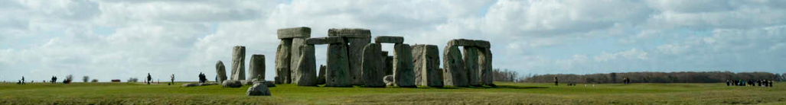
Rock’n’Roll

- Have some fun choosing from the following suggestions or make up a similar activity of your own.
- Please take pride in completing the work to the best of your ability.
- You should choose at least one task – or as many of them as you want!
- Please bring the work into school or send it to your class e-mail in the weeks beginning Monday 15th December
class3@holmeschapelprimary.cheshire.sch.uk or class3a@holmeschapelprimary.cheshire.sch.uk

Design a poster or leaflet to explain how to survive during the Stone, Bronze or Iron Age. | Make a fact file or PowerPoint about Mary Anning or her discoveries. | Make a set of Top Trump cards about different prehistoric creatures such as the giant elk and woolly mammoth. | Visit Tegg’s Nose (a regionally important geological site). Follow the ‘Tegg’s Nose Rocks’ trail. Leaflet on website – Y3 Homework page. | Use some different rocks or stones to create a sculpture. You might like to look at Andy Goldsworthy’s work for inspiration.
Draw or paint a picture or make a model of a prehistoric creature such as a cave lion or saber-tooth tiger. | Write a poem about an ichthyosaur or pterosaur. | Go on a walk. How many places can you see rock being used? Can you identify any of the different types? | Draw or paint a picture in the style of cave art. | Find out about palaeontology – What is it like today? How could you become one? (Links on Y3 Homework page)
‘She sells sea shells on the sea shore’ is a tongue-twister about Mary Anning. Make up your own tongue-twister. | Make a 3D model of a Stone, Bronze or Iron age settlement or house. | Go to the library and chose a non-fiction book about the Stone, Bronze or Iron Age or rocks and fossils. | Invent a board game for surviving during the Stone, Bronze or Iron Age. | Visit Manchester Museum and look at their collection of rocks and fossils – including an ichthyosaur.

