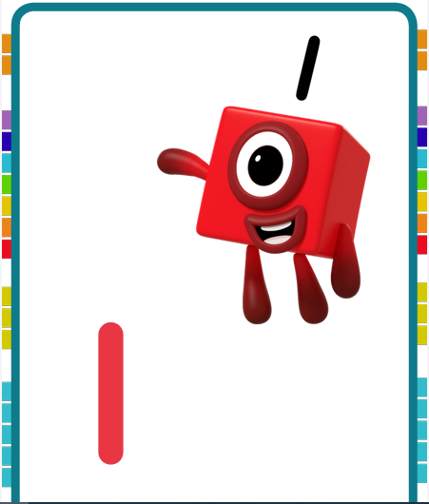 | 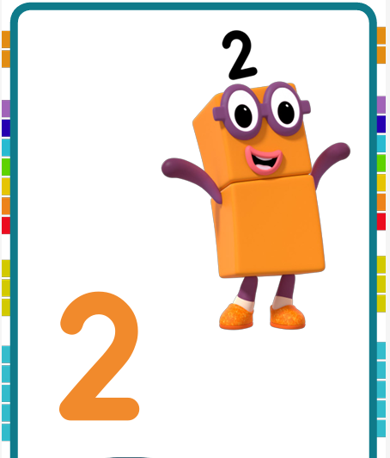 | 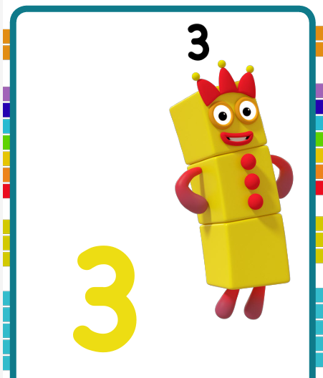 | 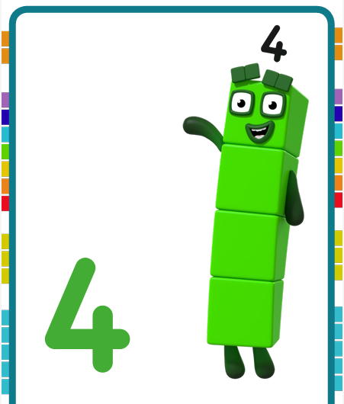
Draw one straight line from top to bottom to make 1 | Round and Down then across the base to make 2 | Go round in a curve and around again and you have got 3 | Draw down and across, then cut the line to make 4
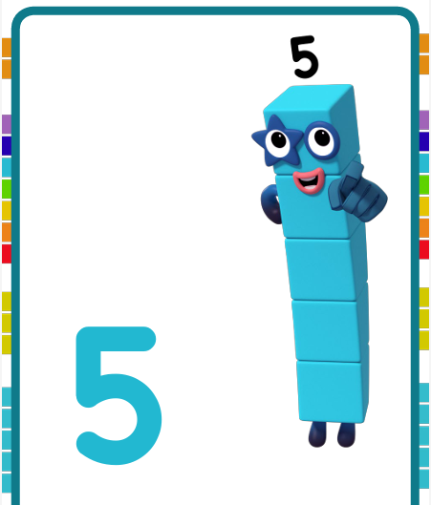 | 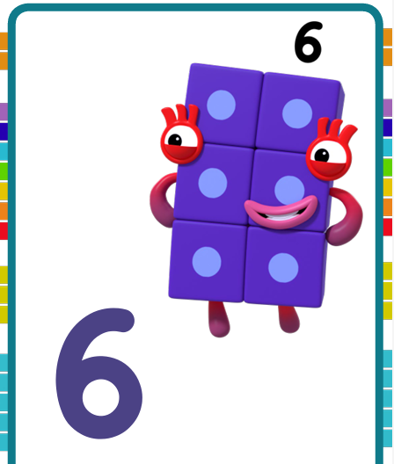 |  | 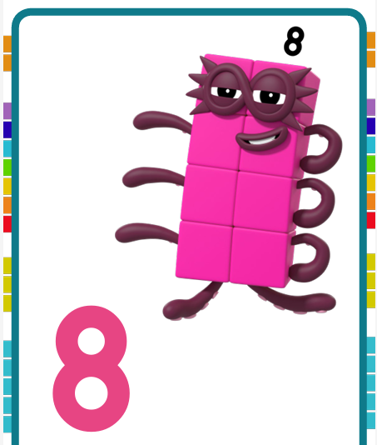
Draw down and around then across at the top to make 5 | Start with a curve and go round in a loop to make 6 | Draw one flat line and one line down to the ground to make 7 | Start with an S then loop back around to make 8
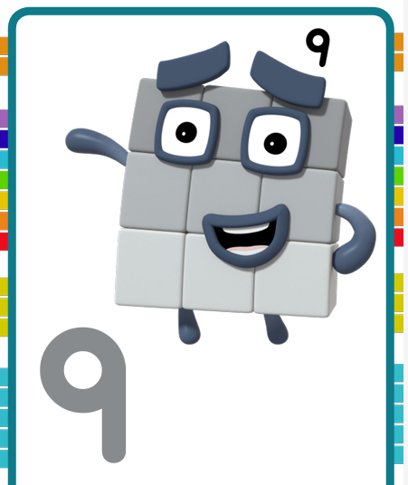 | 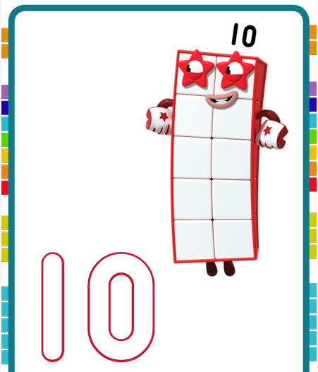 | 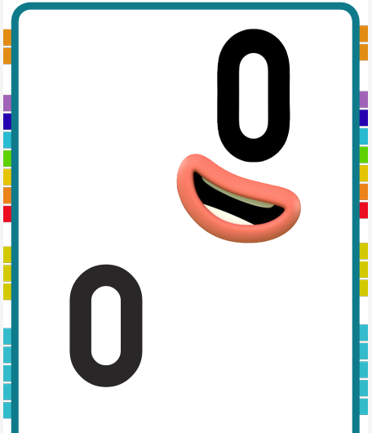
Start with a loop then a line straight down to make 9 | Draw a one and an oval to make 10 | Draw an oval to make 0

