Jupiter
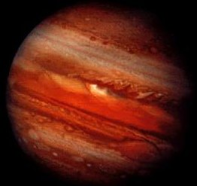

Fact 1: Jupiter is the biggest planet. It is made of gas and some liquids.

Fact 2: Jupiter has 39 moons.

Mercury
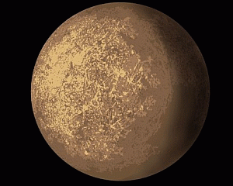

Fact 1: Mercury is a hot and rocky planet.
Fact 3: There are lots of craters on Mercury.
Fact 4: Mercury has no moons.

Venus
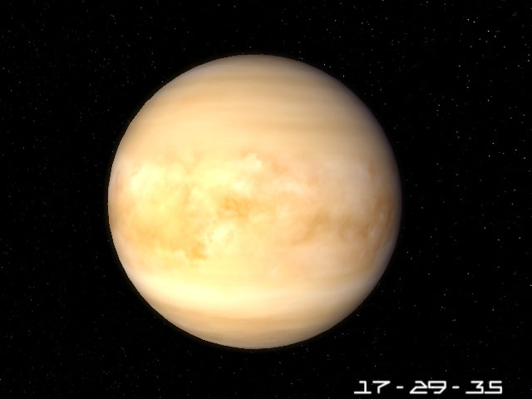
Fact 1: Venus is the hottest planet.
Fact 2: Each day on Venus takes 243 Earth days.
Fact 4: Venus has no moons.

Earth
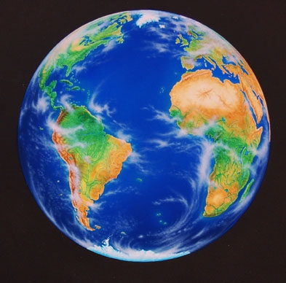

Fact 1: Earth the planet we live on.
Fact 2: Earth has one moon.

Mars
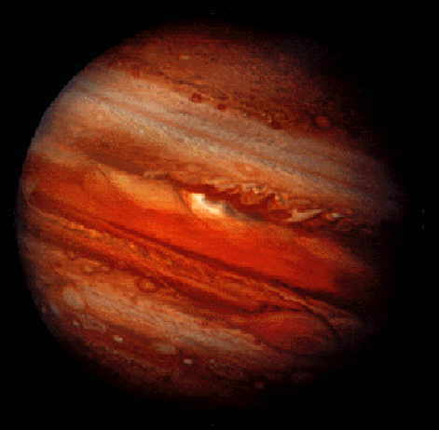
Fact 1: Mars is red because it is covered with rust.
Fact 2: Mars is a dry rocky planet.

Saturn
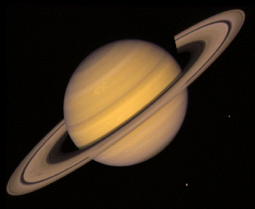
Fact 1: Saturn has rings made of ice.
Fact 2: We can see Saturn with a telescope.
Fact 4: Saturn has 33 moons.

Uranus 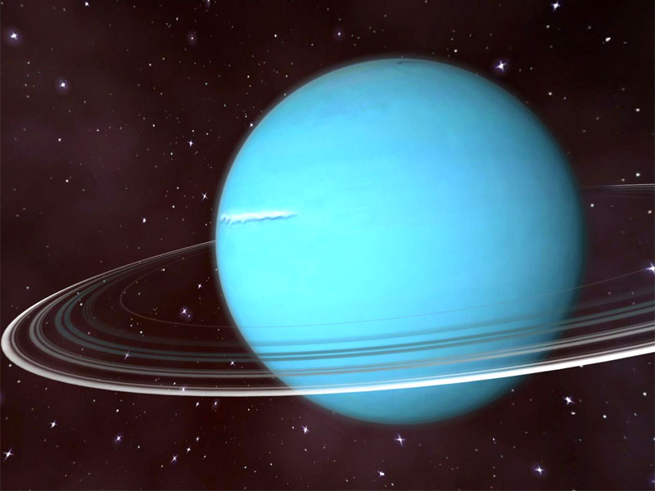
Fact 1: Uranus is a large, icy planet covered in clouds. Uranus is blue.
Fact 2: Uranus has 22 moons.

Neptune
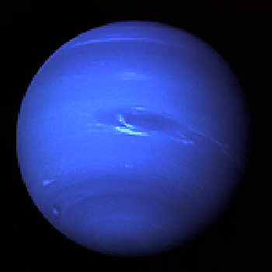
Fact 1: Neptune has rings made up of dark rock and dust.
Fact 4: Neptune has 13 moons.

Pluto
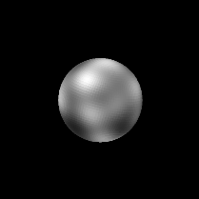
Fact 1: Pluto is very cold because it is so far away from the sun.
Fact 3: Pluto has one large moon and two tiny moons.

