
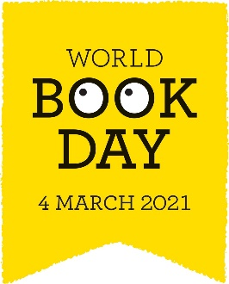
World Book Day 2021
Thursday 4th March

Reading Menu of Activities 1st – 5th March
It is World Book Day this week
Please look at the grid below and choose one activity to complete every day if you can.
Writing | Art | IT | DT
Write a book review | Design a new cover for your favourite book | Create a word cloud about your favourite book | Bake something inspired by your favourite book
Write a letter to your favourite author | Design a World Book Day bookmark | Film a short animation of a scene from your favourite book | Create a menu for a dinner party with your favourite characters – cook the main course
Plan and write your own story | Draw with Rob – 6 WBD Bookmarks https://www.youtube.com/ watch?v=WhMoHJuQuLs | Click on the link for your £1 book token  World Book Day Token | Design a bedroom for a character
Other |  | World Book Day Resources
Make a book wish list | Take your own ‘shelfie’ – picture of you with your book shelf | Recipes  https://www.worldbookday.com/resources/cooking/  Make and Do  https://www.worldbookday.com/resources/make-and-do/  Colouring  https://www.worldbookday.com/resources/colouring/  Extracts  https://www.worldbookday.com/resources/extracts/  Share a story Live  https://www.worldbookday.com/share-a-story-corner/
Spend some time ‘comfy reading’ in your favourite spot | Can you turn your favourite story in to a comic strip?
Find a fun or unusual place to read - ask somebody to take a picture of you reading and send it to us. | Read to your sibling or a pet

