Welcome to Holmes Chapel Primary School Reception 2025
We are so excited to see you all in September; here are a few things you might like to know before you start.
We know that, for some children (and parents), starting school can be a daunting prospect. We are here to make that transition as smooth as possible. Please share this information with your child and talk them through it. If you have any questions or concerns, we can be reached by telephone through the school office, or via email:
School office admin@holmeschapelprimary.cheshire.sch.uk
Class R (Mrs Noble and Ms Cain) classr2025@holmeschapelprimary.cheshire.sch.uk
Class Ra (Miss Sanchez) classra2025@holmeschapelprimary.cheshire.sch.uk
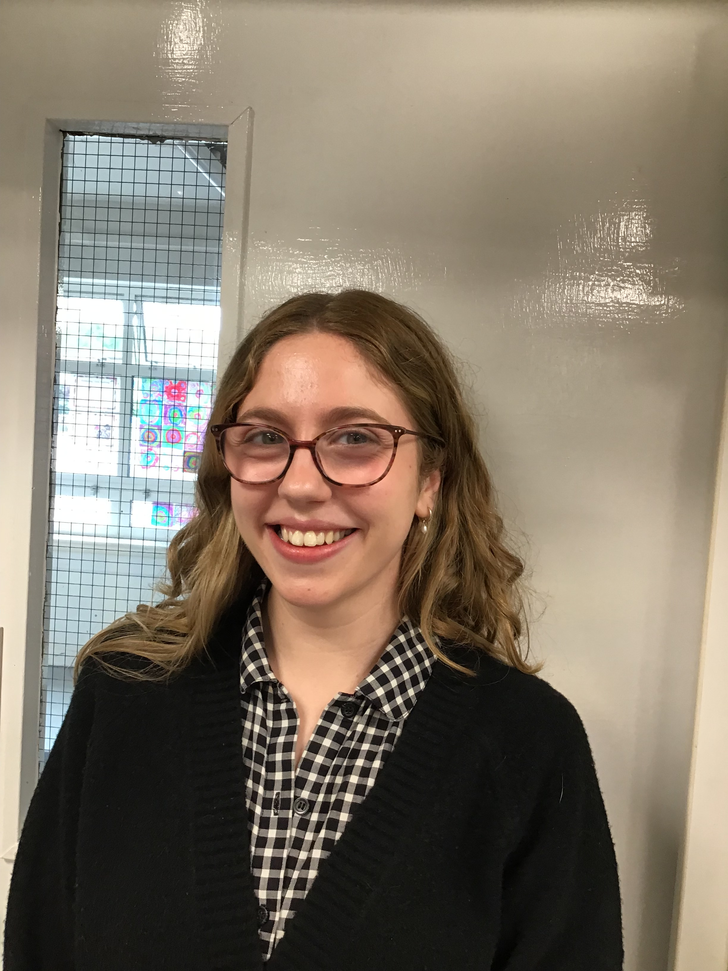
Miss Sanchez
Class Ra teacher
Monday-Friday
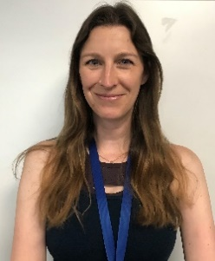
Mrs Noble
EYFS lead
Assistant Head
Class R teacher Mon-Thursday
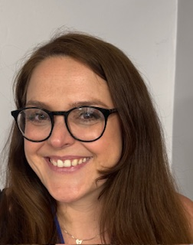
Ms Cain
Class R teacher
Thursday/Friday

For the first two and a half weeks, we will keep the children together as a year group, whilst we observe and conduct baseline assessments. We will then split the group into Class R and Class Ra. Registration and main teaching sessions will take place in your child’s classroom, but the children will have opportunities throughout the day to take part in activities in both classrooms, the shared ‘big room’ and our enclosed, outdoor area. We hang our coats and bags in the classrooms, where they will have their own peg. It is a very small cloakroom, so please don’t bring a big bag, as it will end up getting trampled on. We recommend the blue, satchel-style bags available from the uniform shop, or something large enough to fit an A4 reading folder in.
Class R
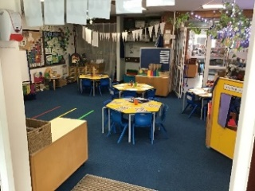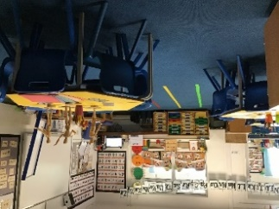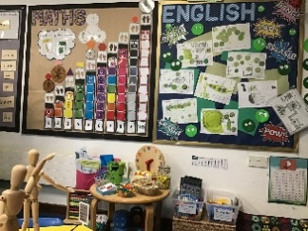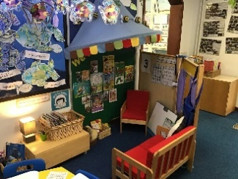
Class Ra
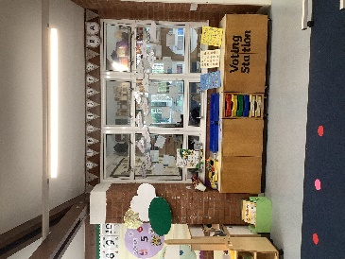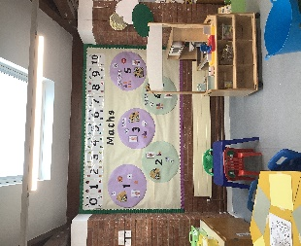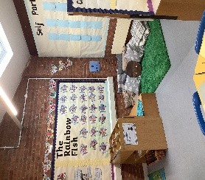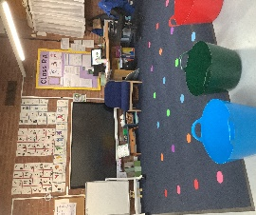
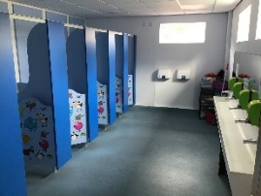
We eat our lunch in the school hall. Children are entitled to a free school meal in Reception and Key Stage 1. Please look through the menu options with your child beforehand, so they know what to choose when we fill in the lunch list every morning. Parents can also pre-select an option for their child. If your child has an allergy, it is important that you tell us, so we can let the kitchen know. Children can also bring a packed lunch from home if they prefer. We also use the hall for assemblies and PE lessons.

We have our own toilets in Reception. The children are free to use the toilet whenever they like, as long as they let an adult know where they are going.

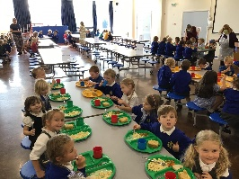

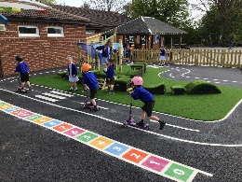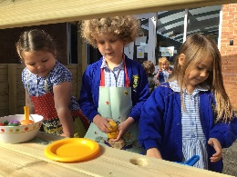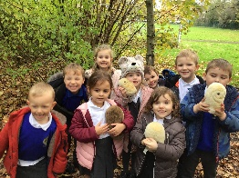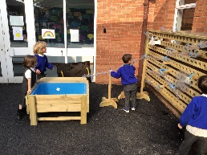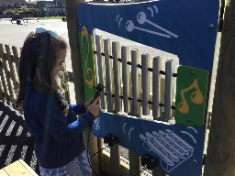
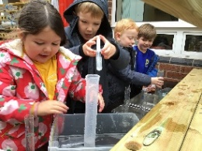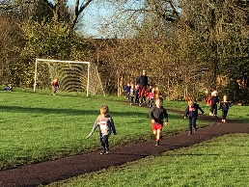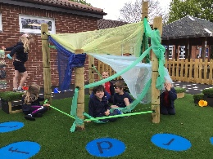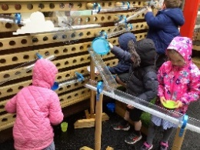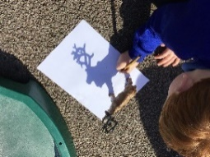
We have lots of lovely outdoor space on our fields, playgrounds, as well as woodland with its own outdoor classroom. We also have a fantastic Reception outdoor area just for us! We make sure all children spend time outdoors everyday- even when it’s raining- so don’t forget your coat. We run round the trim trail most days, so we recommend plain, black trainers, rather than school shoes be worn in Reception.
What should my child know before they start school?
It is helpful if children can recognise their own name. We use lowercase letters (except at the start of names), so please do not print your child’s name in capitals.
Children should be able to put on, zip up and take off their own coat and take their own shoes on and off. They will also need to be able to get into and out of their PE kits themselves, so please practise over the holidays. Please also teach your child how to open their own snacks. We expect all children to be able to use the toilet independently in September.
We are all sharing a very busy and stimulating environment and it’s important that the children understand that it is a shared space where we play and learn collaboratively, learn to tidy up and look after property.
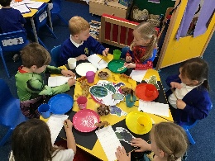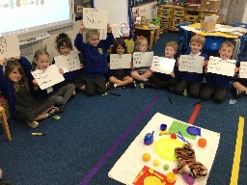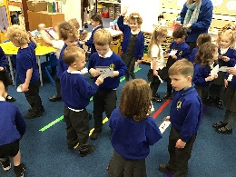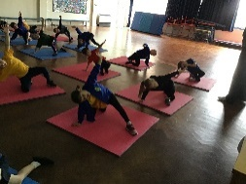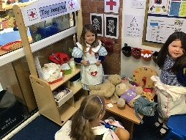
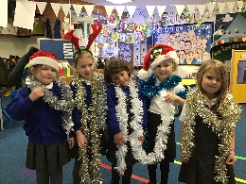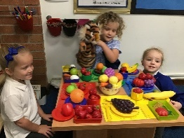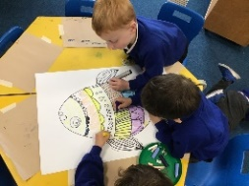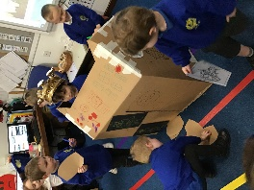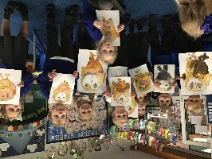
What will the first few weeks look like in Reception?
We will have a variety of activities out, which will provide us with the opportunity to observe the children and conduct our initial, baseline assessments. These are informal assessments that will give us a snapshot of each child’s ability in relation to the seven areas of learning. Some assessments are done on a one-to-one basis and others are done through observations. We will also assess the children against the statutory EYFS baseline assessment. This is done 1-to1 and looks at a child’s early maths, reading and comprehension ability.
We will be using the first few weeks to get to know the children and allow them to get to know each other. The children will be free to make choices about which activities they do and we’ll guide them and observe them in these activities. As we progress through the year, we will move around activities on a rotation basis, with a mixture of independent activities, guided activities and ‘free choice’ activities. The children will all have the opportunity to make use of our outdoor area throughout the day. We encourage independent learning right from the start and tasks are designed to allow the children to gain confidence, work collaboratively and think creatively.
What will we learn in Reception?
We teach a broad and varied curriculum, encompassing the seven areas of learning. All children will be taught phonics daily through the Little Wandle scheme. We enclose a copy of the Phase 2 and 3 sounds that children will be taught in Reception. Our reading will link to the Little Wandle scheme and books will be matched to your child’s phonetic ability. We will send home a reading book weekly from October half term, there will be more information given to you in September. We cannot stress enough how important it is that you read regularly with your child at home. This should be a mixture of you reading to them, them reading to you and a discussion about the content of a book.
We teach Maths and Literacy to the whole class daily, usually in the mornings. In the afternoon, we have several short, focused sessions on the other areas of learning. Most of our learning is based around high quality texts which are linked to our topics. Every Friday, we will post details on the website gallery of what we have been up to and a set of photos for you to share with your child. This gallery is password protected, but we do require permission for your child’s photo to go on. Please see the permission form in your pack for further details.
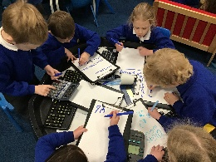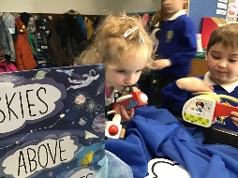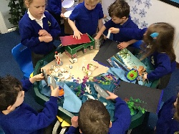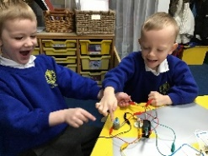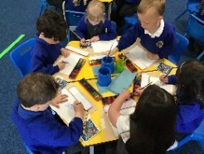
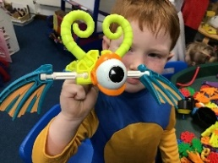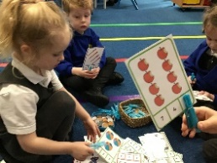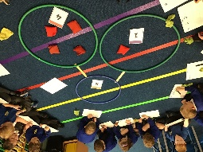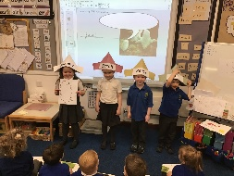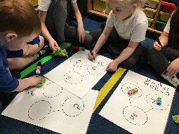
What does my child need for PE?
Whilst the rest of the school come into school dressed in sports clothes on their PE day, in Reception children come in every day in their uniforms and on PE days we get changed in the classrooms. For PE the children are required to wear black shorts, black indoor pumps and a plain t-shirt in their house colour. We will not be starting PE until Monday 6th October, by which time you will know which colour house your child is in. Siblings will be in the same house. PE kits are then brought into school at the start of a half term and sent home for washing before each holiday.

How will we communicate with you?
- If there is anything different happening in Reception e.g. the children are required to come into school in different clothes, we will always send out a digital parent mail notification. We appreciate that parent social media groups can be useful, but please check with a member of the Early Years team if you need clarification on anything.
- All money for lunch, toast, trips etc. is managed digitally through parentpay.
- Relevant dates can be found at the end of the whole-school weekly newsletter and on the school website.
- Our Reception gallery page is updated every Friday with our news and photos from the week. The photo gallery is password protected and you will receive the password in September.
- If your child has had a minor accident that has required first aid, they will be sent home with a notification sticker and explanation slip. If necessary, we will try and speak to the adult collecting them too. If we have concerns about an injury or illness, we will phone you, so it is important we have up-to-date contact details on record.
- If you have any questions or concerns and would like to meet with one of us, please don’t hesitate to get in contact. Please note that drop-off in the morning is not always the best time, as ensuring all the children are entering school safely is our priority. If you phone or email the office, we will contact you as soon as we can to arrange a meeting.

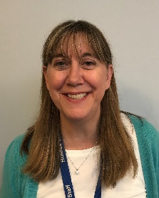
Mrs Gresty – Principle principle@holmeschapelprimary.cheshire.sch.uk
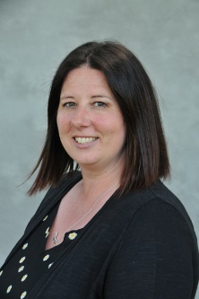
Mrs Bradford – Head of school headofschool@holmeschapelprimary.cheshire.sch.uk

