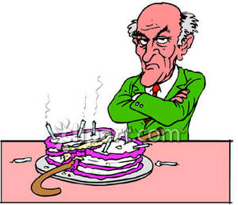
Mr Evans
Aggressive
Punctual
Spiteful
Unappreciative
Conceited
Meticulous

