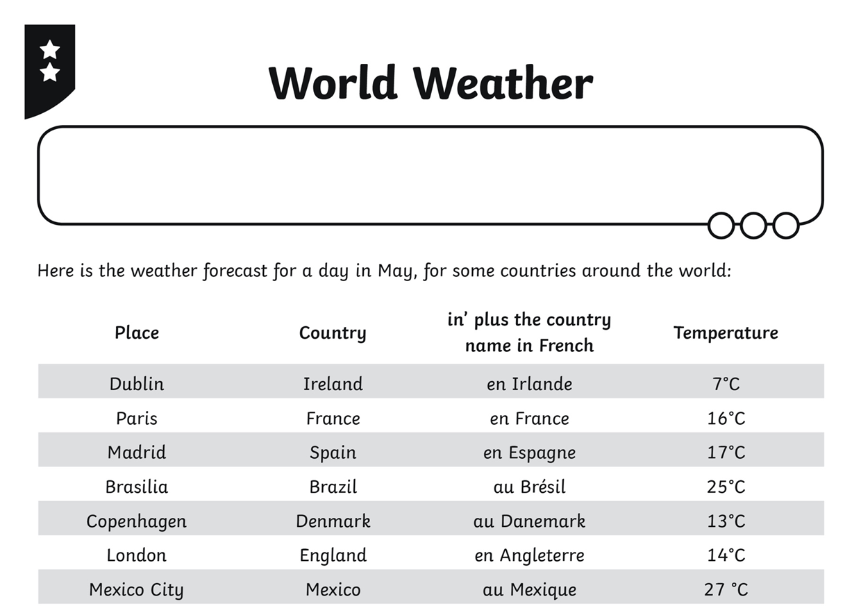
Write sentences about each country saying the temperatures. The first one is done for you.
- Aujourd’hui en Irlande, il fait sept degrés Celsius.

- Aujourd’hui

- Aujourd’hui

- Aujourd’hui

- Aujourd’hui

- Aujourd’hui
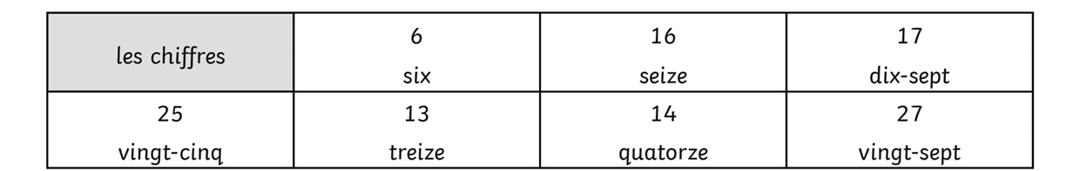
I can use the correct preposition: en for feminine countries, au for masculine countries.

