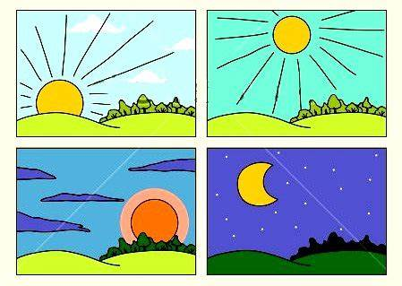
Can you match the times of day to the pictures?
Le matin

L’apres-midi
Le soir
La nuit

