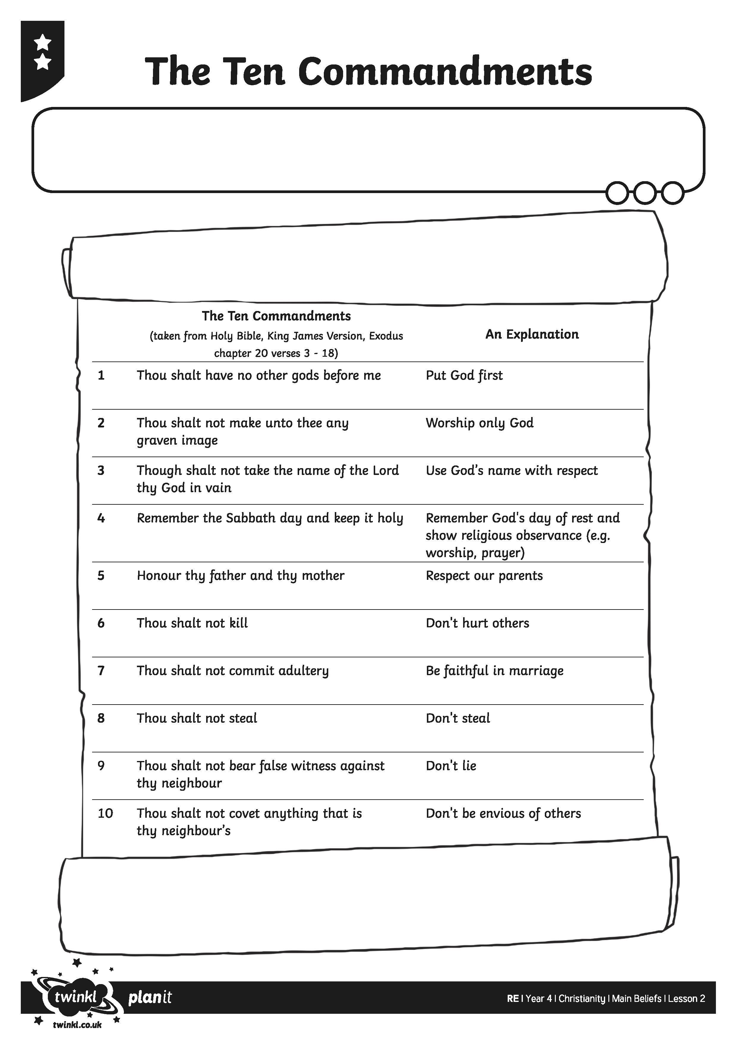

I can explain the main beliefs of Christianity.

