
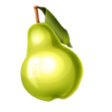
Oranges

Homophones
berry
bury
brake
break
meet
meat
ball
bawl
fair
fare

Due – Friday 15th January 2021
Pears

Homophones
here
hear
heel
heal
main
mane
mail
male
knot
not

Due – Friday 15th January 2021



Apples

(Near) Homophones
quite
quiet
bare
bear
one
won
son
sun
whole
hole

Due – Friday 15th January 2021
Pineapples

the
and
a
to
said

Due – Friday 15th January 2021

