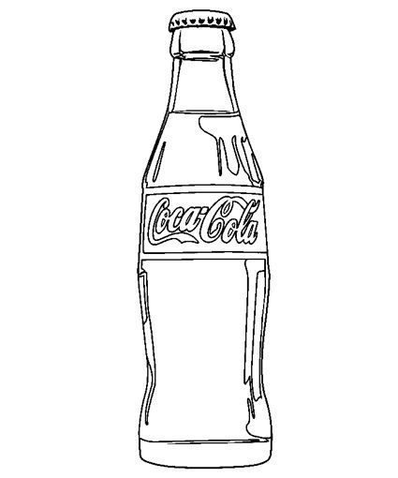
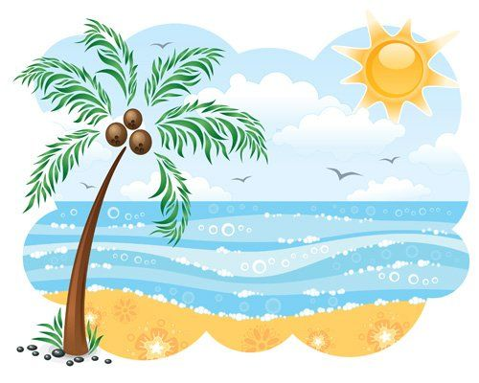

Michael decided to send a letter to his parents to let them know that he was alive. He sent it in a coke bottle that had washed up on the beach. Your task is to write a letter to your parents thinking carefully what you would have written if you had been Michael.

