10th July 2026  Term: Summer 2 Week: Six

Reception Class Newsletter

 Super stars
Well done to Rupert and Scarlett our two stars of the week


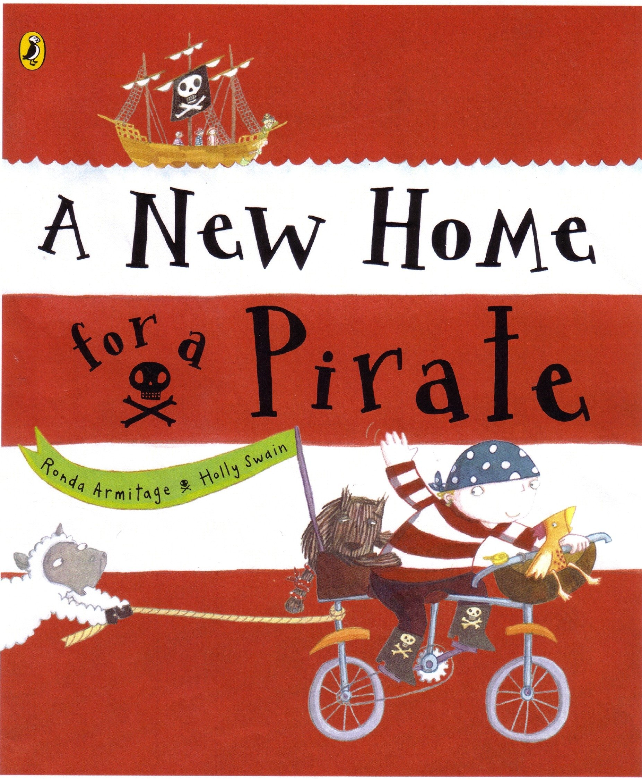 Our new mini pirate topic has been popular this week and is always a lovely way to end our year. We have shared a number of pirate stories and songs and there has been lots of creativity taking place whilst the children are in provision, from following instructions to make their own pirate hats to building pirate ships and creating treasure maps and flags. Our story of the week has been ‘A New Home for a Pirate’. We continue our pirate theme into next week, with lots more pirate fun!

Keyrings, library books and reading books
Next week we will be collecting everything in so that we can sort and restock as necessary over summer. The key rings take a long time to set up so we ask that you return those as we don’t have spare sets and they will be needed for next year’s reception class.

Please can you return any clothing we have lent you? We have no boys shorts/trousers left and we had a drawer full in September. If you have any shorts or trousers your son has grown out of, we would be very grateful for donations as well as socks.
Have a wonderful weekend from the EYFS team

Pirate Party Day – Tuesday 14th July
Come dressed as a pirate for lots of fun with Mrs Jolly Rogers and her pirate crew! The forecast is for a warm day, therefore it might be a good idea to send your child with a pair of shorts and a t-shirt to change into if needed. Pirate clothes can get a bit hot and sweaty!
Dates Ahead:
Tuesday 14th July - Pirate Party Day
Wednesday 15th July – Visit to Wesley Place,
(depending on the weather)
Wednesday 15th July – Reception Disco, we will be changing into our disco clothes before the disco starts, if you would like to send some in a named carrier bag to help speed up the changing process
Friday 17th July – Last day
Wednesday 2nd September – Start of the autumn term
Reports
On Monday your child will be given their school report to bring home. We are so very proud of them all and what they have achieved this year, not just academically but, very importantly, emotionally and socially. Sometimes a tick in a particular box, doesn’t reflect the huge amount of progress made. Children develop at different rates with some children taking longer to achieve certain things. Some children are not yet 5, whilst others are almost 6 which is a huge difference developmentally. There is a comments sheet for you to sign and return to school to acknowledge receipt.

Mystery Readers

Thank you to Alfie’s Mum, Matilda’s Mum and Pacha’s Auntie have all recently come to read to us. A huge thank you to all our mystery readers who have visited us this year.
Carrier Bags/bag for Life on Thursday
Next week your child will bring home their reception work. Please could you send a strong named bag into school on THURSDAY, or before, as this is the day we are planning to send everything home.

