Guided Reading Homework – Mrs Parrot’s Rainforest Lessons – Monday 4th May 2020
Please read pages 69-96 and answer the following questions in full sentences:
- Page 87 - What does “keep on rampaging” mean?
- Page 87 - Why do the ants stop charging?
- Where would you find the pupae? (Page 87)
- How long does a tree take to grow in the rainforest?
- Page 90 - Why did Daniel wipe his hands on his trousers?
Please read the chapter, “Makangy and Emaka”.

Guided Reading Homework – Adventures of Steampunk Pirates – Thursday 5th May 2020
Please read the text and answer the following questions in full sentences:

- Who is in charge of the pirates?
- Who does the gold belong to?
- What are the four main food groups?
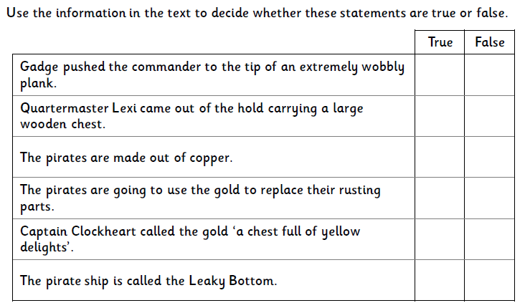

Guided Reading Homework – Roald Dahl – Heroes and Villains – Wednesday 6th May 2020
Please read the text and answer the following questions in full sentences:
- What are the names of the three Roald Dahl ‘heroes’?
- Which character is described as having a hairy, bristly beard?
- How did Mrs Twit become so ugly?
- What is the name of the school where Miss Trunchbull is headmistress?
- Why do you think it is so difficult for Charlie to live so near to Wonka’s Chocolate Factory?
- How are the characters of Sophie and James Trotter similar?
- Why do you think Mrs Trunchbull makes such a poor headmistress?

Guided Reading Homework – The Witches – Thursday 7th May 2020
Please read Chapters 10 and 11 and answer the following questions in full sentences:

- What happened to Bruno and how did he escape?
- What will the ancient ones be given? Why?
- What do you think will happen if a grown-up eats one of the chocolates?
- Why does one of the witches shriek ‘Wait!’ on pg 103?
- Why were the hairs on Luke’s head ‘standing up like the bristles of a nail-brush’?

Guided Reading Homework – George and the Dragon – Friday 8th May 2020
Please read the text and answer the questions at the end of the text.

