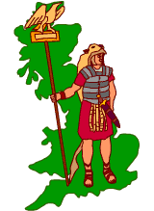
Britain had lots of goods which the Romans wanted:-
Corn; Wool; Leather; Silver; Gold; Tin; Lead; Slaves.


Corn
As the Roman Empire grew bigger, there were more and more people to feed; more Romans started living in towns, leaving fewer people in the country to grow crops... Rome needed to import more food and Briton was a very fertile land...

Raw Materials: Wool
Britain had a good supply of sheep and wool was needed for making Roman togas.

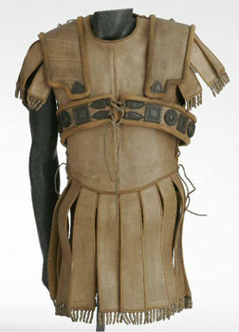
Raw Materials: Leather
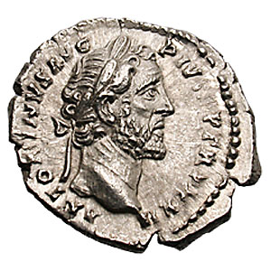
The Roman army used a lot of leather in uniforms and in soldiers’ tents. Leather was also used to make buckets.

Valuable Metals: Silver
The Romans made their money out of silver – more coins were needed as the Empire grew. Britain already had silver mines that the Romans knew about. Silver was a luxury item for rich Romans – and there was a big demand for it.
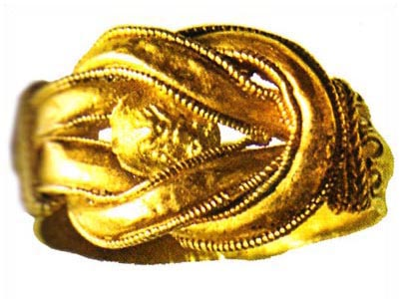
Valuable Metals: Gold
Gold was used for jewellery and was in great demand by the Romans;
Gold was very important in trade as a means of exchange and for gold coins;
There was a scarcity of gold across the Empire, but Britain had some...

Tin
Britain also had tin mines and tin and pewter were used for cups and plates;
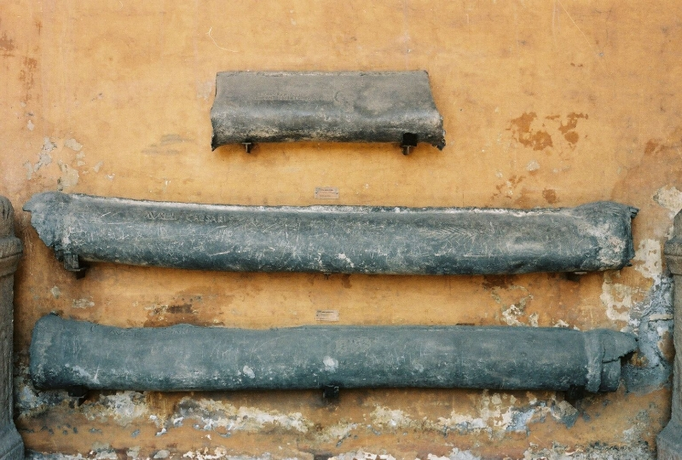
Tin could be mixed with other metals to make strong, hard metals.
Lead
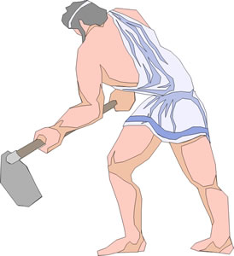
Lead was really useful for the Romans and Britain had a good supply of it.
Lead was used to make water pipes and plumbing systems
Lead was also used to make coffins!

Slaves
Romans planned to used captured Britons as slaves.
Roman society ran on the basis of slave labour and there was big demand for slaves right across the empire;
Slaves were used to work in every type of industry, from nurse maids, to field hands, miners and as galley slaves to row Roman ships.

Power
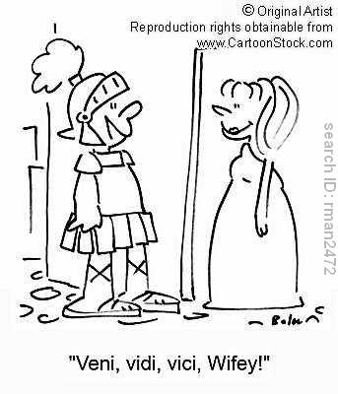
The Romans didn’t just want goods from Britain; they also wanted to invade to show how powerful they were. By conquering more and more countries and making their Empire bigger, it made Rome more powerful. The Romans also believed it was their duty to do this and make the world “civilised” like them.

Ambition
Invading other countries and adding to the Empire was a way to become more powerful and popular; the first invasions took place because Julius Caesar was ambitious and wanted power and glory. Claudius had just become Emperor, in the 1st Century BC, and wanted to prove himself as a good leader of Rome, when his invasion took place.

Revenge
The Britons had been helping the Gauls (French) fight against the Romans.
The Romans wanted to punish the Britons for this and make sure that they could no longer do this.

Task (1)
Complete a detailed spider diagram on why the Romans invaded Britain.
Make sure you explain the following issues:-

Explain why the Romans wanted corn, wool and leather.
Explain why the Romans wanted gold, silver, lead and tin
Explain why the Romans wanted slaves
Why did the Romans think it was their duty to attack other countries and create an empire?
Why did the Romans want revenge on the Britons?

Task (2)
Which in your opinion was the most important cause of the invasion?
Explain your answer

