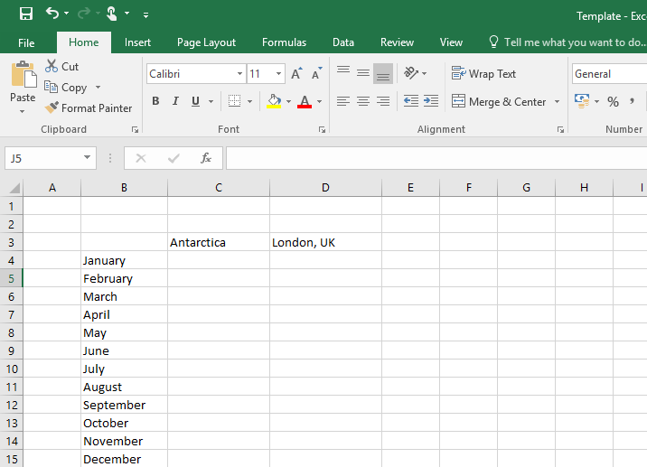
Enter the temperature data into the table. Remember to include minus (-) for the Antarctic temperatures.

*Make sure you save regularly.
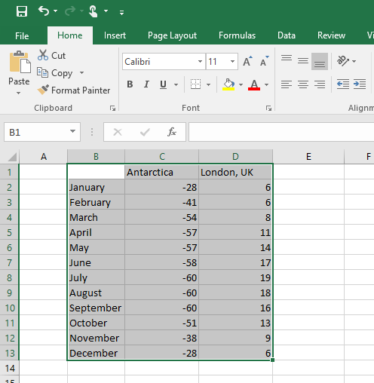

Highlight the information – Click on the top cell, click and hold the left mouse button as you drag to highlight all the information.

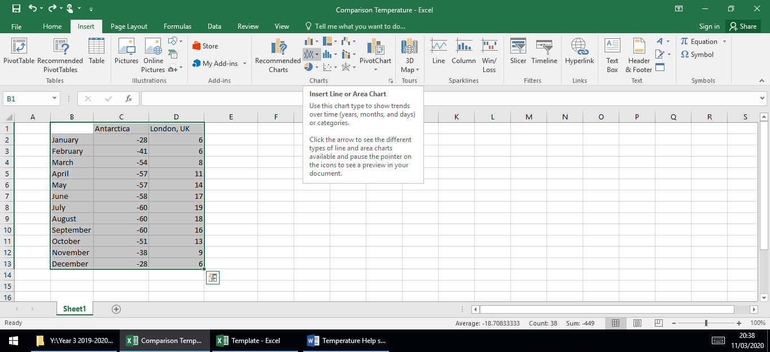

Click the Insert tab and click the lines picture to create a line graph.

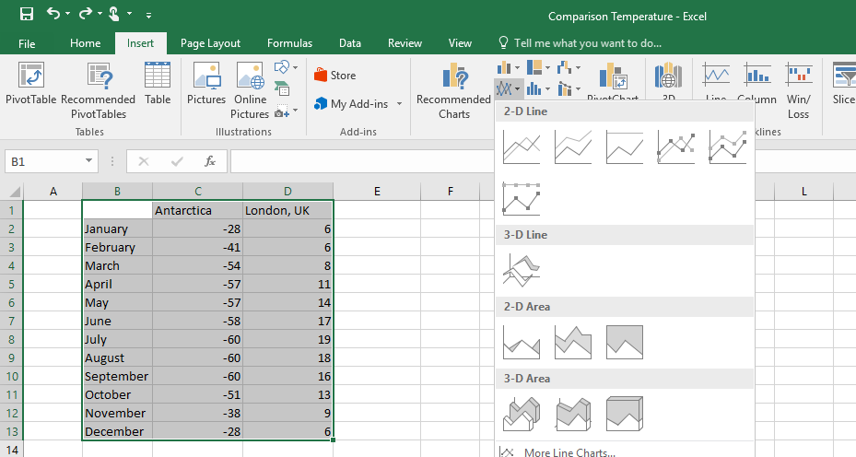
Choose which of the 2D lines you want to create.
Click on it.

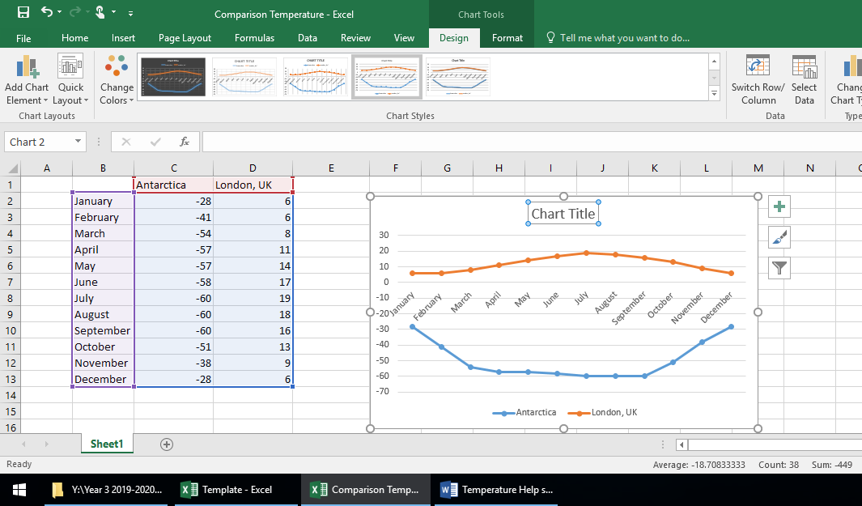
Click on the Chart Title and delete the text.
Type – Comparing the temperature in Antarctica and the UK.

*Make sure you save regularly!
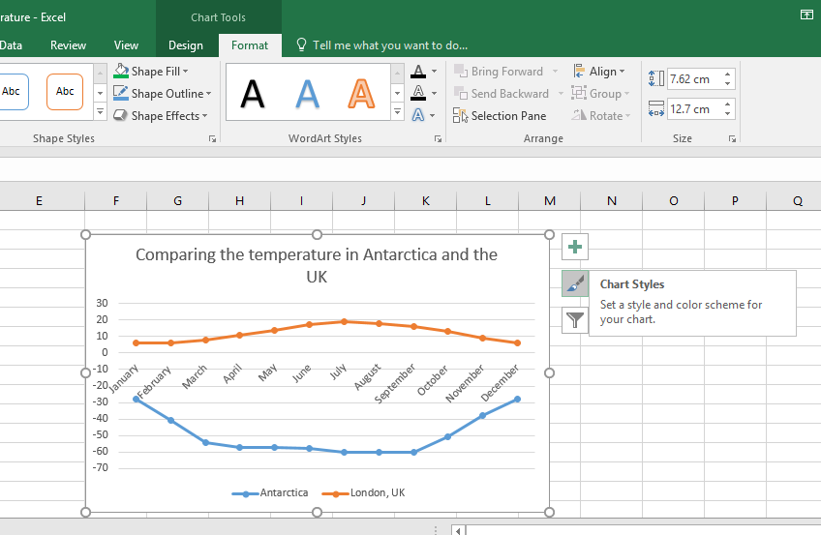
Click on the chart/graph and click the paintbrush (Chart Styles) to change the colour.

