 | Excalibur Primary School | 

Pre-school Curriculum
2026-2027

Nurturing curiosity, confidence and a lifelong love of learning

“The goal of early childhood education should be to activate the child’s own natural desire to learn”

Maria Montessori

PRE-SCHOOL CURRICULUM: YEAR OVERVIEW
Excalibur Progression & Curriculum Overview 2026-2027 Pre-school – Year A
Area of Learning | Autumn 1 – All About Me and My Community  8 weeks | Autumn 2 – Celebrations and Autumn  7 weeks | Spring 1 – Traditional Tales and Winter Wonders  6 weeks | Spring 2 – Colours galore-all creatures great and small  5 weeks | Summer 1 – Growing and Changing  7 weeks | Summer 2 – Where will we go?  6 weeks
Other Possible Themes | Looking after ourselves  What makes me special?  Our Families  Autumn | Autumn is here  Nursery Rhyme Week  Fireworks - Bonfire Night  Christmas  Birthdays  The dark  Diwali 6th Nov 2026 | Lunar New Year  Valentine’s Day  Winter  Freezing and melting | Pancake Day  Easter  Spring is coming  Exploring light and colour  Space | Changes  Spring into summer  Mini-beasts | Summer is here  Weather  Holidays  Transport and travel  Around the world hot/cold  New beginnings and transitions
Enrichment Activities | Harvest Celebration  Stay and play | Nursery Rhyme Week  Nativity Performance  Christmas Jumper/Dinner Day/Elf Run/Children In Need  Christmas Tree Festival  Magic Show/trip and Party  Christmas craft workshop | Lunar New Year  Valentines  Stay and Play  Big Schools Birdwatch  Shrove Tuesday  Storytelling week | Easter  Parent Easter crafts workshop  Walk to library  Elmer Day  Mother’s Day  World book day | Caterpillars/butterflies  Sports week and parents sports event  Vet visit  Mobile Farm Visit  World Bee Day | Stay and Play  Transition to school  Father’s Day
Communication and Language    Communication and Language is developed throughout the year through high quality interactions, daily group discussions, circle times, stories, singing, speech and language interventions, Helicopter Stories and The Poetry Basket. | Enjoy listening to longer stories and remember much of what happens.  Use a wide range of vocabulary.  Begin to sing a large repertoire of songs.  Recite and perform familiar nursey rhymes.  Be able to start a conversation with a friend or an adult and continue it for many turns.  Use talk to organise themselves e.g. “Let’s play in the sand… you have the big spade etc.  Use longer sentences (four to six words). |  | Respond to simple questions and attempt to answer by speaking, pointing or gesturing.  Retell some key events from a story.  Use a wide range of vocabulary.  Understand simple questions about who and what.  Can listen for longer periods but may still need prompting.  Start to engage in longer dialogue.  Recognise pictures in non-fiction books applying new vocabulary. |  | Pay attention to more than one thing at a time. Which can be difficult.  Understand a question or instruction that has two parts, such as “Get your coat and wait at the door”.  Be able to tell a longer story.  Develop communication, but may continue to have problems with irregular tenses and plurals, such as ‘runned’ for ‘ran’, ‘swimmed’ for ‘swam’.  Develop pronunciation but may have problems saying:  - some sounds (e.g. r, j, th, ch and sh)  - multisyllabic words such as pterodactyl or hippopotamus  Be able to express a point of view and to debate when they disagree with and adult or a friend, using words and actions.  Use talk to organise themselves and their play ‘lets go on a bus, you sit there I’ll be the driver’.
Listening, Attention and Understanding: Listen carefully to songs, stories and rhymes and respond by joining in. Understand and respond to instructions with 2 or 3 key words. Understand and respond to ‘why’ questions. Start a conversation and take it in turns to speak
Speaking: Explain, describe, recount and retell. Join in with conversation (linked to listening). Use a sentence of 4-6 words. Use connectives to link words in sentences.

Personal, Social and Emotional Development    Children develop their personal, social and emotional skills throughout the year through My Happy Mind sessions, circle times, social stories, No Outsiders Project, SCARF, diversity stories, | Develop new relationships with the children and adults in a new setting.  Settle into a new setting and be able to say goodbye to their adult (positive leave)  Show increasing confidence in new social situations.  Select resources and activities in the setting independently.  Begin to learn the routines and rules of a new setting.  Be increasingly independent when using the toilet and washing hands.  Begin to develop sense of responsibility and membership of a community.  To be able to follow a one-step instruction.  Begin to take turns.  To talk about themselves.  Start to understand feelings- happy, sad, tired.  Play with one child extending and contributing during play. |  | Find what interests them and stay longer at the activity, starting to show a preference.  Start to identify own emotions.  Start to comply with the rules and boundaries knowing there are rules.  Be more aware of the other children around them and the choices to be made.  Starts to form a special friendship with another peer.  Be able to sit during circle time.  Develop ways of being assertive.  Able to take turns in roleplay.  Follow a 2-step instruction.  Shows they are able to follow rules.  Play with one and more children extending and contributing during play. |  | Develop sense of responsibility and membership of a community.  Become more outgoing with unfamiliar people, in the safe context of the setting.  Find solutions to conflicts and rivalries. For example, accepting that not everyone can be Spider-Man in the game, and suggesting other ideas.  Understand gradually how others might be feeling.  Make healthy choices about food, drink, activity and toothbrushing.  Begin to talk about why these healthy choices are important.  Remember rules without needing an adult to remind them.  Share how they are feeling with a member of staff.  Start to understand feelings happy, sad, tired, worried, angry, and scared.  Begin to understand how someone else might feel.  To sit during circle time and join in with sessions.  Able to choose resources to help and achieve.  Show confidence with others during a social situation.
Self-Regulation: Talk about my feelings and feelings of others. Follow basic instructions and the “rules” of the setting.
Managing Self: Start to handle new experiences with more confidence
Building Relationships Play with others cooperatively
Healthy Living and Hygiene: Use the toilet independently, including. Hygiene. Usually dry throughout the day.
Physical Development    Children improve their gross and fine motor skills daily by engaging in different Funky Fingers activities (threading, cutting, weaving, playdough), mark making, construction, drawing, writing, Dough Disco, Pen Disco and Squiggle While You Wiggle. | Use large muscle movements to paint, wave streamers and make marks.  Develop movement, balancing, riding scooters and bikes and ball skills.  To hop, skip and balance (hold a pose).  Use scissors to snip paper or dough.  Be confident putting on own coat with increasing independence.  Use and remember actions and sequences of movement which relate to music and rhythm.  Explore moving bodies in different ways.  Moves body to music showing when they can stop and start. |  | Continue to develop large muscle movements to paint, wave streamers and make marks.  Continue to develop their movement, balancing, riding and ball skills.  Fine motor- Recognise the changes they can make when using tools and equipment.  Fine motor- show increasing control with one handled tools.  Begin to manage own clothing when changing for PE.  Follow simple movements to music when moving to the rhythm.  To be able to control a ball in different ways, balance on a variety of equipment and climb.  To jump and land safely from a height. |  | Take part in some group activities which they make up for themselves, or in teams.  Choose the right resources to carry out their own plan. For example, choosing a spade to enlarge a small hole they dug with a trowel.  Collaborate with others to manage large items, such as moving a long plank safely, carrying large hollow blocks etc.  Use a comfortable grip with good control when holding pens and pencils.  Show a preference for a dominant hand.  To move safely with confidence and imagination, communicating through ideas and through movement.  Can follow instructions in simple races, running at speed and an obstacle course.
Gross Motor: Show Balance (balance bikes, scooters, climbing), skip, hop and stand on one leg. Use large scale muscle movements
Fine Motor: Use one handed tools confidently. Use a comfortable grip with good control when using pencils.
Healthy Living and Hygiene: Use the toilet independently, including. Hygiene. Usually dry throughout the day. Able to talk about making healthy choices

  Literacy | Understand that print carries meaning.  Begin to name the different parts of a book.  Develop phonetical knowledge to spot and suggest rhymes.  Begin to record letters of their name accurately.  Joins in with repeated phrases for familiar stories.  Discriminates between sounds.  Can draw a straight line.  Expresses simple likes about a shared story.  Develops book handling skills.  Can draw curved lines in both clockwise and anti-clockwise directions.  Phase 1 phonics aspect 1,2, |  | Recognise some commonly used environmental print e.g. days of the week, other children’s names etc.  Have favourite books and talk about the characters and main events in those stories.  Develop phonetical knowledge to spot and suggest rhymes.  Recognise own name and begin to record own name (when writing ready).  Questions who and what questions linked to shared stories shared.  Begin to clap syllables.  Ascribe meanings to marks during play.  Phase 1 phonics aspect 3,4,5 |  | Understand that we read text from left to right and top to bottom.  Use some of their print and letter knowledge in early writing. For example, writing a shopping list that starts at the top, writing ‘m’ for ‘mummy’ etc.  Develop phonological awareness, so that they can:  Count or clap syllables in a word.  Recognise words with the same initial sound, such as money and mother.  Spot and suggest rhymes.  Able to develop oral blending skills.  Identify initial sounds through Read Write Inc daily phonics.  Phase 1 phonics aspect 6,7,
Possible Book Focus’ | Lulu’s First Day  Super Duper You  Pip and Posy: The Super Scooter  Wash your hands Mr Panda  The Family Book  We Walk Through the Forest  The Squirrels who Squabbled  We’re Going on a Leaf Hunt | The Pumpkin Thief  Hello Autumn  That’s Not my Hedgehog  Peace at Last  Pip and Posy: The Super Scooter  Little Owl and the Christmas Star  Maisy’s Christmas Day | Winter Wonderland Adventure  Lost and Found  Goldilocks and the 3 Bears  Little Red Riding Hood  The 3 Little Pigs  The Little Red Hen | I can Eat a Rainbow  Oliver’s Vegetables  Planting a Rainbow  The Colour Monster  Elmer | Caterpillar Spring, Butterfly Summer  Lifecycles  The Hungry Caterpillar  The Growing Story  Twist and Hop: Minibeast Bop | I Love the Seasons Summer  We all Go Travelling By  A Squash and a Squeeze  Polar Bear Polar Bear- What Do You Hear?  Pip and Posy: The New Friend
Possible Book Focus’ | Comprehension: Apply print knowledge to emergent writing. Write their name. Talk about stories they have heard. Retell some familiar stories Use some story language or new vocabulary in my play. Join in with familiar rhymes and songs (and some patterned stories)  Word Reading: Orally segment single sound CVC words e.g. c-a-t. Say the initial sounds in most words. Use good phonological awareness including oral blending skills, rhyme, alliteration and syllables  Writing: Write some letters with good formation e.g. the letters from their name.
Mathematics    White Rose maths  For academic year 26-27 Pre-school will be following the White Rose Curriculum.  From September 25 units to be taught following the progression identified in the White Rose scheme. | Topic blocks 1-8  Comparison 1-More than, fewer than, same  Shape, space and measure 1- Explore and build with shapes and objects  Pattern 1 - Explore repeats  Counting 1 - Hear and say number names  Counting 2 - Begin to order number names  Subitising 1 – I see 1,2,3  Pattern 2 – Join in with repeats  Shape, space and measure 2 – Explore position and space  Development Matters  - Compare quantities using language ‘more than’, ‘fewer than’  - Use informal and formal language to describe 2D and 3D shapes. Combine shapes to make new ones – an arch, a bigger triangle etc.  - Notice patterns and arrange things in patterns  - Select shapes appropriately for building, e.g. a triangle prism for a roof, etc.  - Recite numbers past 5  - Show fingers for numbers up to 5.  - Develop fast recognition of up to 3 objects, without having to count them individually (‘subitising’).  - Notice patterns and arrange things in patterns.  - Understand position through words alone e.g. the bag is under the table with no pointing.  - Make comparisons between objects relating to size, length, weight and capacity. |  | Topic blocks 9-16  Subitising 2- Show me 1,2,3  Counting 3 – Move and label 1,2,3  Shape, space and measure 3 – Explore position and route  Pattern 3 – Explore own first patterns  Counting 4 – Take and give 1,2,3  Shape, space and measure 4 – Match, talk, push and pull  Subutising3 – Talk about dots  Comparison2 – Compare and sort collections  Development Matters  - Develop fast recognition of up to 3 objects, without having to count them individually (‘subitising’).  - Say one number for each item in order: 1,2,3,4,5  - Discuss routes and locations, using words like ‘in front of’ and ‘behind’.  - Talk about and identifies the patterns around them for example: stripes on clothes, designs on rugs and wallpaper. Use informal language like ‘pointy’, ‘spotty’, ‘blobs’ etc.  - Say oner number for each item in order, 1,2,3,4,5. Know the last number reached when counting is the total (cardinal principle).  - Select shapes appropriately flat surfaces for building a triangular prism for a roof etc.  - Combine shapes to make new ones- an arch, a bigger triangle etc.  - Describe a familiar route  - Can recognise up to 3 objects without counting.  - Compare quantities using language ‘more than, fewer than’ |  | Topic blocks 17-24  Pattern 4- Lead on own repeats  Shape, space and measure 5 – Start to puzzle  Patterns 5 – Making patterns together  Subitising 4 – Make games and actions  Counting 5 – Show me 5  Pattern 6 – My own pattern  Counting 6 – Stop at 1,2,3,4,5  Comparison 3 – Match, sort compare  Development Matters  - Talk about and identify the patterns around them. For example, stripes on clothes, designs on rugs and wallpaper. Use information language like ‘pointy, spotty, blobs’.  - Talk about and explore 2D and 3D shapes (for example, circles, rectangles, triangles and cuboids) using informal and mathematical language: ‘sides’, ‘corners’; ‘straight’, ‘flat and round’.  - Discuss routes and locations using words such as in front of, and behind’.  - Talk about and identify patterns around them. For example: Stripes on clothes, designs on rugs and wallpaper. Use information language like ‘pointy’, ‘spotty’, blobs etc.  - Extend and create ABAB patterns – stick, leaf, stick, leaf.  - Develop fast recognition of up to 3 objects, without having to count them individually (‘subitising’).  - Know that the last number reached when counting a small set of objects tells you how many there are in total (‘cardinal principle’).  - Show ‘finger numbers’ up to 5  - Link numerals and amounts: for example, showing the right number of objects to match the numeral up to 5.  - Extend and create ABAB patterns– stick, leaf, stick, leaf.  - Notice and correct an error in a repeating pattern  - Begin to describe a sequence of events, real or fictional, using words such as ‘first’, ‘then…’.  - Experiment with their own symbols and marks as well as numerals.  - Compare quantities using language ‘more than’, ‘fewer than’.
Number: Can count, order, recognise and use numbers to 5
Comparing: Compare quantities using the vocabulary of greater, less, more, fewer and the same
Subitise: Subitise up to 3 objects (recognise up to 3 objects quickly without counting)
Numerical patterns: Talk about patterns and spot errors and continue and create patterns.
Sequencing of patterns and time: Sequence a pattern of events using time language e.g. first, next, then.
Shape and Space: Talk about 2D and 3D shapes (using informal vocab e.g. sides, straight, round, flat).
Understanding the World   | Natural world - Explore how things work. Use all senses in hands on exploration of natural materials. Talk about what they see, using a wide vocabulary.  Past and Present - Begin to make sense of their own life story.  People and communities – Start to notice some of the differences between people and talk about different occupations and job roles. |  | Natural world – Notice when things have changed including changes in state (e.g. ice and melting).  Past and Present- Enjoy talking about family customs and routines. Use simple language about the passing of time.  People and communities – Name other countries in the world and be positive about the differences between people. |  | Natural World – Talk about the key features of life cycles using key vocabulary. Notice and talk about the world around them observing animals and plants.  Past and Present - Talk about some of my own and my family’s history (grandparents, parents, etc.)  People and communities - Talk about the differences in people, countries and communities.
Past and Present: Talk about their own and their family’s history (grandparents, parents, etc.)
People, Culture and Communities: To talk about the differences seen in people, countries and communities.
The Natural World: Talk about the key features of life cycles using key vocabulary. Talk about the world around them observing animals and plants
Expressive Arts and Design    Weekly Rhyme Time classes | Join materials and explore different textures.  Draw with increasing complexity and detail  Make imaginative small worlds using construction kits and building blocks e.g. a castle, a city, or a park.  Talk about what they have created.  Remember and sing entire songs.  Play instruments with increasing control. |  | Explore mark making through colour and texture.  Experiment applying paint using large brushes using different techniques e.g. dabs, sweeps and splodges.  Develop ideas and scenarios during imaginative play.  Listen to music and respond to what is heard. Describe the sound of an instrument.  Play instruments with increasing control. |  | Develop complex stories using small world equipment like animal sets, dolls and dolls houses etc.  Develop their own ideas and then decide which materials to use to express them.  Use drawing to represent ideas like movement or loud noises.  Show different emotions in their drawings and paintings, like happiness, sadness, fear etc.  Sing the pitch of a tone sung by another (pitch match)  Sing the melodic shape (moving melody, such as up and down, down and up) of familiar songs.  Create own songs or improvise a song around one they know.
Creating with Materials: Use a range of art materials, joining and colour mixing purposefully and freely. Sing, respond to and create music with instruments showing understanding of pitch, melody and rhythm
Being Imaginative: Start to develop my own stories linked to what they know through role & small world play.

PROGRESSION OF CUTTING SKILLS – (these can vary depending on the individual child).

 | Holds scissors  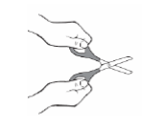 | Opens and closes blades  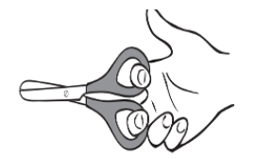 | Starts snipping paper  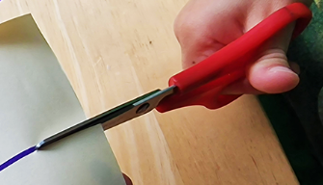 | Snips paper moving forward  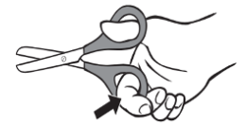 | Uses helping hand  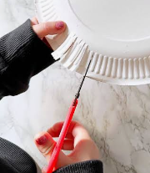 | Cuts straight line  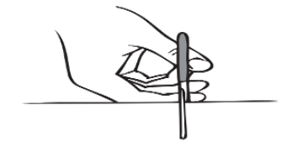 | Cuts curved line  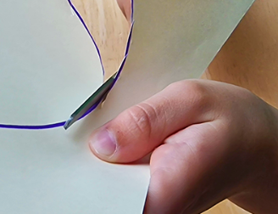 | Cuts circle shape   | Cuts square shape   | Cuts a complex shape  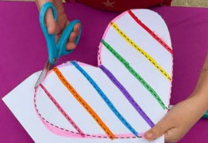
SKILL | Child begins to show an interest in exploring scissors. Will use them with both hands and are learning to open and close the blades. | Children learn how to open and close the blades. They are not ready to use the blades on paper and need to continue with funky finger activities to strengthen finger muscles. | Children begin to quickly make snips in paper on the edge of the paper. They often don’t move forward on the paper when snipping. | Children will begin to make snips whilst moving the scissors across the paper. | Children begin to use their non dominate hand to hold the paper and manipulate it whilst cutting with the other hand. | Children can cut along a short line with increasing accuracy. | Children who can show confidence and mastery cutting a straight line will now begin to learn to manipulate the paper to cut out a curved line showing control. | Once children have acquired small curved lines, they will manipulative the paper to cut out small circle shape. | Children will begin to use their skills to cut out from square shapes from paper. | Children will now attempt to cut out more complex shapes such as figures with some success.
VOCABULARY | Hold, move, in, out, shut, close, bend, cut, snip, squeeze, stretch, fold, open, close, push, pull. | Open, move, apart, close, shut, move in/out, fingers, thumb, together, apart, stretch, up, down. | Snip, cut, hold, forward, backward. | Across, forward, backward, side to side, straight ahead, open close, push, pull. | Upwards, downwards, sideways, hold, still, rest your hand, hands together/apart, up, down. | Straight, across, forward, open and shut, move together/apart, follow the line, close to. | Closer, on the line, next to the line, circle, curve, around, round, wobbly, wavy. | Circle, round, curved, move, twist, turn, pivot, small snips, at the same time. | Stop/start, turn, point, corner, pointed, cross. | Close to the line, on the line, outline, follow the line, background.
HOW TO SUPPORT | Practise tearing paper to gain stronger finger muscles.  Strengthen fingers using playdough and sensory toys to squeeze. | Practise opening and closing blades in the playdough using plastic scissors. Then once accomplished move onto firmer materials such as clay. Encourage the children to do the thumbs up position when  using the scissors. | Practise snipping using sheets of paper, art straws, leaves. Encourage child to hold the paper and snip one handed. Children need lines to show a direction to cut towards. | Practise activities to promote crossing the mid-line of the body e.g. passing balls from one side of the body, or ribbon dancing or taking part in brain gym exercises. | Promote activities to strengthen hand-eye co-ordination e.g. lacing cards, hand clapping games, drawing with a stencil. | Use pieces of paper with pre drawn straight lines onto a length of 15 cm to develop stamina and accuracy. | Use pieces of paper with pre drawn curved lines. Promote activities to cross the midline and strengthen hand eye co-ordination. | Use paper with pre drawn circle shapes. Encourage activities to cross the midline and strengthen hand eye co-ordination. | Use pieces of paper with pre drawn square shapes. Promote activities to cross the midline and to strengthen hand eye co-ordination. | Use pieces of paper with pre drawn complex shapes. Promote activities to cross the midline and to strengthen hand eye co-ordination.

PROGRESSION OF PENCIL GRIP - (stages can vary between each individual child).

 | 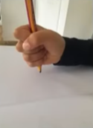 | 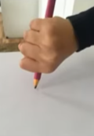 | 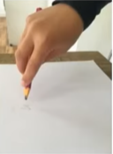 | 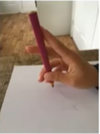 | 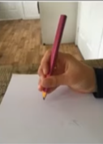 | 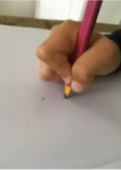
TYPE OF GRIP | Fisted Grasp | Digital Pronate Grip |  | 4 Finger Grasp | Static Tripod Grasp | Dynamic Tripod Grasp
AGE RANGE | Usually around, 1-2 years | Usually around, 2-3 years |  | Usually around 3-4 years | Usually around 4-6 years | Usually around, 6-7 years
EXPLANATION | Children often start to use this grip and whole hands grasp to scribble. | The wrist will now be facing the paper and the movement will mainly be coming from the elbow. The child’s palm should now be facing down. The child may start to copy a horizontal, vertical and circular line. |  | All 4 fingers now holding the writing tool with movement mainly coming from the wrist. | The thumb, index finger and middle finger are now working as one unit. | This is the ideal grasp to help move the pencil effectively and accurately on the paper.
HOW TO SUPPORT | Opportunities for dough disco to strengthen hand and finger muscles. Large gross motor movements such as ribbon dancing and parachute play will help to develop strong shoulder strength. Continue funky finger activities. | Continue to work on stabilizing strong upper body movements in play using buckets of water, digging in the sand, ribbon dancing, cross curricular movements across the body. Enhancements through large mark making opportunities indoors and outdoors supports fine motor skills. |  | Children should now be able to complete simple dots to dots, copy zig zag and crossed lines and draw simple human e.g. head, body, arms legs etc. | Pictures of humans are now more detailed to other features such as both arms, and legs, and facial features such as eyebrows. | Children will now have a stable and secure grip to make detailed pictures of everyday life e.g. drawing a house, family members. Continue to provide a wider range of mark making opportunities of vary stages in provision to strengthen fine motor skills.

PROGRESSION OF MARK MAKING - (stages can vary between each individual child).

 | 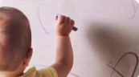 | 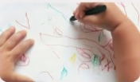 | 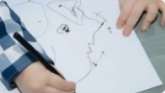  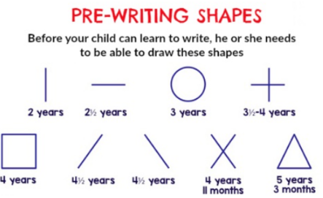 | 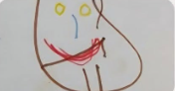 | 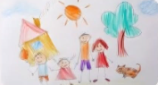 | 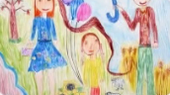
TYPE OF STAGE | Random marks and scribbles | Controlled scribbles | Basic shapes- Pre -Schematic Stage | Patterns and tadpole people | Pictures and Portraits-Schematic Stage | Drawings Represent Interests and Experiences
AGE RANGE | Usually around, 1 year+ | Usually around, 2 years+ | Usually around, 3 years+ | Usually around, 4 years+ | Usually around, 5 years+ | Usually around, 6-7 years
EXPLANATION | Develop motor co-ordination.  Exploring cause and effect.  Scribbles and lines. | Lines, loops, spirals, dots and circles.  Drawings evolve into simple diagrams.  Movements repeated on purpose. | Basic shapes emerge such as lines and circles.  Creations are named and drawn on purpose.  First drawing of a person may emerge. | More shapes and letters emerge (pretend writing).  Drawing of person progresses from head with legs to include details. | Portrait of a person with many details emerges.  Animals, houses, vehicles, trees etc appear.  People and objects may still float in the air. | Own style of drawing emerges.  Drawing represents interests.  Objects are on a baseline, depth and distance shown.
HANDWRITTING | 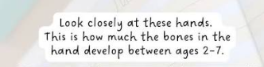  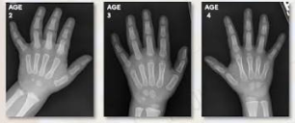  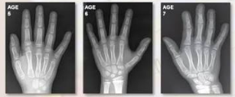  .  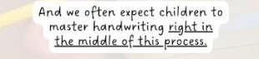
HOW TO SUPPORT | It is essential that children develop a range of skills prior to the introduction of handwriting and that these skills are developed through continuous provision and stimulating environments please see below for ideas and enhancements.  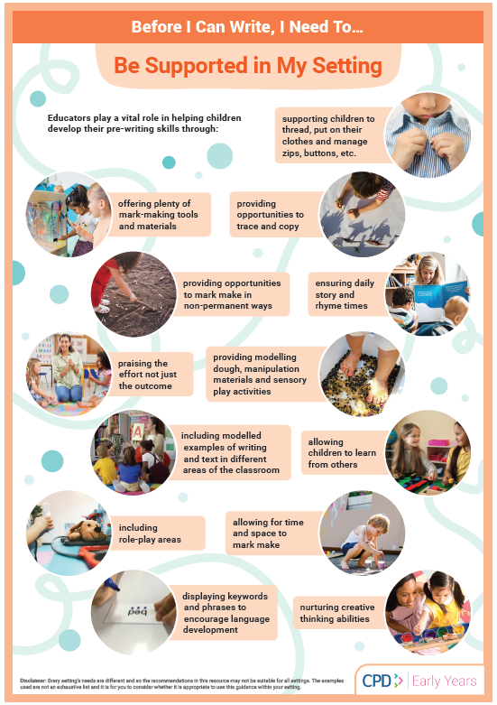  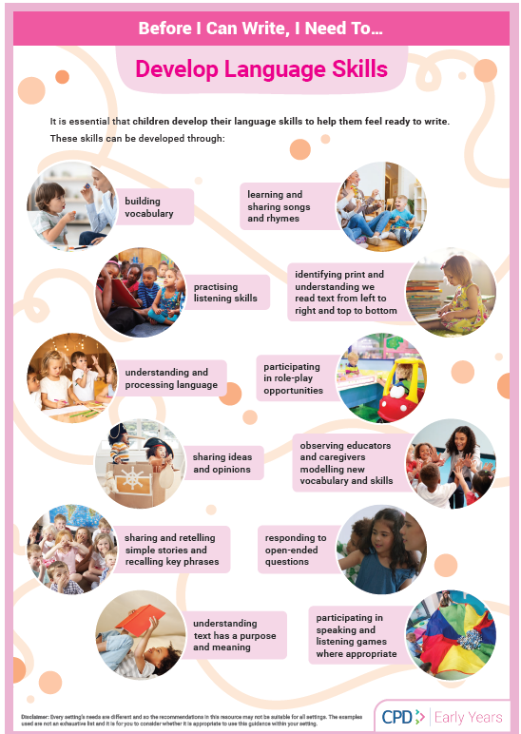  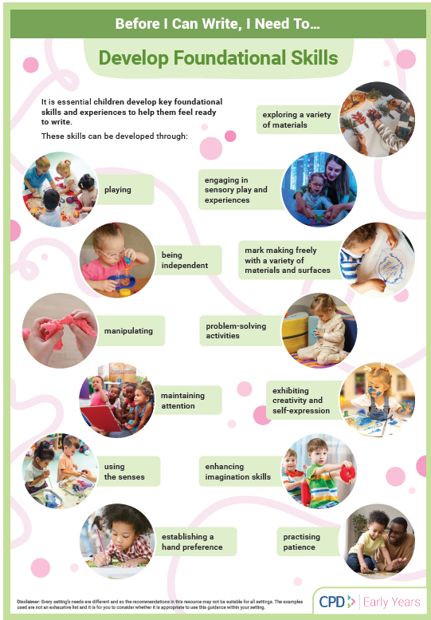  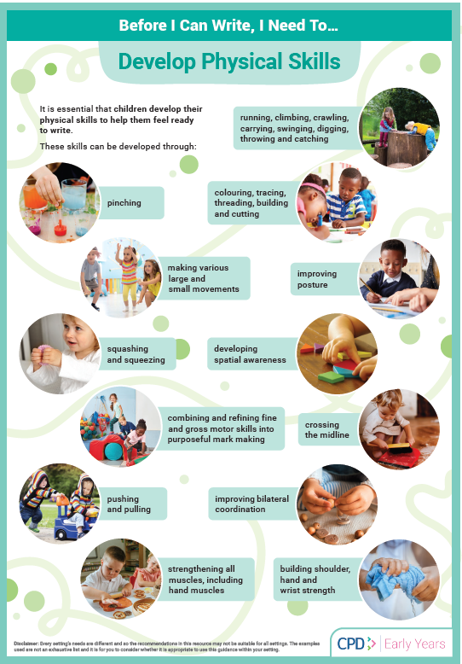

PROGRESSION OF PE

 | Pre-school Progression of Skills
 | Autumn Term 2026 | Spring Term 2027 | Summer Term 2027
 | - Continue to develop their movement, balancing, riding (scooters, trikes, and bikes) and ball skills.  - Go up steps and stairs, or climb up apparatus using alternative feet.  - Skip, hop, stand on one leg and hold a pose for a game like musical statues.  - Use large muscle movements to wave flags and streamers, paint and make marks.  - Are increasingly able to use and remember sequences and patterns of movements which are related to music and rhythm.  - Use a comfortable grip with good control when holding pens and pencils to make marks.  - Running on flat surfaces, beginning to show control in stopping and starting.  - Jumping with both feet off the ground, initially with both feet together.  - Climbing on small structures (e.g., steps or low climbing frames) with assistance.  - Balancing on low beams or lines drawn on the ground. | - Continue to develop their movement, balancing, riding (scooters, trikes and bikes) and ball skills.  - Use large-muscle movements to wave flags and streamers, paint and make marks.  - Start taking part in some group activities which they make up for themselves, or in teams.  - Match their developing physical skills to tasks and activities in the setting. For example, they decide whether to crawl, walk or run across a plank, depending on its length and width.  - Choose the right resources to carry out their own plan. For example, choosing a spade to enlarge a small hole they dug with a trowel.  - Collaborate with others to manage large items, such as moving a long plank safely, carrying large hollow blocks. Use a comfortable grip with good control when holding pens and pencils.  - Running and stopping with more control and awareness of space.  - Hopping on one foot with some assistance.  - Climbing higher on small play structures or trees with minimal support.  - Kicking balls in a straight line or toward a target with more precision. | - Continue to develop their movement, balancing, riding (scooters, trikes and bikes) and ball skills.  - Use one-handed tools and equipment, for example, making snips in paper with scissors.  - Use a comfortable grip with good control when holding pens and pencils.  - Start to eat independently and learning how to use a knife and fork.  - Show a preference for a dominant hand.  - Be increasingly independent as they get dressed and undressed, for example, putting coats on and doing up zips.  - Be increasingly independent in meeting their own care needs, e.g. brushing teeth, using the toilet, washing and drying their hands thoroughly.  - Make healthy choices about food, drink, activity and toothbrushing.  - Skipping or galloping in games with increasing coordination.  - Jumping from greater heights or climbing more complex play structures independently.  - Running, stopping, and changing direction while engaging in group games.  - Riding tricycles or balance bikes, showing better control and confidence.

PRE-SCHOOL MEDIUM TERM WEEKLY VIEW PLAN
Term: Autumn 1 Theme: All about me and my community Academic year: 2026-2027
Curriculum Area | WEEK 1 Transitions  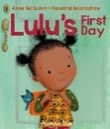  Text/title: Lulu’s first day  Inset Tuesday 1st September 2026  W/C Wednesday 2rd September | WEEK 2 All About Me  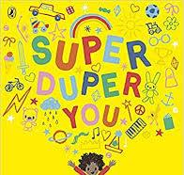  Text/title: Super Duper You  W/C Monday 7th September | WEEK 3 Sharing  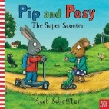  Text/title: Pip and Posy. The super scooter  W/C Monday 14th September  International Dot Day  Tuesday 15th September 2027 | WEEK 4 Staying Healthy  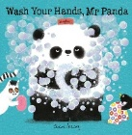  Text/title: Wash your hands Mr Panda.  W/C Monday 21st September | WEEK 5 Families  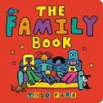  Text/title: My family book  W/C Monday 28th September | WEEK 6 Exploring the Woods  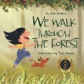  Text/title: We Walk Through The Forest  W/C Monday 5th October | WEEK 7 Friendship  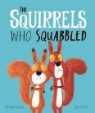  Text/title: The Squirrels Who Squabbled  W/C Monday 12th October | WEEK 8 Environmental  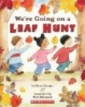  Text/title: Were going on a leaf hunt  W/C Monday 19th October
Personal, social & emotional | Settling in and saying goodbye to their adult without getting upset.  Learning new routines of the school day, areas in the classroom.  Playing alongside others and beginning to make new friends.  Sharing personal experiences –What did you do over the summer? | Settling in and saying goodbye to their adult without getting upset.  Gaining more confidence in the daily routines of the school day, areas in the classroom.  What do I like to do? I can talk about myself and the things I like.  Twinkl PSHE Scheme: Things I like | Following the rules- Why do we need them?  Learning the rules  classroom rules.  Why is it important to share?  I can talk about special people in my life  Twinkl PSHE Scheme: My Wellbeing Box | Following the rules- Why do we need them?  Learning the rules  classroom rules.  Personal Hygiene- How can we stay healthy?  Washing our hands, eating healthy foods, brushing our teeth, feeling thirsty, too hot or cold etc.  Twinkl PSHE Scheme: My Wellbeing Box | Being independent- what can I do for myself?  I can talk about myself and my family.  I can talk about parts of my body and my senses.  Twinkl PSHE Scheme: What Can I See? | I can share how I am feeling with a key member of staff.  I can share my own capabilities.  I can begin to take off my shoes and wellies with some independence.  Twinkl PSHE Scheme: Making Friends | I can begin to take turns.  Getting on and falling out. What can I do?  Share how they feel with a member of staff.  I can begin to understand feelings and emotions.  I can begin to take off my shoes and wellies with some independence.  Twinkl PSHE Scheme: We can Sort this Out | I can begin to take off my shoes and wellies with some independence.  Able to choose resources to help the children to achieve.  I can play with one or more children extending and contributing in play or in class discussions.  Twinkl PSHE Scheme: My Friends Are Special
Physical Development | Personal Hygiene- going to the toilet, washing hands etc.  I can explore moving my body in different ways.  Large scale mark making e.g water and brushes on the wall, chalking outdoors.  To gain confidence in joining in with ring games. | Personal Hygiene- going to the toilet, washing hands etc.  I can move my body to music showing I can stop and start.  Large scale mark making e.g water and brushes on the wall, chalking outdoors. | Personal Hygiene- going to the toilet, washing hands etc.  I can follow simple instructions using the parachute.  Large scale mark making e.g water and brushes on the wall, chalking outdoors.  I can run on a flat surface moving my feet with some control. | Personal Hygiene- going to the toilet, washing hands etc.  Continue to develop their movement, balancing, riding (scooters, trikes and bikes) and ball skills.  I can run on a flat surface moving my feet with some increased control. | Personal Hygiene- going to the toilet, washing hands etc  Continue to explore ball movements such as rolling.  Large scale mark making e.g water and brushes on the wall, chalking outdoors.  I can stop | Personal Hygiene- going to the toilet, washing hands etc  To gain confidence in climbing up apparatus using alternative feet.  Large scale mark making e.g water and brushes on the wall, chalking outdoors.  I can stop and start. | Personal Hygiene- going to the toilet, washing hands etc  Can jump and land safely from one tyre height.  Large scale mark making e.g water and brushes on the wall, chalking outdoors.  I begin to jump off low level equipment with support. | Personal Hygiene- going to the toilet, washing hands etc  Can listen to simple instructions when using the parachute.  Large scale mark making e.g water and brushes on the wall, chalking outdoors.  I begin to jump off low level equipment with less support.
Fine Motor Skills  Funky fingers activities daily in continuous provision to support fine motor skills. | Introduce ribbon dancing.  Use a selection of mark making implements.  Attempts puzzles. | Introduce tracing maps.  Use a selection of mark making implements.  Can draw a straight line with support. | Introduce dough disco if you are happy and you know it.  Use a selection of mark making implements.  Can draw a straight line with increased confidence. | Can hold a mark making tool to make marks.  Use a selection of mark making implements.  Can draw a straight line with increased control. | Continue tracing maps.  Use a selection of mark making implements.  Can draw a horizontal line with support. | Introduce scissor handling.  Use a selection of mark making implements.  Can draw a horizontal line with increased support. | Can snip with scissors.  Use a selection of mark making implements.  Can draw a horizontal line with control and independence. | Can snip with more control.  Use a selection of mark making implements.  Can draw lines vertically and horizontally independently.
Communication & Language | Time to talk- sharing experiences of summer holidays.  Sharing Well-being boxes. | PSHE discussions see above.  Getting to know you.  Sharing Well-being boxes.  Pay attention to more than one thing at a time- which may be difficult. | Use talk to organise their play through role play opportunities.  Getting to know me and you through Seesaw adventures. Children to use a range of vocabulary to share experiences.  Enjoys listening to stories. | Use talk to organise their play through role play opportunities.  Getting to know me and you through Seesaw adventures. Children to use a range of vocabulary to share experiences.  Enjoys listening to stories. | Use talk to organise their play through role play opportunities.  Getting to know me and you through Seesaw adventures. Children to use a range of vocabulary to share experiences.  Enjoys listening to stories. | Use talk to organise their play through role play opportunities.  Getting to know me and you through Seesaw adventures. Children to use a range of vocabulary to share experiences.  Enjoys listening to stories. | Use talk to organise their play through role play opportunities.  Getting to know me and you through Seesaw adventures. Children to use a range of vocabulary to share experiences.  Enjoys listening to stories. | Use talk to organise their play through role play opportunities.  Getting to know me and you through Seesaw adventures. Children to use a range of vocabulary to share experiences.  Enjoys listening to stories.
Literacy & Phonics | Joins in singing familiar songs and rhymes.  Recognising and finding our own name cards to self-register. | Joins in singing familiar songs and rhymes.  Begins to listen to simple stories.  Recognising and finding our own name cards to self-register. | Joins in singing familiar songs and rhymes.  Beginning to show more interest in longer stories.  Introduction of phase 1 phonics aspect 1 Environmental sounds  Recognising and finding our own name cards to self-register. | Joins in singing familiar songs and rhymes.  Beginning to show more interest in longer stories.  Introduction of phase 1 phonics aspect 1 Environmental sounds  Recognising and finding our own name cards to self-register. | Joins in singing familiar songs and rhymes.  Beginning to show more interest in longer stories.  Introduction of phase 1 phonics aspect 1 Environmental sounds  Recognising and finding our own name cards to self-register. | Joins in singing familiar songs and rhymes.  Beginning to show more interest in longer stories.  Introduction of phase 1 phonics aspect 1 Environmental sounds  Recognising and finding our own name cards to self-register. | Joins in singing familiar songs and rhymes.  Beginning to show more interest in longer stories.  Introduction of phase 1 phonics aspect 1 Environmental sounds  Recognising and finding our own name cards to self-register. | Joins in singing familiar songs and rhymes.  Beginning to show more interest in longer stories.  Introduction of phase 1 phonics aspect 1 Environmental sounds  Recognising and finding our own name cards to self-register.
Poetry | Head shoulders knees and toes. | This is Me Poem. | Teddy bear teddy bear.  Build It Up | Wash your hands poem. | Dingle Dangle scarecrow. | The Bear went over the mountain. | Friends, friends 1,2,3. | Autumn leaves are falling.
Texts to Support | See You Later, Mum.  Off to school,  Baby Duck!  Spot loves Nursery  Time to go to Nursery  All are Welcome | From Head to Toe  Only One You  Marvellous Me  The Dot | Peepo  Time to Tidy Up  Topsy and Tim safety first | I don’t want to wash my hands  Superhero’s Wash Their Hands  Funny bones books | Two homes  My Mum and Dad make me Laugh  Peace at Last  The Family Quiz  All Kinds of Families | Owl babies  Look What I did with a Leaf  I hear You, Forest  The Gruffalo  Tidy | Giraffes can’t dance  Elmer’s friends  The Mouse Who Carried a House on His Back. | ‘Wow’ said the Owl  Autumn  That’s not my hedgehog  The Leaf Man  Were Going On A Leaf Hunt
Mathematics | Block 1 - Comparison 1 More than, fewer than, same  Sentence stems  • I made a collection of _____.  • There are a lot of _____.  • There are only a few _____.  • They look the same because…  Key questions  • What have you collected?  • Which has more?  • Which has fewer?  • Which is the largest collection?  • Which is the smallest collection?  • What has changed?  • Do they look the same? |  | Block 2 – Shape, space and measure 1 Explore and build with shapes and objects.  Sentence stems  •I have chosen this shape/object because …  •I need this _____ for my …  •I am using …  •This _____ is big/small  Key questions  • What have you collected?  • What are you using?  • Do you think this will fit?  • Can you find something bigger? |  | Block 3 – Pattern 1 Explore repeats  Sentence stems  • Next, I will say…  •I have used a _____ in my pattern…  •I need this block because…  •I have built a _____...  Key questions  •What will come next in the story/song?  • What have you used to make your pattern?  • What blocks will you use to build a _____?  • What have you built with your blocks |  | Block 4 – Counting 1-Hear and say number rhymes  Sentence stems  • Count with me 1,2,3,4,5,  • Say with me 6,7,8,9,10  • Count with me 5,4,3,2,1,  Key questions  • What numbers can you hear?  • What other numbers do you know?  • What is your favourite rhyme?  • Can you repeat after me?
Maths Texts to Support | •Harry and the Bucketful of Dinosaurs by Ian  Whybrow  • Rosie’s Zoo by Ailie Busby  • More, Fewer, Less by Tana Hoban  • Full, Full, Full of Love by Trish Cooke  • Little Red Riding Hood |  | • Big and Small by Elizabeth Bennett  • Whatever Next! by Jill Murphy  • Crash! Boom! A Math Tale by Robie H. Harris |  | •The Little Red Hen  •Dig Dig Digging by Margaret Mayo |  | •Five Little Ducks by Belinda Gallagher  •Round and Round the Garden by Sarah Williams  •Nursery Rhymes and Finger Play Collections
Understanding the World | Talk about their own lives – the recent past | Who helps us at school? How do they look after us?  Understand differences inn the class and celebrate diversity | Talk about environmental changes e.g. early signs of Autumn. | Explore their senses within the natural environment | Know about different customs celebrated by others e.g. harvest  Understand each family is different and unique | Taking care of the local environment working in the allotments | Taking care of the local environment through planting | Taking care of the local environment working in the forest building bug hotel.
Expressive Arts & Design | Nursery songs and rhymes.  Rhythm time (Fridays)  Make imaginative small worlds using blocks, construction kits etc.  Mark making –indoor and out  Mixing colours- different colours. Making new colours.  Malleable materials: Dough | Nursery songs and rhymes.  Rhythm time (Fridays)  Drawing self-portrait for wall display  Mark making – indoor and out  Mixing colours- different colours. Making new colours.  Malleable materials: shaving foam | Nursery songs and rhymes.  Rhythm time (Fridays)  Drawing our families  Mark making – indoor and out  Dance and movement – finding a space  Malleable materials: gloop | Nursery songs and rhymes.  Rhythm time (Fridays)  Mark making – indoor and out  Dance and movement – stop and go  Malleable materials: cooked pasta | Nursery songs and rhymes.  Rhythm time (Fridays)  Mark making – indoor and out  Dance and movement – fast or slow?  Malleable materials: cloud dough | Nursery songs and rhymes.  Rhythm time (Fridays)  Mark making – indoor and out  Dance and movement – high and low  Malleable materials: clay | Nursery songs and rhymes.  Rhythm time (Fridays)  Mark making – indoor and out  Dance and movement – act out the story  Malleable materials: clay | Nursery songs and rhymes.  Rhythm time (Fridays)  Mark making – indoor and out  Dance and movement – act out the story  Printing autumn objects.  Autumn collage Leaf Art  Malleable materials: jelly
Seasonal Opportunities | Exploring new environment, weather changes    International Dot Day Tuesday 15th September 2027  Autumn starts 23rd September  Harvest  Stay and Play - Autumn themed  Birthdays and parties  Forest School weekly sessions  Weekly baking activities tbc
Assessment | Settling in  Pre writing shapes assessment | Pre writing shapes assessment  Welcomm screening | Welcomm screening |  |  | Cutting assessment | Pre writing shapes assessment lines and circles  Assessment

PRE-SCHOOL MEDIUM TERM WEEKLY VIEW PLAN
Term: Autumn 2 Theme: Celebrations and Autumn Academic year: 2026-2027

Curriculum Area | 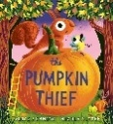    WEEK 1 Bonfire Night  Text/title: The Pumpkin Thief  W/C Tuesday 3rd November | WEEK 2 Changing Seasons  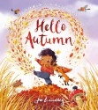  Text/title: Hello Autumn  W/C Monday 9th November  Nursery Rhyme Week | WEEK 3 Autumn  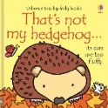  Text/title: That’s Not My Hedgehog  W/C Monday 16th November | WEEK 4 Occupations  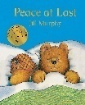  Text/title: Peace at Last  W/C Monday 23rd November | WEEK 5 Celebrations  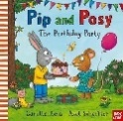  Text/title Pip and Posy: The Birthday Party  W/C Monday 30th November | WEEK 6 The Nativity  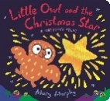  Text/title: Little Owl and the Christmas Star  W/C Monday 7th December | WEEK 7 Christmas  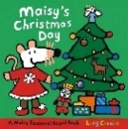  Text/title: Maisy’s Christmas Day  W/C Monday 7th December
Personal, social & emotional | Settling in and saying goodbye to their adult without getting upset.  Learning routines of the school day, areas in the classroom.  Making new friends and sharing and taking turns.  Sharing personal experiences –What did you do over the half term?  Keeping safe and following rules safely e.g., bonfire night  Twinkl PSHE Scheme: My family tree | Settling in and getting back into routine.  Learning routines of the school day, areas in the classroom.  Talk about moving house, having a new baby.  Select resources in dependently within the classroom  Twinkl PSHE Scheme: My friends are special | Following the rules- Why do we need them?  Learning the rules  Classroom rules.  I can talk about special people in my life and personal experiences.  Twinkl PSHE Scheme: Help Goldilocks make safer choices | Being independent- what can I do for myself?  Getting ready for Forest School Adventures with adult support.  I can talk about future occupations, people who help us.  Twinkl PSHE Scheme: Is it safe to eat | Personal Hygiene- How can we stay healthy?  Washing our hands, eating healthy foods, brushing our teeth, feeling thirsty, too hot or cold etc.  Dressing and undressing for P.E  Twinkl PSHE Scheme: Stop, look and listen | I can listen to stories and engage in back-and-forth conversations remembering much of what has happened.  Dressing and undressing for P.E  Talk about road safety and keeping safe when crossing the roads. Act out using bikes on the playground.  Twinkl PSHE Scheme: What do you do online | Christmas from the past/present children to look at similarities and differences.  Explore how Christmas is celebrated around the World.  Twinkl PSHE Spot what’s hot.
Physical Development | Personal Hygiene- going to the toilet, washing hands etc.  Explore the school grounds.  Fire work song – using the parachute and scarfs through dance and movement.  Bikes and scooters  Large scale mark making e.g water and brushes on the wall, chalking outdoors.  Fine motor skills  Firework pictures flicking paintbrushes  Physical skills P.E  Firework dancing with scarves  https://www.youtube.com/watch?v=Jer4UoFnlqA  Rhythm time  Forest School sessions  I can jump and land with both feet together with support. | An introduction to Forest School  Personal Hygiene- going to the toilet, washing hands etc.  Parachute games  Explore the school grounds  Bikes and scooters  Large scale mark making e.g water and brushes on the wall, chalking outdoors  Fine motor skills Making poppies from playdough  Physical skills P.E  Autumn days falling leaves BBC Teach https://www.bbc.co.uk/teach/school-radio/articles/zmxnjhv  Rhythm time  Forest School sessions.  I can jump and land with both feet together with increased confidence and support. | Forest School sessions clay hedgehogs  Personal Hygiene- going to the toilet, washing hands etc.  Ring games  Explore the school grounds  Bikes and scooters  Large scale mark making e.g water and brushes on the wall, chalking outdoors  Fine motor skills  Cutting up leaves  Physical skills P.E Autumn animals BBC Teach https://www.bbc.co.uk/teach/school-radio/articles/zkqy2sg  Rhythm time  Forest School sessions.  I can jump and land with both feet together with increased independence. | Forest School dressing and undressing shoes  Personal Hygiene- going to the toilet, washing hands etc.  Ball games  Adventure playground  Bikes and scooters  Large scale mark making e.g water and brushes on the wall, chalking outdoors  Fine motor skills  Funky fingers cheerio challenge  Physical skills P.E  Sensory circuit to enable children to balance.  Rhythm time  Forest School sessions.  I can climb small structures e.g. steps or low climbing frames with support. | Forest School dressing and undressing shoes  Dressing and undressing for P.E  Dance & movement  Awareness of space and of self  Parachute games  Adventure playground  Bikes and scooters  Large scale mark making e.g water and brushes on the wall, chalking outdoors  Fine motor skills Pencil control challenge  Physical skills P.E  Obstacle course for children to recap on previous skills.  Rhythm time  Forest School sessions.  I can climb small structures e.g. steps or low climbing frames with reduced support. | Forest School dressing and undressing shoes into wellies.  Dance & movement  Awareness of space and of self  Ring games Adventure playground  Bikes and scooters  Large scale mark making e.g water and brushes on the wall, chalking outdoors  Fine motor skills  Shape weaving using ribbons  Physical skills P.E Christmas yoga with cosmic yoga  Rhythm time  Forest School sessions.  I can climb small structures e.g. steps or low climbing frames with confidence and independence. | Forest School dressing and undressing shoes into wellies with confidence.  Dance & movement  Awareness of space and of self  How we feel after exercise? Why do we need exercise?  Bikes and scooters  Bikes and scooters  Large scale mark making e.g water and brushes on the wall, chalking outdoors  Fine motor skills Christmas activities  Rhythm time  Physical skills P.E  Party dances  Rhythm time  Forest School sessions.  I can balance on low beams or lines on the playground.
Fine Motor Skills  Funky fingers activities daily in continuous provision to support fine motor skills | Introduce Wiggle me into a Squiggle. Move 1-Up  Pen disco - lines up  Pincer movement- Fire work picture – tooth brush flicking  Dough disco | Introduce Wiggle me into a Squiggle. Move 1-Up  Pen disco - lines up  Pincer movement - Conker rolling picture  Dough disco | Introduce Wiggle me into a Squiggle. Move 2-Down  Pen disco - lines down  Pincer movement - Clay hedgehogs  Dough disco | Introduce Wiggle me into a Squiggle. Move 2- Down  Pen disco - lines down  Pincer movement – Basic snipping leaves.  Dough disco | Introduce Wiggle me into a Squiggle Move 3-Circles  Pen disco – circles  Pincer movement – Basic ripping of paper to make balloon college.  Dough disco | Introduce Wiggle me into a Squiggle Move 3- Circles  Pen disco - circles  Pincer movement – Make a star biscuit tbc.  Dough disco | Introduce Wiggle me into a Squiggle Recap all three movements- Up, Down, Circles  Pen disco – Recap all moves  Pincer movement – Threading pasta shapes.  Dough disco
Communication & Language | Show and tell seesaw adventures  Sharing personal experiences –What did you do over the October holiday?  Role play opportunities | Show and tell seesaw adventures  Circle time activities – Who is missing?  Role play opportunities | Show and tell seesaw adventures  Circle time activities – I spy with my Little Eye  Role play opportunities | Show and tell seesaw adventures  Circle time activities – My Friend is …  Role play opportunities | Show and tell seesaw adventures  Circle time activities – I can tell a story  Role play opportunities | Show and tell seesaw adventures  Circle time activities – Keeper of the Keys  Role play opportunities | Show and tell seesaw adventures  Circle time activities – I spy in a Bottle  Role play opportunities
Literacy & Phonics | Introduction of phase 2 phonics aspect 2  Instrumental sounds | Introduction of phase 2 phonics aspect 2  Instrumental sounds | Introduction of phase 2 phonics aspect 2  Instrumental sounds | Introduction of phase 2 phonics aspect 3  General sound discrimination body percussion sounds | Introduction of phase 2 phonics aspect 3  General sound discrimination body percussion sounds | Introduction of phase 2 phonics aspect 3  General sound discrimination body percussion sounds | Introduction of phase 2 phonics aspect 3  General sound discrimination body percussion sounds
Poetry  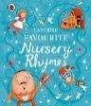 | Baa Baa Black Sheep  Wind the Bobbin Up  When Goldilocks Went to the house of the bears. |  | I see Leaves  Finger family rhyme https://www.google.com/search?sca_esv=744b1af2a639866b&rlz=1C1GCEA_enGB1213GB1213&udm=7&fbs=ABfTbFVQT6KYne3_7HzvYh-3OtGx58b6etG0d4vJA5pSuMg8I4Ji2R4SuoiMnBaXeDa3qS5oi1DJzxzCVvKpl3s5ly6Nb4GmFV76HFjBhoOh_PUgQ3ZBXNB4fBprOwJ0p--OhgykeJhlf-wbOu8hQS0JAeU_5RmPXZ3iaHgMRSNe0xF5cUhApKsNaUrMU07p_nKNIK3LCheEofTvHqFssUACXd9qFdOehSMJ0JOySOaIlq4K2I5Efmg&q=rhymes+about+occupations+eyfs&sa=X&ved=2ahUKEwiTt5zV3rGWAxVZRkEAHflGJ3wQtKgLegQIEBAB&biw=1536&bih=695&dpr=1.25#fpstate=ive&vld=cid:68f50c4c,vid:kIrUHPvIaVQ,st:0 |  | I can clap my hands  Muffin Man |  | Hokey Cokey
Texts to Support |   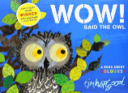  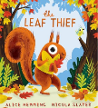  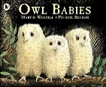    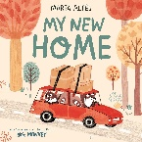 |  | 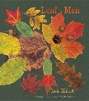  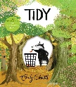  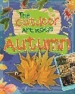 | 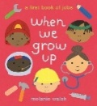  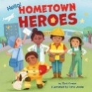 | 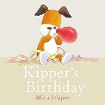  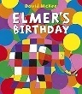  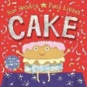 | 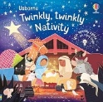  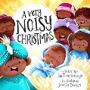  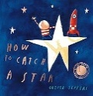 | 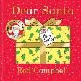    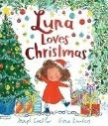
Mathematics | Block 5 – Counting 2 - begin to order number rhymes  Sentence stems  • Count with me:1,2,3,  • I have 1,2,3,  • I can count  Key questions  • How many______ are there?  • How many do you have?  • How many _____ did you have?  • What else can you count? |  | Block 6 – Subitizing 1 - I see 1,2,3,  Sentence stems  • I see…  • There are 1,2,3___  • Point to the page with 1,2,3,  • Show me 1,2,3,  Key questions  • What do you notice?  • What can you see?  • Which is/are the ____?  • Where can you see 1,2,3,?  • Where else can you see ….?  • Where can you find 1,2,3?  • What else in this picture shows 1/2/3 |  | Block 7 – Pattern 2 -join in with repeats  Sentence stems  • Next, I will say ….  • _____ will come next.  • After _____ we need to.  • Next, I will …  • I have made a _____ pattern.  Key questions  • What will come next in the story/song?  • What actions will you do next?  • What comes next in the routine?  • What have you used to make your pattern? |  | Block 8 – Shape, space and measure 2- Explore position and space  Sentence stems  • I will put the block …  • The ___ will/will not fit inside the ____.  • The ____ and _____ are the same.  • My object is …  Key questions  •Where will put your ____?  •What will fit inside the ___?  •What do you notice about this objects/shape?
Maths Texts to Support | • The Three Billy Goats Gruff |  | • Guess Who by Pam Ayres  • Macdog’s Home by Caroline and John Astrop  • Peepo by Janet and Allan Ahlberg  • Each Peach Pear Plum by Janet and Allan Ahlberg  • The Three Little Pigs  • The Three Billy Goats Gruff  • Goldilocks and the Three Bears |  | • Peck, Peck Peck by Lucy Collins  • Splish, splash, Duck by Lucy Collins  • Brown Bear, Brown Bear What do You See by Bill Martin Jr. |  | • Duck in the Truck by Jez Alborough  • Cat Up, Cat Down by Catherine Hnatov
Understanding the World | Autumn is here  Talk about Bonfire night and introduce occupation of a fire fighter.  Seasons and weather – what do we notice.  Begin to develop positive attitudes about the differences between people through Diwali. | Learn about Remembrance Day  Children in Need | Use all their senses in hands on exploration of natural materials. | To show an interest in different occupations and how they help us. | Discuss celebrations such as birthday’s and relieve past experiences.  Posting a letter to Father Christmas. Walking to the Post box? | Begin to make sense of own life story and family history.  Continue to develop positive attitudes about the differences between people through the topic of Christmas.  To prepare for Spring and Summer by caring for growing plants. | Party celebrations
Expressive Arts & Design | Nursery songs and rhymes. Firework dancing Katy Perry instrumental  Make imaginative small worlds using blocks, construction kits etc.  Mark making –indoor and out  Mixing colours- different colours. Making new colours firework picture.  Rhythm time (Fridays)  Malleable materials: playdough | Mixing colours- different colours. Children to paint and explore leaf painting using spray bottles.  Malleable materials: make a clay hedgehog | Remember to sing entire songs using the rhyme Leaves fall down  https://www.google.com/search?q=autumn+rhymes+for+toddlers+with+musical+instrumnets&sca_esv=716aa08019bfedb8&rlz=1C1GCEA_enGB1213GB1213&udm=7&biw=1536&bih=695&ei=dliIauuRNeSBhbIP8Y7M4QQ&ved=0ahUKEwjrpO--77GWAxXkQEEAHXEHM0wQ4dUDCBE&uact=5&oq=autumn+rhymes+for+toddlers+with+musical+instrumnets&gs_lp=EhZnd3Mtd2l6LW1vZGVsZXNzLXZpZGVvIjNhdXR1bW4gcmh5bWVzIGZvciB0b2RkbGVycyB3aXRoIG11c2ljYWwgaW5zdHJ1bW5ldHMyBBAhGBVI9jJQuAVY3zBwAXgBkAEAmAGWAaABwxWqAQQwLjIwuAEDyAEA-AEBmAIVoAKVFsICChAAGEcY1gQYsAPCAggQABiJBRiiBMICBRAAGO8FwgIFECEYnwXCAgUQIRigAcICBxAhGAoYoAGYAwCIBgGQBgeSBwQxLjIwoAfzLLIHBDAuMjC4B48WwgcIMC4xOS4xLjHIByyACAE&sclient=gws-wiz-modeless-video#fpstate=ive&ip=1&vld=cid:c50f7f75,vid:aYxdDl1VLrc,st:0  Rhythm time (Fridays)  Malleable materials: make a clay hedgehog | Make imaginative small worlds using construction blocks and talk about what they have created.  Rhythm time (Fridays)  Malleable materials: gloop | Play instruments with increasing control.  Rhythm time (Fridays)  Malleable materials: pasta | Sing the melodic shape  (moving melody, such as up and down, down and up) of familiar songs.  Create their own songs or improvise a song around one they know.  Rhythm time (Fridays)  Malleable materials: salt dough stars | Respond to what they have heard, expressing their thoughts and feelings.  Rhythm time (Fridays)  Malleable materials: Christmas sensory tray
Seasonal Opportunities | Weekly baking activities tbc  Bonfire night (5th Nov),  Diwali (6th Nov),  Nursery Rhyme Week (9th Nov - 13th Nov)  Remembrance Day  Elf run  Christmas and Hanukkah  Nativity performance  Christmas jumper day  Magic show or theatre trip
Assessment | Pre writing shapes assessment new starters |  |  |  | Self-portrait assessment.  Welcomm assessment | Welcomm assessment | Pre writing assessment

PRE-SCHOOL MEDIUM TERM WEEKLY VIEW PLAN
Term: Spring Term 1 Theme: Winter Warmers and Traditional Tales Academic year: 2026-2027
Curriculum Area | WEEK 1 Changing Seasons  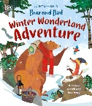  Text/title: Winter Wonderland Adventure  W/C Monday 4th January | WEEK 2 Around the World  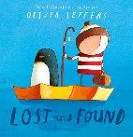  Text/title: Lost and Found  W/C Monday 11th January | WEEK 3 Traditional Stories  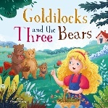  Text/title: Goldilocks and the Three Bears  W/C Monday 18th January | WEEK 4 Traditional Stories  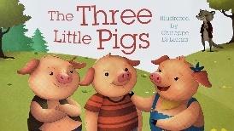  Text/title: The Three Little Pigs  W/C Monday 25th January | WEEK 5 Traditional Stories  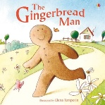  Text/title: Gingerbread Man  W/C Monday 1st February | WEEK 6 Traditional Stories  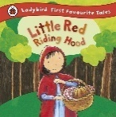  Text/title: Little Red Riding Hood  W/C Monday 8th February
Personal, social & emotional | Settling in and saying goodbye to their adult with more confidence.  Learning the new routines of the school day.  Making new friends and sharing and taking turns.  Sharing personal experiences –What did you do over Christmas?  Continue to show increased confidence in fastenings and getting changed.  Sharing seesaw adventures and  respecting our friend’s special times.  Twinkl PSHE Scheme: We can share | Continue to gain confidence in welcoming new children.  Learning routines of the school day, areas in the classroom.  Select resources in dependently within the classroom.  I can talk about special people in my life and personal experiences.  Continue to gain confidence in gaining control over fastenings.  Sharing seesaw adventures and respecting our friend’s special times.  Twinkl PSHE Scheme: We can take turns. | Begins to show interests and stays longer at activities.  Begins to show some understanding of the daily routine, rules and boundaries.  Begins to understand the need for safety.  Begins to sit during carpet time for a few minutes.  Continue to gain confidence in gaining control over fastenings.  I can show kindness to my peers.  Twinkl PSHE Scheme: Showing Kindness | Being independent- what can I do for myself?  I can begin to show stronger confidence in following rules and boundaries with more independence.  I can express my feelings to my peers with more confidence.  Getting changed with increased confidence in independent skills with buttons and fastenings.  Sharing seesaw adventures and respecting our friend’s special times.  Twinkl PSHE Scheme: Respecting Rules | I can listen to stories and engage in back-and-forth conversations remembering key words in a confident manner.  I am extending my friendships beyond my inner circle.  I can help others in provision or getting changed to offer peer support.  Confident in developing more control when getting dressed and undressed.  Sharing seesaw adventures and respecting our friend’s special times.  Twinkl PSHE Scheme: Magic Manners | I can show an awareness of different celebrations around the world.  I can talk about different customs such as Chinese New Year.  To hold back and forth conversations on topics of interest.  I can begin to form special friendships with another peer or peers.  Confident in developing more control when getting dressed and undressed.  Sharing seesaw adventures and respecting our friend’s special times.  Twinkl PSHE Scheme: Our class ocean
Physical Development | Introduce pre writing vertical shape |  Personal Hygiene- showing more independence in self-care needs.  Explore the school grounds. Bikes and scooters  Large scale mark making e.g water and brushes on the wall, chalking outdoors.  OPAL Play  Rhythm time with Gemma  I can begin to show an awareness of space when running and stopping. | Introduce pre writing horizontal shape –  Continue to show more confidence in self-care needs in dressing and undressing and toileting.  Explore the school grounds  Magic dust dance  https://www.youtube.com/watch?v=56GZPYCMe5o  Then snowflake, snowflake song.  Bikes and scooters  Large scale mark making e.g water and brushes on the wall, chalking outdoors  Rhythm time  I can begin to show an awareness of space when running and stopping. | Introduce pre writing circle shape 0  Continue to show more confidence in self-care needs in dressing and undressing and toileting.  Explore the school grounds  Do the bird dance https://www.youtube.com/watch?v=8NVqdTunPG0  Bikes and scooters  Large scale mark making e.g water and brushes on the wall, chalking outdoors  Obstacle course around the woods  Rhythm time  I can show an awareness of balancing on one leg. | Introduce pre writing cross shape +  Continue to show more confidence in self-care needs in dressing and undressing and toileting.  Explore the school grounds  Creatures of the snow  https://www.bbc.co.uk/teach/school-radio/articles/z44m47h  Bikes and scooters  Large scale mark making e.g water and brushes on the wall, chalking outdoors.  Rhythm time  I can show an awareness of balancing on one leg. | Introduce pre writing cross shape   Continue to show more confidence in self-care needs in dressing and undressing and toileting.  Explore the school grounds  Bikes and scooters  Large scale mark making e.g water and brushes on the wall, chalking outdoors  Scissor skills assessment- who can use scissors/ who can’t  Rhythm time  I can begin to hop with support | Recap all pre writing shapes  Continue to show more confidence in self-care needs in dressing and undressing and toileting.  Continue to explore the school grounds.  Chinese New Year dancing  https://www.youtube.com/watch?v=To9dIBNEOIM  Bikes and scooters  Large scale mark making e.g water and brushes on the wall, chalking outdoors  Rhythm time  I can begin to hop with reduced support.
Fine Motor Skills  Funky fingers activities daily in continuous provision to support fine motor skills | Wiggle me into a Squiggle. Move 3 -Circles  Dough disco  Scissor skills snipping  Name writing | Wiggle me into a Squiggle. Move 3 -Circles  Dough disco  Scissor skills snipping  Name writing | Wiggle me into a Squiggle. Move 4 -Wiggle  Dough disco  Scissor skills snipping  Name writing | Wiggle me into a Squiggle. Move 4 -Wiggle  Dough disco  Scissor skills snipping  Name writing | Wiggle me into a Squiggle. Move 5 - Shake  Dough disco  Scissor skills snipping  Name writing | Wiggle me into a Squiggle. Move 5 -Shake  Dough disco  Scissor skills snipping  Name writing
Communication & Language | Introduce Helicopter stories in small groups.  Sharing personal experiences –What did you do over the half term.  PSE discussions through circle time.  Understands simple instructions such as ‘get your coat’.  Responds to simple questions by pointing and gesturing. | Introduce Helicopter stories in small groups.  Sharing personal experiences –What did you do over the half term.  PSE discussions through circle time.  Begins to recognize pictures in non-fiction books by applying new vocabulary. | Introduce Helicopter stories in small groups.  Sharing personal experiences –What did you do over the half term.  PSE discussions through circle time.  Can listen to longer periods but still needs support. | Introduce Helicopter stories in small groups.  Sharing personal experiences –What did you do over the half term.  PSE discussions through circle time.  Can listen to longer periods with reduced support. | Introduce Helicopter stories in small groups.  Sharing personal experiences –What did you do over the half term.  PSE discussions through circle time.  Can listen to longer periods with increased interest. | Introduce Helicopter stories in small groups.  Sharing personal experiences –What did you do over the half term.  PSE discussions through circle time.  Can listen to longer periods with increased interest.  Beginning to understands who, what where.
Literacy & Phonics | Introduction of phase 2 phonics aspect 4 Rhythm and Rhyme.  Introduce pre writing shapes | Introduction of phase 2 phonics aspect 4 Rhythm and Rhyme.  Introduce pre writing shapes | Introduction of phase 2 phonics aspect 4 Rhythm and Rhyme.  Introduce pre writing shapes | Introduction of phase 2 phonics aspect 4 Rhythm and Rhyme.  Introduce pre writing shapes | Introduction of phase 2 phonics aspect 4 Rhythm and Rhyme.  Introduce pre writing shapes | Introduction of phase 2 phonics aspect 4 Rhythm and Rhyme.  Introduce pre writing shapes
Poetry | Tommy Thumb  Two Little Dicky Birds  Three Blind Mice |  | 1,2,3,4,5, Once I caught a fish alive  When Goldilocks Went to the house of the bears.  Songs with numbers in order | In and out the Dusty Bluebells | I London Bridge is Falling Down
Texts to Support | 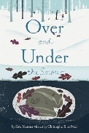    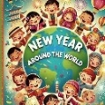 | 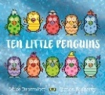  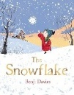  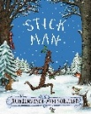 | 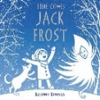  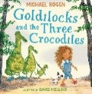  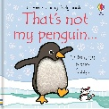 | 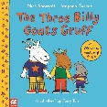  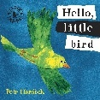  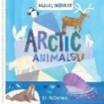 | 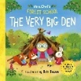  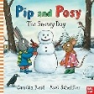  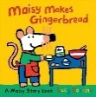 | 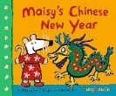  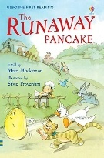  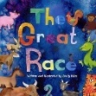  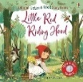
Mathematics | Block 9 – Subitizing 2 - Show Me 1,2,3,  Sentence stems  • I can see ____  • I can subitise ____  • I can show ___  • There are 1,2,3, ___  Key questions  • What can you see?  • Where can you subitise 1,2,3,  • How many ____ can you see?  • How can you show me 1,2,3?  • How can you show me 1,2,3, in a different way?  • Where can you see 1,2,3, on this page?  • Where can you see 1,2,3, in this story? |  | Block 10 – Counting 3- Move and label 1,2,3,  Sentence stems  • I can count ____  • I have 1?2/2/___  • I can see the number ____  Key questions  • How many do you have?  • How many _are there?  • Which numerals can you see? | Block 11 – Shape, space and measures 3- Explore position and routes.  Sentence stems  • I will put the piece/shape …  • The ____ is on/under/between the ____  • I will go on/under/over/between/through the ____.  • I need to move …  Key questions  • How will you make that piece fit?  • How will you move your body?  • Where will you go next? | Block 12 – Pattern 3 -Explore own first patterns  Sentence stems  I can see a ___ pattern.  I will make a ____  I will need …  I am making a pattern with___  Key questions  • What patterns do you notice?  • What are you going to make?  • How will you make ___?  • What will you use to make your pattern?
Maths Texts to Support | • Fox’s Socks by Julia Donaldson  • Three Little Bunnies by Beatrix Potter  • Peepo! by Janet and Allan Alhberg |  | • Goldilocks and the Three Bears | • Where’s Spot by Eric Hall  • Everyone Hide from Wibbly Pig by Mick Inkpen  • Where oh where is Rosie’s Chick? | •The Three Billy Goats Gruff  • Dinosaur Roar by Paul and Harriet Stickland  • Cave Baby by Julia Donaldson
Understanding the World | Seasons and winter introducing snow  Melting and freezing exploring hands on.  Notice environmental changes e.g. signs of winter. | Seasons and winter  Introducing snowflakes through the story The Snowflake.  Melting and freezing exploring hands on.  Notice the environmental weather. Describe the conditions https://www.bbc.co.uk/bitesize/articles/zrm98hv | Seasons and Winter  Melting and freezing exploring hands on.  Notice different countries in the world and discuss the differences.  Penguin awareness day Wednesday 20th January 2027.  Notice and discuss similarities and differences between animals around the world. | Seasons and weather  Melting and freezing exploring hands on.  Making bird feeders to look after the birds during winter.  Caring for the world around us through planting. | Caring for the world around us through the school environment-tidying up the allotment.  Understand how to look after the environment.  Use senses to explore the world around us. | Lunar New Year- how do people celebrate.  Question why things happen e.g. Chinese new year celebrations.  Valentine’s Day who do we love and why?.
Expressive Arts & Design | Nursery songs and rhymes.  Rhythm time (Fridays)  Learn snowman song  https://www.youtube.com/watch?v=FczqntFwb6k  Mark making –creating a winter snowman picture.  Malleable materials: exploring ice and snow. | Nursery songs and rhymes.  Rhythm time (Fridays)  Use scissors to make a snowflake. Procession of cutting skills.  Mark making – making salt snowflake pictures    Mixing colours- different colours for classroom display.  Malleable materials make snowballs in dough or snow.  Dance and movement- snowflake dancing | Nursery songs and rhymes.  Rhythm time (Fridays)  Learn Penguin song for Penguin Awareness Day  Penguin awareness day 20.01.2026 Children to begin to join materials together to make a penguin.  Malleable materials: ice  Dance and movement – begin to gain control over body movements penguin dance | Nursery songs and rhymes.  Rhythm time (Fridays)  Learn snowman song  Mark making – indoor and out  Malleable materials: cooked pasta  Dance and movement-  Do the bird dance https://www.google.com/search?sca_esv=7dcbc37479457eb0&rlz=1C1GCEA_enGB1178GB1178&udm=7&fbs=AIIjpHz30rPMyW-0vSP0k1VTNmO_kCOARpjPjQRkBWH2HwUIz5XUSIJvSK0oms7XOxizDlmapc3S9dUP-_MTiIHH95WkmU3OJ0Y1hJaAJdBCt0P7bfmzdEjKwYZ8G0dxHpKwLwHJut2izkqnx-71uXW69hylvOXhRTvxKdha5J7ugSYATcLpqmZgF_sIZgikwPjaDTpQp9Mm0No0qwsop4SNF-Pl8TY9vMWQQg4MKCTLt3o4ItIw-6A&q=dance+and+movement+eyfs+bird+dancing+with+ribbons+little+movers&sa=X&ved=2ahUKEwjOzJO5uO2RAxVtV0EAHY7kJHgQtKgLegQIDBAB&biw=1522&bih=687&dpr=1.25#fpstate=ive&vld=cid:f76fedd7,vid:8NVqdTunPG0,st:0 | Caring for the world around us through the school environment-tidying up the allotment.  Understand how to look after the environment.  Use senses to explore the world around us.  Nursery songs and rhymes.  Rhythm time (Fridays) | Nursery songs and rhymes.  Rhythm time (Fridays  Learn Red Riding Hood’s song I love Red  https://www.bbc.co.uk/teach/school-radio/articles/z74txyc
Seasonal Opportunities | Penguin Awareness Day Wednesday 20th January  Big School’s Birdwatch  Pancake Day Tuesday 9th February  Lunar New Year- February 6th Year of the Goat  Valentine’s Day  Winter  Freezing and Melting  Birthdays
Assessment | Welcome and settle in new starters | Welcome and settle in new starters  Pre writing shapes assessment  Pencil grip assessment |  | Wellcomm assessment | Wellcomm assessment

PRE-SCHOOL MEDIUM TERM WEEKLY VIEW PLAN
Term: Spring 2 Theme: I Spy with My Little Eye… colours everywhere! Academic year: 2026-2027

Curriculum Area | WEEK 1 Colours  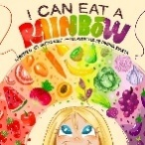  Text/title: I can Eat a Rainbow  W/C Monday 22nd February | WEEK 2 Growing  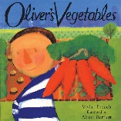  Text/title: Oliver’s Vegetables  W/C Monday 1st March  World Book Day Thursday 5th March 2027  British Science Week 5-14th March | WEEK 3 Gardening  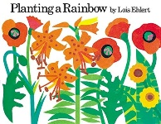  Text/title: I can plant a rainbow  W/C Monday 8th March  Mother’s Day Sunday 7th March 2027 | WEEK 4 Emotions and Feelings  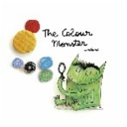  Text/title: The Colour Monster  W/C Monday 15th March | WEEK 5 All Welcome/Diversity  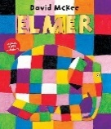  Text/title: Elmer  W/C Monday 22nd March  Easter Stay and Play
Personal, social & emotional | Settling in and being more confident leaving primary carers.  Learning the new routines of the school day e.g. splitting for phonics.  Making new friends and sharing and taking turns.  Sharing personal experiences –What did you do over half term?  Circle time-time to chat and share experiences and thoughts.  Twinkl PSHE Scheme: See Twinkl planning | Being independent- I Can take off my shoes and socks with support.  Learning routines of the school day e.g. splitting for phonics.  Select resources in dependently within the classroom.  Sharing seesaw adventures and respecting our friend’s special times.  Circle time-time to chat and share experiences and thoughts.  Twinkl PSHE Scheme: See Twinkl planning | Being independent-I can take off my shoes and socks with reduced support.  Showing confidence in knowing the routines of the school day e.g. splitting groups for phonics.  Begin to explore own emotions through the Colour Monster story  Sharing seesaw adventures and respecting our friend’s special times.  Circle time-time to chat and share experiences and feelings.  Twinkl PSHE Scheme: See Twinkl planning | Begins to explore emotions.  Begins to explore own emotions through the Colour Monster story.  I can demonstrate confidence in the daily routine with reduced adult support  I can express my feelings to my peers with more confidence.  Sharing seesaw adventures and respecting our friend’s special times.  Circle time-time to chat and share experiences and feelings.  Twinkl PSHE Scheme: See Twinkl planning | Being independent- can I get dressed for P.E with adult support.  I can demonstrate more confidence in the daily routine of the Pre School with reduced adult support.  I can help to look after younger peers in the classroom.  Sharing seesaw adventures and respecting our friend’s special times.  Circle time-time to chat and share experiences and feelings.  Twinkl PSHE Scheme: See Twinkl planning
Physical Development | Personal Hygiene- showing more independence in self-care needs.  Explore the school grounds.  Go Danny Go colour work out dance https://www.youtube.com/watch?v=q-6g_viAcIk  Bikes and scooters to support sensory regulation.  Large scale mark making e.g water and brushes on the wall, chalking outdoors.  Dough disco interventions  Scissor skills snipping  Name writing daily  Rhythm time with Gemma  Practise for Sports Day  I can begin to climb higher on play structures with confidence. | Continue to show more confidence in self-care needs in dressing and undressing and toileting.  Explore the school grounds using the obstacle course  Go Danny Go work out grocery dash.  Bikes and scooters to support sensory regulation.  Large scale mark making e.g water and brushes on the wall, chalking outdoors  Dough disco  Scissor skills snipping  Name writing daily  Rhythm time  Practise for Sports Day  I can kick a ball towards a target with accuracy. | Continue to show more confidence in self-care needs in dressing and undressing and toileting.  Explore tyre rolling on the playground.  Bikes and scooters to support sensory regulation.  Large scale mark making e.g water and brushes on the wall, chalking outdoors  Fine motor skills  Dough disco  Scissor skills snipping  Name writing daily  Rhythm time  Practise for Sports Day  I can throw a ball with accuracy. | Is showing more confidence in self-care needs in dressing and undressing and toileting.  Explore the school grounds can kick a ball.  Bikes and scooters to support sensory regulation.  Large scale mark making e.g water and brushes on the wall, chalking outdoors  Fine motor skills  Dough disco  Scissor skills snipping  Name writing daily  Rhythm time  Rainbow dance https://www.youtube.com/watch?v=zRj1JxYuMoo  Practise for Sports Day  I can catch a ball with control. | Beginning to show more confidence in self-care needs in dressing and undressing and toileting.  Explore the school grounds  Obstacle course around the wood.  Bikes and scooters to support sensory regulation.  Large scale mark making e.g water and brushes on the wall, chalking outdoors  To develop balance and co-ordination through simple yoga shapes.  Fine motor skills  Dough disco  Scissor skills assessment- who can use scissors/ who can’t.  Name writing daily  Rhythm time  I can catch a ball with control.
Fine Motor Skills  Funky fingers activities daily in continuous provision to support fine motor skills | Wiggle me into a Squiggle. Move 6 – Hop  Musical notes patterns finger tracing. | Wiggle me into a Squiggle. Move 6 - Hop  Cheerio challenge | Wiggle me into a Squiggle. Move 7 - Jump  Lacing activities | Wiggle me into a Squiggle. Move 7 - Jump  Pompom challenge | Wiggle me into a Squiggle. Move 7 - Jump  Pen disco
Communication & Language | Sharing personal experiences –What did you do over the half term.  PSE discussions through time to talk.  Helicopter stories- using props to make up a story to develop children’s oracy skills.  Show and tell- Seesaw  Circle time  Role play activities  Wellcomm interventions  Forest School | Respond to simple questions by speaking, or gesturing.  PSE discussions through time to talk.  Helicopter stories-using props to make up a story to develop children’s oracy skills.  Show and tell-Seesaw  Circle time  Role-play activities  Wellcomm interventions  Forest School | Beginning to show more confidence in listening for longer with adult support.  PSE discussions through time to talk.  Helicopter stories-using props to make up a story to develop children’s oracy skills.  Show and tell-Seesaw  Circle time  Role-play activities  Wellcomm interventions  Forest School | Gaining more confidence in listening for longer periods with reduced adult support  PSE discussions through time to talk.  Helicopter stories- to make up a story to develop children oracy skills.  Show and tell-Seesaw  Circle time  Role-play activities  Wellcomm interventions  Forest School | Showing extended confidence in listening for longer periods.  PSE discussions through time to talk.  Helicopter stories  Show and tell-Seesaw  Circle time  Role-play activities  Wellcomm interventions  Forest School
Literacy & Phonics | Introduction of phase 2 phonics aspect 5 Rhythm and Rhyme and Syllable counting. | Introduction of phase 2 phonics aspect 5 Rhythm and Rhyme and Syllable counting. | Introduction of phase 2 phonics aspect 5 Rhythm and Rhyme and Syllable counting. | Introduction of phase 2 phonics aspect 5 Rhythm and Rhyme and Syllable counting. | Introduction of phase 2 phonics aspect 6 Voice sounds
Poetry | Three Little Speckled Frogs  Three Little Monkeys  Three Little Men in a Flying Saucer  One Man Went to Mow | Humpty Dumpty  Teddy’s Bear Picnic | 1,2,3, black Dots (sing to the rhyme of 1,2,3,4,5 once I caught a fish a live  1,2,3, black dots.  Can you see how many spots?  1,2,3, black dots.  Can you see how many spots?  How many did you see?  Can you spot them easily?  Which pattern did you see?  Is it 1 or 2 or 3? |  | Teddy Bears Picnic
Texts to Support | 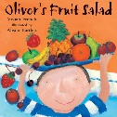  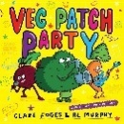  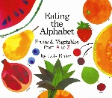 | 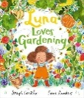  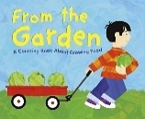  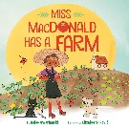 | 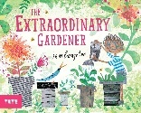  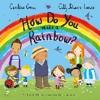  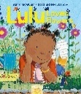  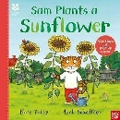 | 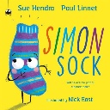  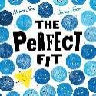  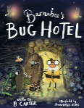  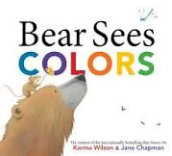 | 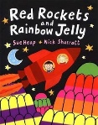  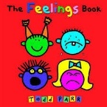    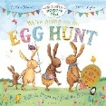
Mathematics | Block 13 – Counting 4 - take and give 1,2,3,  Sentence stems  • I want to count  • There are …  • 1,2, I have ___/1,2,3, I have ___  Key questions  • What would you like to count  • How many are there?  • How many do you have?  • What number do you need to stop counting at? | Block 14 – Shape, space and measure 4-Match, talk, push, and pull  Sentence stems  • These ___ are the same.  • I have used these because…  • The ___ fit together because …  • I will go ___ the ___  Key questions  • What will you use?  • What have you made?  • Where shall I put this? Will this fit?  • Which way will you go? | Block 15 – Subitising 3 – Talk about dots  Sentence stems  • I can see ___  There are ____ dots  I have 1/2/3/ ___  It is not ___  Key questions  • What can you see?  • How many can you see?  • How many are there?  • Where can you see 1/2/3/?  • What pattern can you see? |  | Block 16 – Comparison 2  Sentence stems  • This collection has ___  • I can see ___  • I have made a collection using …  Key questions  • What collection has more?  • Which collection has fewer?  • Which collection has the same?  • How do you know the collections are the same?  • How can we make the collections the same?  • What do you notice?  • What will you use for your collection?
Maths Texts to Support | • Postman Bear by Julia Donaldson  • Three Little Bunnies by Beatrix Potter  • Meg and Mog by Helen Nicoll and Jan Pienkowski | • The Train Ride by June Crebbin  • The Naughty Bus by Jan and Jerry Oke  • Where is Bear by Jonathan Bentley | • Touch Think Learn: Numbers by Xavier Deneux  • Let’s Play! By Herve Tullet |  | • Oliver’s Fruit Salad by Vivan French  • The Very Hungry Caterpillar’s 123 Finger puppet counting book by Eric Carle  • Never Touch a Hippo by Rosie Greening  • Handa’s Surprise by Eileen Browne
Understanding the World | Seasons and winter introducing continued signs of Winter or early Spring.  Melting and freezing exploring hands on.  Discuss family celebrations e.g. pancake day or what they did over the holidays.  Forest School sessions planting | Seasons and winter  Introducing growing a rainbow by planting flowers.  Melting and freezing exploring hands on.  Notice any signs of changes e.g. bulbs growing. Discuss the differences.  Forest School sessions planting | Seasons and Winter  Continue with planting a rainbow using flowers and bulbs.  Melting and freezing exploring hands on. Discuss the changing state of matter.  Notice different countries in the world and discuss the differences.  Notice and discuss similarities and differences between animals around the world.  Forest School sessions planting  Mother’s Day Sunday 7th March 2027 | Seasons and weather  Looking after the wildlife make a bug hotel.  Melting and freezing exploring hands on.  Making bird feeders to look after the birds during winter.  Caring for the world around us through planting.  Forest School sessions planting | Caring for the world around us through the school environment-tidying up the allotment.  Continue to make a bug hotel.  Notice any differences in people, countries and communities.  Use senses to explore the world around us.  Easter Stay and Play session  Explore the meaning of Easter-looking at different celebrations and festivals.  Forest School sessions planting
Expressive Arts & Design | Nursery songs and rhymes.  Rhythm time (Fridays)  Learn elephant hokey pokey https://www.youtube.com/watch?v=5uMNVpPljmk  Dance and movement through the elephant dance song. Learn Elmer elephant song on Twinkl  Mark making – creating a colourful elephant using different paint techniques e.g. dabs, swirls, patterns.  Malleable materials: exploring ice. | Nursery songs and rhymes.  Rhythm time (Fridays)  Mother’s Day cards | Nursery songs and rhymes.  Rhythm time (Fridays)  Learn rainbow song  Dance and movement – begin to gain control over body movements https://www.youtube.com/watch?v=zlooJ2KgYas  Mark making through colour and texture.  Malleable materials: flowers and flower potions in the mud kitchen | Nursery songs and rhymes.  Rhythm time (Fridays)  Learn brown bear song https://www.youtube.com/watch?v=paw2RGSdwG0  https://www.youtube.com/watch?v=HaDDsT9IAWc  Dance and movement- were going on a bear hunt cosmic yoga  Mark making – indoor and out  Malleable materials: cooked pasta | Nursery songs and rhymes.  Rhythm time (Fridays)  Learn Easer songs to perform at the Stay and Play session.  Dance and movement– join some movements together.  Sleeping bunnies  Spring Chicken  Mark making- indoor and outdoor  Malleable materials: cloud dough  Mark making – indoor and out
Seasonal Opportunities | Mother’s Day Sunday 7th March 2027  Eid Wednesday 10th March 2027  Stay and Play workshop - Easter themed  Easter Friday 26th March 2027  Spring  Mobile farm visit TBC
Assessment |  | Welcomm assessment  Cutting assessment |  | Pencil grip assessment  Pre writing assessment

PRE-SCHOOL MEDIUM TERM WEEKLY VIEW PLAN
Term: Summer 1 Theme: Growing and changing - all around the World Academic year: 2026-2027

Curriculum Area | WEEK 1 Changing Seasons  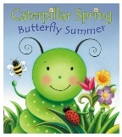  Text/title: Caterpillar Spring Butterfly Summer  W/C Monday 12th April | WEEK 2 Life Cycles  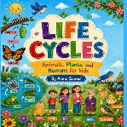  Text/title: Life Cycles  W/C Monday 19th April  Thursday 22nd April Earth Day 2027 | WEEK 3 Healthy Eating  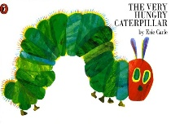  Text/title: The Hungry Caterpillar  W/C Monday 26th April | WEEK 4 Growing Up  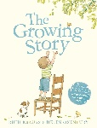  Text/title: The Growing Story  W/C Monday 3rd May | WEEK 5 Minibeasts  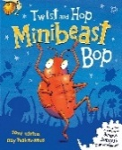  Text/title: The Minibeast Bop  W/C Monday 10th May  Sports Week
Personal, social & emotional | Settling in new starters.  Learning the new routines of the school day e.g. splitting for phonics.  Looking after new starters and developing a sense of responsibility.  Select resources independently within the classroom.  Sharing personal experiences –What did you do over Easter?  Circle time-time to chat and share experiences and thoughts.  Twinkl PSHE Scheme: See Twinkl planning | Being independent- I can take off my shoes and socks with no support.  Learning routines of the school day e.g. splitting for phonics.  Select resources independently within the classroom.  Sharing seesaw adventures and listening to our friends.  Circle time-time to chat and share experiences and thoughts.  Twinkl PSHE Scheme: See Twinkl planning | Being independent-I can put on my socks and shoes with support.  Showing confidence in knowing the routines of the school day e.g. splitting groups for phonics.  Begin to explore own emotions through the story The Squirrels who squabbled. Understanding conflict.  Sharing seesaw adventures and respecting our friend’s special times.  Make healthy choices about food, drink, activity and tooth brushing.  Begin to talk about why these choices are important.  Circle time-time to chat and share experiences and feelings.  Twinkl PSHE Scheme: See Twinkl planning | Being independent- I can put on my socks and shoes with support.  I can demonstrate confidence in the daily routine with reduced adult support  I can express my feelings to my peers with more confidence.  Sharing seesaw adventures and respecting our friend’s special times.  Circle time-time to chat and share experiences and feelings.  Find solutions to conflicts and rivalries.  I can understand the importance of tooth brushing.  Twinkl PSHE Scheme: See Twinkl planning | Being independent- I can put on my shoes and socks with no help.  Making new friends and sharing and taking turns.  I can help to look after younger peers in the classroom.  Sharing seesaw adventures and respecting our friend’s special times.  Circle time-time to chat and share experiences and thoughts.  Understand how others might be feeling.  Twinkl PSHE Scheme: See Twinkl planning
Physical Development | Personal Hygiene- showing more independence in self-care needs.  Explore the school grounds adventure park  Go Danny Go colour work out dance millipede https://www.youtube.com/watch?v=U_Ld1L6c1p4  Bikes and scooters to support sensory regulation.  Large scale mark making e.g. water and brushes on the wall, chalking outdoors etc.  Fine motor skills  Dough disco  Scissor skills cutting a straight line  Name writing daily  Rhythm time with Gemma  Allotment time | Begin to collaborate the right resources to carry out their plan for example when using the OPAL equipment.  Fine motor skills  Dough disco  Scissor skills cutting a straight line  Name writing daily  Rhythm time with Gemma  Allotment time  Develop confidence in skipping | Begin to show a preference for a preferred hand making large movements with streamers.  Fine motor skills  Dough disco  Scissor skills cutting a straight line  Name writing daily  Rhythm time with Gemma  Allotment time  Develop confidence in skipping | Begin to show a preference for a preferred hand when painting.  Fine motor skills  Dough disco  Scissor skills cutting a straight line  Name writing daily  Rhythm time with Gemma  Allotment time  Begin to show confidence in jumping from height. | Take part in group activities and in teams e.g. Sports Week.  Dancing in the Ugly Bug ball  Fine motor skills  Dough disco  Scissor skills cutting a straight line  Name writing daily  Rhythm time with Gemma  Allotment time.  Begin to show confidence in jumping from height.
Fine Motor Skills  Funky fingers activities daily in continuous provision to support fine motor skills | Wiggle me into a Squiggle. Move 8 – Turning Turtle | Wiggle me into a Squiggle. Move 9 – Turning Turtle | Wiggle me into a Squiggle. Move 10 – Crawling | Wiggle me into a Squiggle. Recap all moves. | Wiggle me into a Squiggle. Recap all moves.
Communication & Language | Sharing personal experiences –What did you do over the half term.  PSE discussions through time to talk.  Helicopter stories- using props to make up a story to develop children’s oracy skills.  Show and tell- Seesaw  Role play activities  Wellcomm interventions | Respond to simple questions by speaking, or gesturing.  PSE discussions through time to talk.  Helicopter stories-using props to make up a story to develop children’s oracy skills.  Show and tell-Seesaw  Role-play activities  Wellcomm interventions | Beginning to show more confidence in listening for longer with adult support.  PSE discussions through time to talk.  Helicopter stories-using props to make up a story to develop children’s oracy skills.  Show and tell-Seesaw  Role-play activities  Wellcomm interventions | Showing extended confidence in listening for longer periods.  PSE discussions through time to talk.  Helicopter stories- to make up a story to develop children oracy skills.  Show and tell-Seesaw  Role-play activities  Wellcomm interventions | Showing extended confidence in listening for longer periods.  PSE discussions through time to talk.  Helicopter stories- to make up a story to develop children oracy skills.  Show and tell-Seesaw  Role-play activities  Wellcomm interventions
Literacy & Phonics | Introduction of phase 2 phonics aspect 6  Voice sounds  Introduction of RWI for school starters | Introduction of phase 2 phonics aspect 6  Voice sounds  Introduction of RWI for school starters | Introduction of phase 2 phonics aspect 7  Oral blending and segmenting  Introduction of RWI for school starters | Introduction of phase 2 phonics aspect 7  Oral blending and segmenting  Introduction of RWI for school starters | Introduction of phase 2 phonics aspect 7  Oral blending and segmenting  Introduction of RWI for school starters
Poetry | Twinkle Twinkle Little Star,  I’m a Little Teapot  1,2,3,4,5, Once I caught a Fish Alive  Baa Baa Black Sheep,  Wind The Bobbin Up  Three Little Ducks |  | Tongue twister patterns such as Red Lorry, Yellow Lorry |  | Hickory Dickory Dock
Texts to Support | 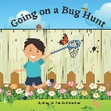  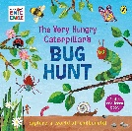  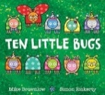  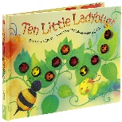  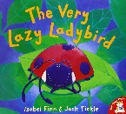  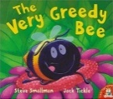  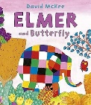  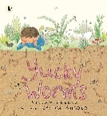  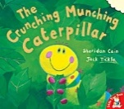  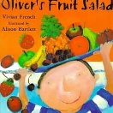  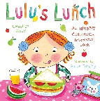  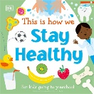  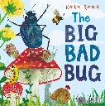  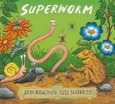  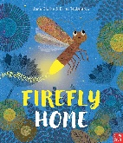  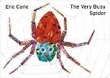  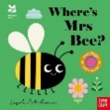
Mathematics | Block 17 – Pattern 4 – Lead on own repeats  Sentence stems  • Count with me:1,2,3,  • I have 1,2,3,  • I can count  Key questions  • How many______ are there?  • How many do you have?  • How many _____ did you have?  • What else can you count? | Block 18 – Shape, space and measure 5 – starting to puzzle  Sentence stems  • The ___ matches this.  • I will put my piece ...  • I can/can’t see ...  • My path goes to  Key questions  •Which shape/object matches?  • Where does this piece fit?  • What can you see? What can you see now?  • Where will your path go to? | Block 19 – Pattern 5 – Making patterns together  Sentence stems  • My song is ...  •____ comes next.  •I can see ____ in the pattern.  •I want to use ...  Key questions  • What song are you singing?  • What can you see/hear?  • What pattern are you making?  • What will come next in the pattern? | Block 20 – Subitising 4 – Making games and actions  Sentence stems  •I see ___  • There are ____ dots.  • I can hear ___ sounds.  • I need 1/2/3 ____.  Key questions  • How many ___ can you see?  • How many dots are there?  • Where can you see 1/2/3?  • How can you show me 1/2/3 in a different way?  • What can you hear?  • How many sounds did you hear?  • How many ____ do you need? | Block 21 – Counting 5 – Show me 5  Sentence stems  • I will put the block …  • The ___ will/will not fit inside the ____.  • The ____ and _____ are the same.  • My object is …  Key questions  •Where will put your ____?  •What will fit inside the ___?  •What do you notice about this objects/shape?
Maths Texts to Support | •Traditional Tales: The Enormous Turnip,  •The Gingerbread Man,  •The Three Little Pigs  • Little Red Hen  • Elmer by David McKee | • Usborne First Jigsaws: Wild Animals by Matthew Oldham  • Usborne First Jigsaws: Things that go by Matthew Oldham  • Shark in the Park by Nick Sharratt  • Off to the Park! by Stephen Cheetham  • The Gruffalo by Julia Donaldson  • The Gingerbread Man | • Hooray for Fish! by Lucy Cousins  • Beep Beep, Vroom Vroom! by Stuart J. Murphy  • A–B–A–B–A– a Book of Pattern Play by Brian P. Cleary | • The Very Hungry Caterpillar by Eric Carle  • Ooo Ooo Ooo Gorilla! by Lydia Monks | • Bears in Beds by Shirley Parenteau  • Five Wriggly Babies by Nicola Smee  • Never Touch series by Make Believe Ideas
Understanding the World | Introduce Spring and seasonal changes.  Notice when things have changed e.g. ice and freezing.  Discuss family celebrations e.g. celebrations over Easter | Planting a variety of seeds and looking at lifecycles.  Begin to make sense of their own life story and family’s history.  Begin to understand and respect the natural environment and all living things- Earth Day 2026  Understand life cycles | Seasons and environmental changes.  Continue planting and using flowers and bulbs taking care of the environment.  Forest School sessions. | Caring for the world around us through the school environment-tidying up the allotment.  Forest School sessions. | Talk about what they see using a wide range of vocabulary.  Forest School sessions.
Expressive Arts & Design | Nursery songs and rhymes.  Rhythm time (Fridays)  Create their own songs through dance and movement.  Mark making – creating a colourful elephant using different paint techniques e.g. dabs, swirls, patterns.  Malleable materials: exploring sand. | Nursery songs and rhymes.  Rhythm time (Fridays)  Dance and movement- through mini beast activity  https://www.twinkl.co.uk/resource/minibeast-movement-display-posters-t-tp-1644833544  Show different emotions through drawings and paintings such as happy, sad.  Malleable materials explore gloop. | Nursery songs and rhymes.  Rhythm time (Fridays)  Dance and movement – https://www.bbc.co.uk/teach/school-radio/articles/zhh6jhv  Join different materials together e.g. cellotape, masking tape to make creations..  Malleable materials: flowers and flower potions in the mud kitchen | Nursery songs and rhymes.  Rhythm time (Fridays)  Dance and movement- https://www.bbc.co.uk/teach/school-radio/articles/z72q92p  Mark making – indoor and out  Malleable materials: cooked pasta | Nursery songs and rhymes.  Rhythm time (Fridays)  Dance and movement– join some movements together through ugly bug ball.  Mark making- indoor and outdoor  Malleable materials: play dough
Seasonal Opportunities | Caterpillars to be ordered in week 1  World Bee Day  Earth day  Sports week  Sports day  Zoo2U or trip to Reaseheath
Assessment | Welcome and settle in new starters | Wellcomm assessment new starters  Cutting assessment | Wellcomm assessment  Mark making assessment.  Pencil grip assessment. | Name writing assessment.

PRE-SCHOOL MEDIUM TERM WEEKLY VIEW PLAN
Term: Summer 2 Theme: Where Will We Go? Academic year: 2026-2027

Curriculum Area | WEEK 1 Changing Seasons  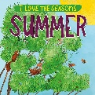  Text/title: I love the Seasons Summer  W/C Monday 7th June | 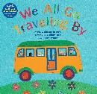  WEEK 2 Travel and Transport  Text/title: We All Go Travelling By  W/C Monday 14th June  Father’s Day Sunday 19th June | WEEK 3 Farm Animals  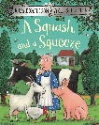  Text/title: A Squash and a Squeeze  W/C Monday 21st June  Walk to the library? | WEEK 4 Jungle and Sea Animals  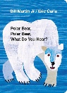  Polar Bear, Polar Bear What Do You Hear?  W/C Monday 28th June | WEEK 5 Transitions  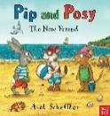  Text/title: Pip and Posy; The New Friend  W/C Monday 5th July | WEEK 6 Travelling Around  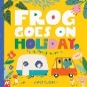  Text/title: Frog Goes on Holiday  W/C Monday 12th July
Personal, social & emotional | I can settle back with independence and confidence.  Learning the new routines of the school day e.g. splitting for phonics.  Select resources independently within the classroom.  Sharing personal experiences –What did you do over the holiday  Circle time-time to chat and share experiences and thoughts.  Twinkl PSHE Scheme: See Twinkl planning | Being independent- I can take off my shoes and socks with no support.  Learning routines of the school day e.g. splitting for phonics.  Select resources independently within the classroom.  Sharing seesaw adventures and listening to our friends.  Circle time-time to chat and share experiences and thoughts.  Twinkl PSHE Scheme: See Twinkl planning | Begin to explore own emotions through the story The Squirrels who squabbled. Understanding conflict  Sharing seesaw adventures and respecting our friend’s special times.  Select resources independently within the classroom.  I feel comfortable about being taken out of the classroom.  Sharing seesaw adventures and listening to our friends.  Circle time-time to chat and share experiences and feelings.  Twinkl PSHE Scheme: See Twinkl planning | Being independent- I can put on my socks and shoes with support.  I can demonstrate confidence in the daily routine with reduced adult support  I can express my feelings to my peers with more confidence.  I am beginning to find solutions to conflicts and rivalries.  Sharing seesaw adventures and respecting our friend’s special times.  Twinkl PSHE Scheme: See Twinkl planning | Being independent- I can put on my shoes and socks with no help.  I can understand the importance of tooth brushing. I can make healthy choices about food and drink.  Sharing seesaw adventures and respecting our friend’s special times.  Circle time-time to chat and share experiences and thoughts.  Twinkl PSHE Scheme: See Twinkl planning | Being independent- I can put on my shoes and socks with confidence.  I can begin to understand the importance of healthy eating.  I can help to look after younger peers in the classroom.  Sharing seesaw adventures and respecting our friend’s special times.  Circle time-time to chat and share experiences and thoughts.  Twinkl PSHE Scheme:  See Twinkl planning
Physical Development | Learning to run, stop, and change direction with control.  Personal Hygiene- showing more independence in self-care needs.  Explore the school grounds adventure park.  Bikes and scooters to support sensory regulation.  Large scale mark making e.g. water and brushes on the wall, chalking outdoors etc.  Fine motor skills  Dough disco  Scissor skills cutting  Name writing daily | Learning to run, stop, and change direction with control.  Continue to show more confidence in self-care needs.  Explore the school grounds tyre park  Cosmic yoga  https://www.youtube.com/watch?v=QIfCALKceOs  Bikes and scooters to support sensory regulation.  Large scale mark making e.g. water and brushes on the wall, sand in builder’s tray etc.  Fine motor skills  Dough disco  Scissor skills cutting  Name writing daily  Rhythm time | Continue to show more confidence in self-care needs in dressing and undressing and toileting.  Explore the school grounds opal equipment  Go Danny Go workout  https://www.youtube.com/watch?v=oxdGXfwKE0k&list=RDoxdGXfwKE0k&start_radio=1  Bikes and scooters to support sensory regulation.  Large scale mark making e.g. water and brushes on the wall, buckets and sponges etc.  Fine motor skills  Dough disco  Scissor skills cutting  Name writing daily  Rhythm time | Riding with more control and confidence in a straight line.  I can take part in team games e.g. duck duck goose.  Explore the school grounds allotments  Using the apparatus and obstacle course  Bikes and scooters to support sensory regulation.  Large scale mark making e.g. water and brushes on the wall, chalking outdoors etc.  Fine motor skills  Dough disco  Scissor skills cutting  Name writing daily  Rhythm time | Riding with more control and confidence in a straight line.  Continue to show confidence in taking off and on your jumper.  Explore the school grounds forest  Frog yoga- see book below  Bikes and scooters to support sensory regulation.  Large scale mark making e.g. water and brushes on the wall, ribbon dancing etc.  Fine motor skills  Dough disco  Scissor skills assessment- who can use scissors/ who can’t.  Name writing daily  Rhythm time | Riding with more control and confidence avoiding obstacles.  Holiday Dance choo choo wa  https://www.youtube.com/watch?v=3T5cPaZIW8M  I can take off my clothing with independence.  Rhythmic dancing exploring pre writing patterns.  Bikes and scooters to support sensory regulation.  Large scale mark making e.g. water and brushes on the wall, balls etc  Fine motor skills  Dough disco  Rhythm time
Fine Motor Skills  Funky fingers activities daily in continuous provision to support fine motor skills | Squiggle Whilst you Wiggle.  Dance 1 - Up, down, side to side, cross over.  Dance 2 – The wiggle | Squiggle Whilst you Wiggle.  Dance 3 – The circle  Dance 4 – The hump | Squiggle Whilst you Wiggle.  Dance 5 – The hook  Dance 6 – The spiral | Squiggle Whilst you Wiggle.  Dance 7 – The wave  Dance 8 – The letter s | Squiggle Whilst you Wiggle.  Dance 9 – The straight line  Recap all movements | Squiggle Whilst you Wiggle – Recap all movements.
Communication & Language | Sharing personal experiences –What did you do over the half term.  PSE discussions through time to talk.  Helicopter stories- using props to make up a story to develop children’s oracy skills.  Show and tell- Seesaw  Role play activities  Wellcomm interventions | Respond to simple questions by speaking, or gesturing.  PSE discussions through time to talk.  Helicopter stories-using props to make up a story to develop children’s oracy skills.  Show and tell-Seesaw  Role-play activities  Wellcomm interventions | Gaining more confidence in listening for longer periods with reduced adult support.  PSE discussions through time to talk.  Helicopter stories- to make up a story to develop.  Show and tell-Seesaw  Role-play activities  Wellcomm interventions | Showing extended confidence in listening for longer periods.  PSE discussions through time to talk. Can tell a longer story.  Helicopter stories- to make up a story to develop children oracy skills.  Wellcomm interventions | Showing extended confidence in listening for longer periods.  PSE discussions through time to talk. Confident to tell a longer story.  Helicopter stories- to make up a story to develop children oracy skills.  Show and tell-Seesaw  Role-play activities  Can express a point of view using words.  Wellcomm interventions | I can extend my confidence in listening for longer periods.  PSE discussions through time to talk. Confident to tell a longer story.  Helicopter stories- to make up a story to develop children oracy skills.  Wellcomm interventions
Literacy & Phonics | Introduction of RWI for school starters  Introduction of phase 2 phonics aspect 7  Oral blending and segmenting | Introduction of RWI for school starters  Introduction of phase 2 phonics aspect 7  Oral blending and segmenting | Introduction of RWI for school starters  Introduction of phase 2 phonics aspect 7  Oral blending and segmenting  Write some letters accurately when attempting to write initial letter | Introduction of RWI for school starters  Introduction of phase 2 phonics aspect 7  Oral blending and segmenting | Introduction of RWI for school starters  Introduction of phase 2 phonics aspect 7  Oral blending and segmenting | Introduction of RWI for school starters  Introduction of phase 2 phonics aspect 7  Oral blending and segmenting
Poetry | Pretty Patterns Rhyme |  | Five little Men in a Flying Saucer  One Elephant Went Out to Play
Texts to Support | 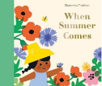  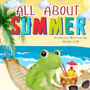  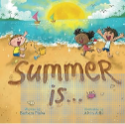 | 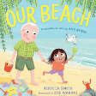  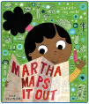  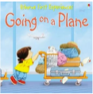 | 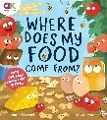  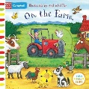  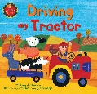  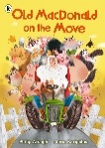 | 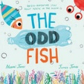  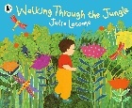  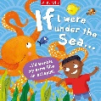  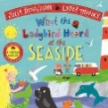 | 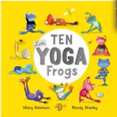    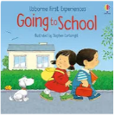 | 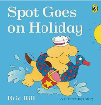  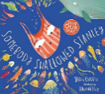  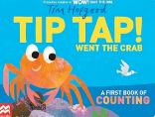
Mathematics | Block 22 – Pattern 6 – My own pattern  Sentence stems  • My pattern is ____and ____.  • ____ comes next in the pattern.  • I need a ____ to finish my model.  • Now/first we need to ... Next/then we need to ...  Key questions  • What will come next in the pattern?  • Is the pattern correct? Which object doesn’t belong?  • How does your construction look the same as mine?  • What will we do first/next? |  | Block 23 – Counting 6 – stop at 1,2,3,4,5  Sentence stems  • I will count out ____.  • There are ____  • I will stop at ____  • I have made ____ marks  Key questions  • How many do you need?  • How many can you see? How many now?  • What have you drawn? What do your marks show? |  | Block 24 – Comparison 3 – Match, sort and compare  Sentence stems  • There are more ____ than ____.  • The ____ and the ____ match.  • The ____ and ____ are the same/different.  • These are ____. These are not ____.  Key questions  •Which group has more/fewer?  • Which groups have the same?  • Are there more/fewer ____ or ____?  • What objects are in your set?  • What is the same/different?  • Which object matches?  • How have you sorted your objects?
Maths Texts to Support | • The Skipping-Rope Snake by Carol Ann Duffy  • A New House for Mouse by Petr Horáček  • The View at the Zoo by Kathleen Long Bostrom  • When I Build With Blocks by Niki Alling  • Lulu’s First Day by Anna McQuinn |  | •Trains Trains Trains! by Donna David  • Five Little Dinosaurs by Mike Brownlow  • Five Little Princesses by Mike Brownlow |  | • We’re Going to a Birthday Party: A Lift-the-Flap Adventure by Martha Mumford  • Kipper’s Birthday by Mick Inkpen  • A Mother for Choco by Keiko Kasza  • Farmer Duck by Martin Waddell  • Aliens Love Underpants by Claire Freedman
Understanding the World | Introduce Summer and seasonal changes  I can talk about my family members.  Discuss family celebrations e.g. celebrations over the holiday. | I can share memories with my extended family members e,g, grandparents | Seasons and environmental changes.  Continue planting and using flowers and bulbs.  Know about different countries in the world. | Seasons and environmental changes.  I can understand the importance of looking after the world e.g no litter, water for plants, caring for the oceans.  Understand the life cycle of a plant and animal. | Caring for the world around us through the school environment-tidying up the allotment. | I can talk about differences in countries.
Expressive Arts & Design | Nursery songs and rhymes.  Rhythm time (Fridays)  Create their own songs through dance and movement.  Mark making – creating a colourful elephant using different paint techniques e.g. dabs, swirls, patterns.  Malleable materials: exploring sand.  Mark making- indoor and outdoor | Explore different forces.  Nursery songs and rhymes.  Rhythm time (Fridays)  Create own songs around ones they know.  Show different emotions through drawings and paintings such as happy, sad.  Mark making- indoor and outdoor | Nursery songs and rhymes.  Rhythm time (Fridays)  Dance and movement to Zumba https://www.youtube.com/watch?v=ymigWt5TOV8  Join different materials together.  Mark making- indoor and outdoor | Nursery songs and rhymes.  Rhythm time (Fridays)  Dance and movement– Go Danny Go https://www.youtube.com/watch?v=R7OxutH5AZY  Explore colour and colour mixing  Mark making- indoor and outdoor | Nursery songs and rhymes.  Rhythm time (Fridays)  Dance and movement under the sea  https://www.youtube.com/watch?v=oq7Rli5XCYg  Mark making – indoor and out | Nursery songs and rhymes.  Rhythm time (Fridays)  I can create my own songs around ones I know.  Mark making- indoor and outdoor
Seasonal Opportunities | Father’s Day June 20th 2027
Assessment |  | Pencil grip assessment  Welcomm assessment new starters |  | Welcomm final assessment  Pencil assessment  Pre writing assessment | Cutting assessment  Name writing assessment | Name writing assessment

