Welcome to
Excalibur Pre-School

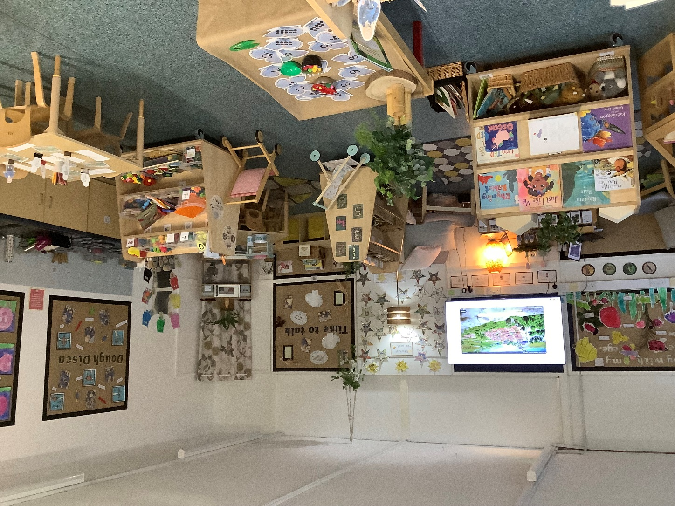

Headteacher’s Welcome

Dear Parents and Carers,

I would like to take this opportunity to welcome you and your child to our pre-school community. Starting pre-school is an exciting milestone and we are delighted to begin this important journey alongside you.

At our school, we believe that the early years lay the foundation for a lifelong love of learning. Our dedicated team is committed to creating a safe, nurturing, and inspiring environment where every child feels valued, confident, and eager to explore the world around them. Through play, discovery, and meaningful relationships, we support each child to develop socially, emotionally, and academically at a pace that is right for them.

We recognise that strong partnerships between home and school are key to a child’s success. We look forward to working with you, getting to know your child as an individual, and sharing in their achievements and growth throughout the year.

Please do not hesitate to speak to us if you have any questions, concerns or insights about your child. Together, we can ensure they have a happy, secure, and enriching start to their education.

Once again, welcome to our pre-school family—we are excited for the year ahead.

Yours sincerely,

Juliet Jones
Headteacher
Excalibur Primary School

Email: head@excalibur.cheshire.sch.uk
Tel: 01270 845781

Welcome to Excalibur Pre-School

The information in this booklet is a supplement to the school website that we hope will help you and your child to settle into a happy school life here at Excalibur.

As a school, we are required to set up systems and procedures that help us to ensure that the children in our care are safe and happy. The following pages will clarify some of these areas as your child begins our pre-school.

Contents

- Transition to pre-school
- Personal details, emergency contact and ParentMail
- Dropping off and picking up
- Snacks
- Water bottles
- School dinners
- Attendance and late arrivals
- Uniform
- Medicines at school and asthma forms
- The pre-school day
- The Early Years Foundation Stage Curriculum
- Transition to reception
- Learning at home
- Treetops
- Funded hours and charges

1. Transition to pre-school

Starting pre-school can seem quite daunting. However there are a few things you can do to help your child. Encourage them to recognise their own belongings, attaching a familiar item such as a keyring to a bag, can help. Practise getting dressed and undressed by themselves and to fasten coats and shoes. These things might seem quite insignificant; however, they can save a lot of time getting ready to go home or when going outside. Activities such as these also help to develop your child’s independence and motor skills.

We promote independent toileting for all children who are 3 years old and over. Toilet training will be supported by staff working closely with parents, sharing what works best for the individual child.

Children are encouraged to ask a member of staff if they need to use the toilet. This enables toileting to be closely monitored by staff who can also supervise hand washing afterwards.

Nappies and Wipes: Children not yet completely toilet trained are required to provide sufficient disposable nappies and wipes for each day. Parents/carers are also required to read and sign the Intimate Care Policy.

2. Personal details, emergency contacts and Parent Mail

Please complete the necessary registration forms and return them to school as soon as you can. These details are essential for us to hold, particularly in the case of illness or an emergency. Other details are requested by government for school admission and statistical purposes.

We have ‘Parent Mail PMX’ in school. This is a system where we can email
letters and other important information are sent out in this way too. A registration email will be sent to you once your details have been entered into the School’s Management Information System, SIMS. This is where you will also pay for your child’s school lunch, if they are having one.

If your child has any medical, physical or behavioural difficulties, please share your knowledge and concerns with us so that we can ensure that the best provision possible is made for them. This includes information about any allergies (including food allergies).

3. Dropping off and picking up

If you need to bring your child to school by car we ask that you park legally and not in the school grounds. Please be careful where you park in Ivy Lane so as not to create an obstruction that could be hazardous to children. Please do not bring cars up the school drive.

The pre-school day begins at 8.50 am. The end of the day is 3:20 pm. Wrap around care is available from 7.30 am until 8.50 am and from 3.20 pm until 6pm.

We will ask you to say goodbye to your child and allow them to come into pre-school by themselves. Having lots of unknown adults in the classroom can be overwhelming for some children.

If you have arranged for friends or relatives to collect your child at the end of the day, rather than yourself, please ensure you let us know who will be collecting your child on your behalf. We will not be able to release your child to someone other than you without your consent to do so. We ask that you phone the school office to let them know of a change in pickup arrangements and that you provide them with a password that we can use before handing your child over.

4. Snacks

Pre-school children are offered a snack each morning in line with DFE guidance. This is provided by school, there is no additional charge.

For their afternoon snack, children attending pre-school are given fruit or veg under the government’s fruit scheme. Children under 5 are also entitled to free milk each day. If your child has an allergy to cow’s milk an alternative is provided, or they may just have water.

5. Water bottles

All children need a named water bottle in school each day which should be filled with clean tap water only. We have a water cooler in the classroom if children need to refill it during the day.

Children have access to their water bottle throughout the day. Bottles are sent home each day to be cleaned and refilled.

Please do not put squash, fizzy or flavoured drinks into the water bottles even if your child tells you they do not like water!

6. School dinners or packed lunches

In pre-school you need to either send your child with a packed lunch or order a lunch from school. School dinners cost £3.10 per day and you can order on the day. Your child can have a mixture of packed lunches and hot dinners throughout the week.

If your child is having a packed lunch from home it is easier for your child to manage their lunch if it is together in a lunch bag. Please could you ensure their lunch bag and any little plastic boxes or pots that are used are clearly named. Could we politely ask that you do not include sweets, bars of chocolate or fizzy drinks? Chocolate covered biscuit bars such as Penguin biscuits are okay.

We offer a varied and attractive menu offered each day. The menu is on a 3-week rotation and changes seasonally. Copies of the menu are available from the school office and can be viewed on the school website. http://www.excalibur.cheshire.sch.uk/page/school-lunches/6053

Each day there is a vegan option, a meat option, pasta or jacket potato. Please notify us as soon as possible if your child has any food allergies or intolerances. We also ask that, where possible, you provide us with a letter from your child’s GP or consultant indicating their food allergies and/or intolerances. There is also an allergen free menu.

7. Attendance

We all have ‘one of those mornings’. If you are late and the large blue gates are locked, please come into school through the front door and sign your child in at the front desk so that we know that your child is in school. They will then be brought down to the pre-school classroom.

Please ring school on the first day of absence so that a reason for your child’s non-attendance can be recorded in the registers. If we do not hear from you, we will contact you to find out why your child is absent.

8. Pre-school uniform

Blue jumper or cardigan (with or without school logo)
White polo shirt (with or without school logo)
Dark coloured leggings, jogging bottoms or shorts with elasticated waist (with or without school logo)
Velcro/zip fastening dark coloured shoes
In the summer, shorts and blue/white dresses can be worn.

Please could your child also bring a pair of named wellies to leave at school for use outdoors?

Excalibur uniform can be purchased directly from Smart Choice Uniform, 63 Crewe Road, Alsager. Telephone 01270 747170. Smart Choice is run by Mr. Mittal who has been the supplier of our uniform for many years.

9. Medicines

On occasions, it is necessary for children to take medication in school. In line with Health and Safety guidelines school policy is to administer only medicines prescribed by a doctor. Please fill in a form and give the labelled packets/bottles in at the office. They will then be kept in a safe place until administered to your child. You will need to collect the medicine from the school office at the end of each day.

For safety reasons children must not bring their own medicine into school or take it home. It must be handed over to us by an adult.

It is Cheshire East policy that children remain at home for 48 hours after they were last sick or had diarrhoea.

Asthma medication is kept in the classroom so that it is easily accessible when needed. It is essential that you fill out an asthma form (also located outside the school office) and label the medication and volumiser.

10. The pre-school day

8.50 am start of the pre-school day
9.20 am late start option, morning activities, including snack time and lunchtime
12.20 pm afternoon activities and snack time
3.20 pm home time

11. Early Years Foundation Stage Curriculum

During their timer in pre-school your child will follow the Early Years Foundation Stage Curriculum (EYFS). The Foundation Stage is centred on learning through play and giving your child opportunities to acquire skills through practical experiences which form the foundation for future learning. The EYFS curriculum is designed to place each child at the centre of the learning process through playing and exploring, active learning and creative and critical thinking.

There are 3 ‘prime’ areas and 4 ‘specific’ areas of learning.
Prime areas

Personal, social and emotional development (PSED)
This area focuses on forming relationships, self-confidence and independence. The children are also supported in the development of their feelings and behaviour. Play is used to build up basic skills such as sharing, self-regulation, turn taking and looking out for others.
Communication and language
This area focuses on the development of children’s language skills for communication. This is an important skill which will enable the children to learn effectively in other areas. Language play through stories, songs and rhymes and quality adult child interactions are key.

Physical development
Throughout pre-school we will help to develop both children’s fine and gross motor skills. Activities range from handling play dough and our daily ‘Squiggle while you Wriggle, Dough Disco and Funky Finger’ sessions, using scissors and pencils to riding bikes and climbing large equipment. We will help to develop the children’s spatial awareness and control movements. We have a weekly slot in the hall for physical development opportunities such as parachute play or movement games. We also support your child’s awareness of their health and social care by promoting healthy eating and encouraging an active lifestyle.

Specific areas

Literacy
This area of learning relates directly to developing your child’s pre-reading and pre-writing skills. We also help to build knowledge and enjoyment of stories and rhymes.

Mathematics
We ensure that the children develop an early sense of number, subisitisng (recognising a small amount without counting), spotting patterns and relationships within numbers. We also learn about patterns, shapes, measures and real life problems e.g. do we have enough plates or cups for snack time?

Understanding the world
Children are given the opportunity, both through structured play and focused activities, to explore the world around them, making observations and encouraging them to ask questions.

Creative development
Children are encouraged to develop their own creativity in music, art and drama. Role play allows children to explore real and imagined experiences. Role play also takes place out of doors too! Art activities include opportunities for the children to explore various art techniques (weaving, printing, painting, collage etc.). Weekly Rhythm time classes take place on a Friday for those children that are with us then. There is no additional charge for this.

Assessment and sharing progress

Assessment of your child is continuous allowing us to plan for their next steps. There are two parents’ evenings a year and an annual report is sent out in the summer term. However, we operate an open door policy and are both reactive and responsive to the needs of your child. Please do not hesitate to speak to us if you have any questions, concerns or insights about your child.

12. Transition to reception
When your child moves on into reception, whether it is at Excalibur or another setting, we support your child with any induction visits and liaise with reception staff. We make gradual changes to our routines and share stories about starting school. If your child is transferring to reception here at Excalibur, the reception staff regularly come into the setting to get to know the children and there are plenty of opportunities throughout the year for pre-school to visit the reception environment. There is a parent and carers meeting in June and a Teddy Bear’s picnic for all new starters in July.

13. Supporting your child’s learning at home

We use on online learning platform called ‘Seesaw’ as one means of communication. Here we can share photographs with you of what your child has done at pre-school. We can post videos so you know how to continue your child’s learning and support them at home. We will also send messages and announcements. We hope to get you signed up to Seesaw before your child starts pre-school. We share learning that can be built on at home through our weekly pre-school newsletter.

14. Tree tops

In house wrap around care is provided ‘Tree tops’ and runs out of our school hall.

breakfast | 7.30-8.50 am | £6 (includes breakfast)
short after school | 3.20-4.30 pm | £6
long after school | 3.20-6.00 pm | £12 (includes a light tea)
holiday club | 9.00- 3.20 pm | £22 (need to bring a packed lunch)

15. Funded hours and charges

A full week in pre-school is 32.5 hours. Maximum funding is for 30 hours which covers 4.5 days.

If you require a full-time 5 day place, there is a charge for the additional 30 minutes each day of £5.50 per day. Alternatively, if you do not wish to pay this your child can come at 9.20 am for a late start.

Please contact the school office to discuss options for your 30 hours entitlement, including early starts, wrap around and holiday club.

Pre-school early start (if chargeable) | 8.50 am – 9.20 am | £5.50
Morning session | 9.20 am – 12.20 am | £18.00
Afternoon session | 12.20 pm – 3.20 pm | £18.00

We hope you have found this information useful. If there is anything we have missed, please ask. We look forward to welcoming you and your child to our pre-school.

The Excalibur Early Years Team

