Summer 1
Possible Themes & Interests  (based on interests the children have had in past years) |  | Planting/ Gardening/Spring Growing Up/Generations Keeping healthy PETS LIFE CYCLES  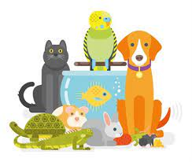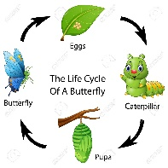
Suggested Texts | Books following possible themes | 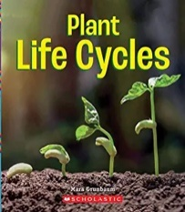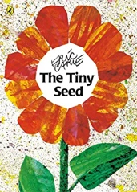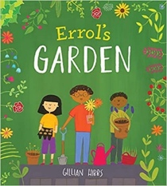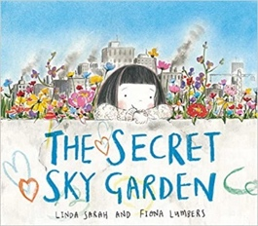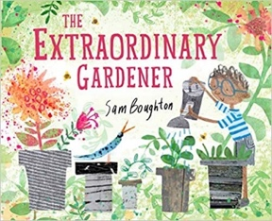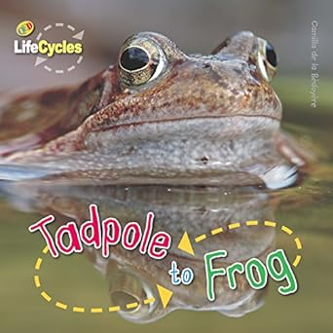  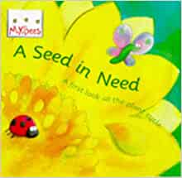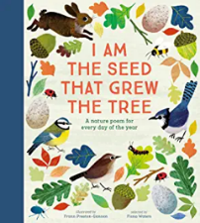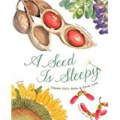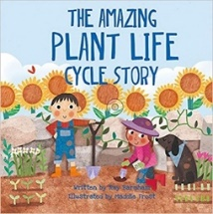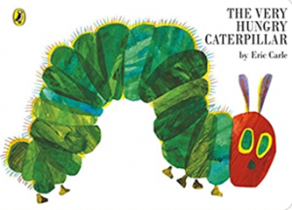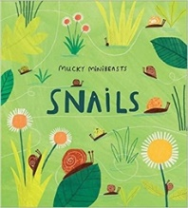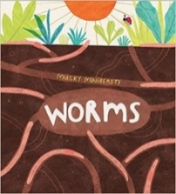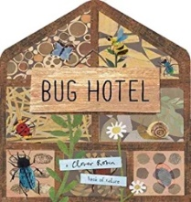  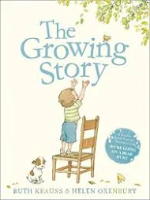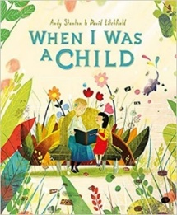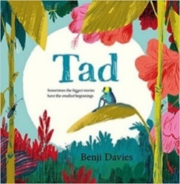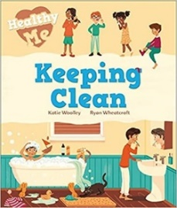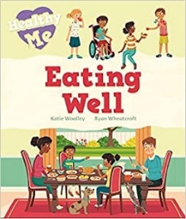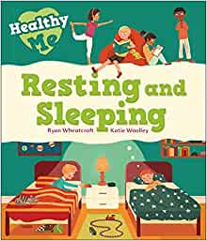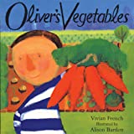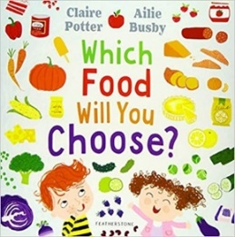  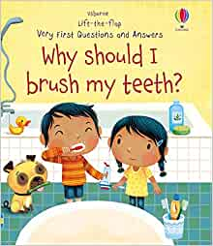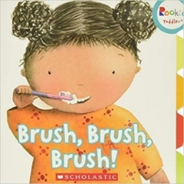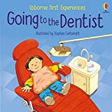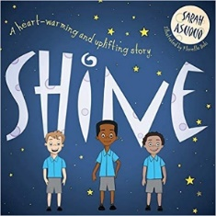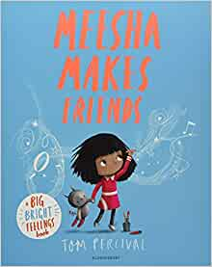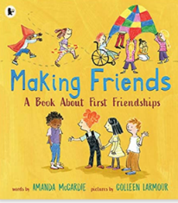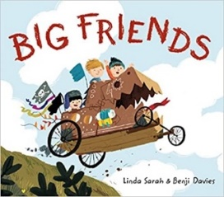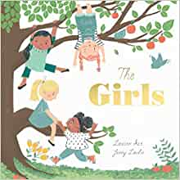
Suggested Texts | Spring 2  Literacy Texts | 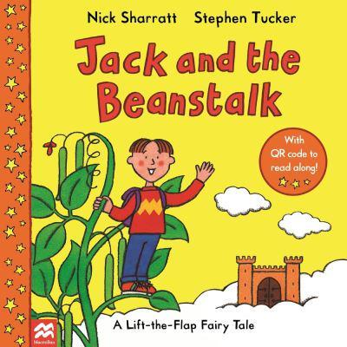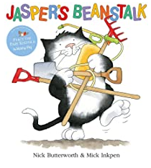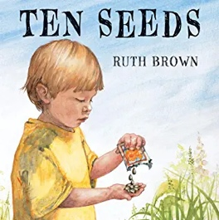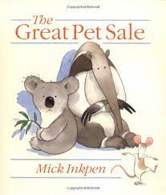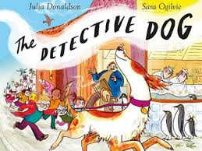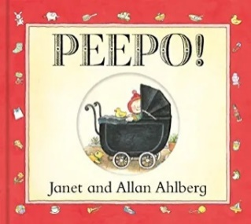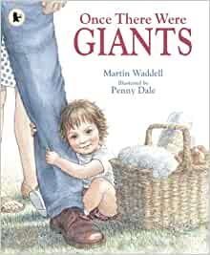  + Daily songs, poetry basket and school/class songs.
Prime Areas

Area of learning |  | Objectives/skills |  | Revisit/ongoing  throughout the year | Best fit assessment
 |  |  |  | Revisit/ongoing  throughout the year | On track | not on track | extra focus assessment needed
Communication and Language   |  | Listening:  Listen to and understand instructions about what they are doing, whilst busy with another task  Attention:  Listen and continue with an activity for a short time.  Respond:  Keep play going in response to the ideas of others and engage in conversation relevant to play theme.  Ask and answer ‘what’, ‘where’, ‘when’, and ‘what could we do next’ questions.  Listen to and talk about selected non-fiction to develop a deep familiarity with new knowledge and vocabulary.  Understanding:  Carry out a series of 3 directions. Show familiarity with selected non-fiction by using new knowledge and vocab in conversation and play. Understand ‘how’, ‘why’ and ‘where’ questions.  Speaking:  Recount an event in the correct order and some detail.  Give details that they know are important and will influence the listener E.g., “Ahmed fell over that stone, Javid didn’t push him”.  Express ideas about feelings and experiences.  Articulate their ideas in well-formed sentences.  Show that they can use language to reason and persuade E.g. “Can I go outside because it’s stopped raining?” |  | Learn new vocabulary Use new vocabulary in different contexts.  Use new vocabulary through the day in discussions and conversations.  Learn new rhymes, poems, and songs.  Listen to and talk about stories to build familiarity and understanding.  Listen to and talk about selected non-fiction to develop a deep familiarity with new knowledge and vocabulary.
Personal, Social  and Emotional Development   |  | Express feelings:  Initiate an apology where appropriate. Beginning to know that children think and respond in different ways to them.  Manage behaviour:  Can follow instructions, requests, and ideas in a range of situations.  Self-awareness:  Can talk about their own abilities positively.  Independence:  Confident to try new activities and say why they like some activities more than others.  Show resilience and perseverance, a belief that with more effort or with a different approach success will occur.  Understands rules linked to road safety.  Can follow directions with 3 parts.  Collaboration:  Know it is important for all of us to keep safe when using and transporting tools, equipment, and resources.  Social skills:  Can be considerate to the needs of others, beginning to respect a different point of view and work together in collaboration.  No Outsiders: ‘Mommy, Mama and Me’: celebrating my family |  | Continue to develop skills of using gestures, non-verbal communication, facial expressions, body language, appropriate language, and vocabulary; to listen to others, speak to peers and adults and engage in discussions in a positive way.
Physical  Development   |  | Develop the foundations of a handwriting style which is fast, accurate and efficient.  Continue to develop their small motor skills so that they can use a range of tools competently, safely, and confidently. Suggested tools: pencils for drawing and writing, paintbrushes, scissors, knives, forks, and spoon.  Fine motor skills are the small movements used for control and precision during activities.  It is important to recognise that the development of fine motor skills happens through daily access to resources, activities and opportunities provided through continuous provision e.g., threading, play dough, building and creating, colouring, puzzles etc. All areas of learning are interconnected and not all learning has a predetermined outcome. |  | Continue to develop overall body-strength, balance, co-ordination, and agility through use of outdoor play equipment continuously available. | Complete separate fine motor writing assessment.  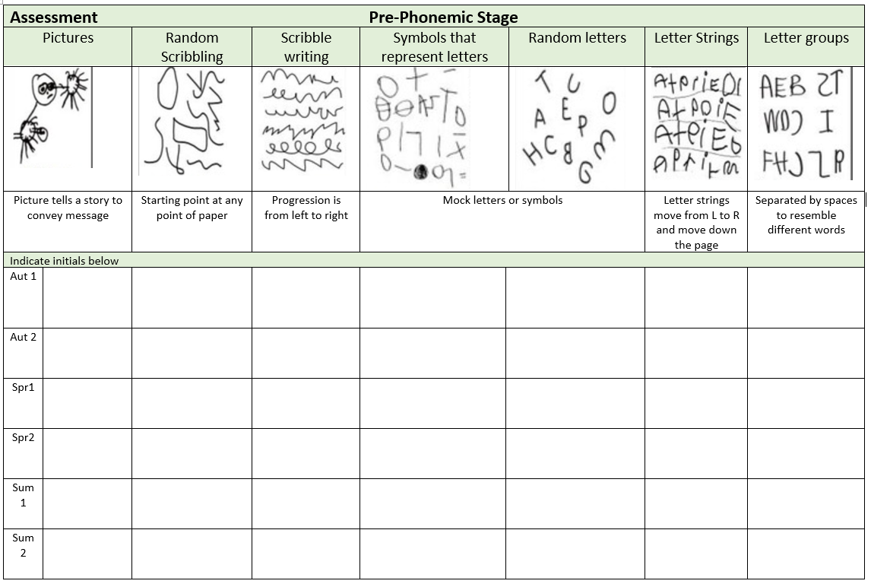
Develop the overall body strength, co-ordination, balance, and agility needed to engage successfully with future physical education sessions and other physical disciplines including dance, gymnastics, sport, and swimming.
Combine different movements with ease and fluency.
PE– Fundamental Skills Programme
Coordination skill: object control, games
May 18th-22nd - Sports Week
Specific Areas
Literacy   |  | COMPREHENSION  Correctly sequence a story or event using pictures and/or captions.  Make simple, plausible suggestions about what will happen next in a book they are reading.  Know the difference between different types of texts (fiction, nonfiction, poetry)  Make inferences to answer a question beginning 'Why do you think…?' in a picture book that has been read to them, where answer is clearly signposted.  Play influenced by experience of books - gestures and actions used to act out a story, event or rhyme from text or illustrations.
 |  | WORD READING  Read some letter groups that each represent one sound and say sounds for them.  Read simple phrases and sentences made up of words with known letter–sound correspondences and, where necessary, a few exception words. |  | Re-read books to build up their confidence in word reading, their fluency and their understanding and enjoyment. Read books consistent with their phonic knowledge.
WRITING
Emergent writing:
Continue to build on knowledge of letter sounds to build words in writing. Use writing in play. Use familiar words in their writing.
Composition:
Begin to write a simple sentence/caption may include a full stop. To write longer sentences that are joined. To write a series of sentences.
Spelling:
Spell words by drawing on knowledge of known grapheme correspondences.
Make phonetically plausible attempts when writing more complex unknown words.
Handwriting:
To form lower-case letters correctly, starting and finishing in the right place, going the right way round and correctly orientated. Correctly positioned on a line.
To include spaces between words.
Phonics |  | Set 2 and 3 sounds  Consolidate set 1 sounds including set 1 special friends, move onto set 2 if ready (ditty group)  Consolidate set 2 sounds (green and purple group)  Consolidate set 2 sounds and begin set 3 sounds (pink group)  Continue to apply knowledge of blending and segmenting to reading and spelling words and captions.  Write graphemes from memory and write simple sentences using phonic knowledge – daily spellings and weekly hold a sentence. |  | Continue to develop general sound discrimination, rhythm and rhyme, alliteration, voice sounds, oral blending, and segmenting.
Mathematics   |  | 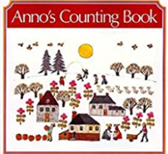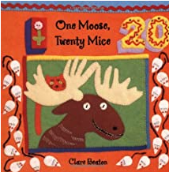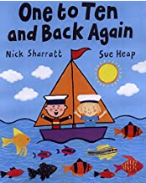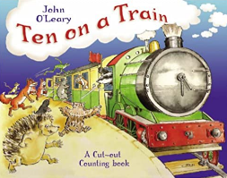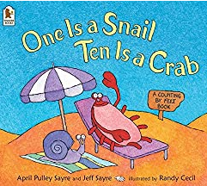  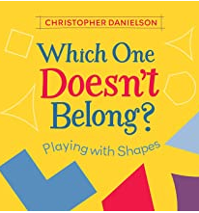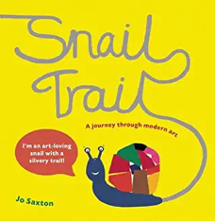 |  | Subitising:  Continue to provide regular opportunities to instantly recognise small quantities e.g. dice, dominoes, bingo.  Counting:  Continue to apply counting principles when counting forwards and backwards within 10.  Continue to support counting principles to find how many in a set or count out a required number of objects from a larger group.  Composition:  Continue to develop understanding that all quantities are composed of smaller quantities.  Sorting and Matching:  Continue to notice similarities and differences in matching and sorting objects in new contexts.  Comparing and Ordering:  Provide regular opportunities to compare and order quantities and measures.  Continue to make comparisons by lining items up with 1:1 correspondence to compare directly.
 |  | Building numbers beyond 10  WRM:  To 20 and beyond, How many now?, Manipulate, compose and decompose | Use a range of resources e.g., 10 frames, number shapes, tower cubes, rekenreks, bead strings show a full 10s and part of the next 10.  Recognise numbers 1-9 repeat after every full 10. So, 1 full ten and 1. 1 full ten and 2 etc. Then 2 full tens and 1, 2 full tens and 2 and so on.
 |  | Counting Patterns Beyond 10  WRM:  To 20 and beyond, How many now?, Manipulate, compose and decompose | Provide representations which clearly show the full 10s and the part of 10 e.g., 14 is one full ten and four.  Count on and back from different starting points, say what comes before or after a given number and to place sequences of numbers in order. Challenge to find larger numbers on number tracks and 100 squares.
 |  | Spatial Reasoning  WRM:  To 20 and beyond, How many now?, Manipulate, compose and decompose | Provide opportunities to select and rotate shapes to fill a given space. Say why they chose a particular shape and why a different one wouldn’t fit.  Provide opportunities to match arrangements of shapes, use positional language to describe where shapes are in relation to each other. Provide opportunities for children to select shapes to complete picture boards or tangram outlines.
Understanding the World   |  | Chronology: Talk about and understand changes in their own lifetime, by creating a personal timeline. Recount an event, orally, pictorial and/or with captions. (relate to growth). Observe and comment on changes in frog spawn, caterpillars and snails.  Enquiry: Describe images of familiar situations in the past using books such as,’Grandmas’s Bill’, ‘Once There Were Giants’, ‘Peepo’, Shirley Hughes stories. Identify features of growth and change. Comment and ask questions about their immediate environment. Find out more about life cycles. Identify key features of a life cycle of a plant and animal, explain what plants need.  Respect: Understand the value of being curious and interested in finding out about people within their own community and in other countries - special places and events or objects – through non-fiction texts, stories, visitors, celebrations. Describe special events.  Concepts and Approaches in Computing: Abstraction, tinkering, collaborating, algorithms, persevering, decomposition. Explore sequencing whilst planting seeds.  Algorithms, decomposition, debugging, logic patterns, abstraction. Simple algorithms created and adapted to form a routine of movements.  Kapow RE: What makes the World Special? |  | Comment on what they notice about the environment where they live and understand the effect of the changing seasons on the natural world around them. Describe what they see, hear, and feel outside.
Expressive Arts and Design   |  | Children will experience and develop a range of creative, artistic skills. The children will have daily, continuous access to a wide range of open ended, ambiguous resources allowing the opportunity to explore, experiment and develop their own creativity. They will have the opportunity to create collaboratively sharing Ideas and resources as well on solo work. Throughout the year the children will have the opportunity to return to and build on their previous learning, refining ideas and developing their ability to represent them. In addition, specific skills and/or experiences will be planned (see below).  Marking Making/Drawing: observational drawing – Sunflowers, people. Show accuracy and care in their drawing.  Colour: identifying shades of colour and how to make different shades.  Painting: explore working with paint on different surfaces and in different ways i.e., coloured, sized, and shaped paper. Explore using different brush types.  Printing: symmetrical printing - butterflies as inspiration.  Textiles/materials: Weaving (natural and manmade materials)  3D Work: Making own props/puppets to retell a story. Folding techniques e.g., fans, aeroplanes, books. Choosing materials for effect e.g., feather headdress  Cutting Skills: use scissors independently.  Artist Study: Van Gogh: Sunflowers, Matisse: The Snail, Eric Carle, collage techniques  Art Kapow: Let’s Get Crafty, sculpture and 3D  Poetry Basket:  I have a little frog Dance  Five little peas Pitter Patter  Monkey Babies If I were so very small  Music: Children will play an instrument following a musical pattern, changing the tempo and dynamics of their music.  Charanga unit – Big Bear Funk!  Being Imaginative:  Invent, adapt and recount narratives and stories with peers and their teacher. Creates representations of both imaginary and real-life ideas, events, people and objects.  Uses combinations of art forms, e.g. moving and singing, making and dramatic play,  drawing and talking, constructing, and mapping |  | Explore, use, and refine a variety of artistic effects to express their ideas and feelings.  Explore and engage in music making and dance, performing solo or in groups.

Experiences: Visit to Wesley Place?
Sports Week
Tadpoles, butterflies and snails.

