Spring 2
Possible Themes & Interests  (based on interests the children have had in past years) |  | Planting/ Gardening/Spring traditional Tales friendships easter NO OUTSIDERS  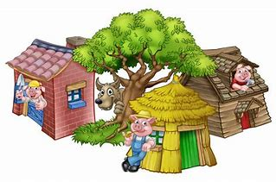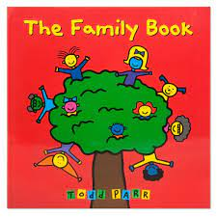
Suggested Texts | Books following possible themes | 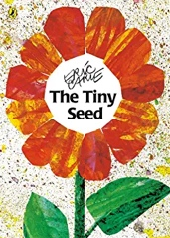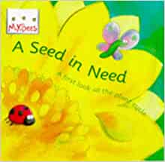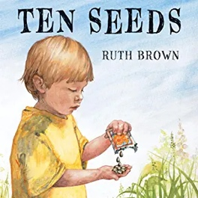  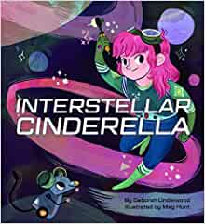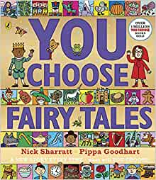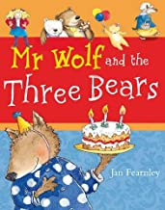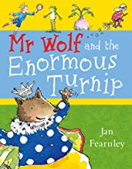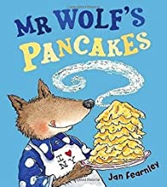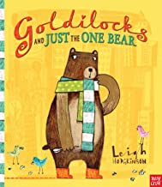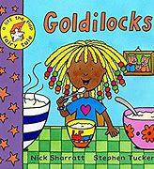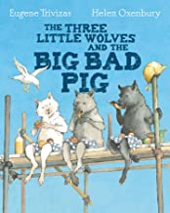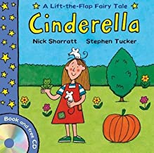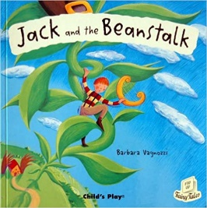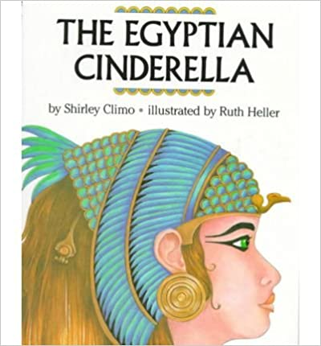  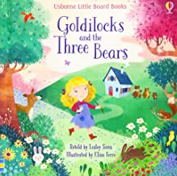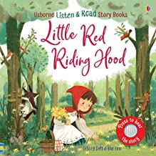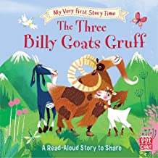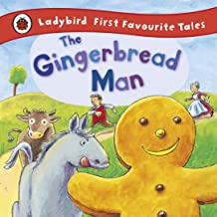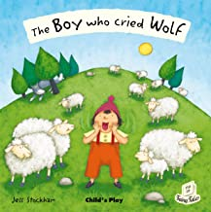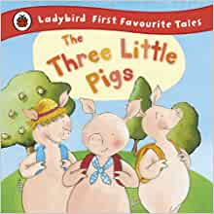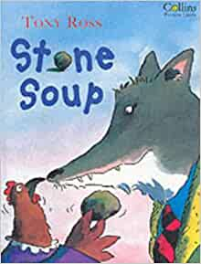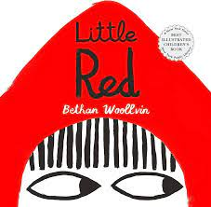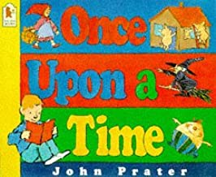  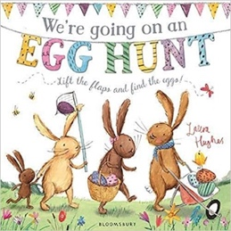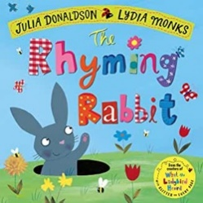
Suggested Texts | Spring 2  Literacy Texts | 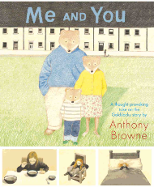  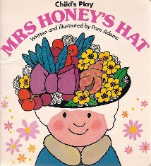  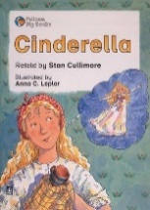  + Daily songs, the poetry basket,
Prime Areas

Area of learning |  | Objectives/skills |  | Revisit/ongoing  throughout the year | Best fit assessment
 |  |  |  | Revisit/ongoing  throughout the year | On track | not on track | extra focus assessment needed
Communication and Language   |  | Listening:  Understand why listening is important.  Attention:  Maintain attention in different contexts, attend to peers and adults that are familiar and unfamiliar.  Respond:  Keep play going in response to the ideas of others and engage in conversation relevant to play theme.  Use talk to help work out problems and organise thinking and activities explain how things work and why they might happen.  Listen to, engage in and talk about selected texts to develop a deep familiarity with new knowledge and vocabulary.  Understanding:  Ask questions to clarify understanding of a text or task. Ask questions to find out more and check understanding.  Retell a story.  Speaking:  Use talk to clarify thinking, connect ideas and share thinking with others. Articulate thoughts into sentences.  Retell/create own stories for teacher scribing (helicopter stories).  Begin to connect one idea or action to another. Use simple conjunctions ‘and’, ‘because’.  Use talk to help work out problems and organise thinking and activities. |  | Learn new vocabulary Use new vocabulary in different contexts.  Use new vocabulary through the day in discussions and conversations.  Learn new rhymes, poems, and songs.  Listen to and talk about stories to build familiarity  and understanding.
Personal, Social  and Emotional Development   |  | Express feelings:  Can make choices and communicate what they need.  Can name people in school they can turn to if they help or are worried.  Manage behaviour:  Understand why listening is important and attend to other people both familiar and unfamiliar.  Self-awareness:  Able to stand in front of the class or a small group and share achievements with others.  Independence:  Can manage to put on own coat, wellies etc.  Begin to show persistence when faced with challenges.  Collaboration:  Knows it is important to work together to look after our classroom resources and our school grounds.  Can keep play going by co-operating, listening, speaking, and explaining.  Can reflect on the work of others and self-evaluate their own work.  Social skills:  Friendship - Use language to negotiate, play and organise. Knowing what makes a good friend.  PSHE  How I feel?  My Opinions  My Magic Box  Loose Parts-Feeling Faces  My Body  Healthy Habits  A Balanced Diet  My Healthy Smile  RE – What times are special for Christians? (Easter)  Talk about how Christians celebrate.  Share how I celebrate  No Outsiders Project  The Family Book – By Todd Parr |  | Continue to develop skills of using gestures, non-verbal communication, facial expressions, body language, appropriate language, and vocabulary; to listen to others, speak to peers and adults and engage in discussions in a positive way.
Physical  Development   |  | Continue to develop their small motor skills so that they can use a range of tools competently, safely, and confidently. Suggested tools: pencils for drawing and writing, paintbrushes, scissors, knives, forks, and spoon.  Development of threading, weaving, and cutting skills.  Hold pencil effectively and comfortably. Holds a pencil effectively to form recognisable letters.  Know how to form clear ascenders and descenders. |  | Continue to develop overall body-strength, balance, co-ordination, and agility through use of outdoor play equipment. | Complete separate fine motor writing assessment.  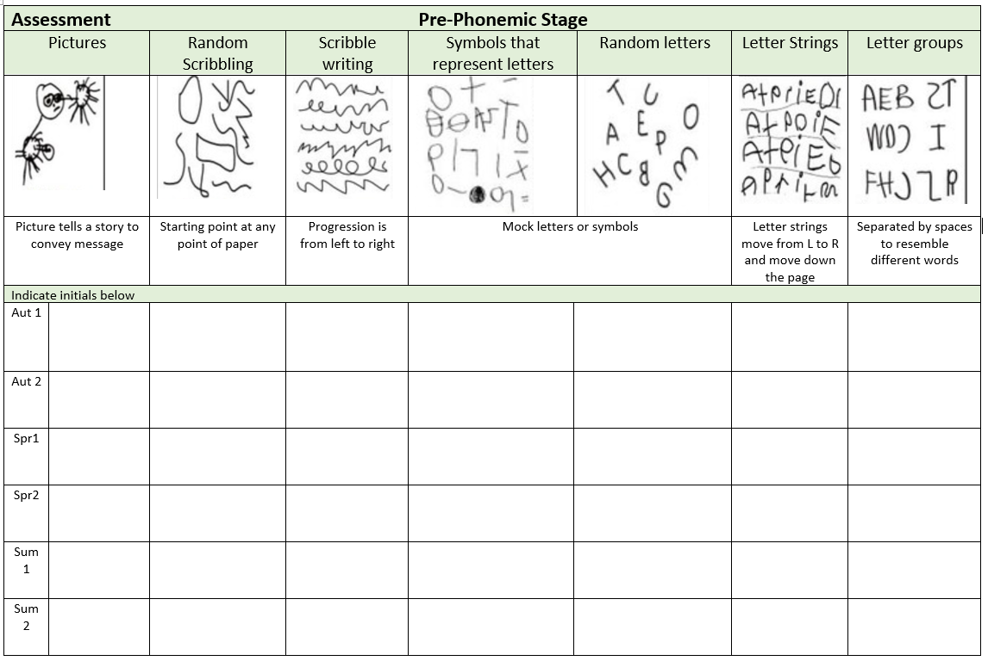
Develop the overall body strength, co-ordination, balance, and agility needed to engage successfully with future physical education sessions and other physical disciplines. Resume Fundamental skills programme.

Know and talk about the different factors that support their overall health and wellbeing: regular physical activity, healthy eating, toothbrushing, sensible amounts of ‘screen time’, having a good sleep routine, being a safe pedestrian.

Specific Areas
Literacy   |  | COMPREHENSION  Retell stories in the correct sequence, draw on language patterns of stories.  With prompting, show understanding of many common words and phrases in a story that is read aloud to them.  Suggest how an unfamiliar story read aloud to them might end.  Give a simple opinion on a book they have read, when prompted.  Recognise repetition of words or phrases in a short passage of text.  Play influenced by experience of books  Innovate a well-known story with support.
 |  | WORD READING  Read some letter groups that each represent one sound and say sounds for them.  Read simple phrases and sentences made up of words with known letter–sound correspondences and, a few common exception words. |  | Re-read books to build up their confidence in word reading, their fluency and their understanding and enjoyment. Read books consistent with their phonic knowledge.
WRITING
Emergent writing:
Build words using letter sounds in writing.
Composition:
Use talk to organise describe events and experiences. Begin to write a simple sentence with increasing independence. To read their sentence back. To use a full stop at the end of the sentence and begin to use capitals to start their sentence.
To link ideas together using and.
Spelling:
Spell to write VC, CVC and CVCC words independently using RWI set 1 and 2 graphemes.
Spell some irregular common (tricky) words e.g. I, the, to, no, go, he, she, my, me, you, your independently.
Handwriting:
Holds a pencil effectively to form recognisable letters.
Know how to form clear ascenders and descenders.
To begin to position letters correctly on a line.
Helicopter stories progression:
More phonetically correct words are written by child along with common words, e.g., ‘the’ and known tricky words. Can use a phonic mat or work bank to support.
Opportunities to demonstrate writing skills – Story maps, labels and captions for life cycles, lists.
Phonics |  | To orally blend to read VC and CVC words (lower group)  Consolidate set 1 special friends  Teach and consolidate set 2 sounds when ready.  Know tricky words, the, to, he, she, we, me, be, was, my, you, your, said, be, I  Write graphemes and digraphs when they hear them, using a sound mat or sound wall for support if needed. |  | Continue to develop general sound discrimination, rhythm and rhyme, alliteration, voice sounds, oral blending, and segmenting.
Mathematics   |  | 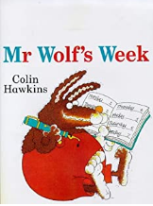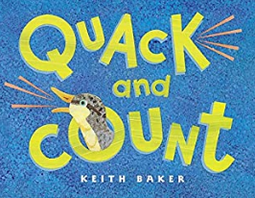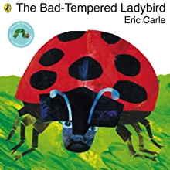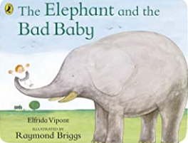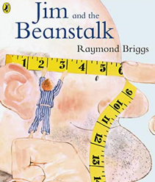  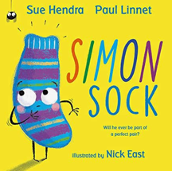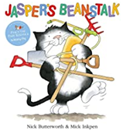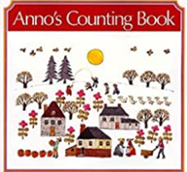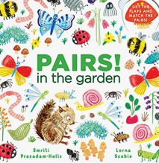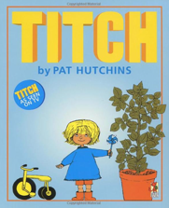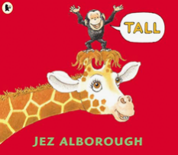 |  | Continue to revisit key skills – Counting, Subitising, Composition, Sorting, matching, comparing & ordering
 |  | Numbers 7, 8, 9 | Represent 7,8, 9 in different ways. Count out the required number from a larger group. Arrange into smaller groups to support conceptual subitising and explore their composition.
 |  | Making pairs. | Encourage to arrange small quantities into pairs, notice some quantities will have an odd one left over, no partner.
 |  | Combining 2 groups | Explore using real objects. Other manipulatives – fingers, bead strings, numicon tiles.
 |  | Length and Height | Encourage to use specific maths vocab relating to length (longer, shorter), height (Taller, shorter), and breadth (wider, narrower)
 |  | Time | Order and sequence important times in the day and use language such as now, before, later, soon, after, then and next, to describe when events happen.
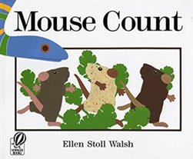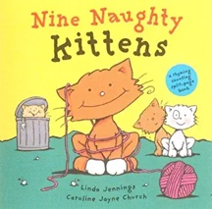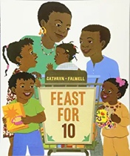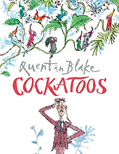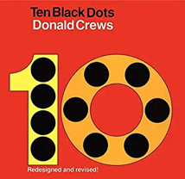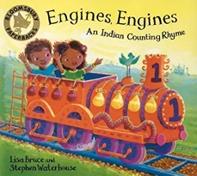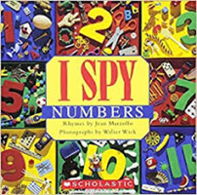

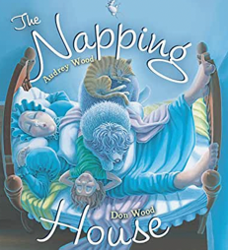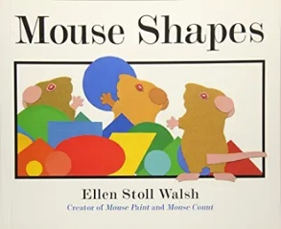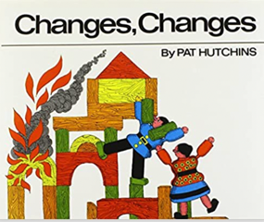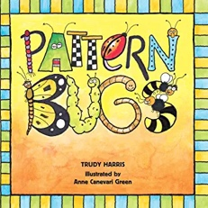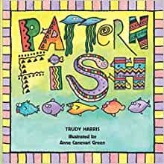

 |  | Building 9 and 10 | Represent in different ways. Support conceptual subitising by arranging 9 or 10 items into small groups. Notice a full ten frame.
 |  | Comparing numbers to 10 | Make comparisons by lining up items with 1:1 correspondence to compare them directly or by counting each set carefully and comparing their position in the counting order. Begin by comparing 2 quantities and progress to ordering 3 or more quantities.
 |  | Bonds to 10 | Explore using real objects in different contexts. Other manipulatives such as fingers, bead strings and number shapes are useful.
 |  | 3D shapes | Build and create using a variety of 3D shapes. Which stack, roll and why. Sort according to what they notice.
 |  | Pattern | Build on AB by introducing ABB, AAB, AABB, AABBB. Important each pattern has at least three full units of repeat. The more units of repeat, the easier to identify and continue. Encourage to say pattern aloud. Create around the edges of shapes as well as in a straight line.
Understanding the World   |  | Chronology:  Talk about and understand changes in their own lifetime, by creating a personal timeline.  Enquiry: Describe images of familiar situations in the past using books. Identify features of growth and change.  Respect:  Understand the value of being curious and interested in finding out about people within their own community and in other countries - special places and events or objects – through non-fiction texts, stories, visitors, celebrations. Describe special events (Easter)  Mapping:  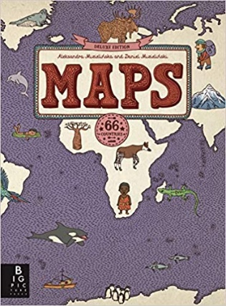  Identify how technology is used to share information e.g., google maps.  Kapow Geography : Exploring Maps  Enquiry:  Comment and ask questions about their immediate environment. Find out more about life cycles. Identify key features of a life cycle of a plant and animal, explain what plants need.  Bearfoot computing  Boats Ahoy  Springtime  Concepts and Approaches:  Abstraction tinkering creating, collaborating, Algorithms, persevering, decomposition |  | Comment on what they notice about the environment where they live and understand the effect of the changing seasons on the natural world around them. Describe what they see, hear, and feel outside.  Explore the natural world around them and making observations and drawing pictures of animals and plants.
Expressive Arts and Design   |  | Create collaboratively sharing ideas, resources, and skills  Combining different media and skills.  Exploration of natural resources for art - Rubbings of leaves and plants.  Kapow Art  Sculpture and 3D unit  Spring Artist Study: Eric Carle  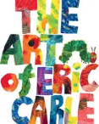  Charanga Songs:  Old Macdonald The Wheels on The Bus  Incy Wincy Spider The Hokey Cokey  Baa, Baa Black Sheep  Row, Row, Row Your Boat  Music –  Play different instruments and create their own sequences varying the tempo and dynamics  Use computer software to create their own music sequences  Learn about pulse and be able to clap along to it  Create their own simple their own simple rhythms using their body to make the sounds  Record their rhythms using simple notation  Poetry Basket  Spring Wind, Furry Furry Squirrel, Hungry Birdies, A Little Seed, Stepping Stones, Mrs Bluebird, Mix a Pancake |  | Explore, use, and refine a variety of artistic effects to express their ideas and feelings.  Explore and engage in music making and dance, performing solo or in groups.

