Spring 1 – Winter Wonderland & Journey Around the World
Possible Themes & Interests  (based on interests the children have had in past years) |  | WINTER NORTH & SOUTH POLE FRIENDSHIP/FEELINGS LUNAR NEW YEAR (29.1.2025) VALENTINE’S DAY MAKING A JOURNEY  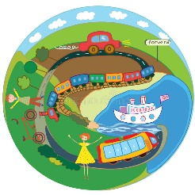
Suggested Texts | Books following possible themes | 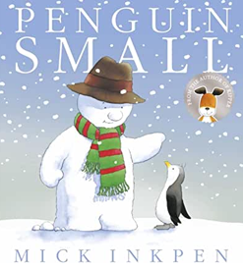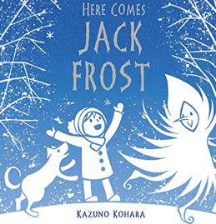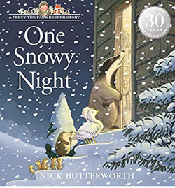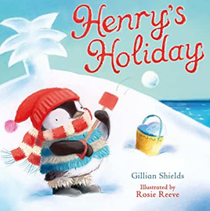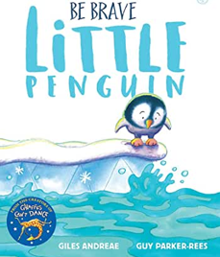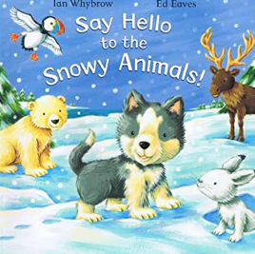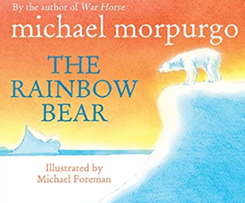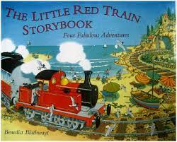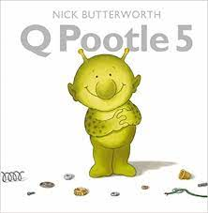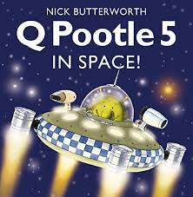  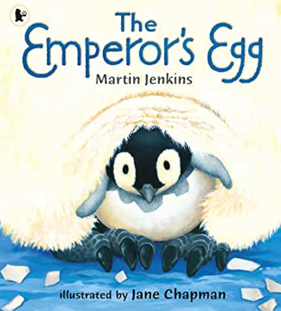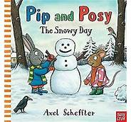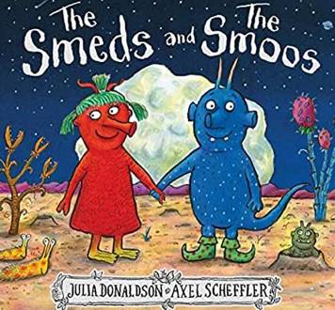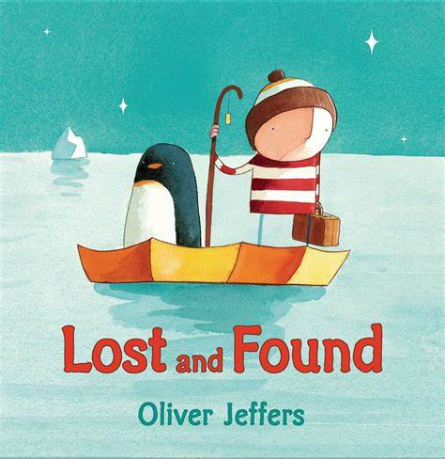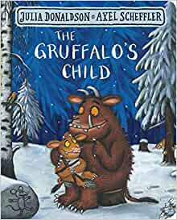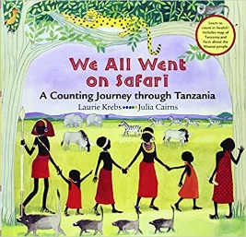  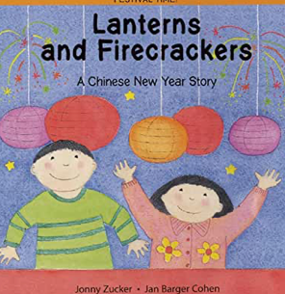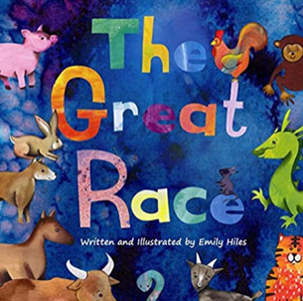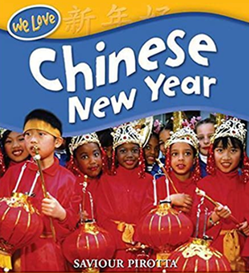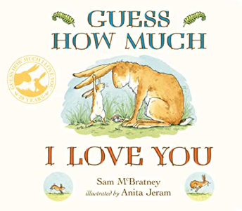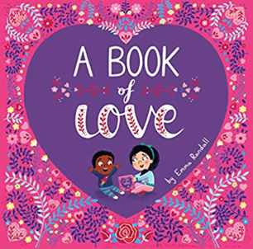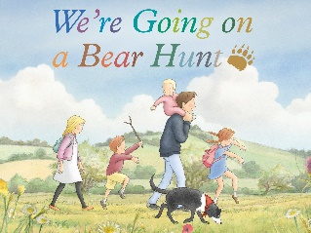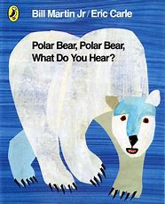
Suggested Texts | Spring 1  Literacy Texts | 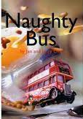  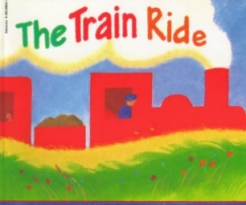  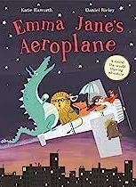  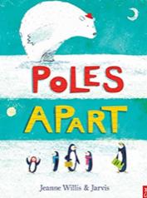  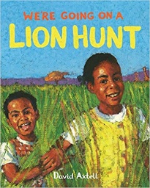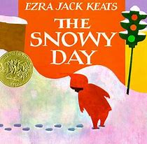  + Daily songs, nursery rhymes and school/class songs.
Child led interests covered during the half term:

Prime Areas

Area of learning |  | Objectives/skills |  | Revisit/ongoing  throughout the year | Best fit assessment
 |  |  |  | Revisit/ongoing  throughout the year | On track | not on track | extra focus assessment needed
Communication and Language   |  | Listening:  Listen attentively in a range of situations and know how to listen carefully e.g., understand they need to look at who is talking to them and think about what they are saying.  Attention:  Maintains attention, concentrates, and sits quietly during appropriate activity for a short time in the classroom.  Respond:  Make predictions about what might happen next or story endings in response to texts read.  Engage in non-fiction books.  Link events in a story to their own experiences. Introduce a storyline into their play.  Understanding:  Consider the listener and takes turns to listen and speak in different contexts.  Speaking:  Use talk to pretend objects stand for something else in play.  Demonstrate use of past tense verbs, such as "ran" or "fell" but may still get confused. Offer explanations for why things happen. Recount events that happen in their day. |  | Learn new vocabulary Use new vocabulary in different contexts.  Use new vocabulary through the day in discussions and conversations.  Learn new rhymes, poems, and songs. Listen to and talk about stories to build familiarity and understanding.
Personal, Social  and Emotional Development   |  | Express feelings:  Can show pride in achievements by showing work to others.  Manage behaviour:  Understand behavioural expectations of the setting.  Self-awareness:  Take pride in themselves, work, and achievements.  Can explain right from wrong and try to behave accordingly.  Independence:  Can independently manage their own needs; eating, drinking, accessing snack when hungry and communicate own needs in relation to  being thirsty, hungry, tired, using the toilet.  Can talk about healthy and unhealthy foods.  Collaboration:  Consider the listener and takes turns to listen and speak in different contexts.  Can identify kindness and considerate behaviour of others.  Social skills:  Seek others to share activities and experiences.  PSHE – Twinkl units  Working together  How I feel  RE - Special objects and Places  Why are some objects/places more special than others?  Do Christians have a special place/object? What makes them special?  No Outsiders – Hello Hello  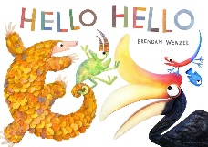  To say hello. I can make friends with different people. I know how to make friends. I know in my class we are not all the same. I know that we are different. |  | Continue to develop skills of using gestures, non-verbal communication, facial expressions, body language, appropriate language, and vocabulary; to listen to others, speak to peers and adults and engage in discussions in a positive way.
Physical  Development   |  | Continue to develop their small motor skills so that they can use a range of tools competently, safely, and confidently. Suggested tools: pencils for drawing and writing, paintbrushes, scissors, knives, forks, and spoon.  Scissor skills progression (see chart on wall)  Daily Dough Disco/FF routines  FF activities in provision |  | Continue to develop overall body-strength, balance, co-ordination, and agility through use of outdoor play equipment. | Complete separate fine motor writing assessment.  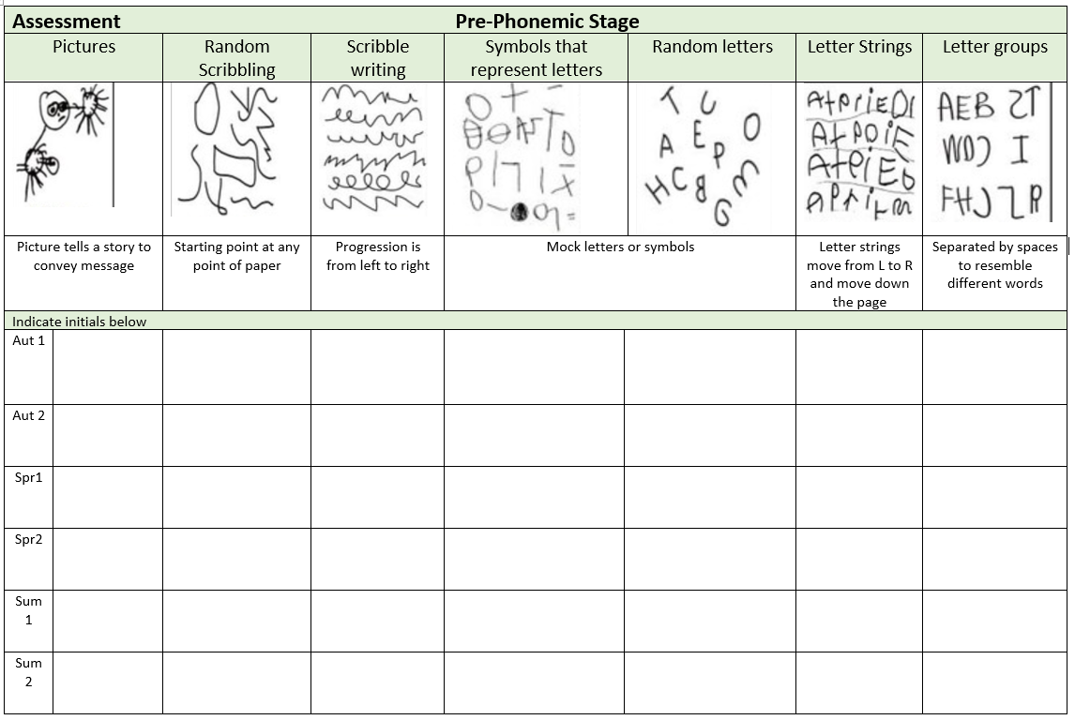
Develop the overall body strength, co-ordination, balance, and agility needed to engage successfully with future physical education sessions and other physical disciplines including dance, gymnastics, sport, and swimming.
Fundamental Skills programme
Further develop and refine a range of ball skills including throwing, catching, kicking, passing, batting, and aiming.
Develop confidence, competence, precision, and accuracy when engaging in activities that involve a ball.
Gymnastics
Travel along, over and under a range of gymnastics apparatus. To explore jumps and rolls. To link 3 movements into a short sequence.

Specific Areas
Literacy   |  | COMPREHENSION  Use picture clues to help read a simple text.  Make a simple prediction based on the pictures or text of a straightforward story that is read aloud to them.  Show understanding of some words and phrases in a story that is read aloud to them.  Express a preference for a book, song or rhyme, from a limited selection.  Play is influenced by experience of books (small world, role play). |  | Daily questioning to develop comprehension skills.
 |  | WORD READING  Read individual letters by saying the sounds for them.  Blend sounds into words, so that they can read short words made up of known letter-sound correspondences.  Read a few common exception words matched to the school’s phonic programme. |  | Re-read books to build up their confidence in word reading, their fluency and their understanding and enjoyment. Read books consistent with their phonic knowledge.
 |  | WRITING  Emergent writing:  Use appropriate letters for initial sounds.  Composition:  Orally compose a sentence and hold it in memory before attempting to write it.  Spelling:  Spell to write VC and CVC words independently using set 1 and, when taught, set 2 RWI sounds.  Handwriting:  Shows a dominant hand. Write from left to right and top to bottom. Form recognisable letters, begin to sit them on a line. |  | Handwriting - Continue to revisit/practice letter formation relating to name, phonics phases and other letters which children have been taught to form correctly.
Phonics |  | Consolidate set 1 sounds and set 1 special friends.  Recognise digraphs -ck + consonant endings - ff, ll, ss, zz  Know tricky words - the, to, and, no, go, I, my, of (red books) you, your, said, be, are (green books)  Blend and segment known sounds for reading and spelling VC, CVC, CVCC  When ready learn set 2 sounds and read and write them in words. |  | Continue to revisit all taught sounds daily and practice sound discrimination.
Mathematics   |  | Numbers 5 and 0  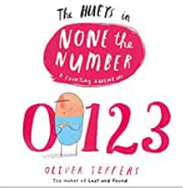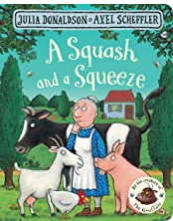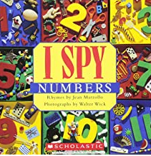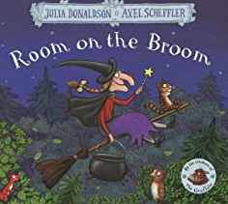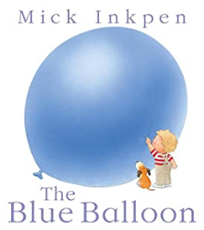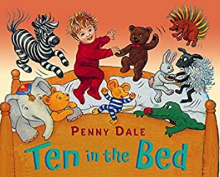  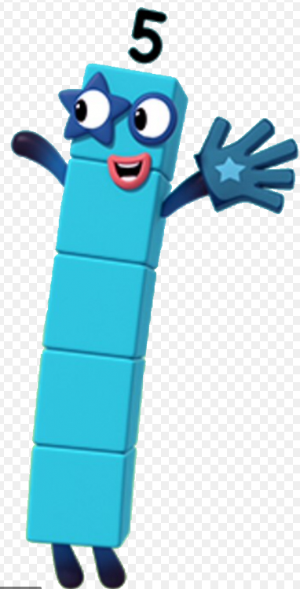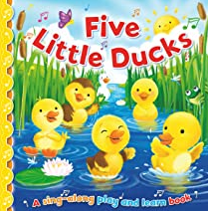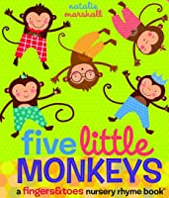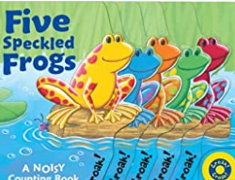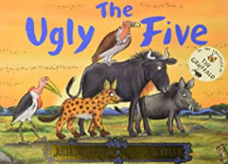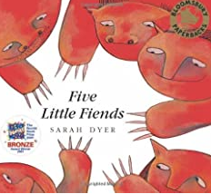  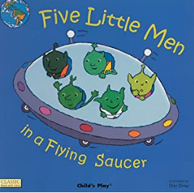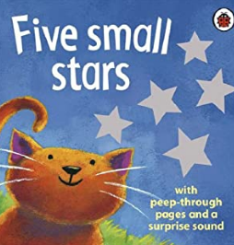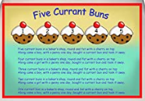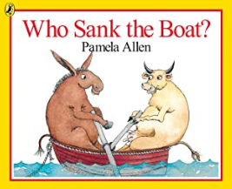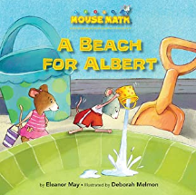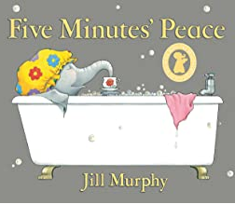 |  | Continue to revisit key skills – Counting, Subitising, Composition, Sorting, matching, comparing & ordering
 |  | Coverage | Guidance
 |  | Introducing zero | Ongoing opportunities to explore and apply the understanding of ‘nothing there’ or ‘all gone’ - the number name zero and the numeral 0 used to represent this idea.
 |  | Comparing numbers to 5 | Continue to compare numbers, one quantity can be more than, the same as or fewer than another quantity.  Use a range of representations to support this understanding and encourage the children to compare quantities using a variety of objects and representations.
 |  | Composition of 5, five wise | Continue to develop the understanding that all numbers are made up of smaller numbers, composed of 2 parts or more than 2 parts. Opportunities in provision to explore and notice the different compositions of 4 and 5.
 |  | Comparing Mass | Encourage children to make direct comparisons holding items to estimate heaviest, use balance scales to check. Prompt language of heavy, heavier than, heaviest, light, lighter than, lightest. Common misconception than the bigger item is the heaviest.
 |  | Comparing Capacity | Continue to build on understanding of full and empty to show half full, nearly full, and nearly empty. Provide opportunities to explore capacity using different materials such as water, sand, rice, and beads. Provide different sized and shaped containers to investigate. Prompt them to use the language of tall, thin, narrow, wide, and shallow.  Encourage the children to make direct comparisons by pouring from one container into another. They can also use small pots or ladles to make indirect comparisons by counting how many pots it takes to fill each container.
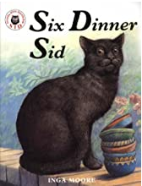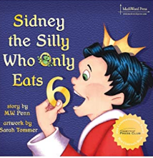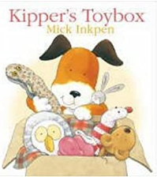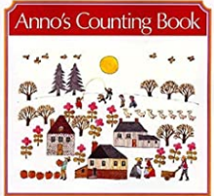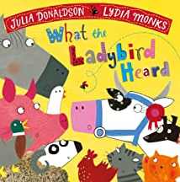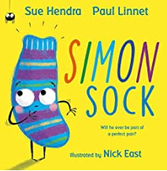

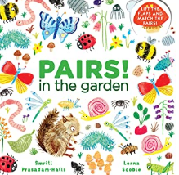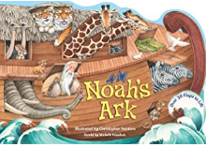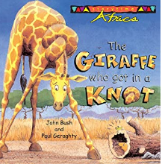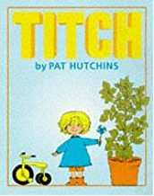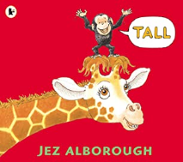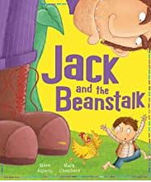

 |  | Number 6, 7, 8 | Represent 6,7,8 in different ways, count out from a larger group. Support conceptual subitising by arranging 6,7 or 8 items into small groups and see how the numbers are made up of smaller numbers.
 |  | Making pairs - pairs wise | Begin to understand that a pair is two. Provide collections of items that come in pairs. Encourage to arrange small quantities into pairs, notice some quantities will have an odd one left over, no partner. Use Snap or memory games.
 |  | Combining 2 groups | Use real objects to combine and see how many altogether. Encourage subitising skills.
 |  | Length, height | Make direct comparisons. Encourage mathematical vocab relating to length – longer, shorter. To height – taller, shorter and breadth – wider, narrower. Make indirect comparisons using objects to measure items e.g., cubes or blocks.
 |  | Time | Order and sequence important times in the day and use language such as now, before, later, soon, after, then and next, to describe when events happen.
Understanding the World   |  | Chronology:  Talk about the past and present. Use a simple timeline to show now and ‘in the past’.  Respect:  Understand the value of being curious and interested in finding out about people within their own community and in other countries - special places and events or objects – through non-fiction texts, stories, visitors, celebrations.  Mapping:  Program a BeeBot or instruct a friend to move along a track or small world setup in a specific direction using terms up, down, side.  Recognise some environments that are different to the one in which they live e.g., Antarctica.  Enquiry:  Use technology and IT equipment to make observations or find information about different locations and places.  Recognise, know, and describe features of different places. Look closely at similarities and differences. |  | Communication: Comment on what they notice about the environment where they live and understand the effect of the changing seasons on the natural world around them. Describe what they see, hear, and feel outside.  Observation: Explore the natural world, making observations. Understand the need to respect and care for the natural environment and all living things.
Expressive Arts and Design |  | Develop storylines in their pretend play.  Return to and build on their previous learning, refining ideas and developing their ability to represent them.  Art & Design: Paint My World (Kapow Unit)  Exploring paint and painting techniques through nature, music and collaborative work.  Seasonal Craft: Threaded Snowflakes  Artist: Turner: Rain, Steam and Speed  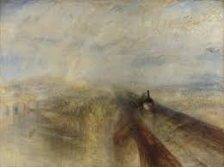  Poetry Basket:  - Popcorn – a six-line poem  - A Little House – an eight-line poem  - Pancakes – a six-line poem  - Let’s Put on Our Mittens – a six-line poem  - I Can Build a Snowman – a four-line poem  - Carrot Nose – a four-line poem  Music: Being Imaginative  Children will create narratives based around stories.  Charanga unit – Everyone!  Musical learning focus  - Listening and responding to different styles of music  - Embedding foundations of the interrelated dimensions of music  - Learning to sing or sing along with nursery rhymes and action songs  - Improvising leading to playing classroom instruments  - Singing and learning to play instruments within a song  - Share and perform the learning that has taken place |  | Explore, use, and refine a variety of artistic effects to express their ideas and feelings.  Explore and engage in music making and dance, performing solo or in groups.

