Autumn 2
Possible Themes & Interests  (Based on interests the children have had in past years) |  | AUTUMN BONFIRE NIGHT/FIRE SERVICE CHRISTMAS      
Suggested Texts | Books following possible themes. | 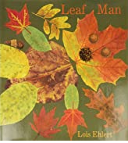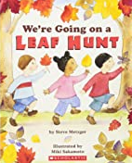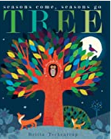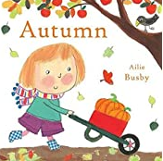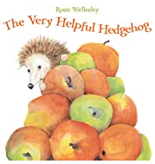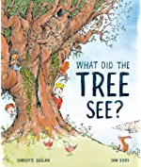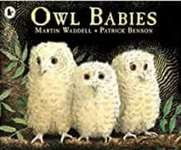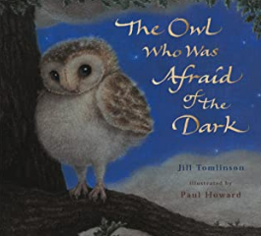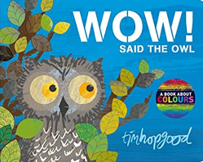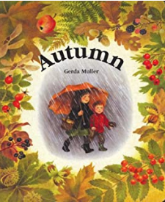  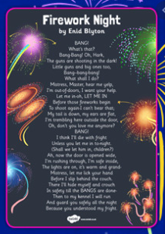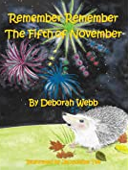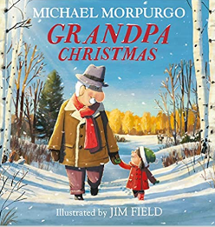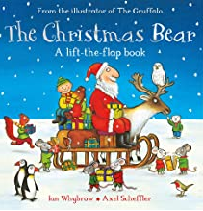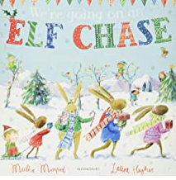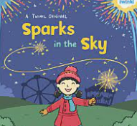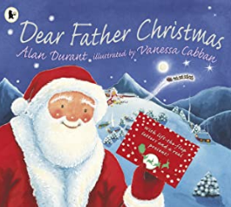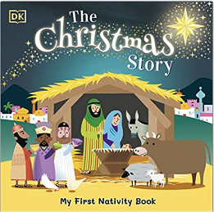  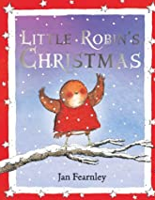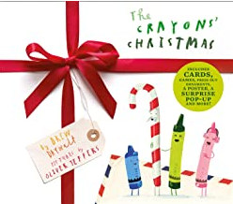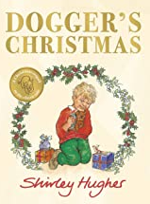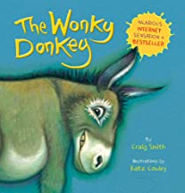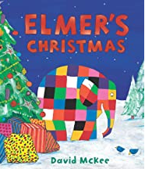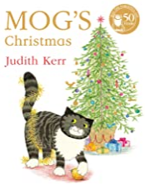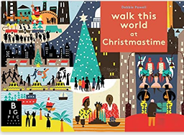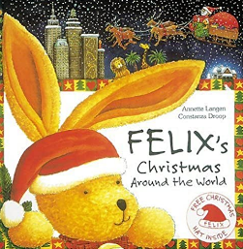
Suggested Texts | Autumn 2  Literacy texts | 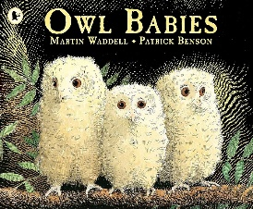  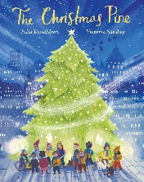  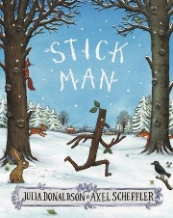  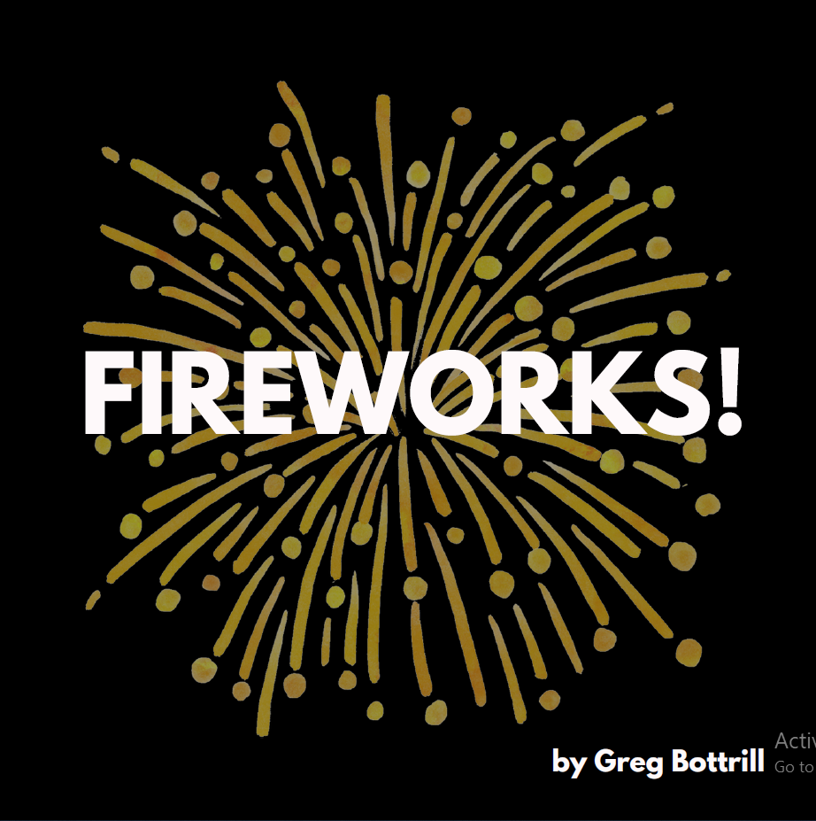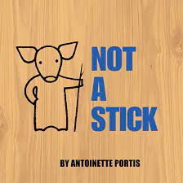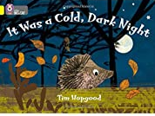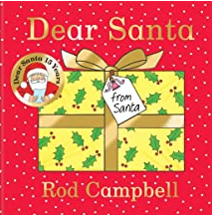  + Daily songs, rhymes and poems
Child led interests covered during the half term:

Prime Areas

Area of learning |  | Objectives/skills |  | Revisit/ongoing throughout  the year | Best fit assessment
 |  |  |  | Revisit/ongoing throughout  the year | On track | not on track | extra focus assessment needed
Communication and Language   |  | Listening:  Listen in familiar and new situations.  Engage in stories that are familiar and new with interest and enjoyment.  Attention:  Maintain attention in new situations e.g., whole school assembly or PE sessions in the hall.  Shift attention when required e.g., when given a clear prompt - ‘name’.  Respond:  Make relevant comments when listening to a story and can answer ‘why’ questions.  Link events in a story to their own experiences.  Ask questions to find out more and to check they understand what has been said to them.  Respond to others appropriately in play.  Engage in story times.  Engage in non-fiction book.  Understanding:  Follow instructions or a question with 2 parts in familiar situations.  Speaking:  Use intonation to make meaning clear to others.  Start a conversation with peers and familiar adults and continue it for many turns.  Use simple conjunctions in talk to link thoughts ‘and’ ‘because’.  Retell a simple event e.g., how scratched knee’ Recognise words that rhyme or sound similar E.g., “Cat and hat”.  Develop social phrases – “Good morning, how are you?” |  | Learn new vocabulary Use new vocabulary in different contexts.  Use new vocabulary through the day in discussions and conversations.  Learn new rhymes, poems, and songs.  Listen to and talk about stories to build familiarity  and understanding.
Personal, Social  and Emotional Development   |  | Express feelings:  Can show concern for others and show awareness of how their actions may impact on others.  Talk with others to solve conflicts.  Beginning to express their feelings and consider the perspectives of others.  Manage behaviour:  Begin to take turns and share resources.  Can usually tolerate delay when needs are not immediately met.  Self-awareness:  Can talk about what they are doing and why.  Independence:  Can independently choose areas they would like to play in or resources they would like to use.  Can say when they help.  With some support can get dressed and undressed for PE sessions.  Can follow instructions with 2 parts.  Collaboration:  Begin to share and take turns.  Social skills:  Continue to build constructive and respectful relationships.  Seek familiar adults and peers to engage in conversations and ask for help.  PSHE:  No Outsiders – Red Rockets and Rainbow Jelly  - It’s okay to like different things |  | Continue to develop skills of using gestures, non-verbal communication, facial expressions, body language, appropriate language, and vocabulary; to listen to others, speak to peers and adults and engage in discussions in a positive way.
Physical  Development   |  | Develop their small motor skills so that they can use a range of tools competently, safely, and confidently. Suggested tools: pencils for drawing and writing, paintbrushes, scissors, knives, forks, and spoon.  Dough Disco, Pen Disco, Fine Motor activities |  | Continue to develop overall body-strength, balance, co-ordination, and agility through use of outdoor play equipment. | Complete separate fine motor writing assessment.  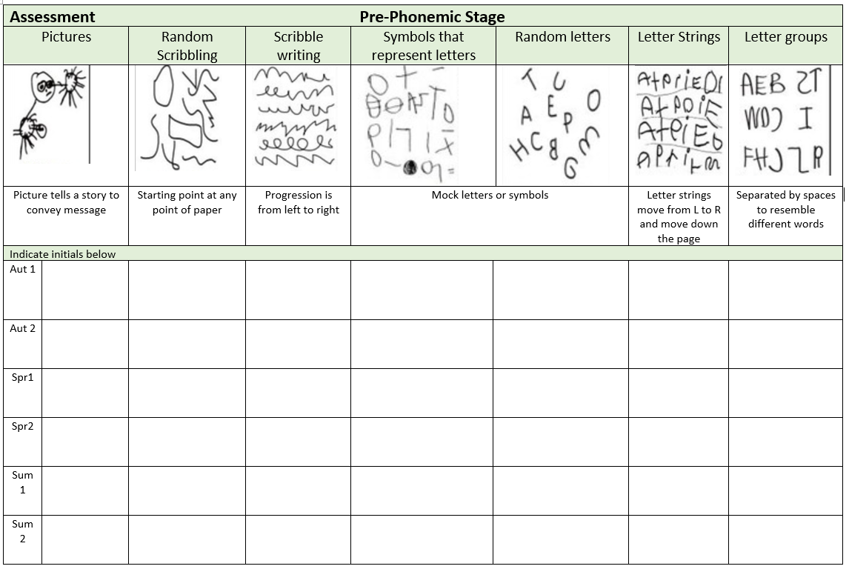
Develop the overall body strength, co-ordination, balance, and agility needed to engage successfully with future physical education sessions and other physical disciplines including dance, gymnastics, sport, and swimming.

Revise and refine the fundamental movement skills they have already acquired: rolling, crawling, walking, jumping, running, hopping, skipping, climbing.

Fundamental skills programme weeks 8-16
Dance/Yoga: fireworks, bonfire, autumn, Christmas themed
Specific Areas
Literacy   |  | COMPREHENSION  Experience and respond to different types of books, e.g., story books, factual/real-world books, rhyming and non-rhyming stories, realistic and fantasy stories.  Respond to ‘who’, ‘where’ ‘what’ and ‘when’ questions linked to text and illustrations.  Make simple inferences to answer yes/no questions about characters' emotions in a familiar picture book read aloud to them, with prompts.  Sequence two events from a familiar story, using puppets, pictures from book or role-play.
 |  | WORD READING  Read individual letters by saying the sounds for them.  Blend sounds into words, so that they can read short words made up of known letter-sound correspondences.  Read a few common exception words matched to our phonic programme. |  | Re-read books to build up confidence in word reading, fluency, understanding and enjoyment. Read books consistent with their phonic knowledge.
WRITING
Emergent writing:
Copies adult writing behaviour e.g., writing on a whiteboard, writing messages.
Makes marks and drawings using increasing control.
Know there is a sound/symbol relationship.
Use some recognisable letters and own symbols.
Write letters and strings, sometimes in clusters like words.
Write CVC words and begin to write simple phrases e.g. a big stick
Drawing Club:
Make marks, write VC, CVC or numbers to communicate meaning
Composition:
Orally compose sentences and stories which are shared through helicopter stories and Drawing Club.
Spelling:
Orally spell VC and CVC words by identifying the sounds.
Write own name.
Handwriting:
Form letters correctly.
Helicopter stories and Drawing Club:
Adults are dictated to by the child, the adult says each word as it is written, pointing out gaps and punctuation.
Re-reading and scanning and checking writing.
Phonics |  | RWI  Consolidate set 1 sounds (26)  Learn set 1 special friends (10)  Blend with known letters for reading VC and CVC words.  Orally segment for VC and CVC words for spelling  Know high-frequency common words (the, to, no, go, I). |  | Continue to develop general sound discrimination, rhythm and rhyme, alliteration, voice sounds, oral blending, and segmenting.
Mathematics   |  | 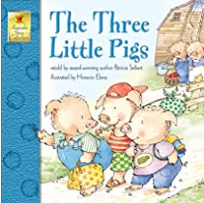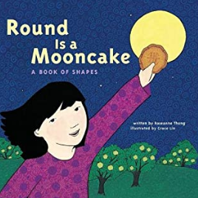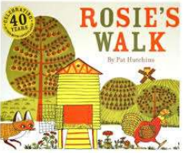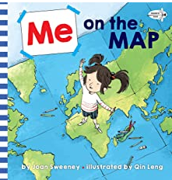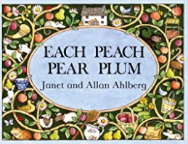  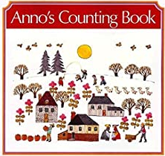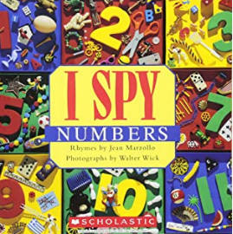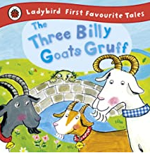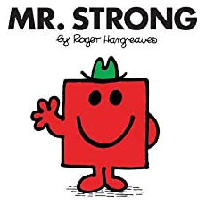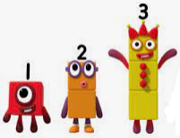 |  | Develop confidence in using manipulatives, graphical representations, subitising and exploring pattern.  Counting real life objects, subitising and counting objects that are identical before moving onto objects with slight differences such as size or colour.  Children encouraged to put objects into a line when counting so there is a clear start and end point.  Five frames used to support and compare numbers within 5.  Numerals introduced but not expected to write them at this stage.  Informal jottings/drawings to record thinking.  When counting continue to learn that the final number they say names the quantity of the set.  Continue to count, subitise and compare as they explore one more and one less.
 |  | Coverage | Guidance (subject knowledge)
 |  | Representing 1,2,3 | Subitise or count to find how many and make own collections of 1, 2, 3 objects. Match number names to numerals and quantities. Count up to 3 objects in diff arrangements by touching each object as they count. Recognise that the final number they say names the quantity in a set. Use own mark making to represent 1, 2 and 3.
 |  | Comparing 1,2,3 | Begin to understand as we count each number is one more than the number before. Similarly, as we count back, each number is one less than the previous number.
 |  | Composition of 1,2,3 | Intro idea all numbers are made up of smaller numbers. Explore and notice diff compositions of 2 and 4.
 |  | Formation of 1,2,3
 |  | Circles and triangles | Circles have one curved side, triangles have 3 straight sides. Recognise these shapes in everyday life. Show a variety of diff sized circles and triangles in diff orientations and sides with diff lengths.
 |  | Spatial awareness: Positional language | Hear and begin to use positional language to describe how items are positioned in relation to other items.
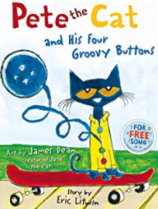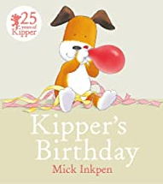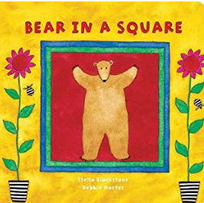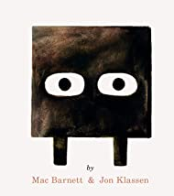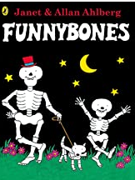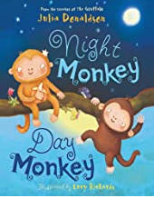

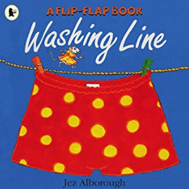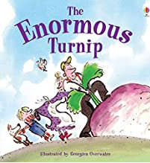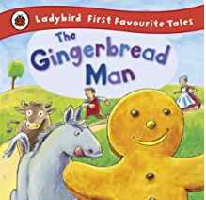
 |  | Coverage | Guidance (Subject knowledge)
 |  | Representing 1-4, Comparing 1-4, Composition of 1-4, Formation of 1-4 | Count on and back to 4. Subitise up to 4 objects. Match number name to numeral and quantity. Say which sets have more and fewer.
 |  | One more and less | Use a five frame to represent numbers and predict how many there will be if they add one more or take one away. Understand the link between counting forwards and the one more pattern, then counting back and the one less pattern. Support with books and number rhymes e.g., 5 speckled frogs, 5 current buns, 5 little ducks.
 |  | Shapes with 4 sides | Squares (classes as special rectangles with 4 equal sides) and rectangles have 4 straight sides and 4 corners. Recognise these shapes in everyday life. Show these shapes in a variety of diff sizes and orientations.
 |  | Time: Night and Day | Talk about night and day and order key events in daily routines. Use language to describe when events happen e.g., day, night, morning, afternoon, before, after, today, tomorrow. Begin to measure time in simple ways e.g., counting number of sleeps, timers to measure durations.
Understanding the World   |  | Chronology:  Use the language of time when talking about past/present events in their own lives and in the lives of others including people they have learnt about through books.  Enquiry:  Find out about key historical events and why and how we celebrate today? Bonfire Night, Remembrance Day, Hanukkah, Christmas Day.  Ask questions, use different sources to find answers including books.  Comment on images of familiar situations in the past.  Continue to develop a sense of continuity and change by being able to compare characters from stories.  Respect:  Recognise that people have different beliefs and celebrate special times in different ways.  Recognise some similarities and differences between life in this country and life in other countries.  Barefoot computing:  Awesome Autumn: computational thinking, creating, pattern, logic  RE: (Kapow)  What are Special Times? Christmas,  Time to Celebrate: Hannukkah  Why are Some Stories Special? |  | Scientific skills –  Comment on what they notice about the environment where they live and understand the effect of the changing seasons on the natural world around them. Describe what they see, hear, and feel outside.  Explore the natural world around, making observations and drawing pictures of animals and plants.
Expressive Arts and Design   |  | Develop storylines in their pretend play.  Artist Study: Frida Kahlo  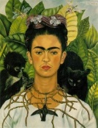  Kapow Art: Marvellous Marks (complete unit), Paint My World - Explore mark making through different drawing materials. -Beginning to draw from observation using faces and self-portraits as a stimulus.  Music  Children will sing and perform nursery rhymes, learning about dynamics and how to change their voices.  Children will begin to vary dynamics in clapped rhythms and simple sequences.  Children will begin to play musical instruments such as claves.  Charanga unit – Me!  Charanga unit – My Stories  Musical learning focus  - Listening and responding to different styles of music  - Embedding foundations of the interrelated dimensions of music  - Learning to sing or sing along with nursery rhymes and action songs  - Improvising leading to playing classroom instruments  - Share and perform the learning that has taken place  - Listen and Respond to a different style of music each week/step  - Explore and Create - initially using voices only but building to using classroom instruments too  - Singing - nursery rhymes and action songs - building to singing and playing  - Share and Perform  Charanga Songs:  Pat-a-cake  1, 2, 3, 4, 5, Once I Caught a Fish Alive  This Old Man  Five Little Ducks  Name Song  Things For Fingers  - I’m A Little Teapot  - The Grand Old Duke Of York  - Ring O’ Roses  - Hickory Dickory Dock  - Not Too Difficult  - The ABC Song  The Poetry Basket:  Breezy Weather, Cup of Tea, Mice. Shoes, Who has seen the wind? Christmas poems |  | Explore, use, and refine a variety of artistic effects to express their ideas and feelings.  Explore and engage in music making and dance, performing solo or in groups.

