Autumn 1 – It’s Marvellous Me!
Themes/Interests/  Lines of Enquiry |  | TEDDY BEARS Pete the Cat Family Feelings Starting School  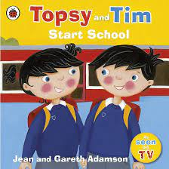  (school values)  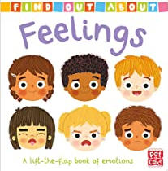      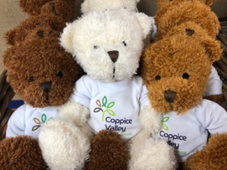
Suggested Texts | Baseline & Transition Themed Books | 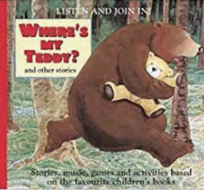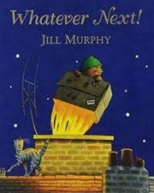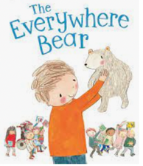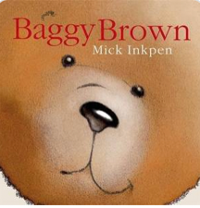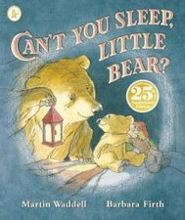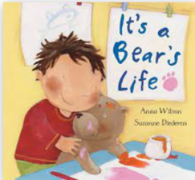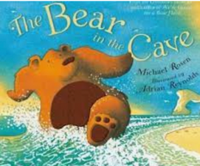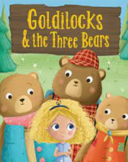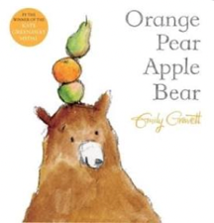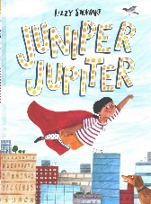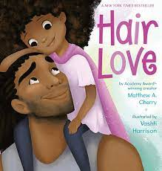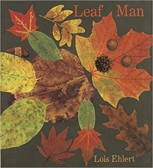  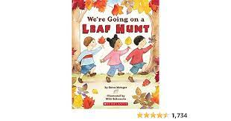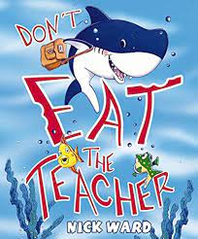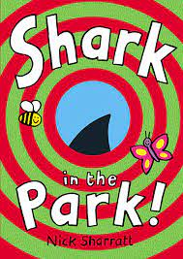
 | Autumn 1  Literacy texts | 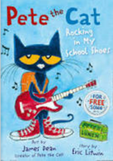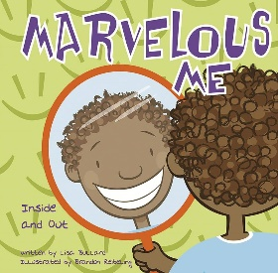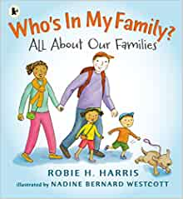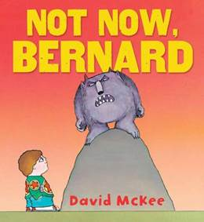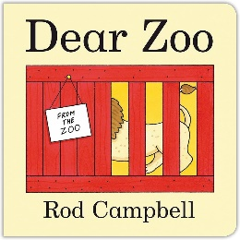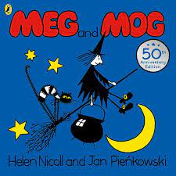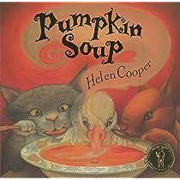  + Daily songs, nursery rhymes and school/class songs.
Prime Areas

Area of learning |  | Objectives/skills | Revisit/ongoing  throughout the year | Best fit assessment
 |  |  |  | On track | not on track | extra focus assessment needed
Communication and Language   |  | Listening:  Listen to others 1:1, in small groups and whole class.  Enjoy listening to stories and can remember what happens.  Listen carefully to rhymes and songs, paying attention to how they sound.  Understand how to listen carefully and why listening is important.  Attention:  Maintain attention in whole class and small group contexts for a short time.  May find it difficult to pay attention to more than one thing at a time.  Respond:  Engage in story times.  Join in with repeated refrains and anticipate key events and phases in stories or rhymes.  Respond appropriately when asked e.g. show me 10  Understanding:  Follow 1 step instructions e.g. put bookbag in drawer.  Understand ‘why’ questions.  Speaking:  Use sentences of 4-6 words.  Sing a large repertoire of songs e.g., nursery rhymes or numbers of songs.  Begin to use social phrases e.g., ‘Good Morning!  Use talk to organise themselves and their play. | Learn new vocabulary Use new vocabulary in different contexts.  Use new vocabulary through the day in discussions and conversations.  Learn new rhymes, poems, and songs.  Listen to and talk about stories to build familiarity  and understanding.
Personal, Social  and Emotional Development   |  | Express feelings:  Aware of own feelings, can talk about feelings using words like ‘happy’, ‘sad’, ‘angry’.  Begin to understand how others might be feeling.  Know they can rely on their teachers, friends, and ‘buddy’ for support if they are worried.  School transition.  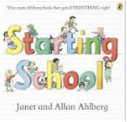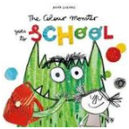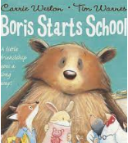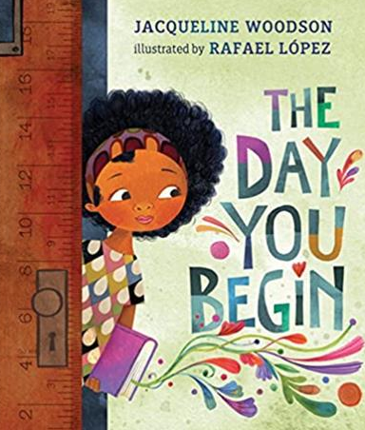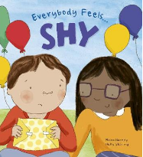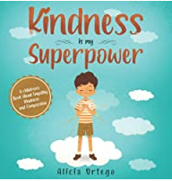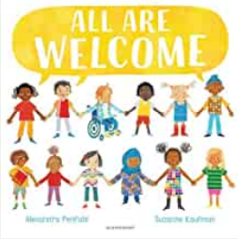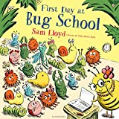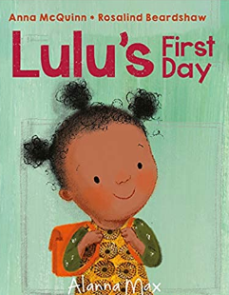  Manage behaviour:  Can inhibit own actions, welcome distractions when upset.  Understand behavioural expectations of the setting.  Increasingly follow rules understanding why they are important.  Self-awareness:  Know what they like and do not like.  Understands there are rules in the classroom to follow and expectations for behaviour.  Independence:  Can independently organise themselves in the morning e.g., bookbag in trug, coat on peg, water bottle in holder, self register and choose lunch  Can manage their own personal hygiene e.g., toileting. Can follow 1 step instructions.  Collaboration:  Interested in others play and starting to join in.  Knows we work together to keep the class rules and earn positive rewards.  Social skills: Build constructive and respectful relationships.  Engage in positive interactions with adults and peers.  Play with one or more children, extending and elaborating play ideas.  Twinkl PSHE – Super Me, Positive Relationships  No Outsiders: ‘You Choose’, Children will be able can choose what they like | Continue to develop skills of using gestures, non-verbal communication, facial expressions, body language, appropriate language, and vocabulary; to listen to others, speak to peers and adults and engage in discussions in a positive way.
Physical  Development   |  | Further develop the skills they need to manage the school day successfully: lining up and queuing, mealtimes, personal hygiene.  Develop their small motor skills so that they can use a range of tools competently, safely, and confidently. Suggested tools: pencils for drawing and writing, paintbrushes, scissors, knives, forks, and spoon.  Dough Disco | Continue to develop overall body-strength, balance, co-ordination, and agility through use of outdoor play equipment. | Complete separate fine motor writing assessment.  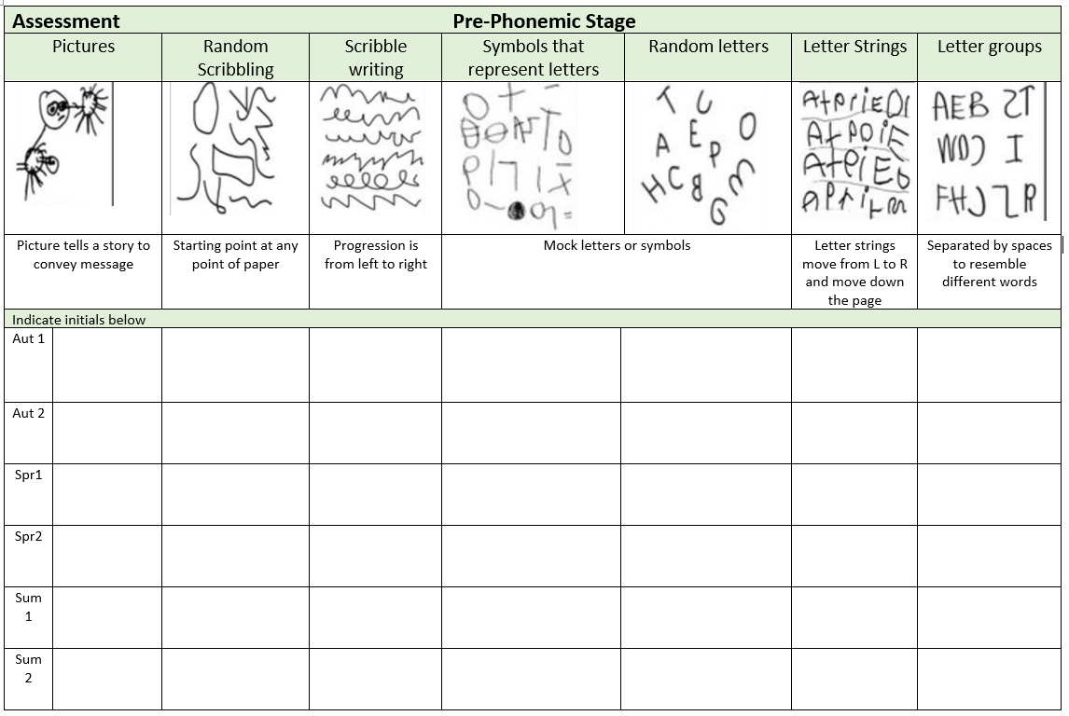
Develop the overall body strength, co-ordination, balance, and agility needed to engage successfully with future physical education sessions and other physical disciplines.
Outdoor equipment: climbing, bike and scooters
PE: Fundamental Skills Programme weeks 1-7, dance, parachute
Specific Areas
Literacy   |  | COMPREHENSION  Listen and enjoy sharing a range of books.  Hold a book correctly, handle with care and turn pages from front to back and recognise front and back cover.  Know that print carries meaning and in English, is read from left to right and top to bottom.  Know the difference between text and illustrations.  Enjoy joining in with rhyme, songs, and poems.  Join in with repeated refrains and key phrases.
 |  | WORD READING  Hear general sound discrimination and be able to orally blend and segment. | Re-read books to build up their confidence in word reading, their fluency and their understanding and enjoyment. Read books consistent with their phonic knowledge.
WRITING
Emergent writing:
Develop listening and speaking skills in a range of contexts.
Aware that writing communicates meaning.
Give meaning to marks they make. Understand that thoughts can be written down.
Write their name copying it from a name card or try to write it from memory.
Composition:
Use talk to link ideas, clarify thinking and feelings. Understands that thoughts and stories can be written down.
Spelling:
Orally segment sounds in simple words.
Write their name copying it from a name card or try to write it from memory.
Handwriting:
Know that print carries meaning and in English, is read from left to right and top to bottom.
Draws lines and circles.
Helicopter stories:
Adults scribing and writing down word for word, child decides part he/she would like to play and then on a simple stage to act out the story.
Drawing Club
Response to text, either pictorial or written
Message centre
Sending messages
Phonics |  | RWI set 1 sounds (from week 2), Fred games (oral blending)  Hear general sound discrimination, identify rhythm, rhyme and alliteration and be able to orally blend and segment simple words. | Continue to develop general sound discrimination, rhythm and rhyme, alliteration, voice sounds, oral blending, and segmenting.
Mathematics   |  | 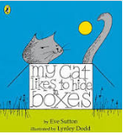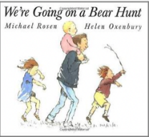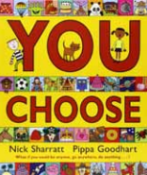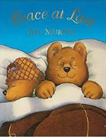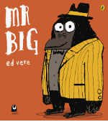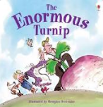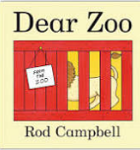  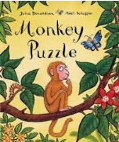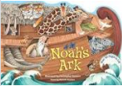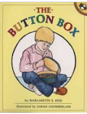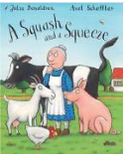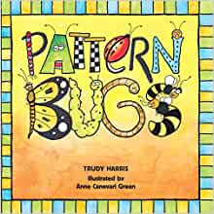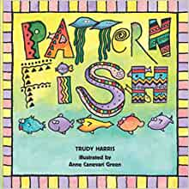
Baseline – 3 weeks
Opportunity to settle in, intro the areas of provision inside and outside and get to know the children’s mathematical knowledge through play, intro key times of day, class routines, where do things belong? Positional language
Count objects, actions, and sounds.
Subitise
Matching - same/different, colour, size, shape.
Sorting into groups – counting by rote, counting aloud, clapping, stamping, drumming etc, nursery rhymes, counting songs, using fingers to represent numbers.
Comparing amounts – equal, more than, fewer than.
Comparing size, mass & capacity – big/little, large/small, short/tall, tallest/shortest
Exploring pattern - making simple patterns, odd one out, exploring more complex patterns.
Understanding the World   |  | Chronology:  Talk about members of their immediate family and the relationship to them, name and describe people who are familiar to them both in the past and present.  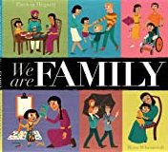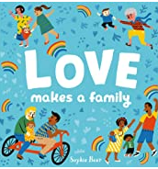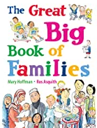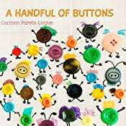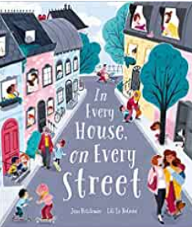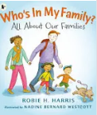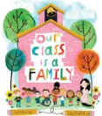  Begin to develop a sense of continuity and change by being able to compare characters from stories.  Respect  Themselves, special things in their own lives.  Talk about and describe features of their own family, talk about families in other countries across the world.  Mapping:  Talk about the features of their immediate environment with visual representations e.g., classroom maps, Pete’s story map around school, seating maps, nature area map and read commons signs and logos.  RE:  Kapow: What makes us special? Time to Celebrate - Harvest | Communication: Comment on what they notice about the environment where they live and understand the effect of the changing seasons on the natural world around them. Describe what they see, hear, and feel outside.  Observation: Explore the natural world around them and making observations and drawing pictures of animals and plants. Understand the need to respect and care for the natural environment and all living things.
Expressive Arts and Design   |  | Develop storylines in their pretend play.  Artist study – Yayoi Kusama (pumpkins), Hanoch Piven  Kapow: Marvellous Marks: creating with materials - Explore mark making through different drawing materials. -Beginning to draw from observation using faces and self-portraits as a stimulus.  Refer to Art and design progression map to facilitate progression through child led interests.  Charanga Songs: Me!  Pat-a-cake, 1, 2, 3, 4, 5, Once I Caught a Fish Alive, This Old Man, Five Little Ducks, Name Song, Things For Fingers  The Poetry Basket, Helicopter stories | Explore, use, and refine a variety of artistic effects to express their ideas and feelings.  Explore and engage in music making and dance, performing solo or in groups.
Enrichment/Experiences |  | Harvest  Leaf Hunt  Pumpkin Soup

