Look, say, cover, write, check  First, look at the word. Next, say the word out loud. Then, cover the word. Finally, check the word. If you have got it correct, write it again and again! If not, start the process again. | Drawing around the word to show the shape  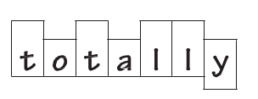  By drawing around the word, it makes it clear where there are tall letters (ascenders) and letters which sit on the line (descenders) in the word.
Drawing an image around the word  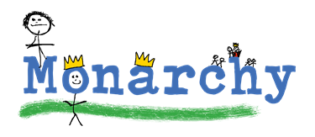  Make the word memorable. Draw pictures which link to the meaning of the word to make the spelling more noticeable. | 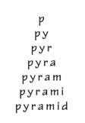  Pyramid words  This method makes you think of each letter separately and the order that they appear in the word.
Rainbow writing  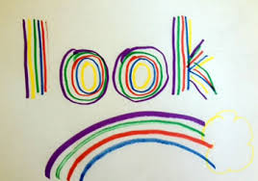  Using coloured pencils in different ways can help make the word or parts of the word memorable. You could highlight the tricky part of the word or write it in a different colour. Also, you could write each letter in a different colour or write the word in each colour of the rainbow. | Words without vowels  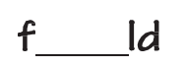  This strategy is useful when the vowel choices (a, e, i, o, u) are challenging. Write the word without the vowels and leave a space for the correct vowel/vowels to be added.
Top tips for Spelling!

