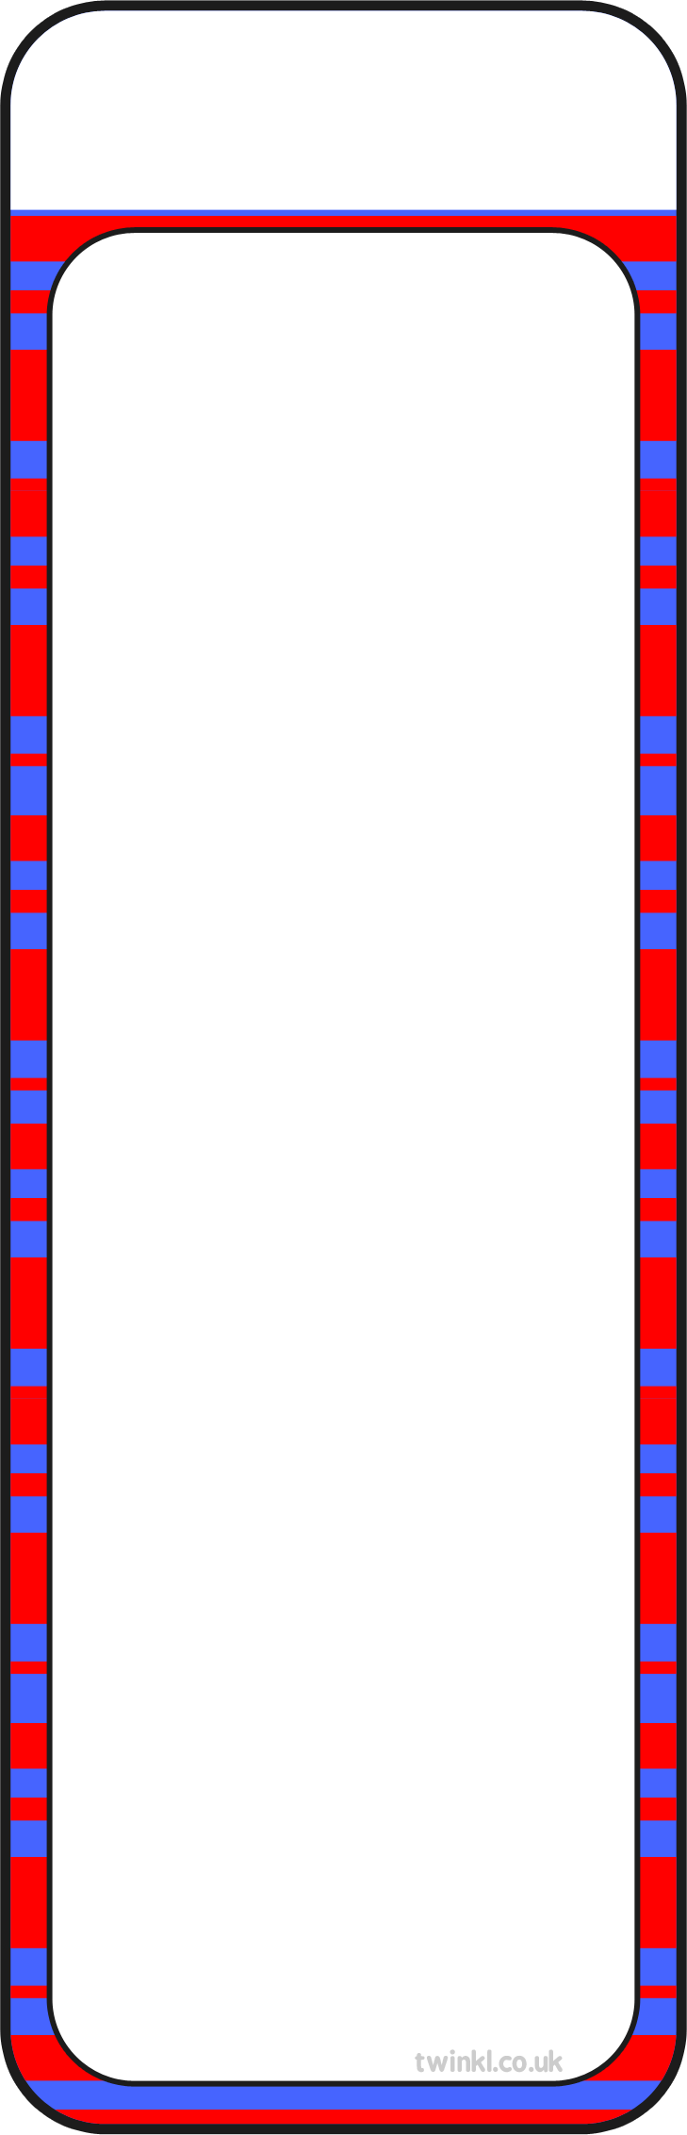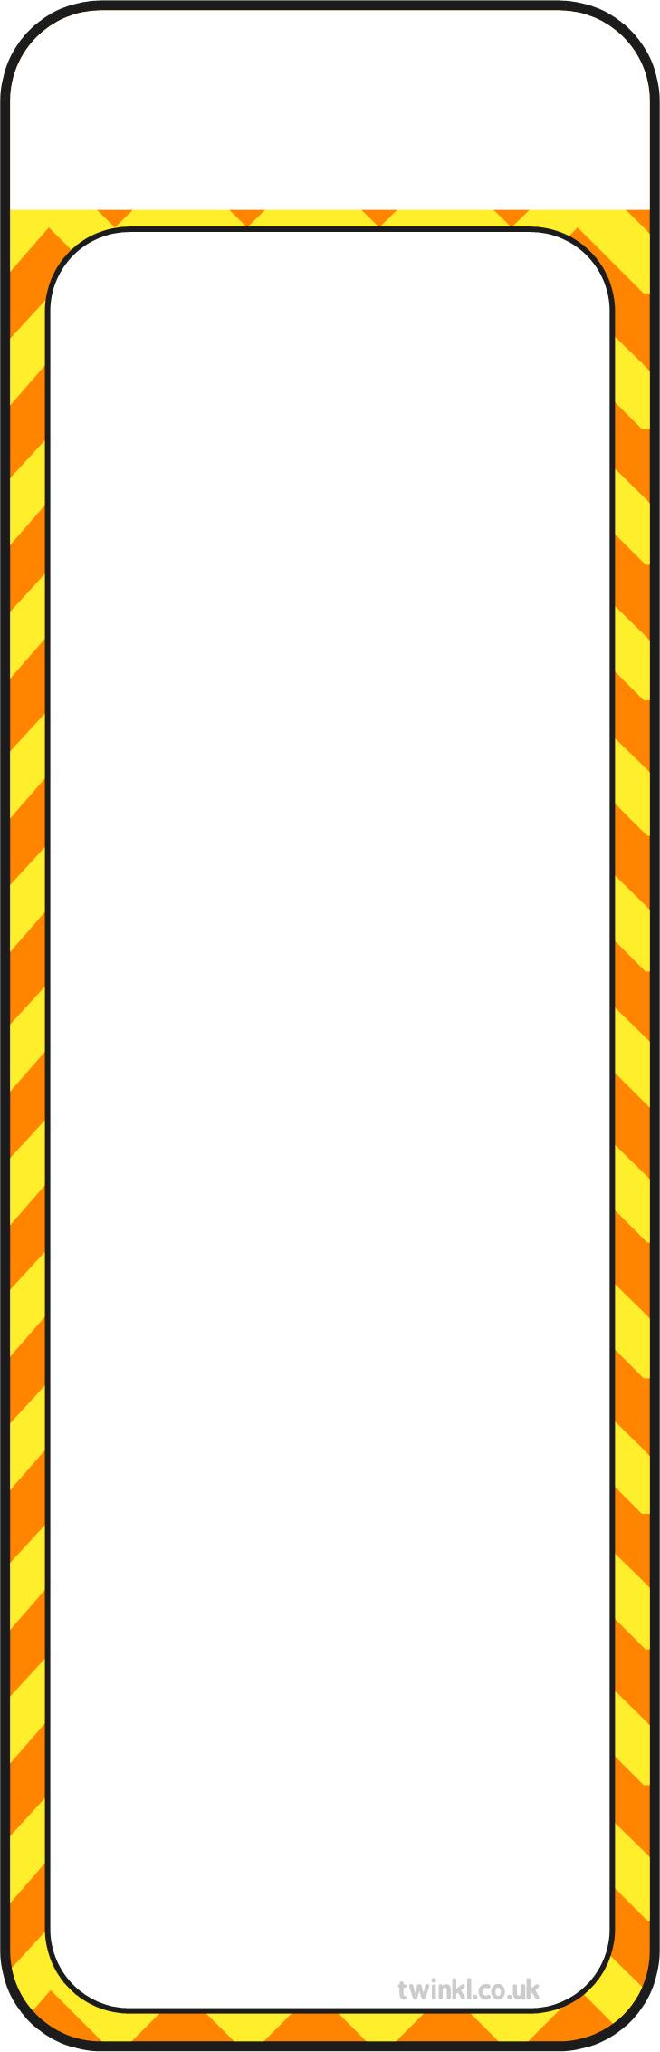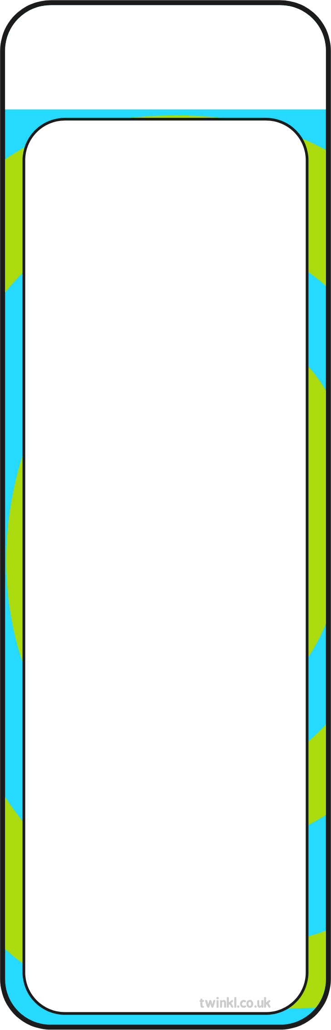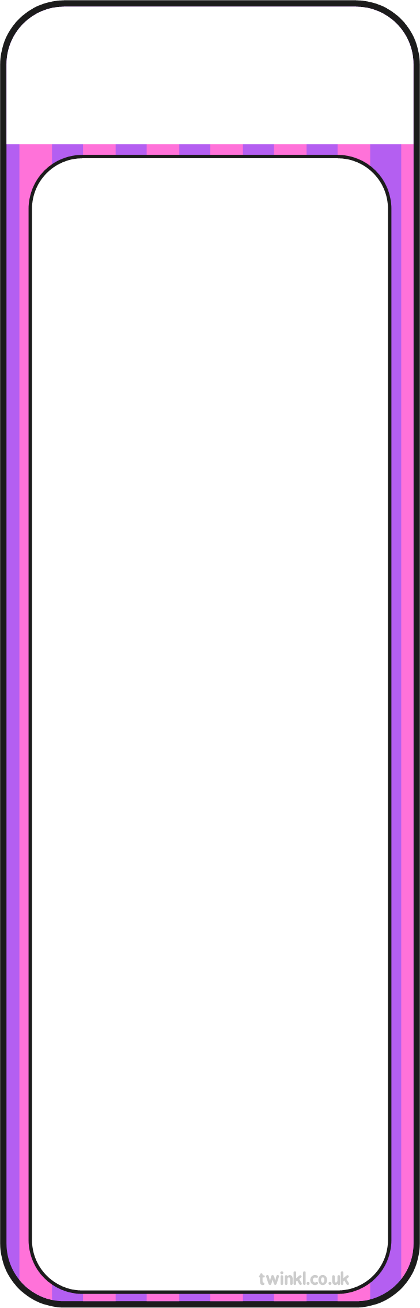
If you can’t read a word, say:
- Can you break it up?
- Are there any sounds you know?
- Do you know a word that looks like it?
- What could it say?
- Does the picture help?
- Do you recongise any words within it?
- Read to the end of the sentence and think about what words that might fit.
Sequencing questions
- What happens in the beginning of the story?
- How/where does the story start?
- What happened at the end of the…?
- Can you re-tell the story to me in 20 words or less?
- What happened before that?
Vocabulary Questions
- Can you find a word/sentence that tells/shows you that…
- Why do you think that the author used the word… to describe…?
- Can you find a word in the text that means the same as…?
- Find an adjective in the text.



Inference Questions
- What do you think…means? Why do you think that?
- Why do you think…?
- How do you think…?
- When do you think…?
- Where do you think…?
- How has the author made us think that…?

Retrieval Questions
- Who is/are the main character(s)?
- When/where is the story set?
- Which is your favourite/worst/ funniest/scariest part of the story? Why?
- Tell me three facts you have learnt from the text.
- Find the part where…
Prediction questions
- Where do you think… will go next?
- What do you think…will say/do next?
- What do you think this book will be about and why?
- What do you think will happen in this chapter?
- How do you think this will end?
- Who do you think has done it?
- What might…say about that?

Remember:
Enjoy the moment!

Share your thoughts and opinions!

Just five minutes every day makes a HUGE difference!
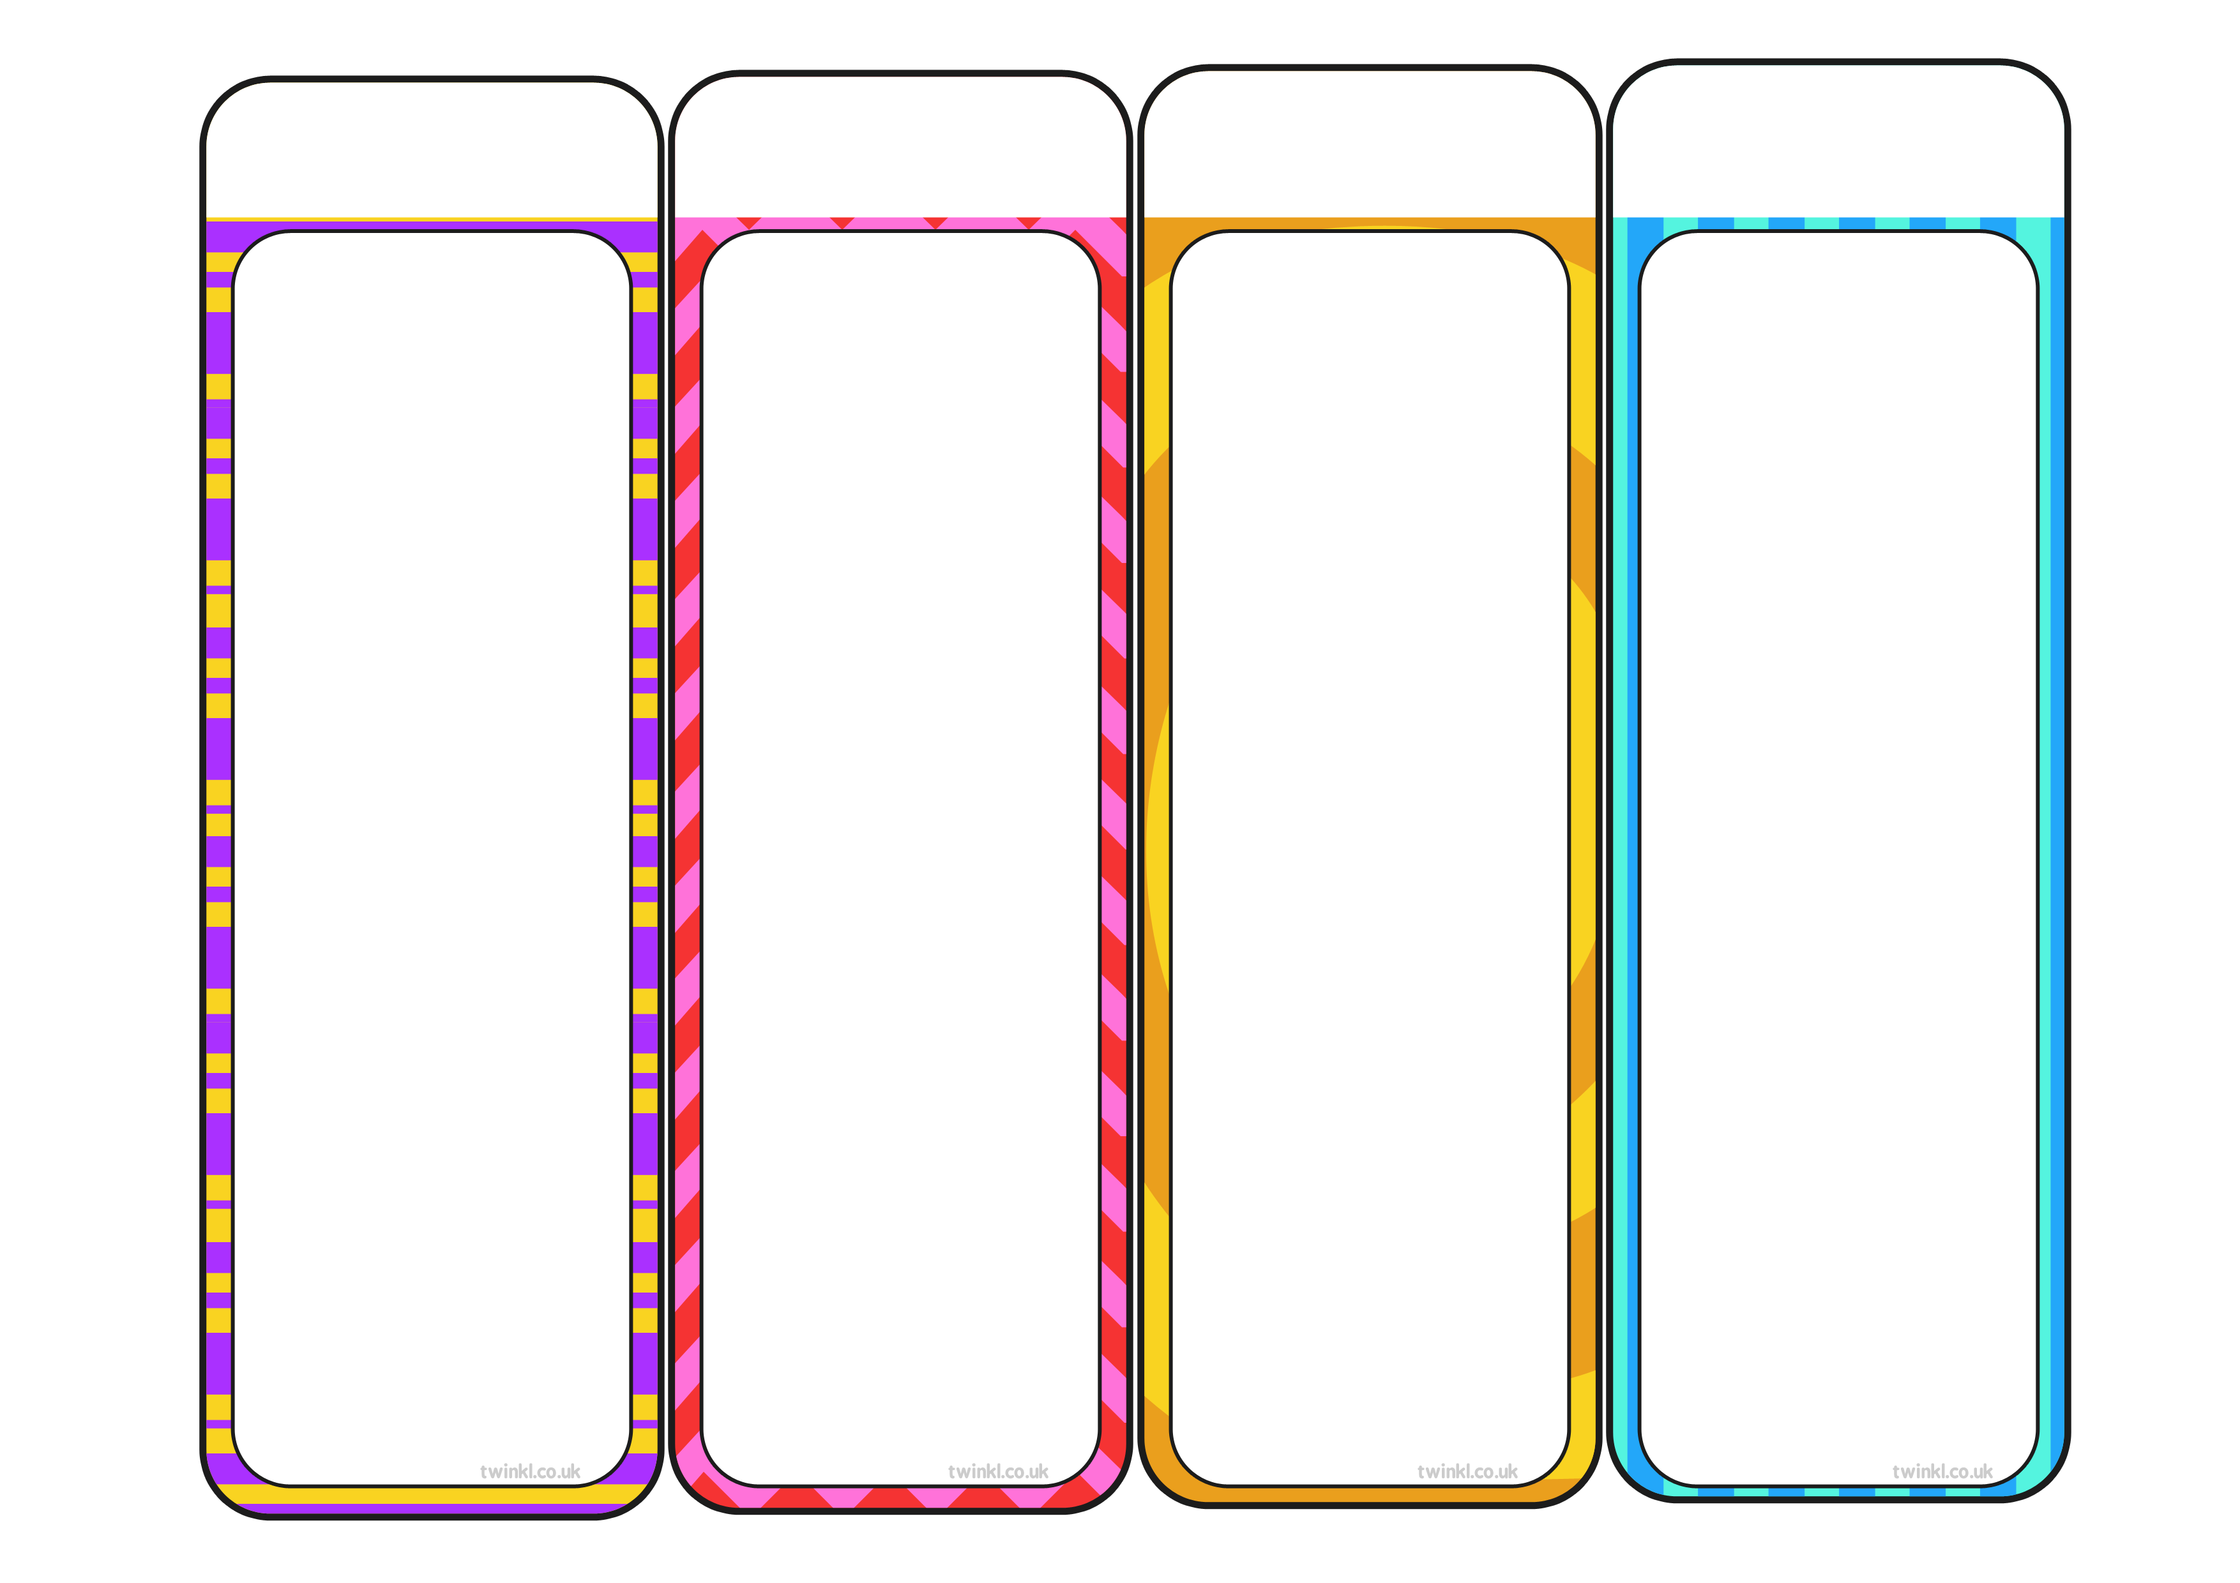
text
text
text
text
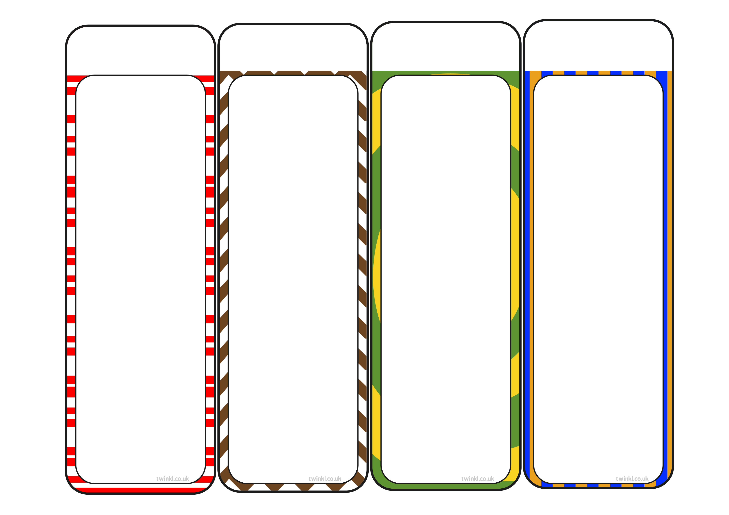
text
text
text
text

