Write a fact file about a Viking God or Goddess. | Research Viking Long Houses.  Can you design and make a long house out of materials you have at home? | Choose a city in the UK.  Create an information leaflet all about the city that you could give to a tourist! | Electricity hunt!  Can you go around your home and find things that use electricity?  Can you draw a picture of the things you found and whether it is using an electrical source or batteries? | Can you use an image of a Viking longboat and sketch it?  Remember to use your pencil lightly and practise cross hatching for added effect!
Brooches were often worn by Vikings to show their status in community.  Can you design and make your own brooch? You could use, paper, cardboard, tin foil. | Can you make your own parachute using things from home?  Drop it from a height and time how long it takes to fall to the ground. | Can you use a blank map of the UK and label it with key cities? Make sure you are putting them in the right places.  (You might even want to draw a map of the UK yourself) | Recycling invention!  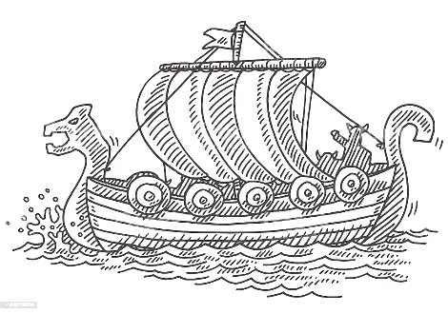  Using recycled materials can you create your own invention? | Can you make your own Viking bread?  Or you could try making the oatcake and fruit recipe which you can find on bitesize.  Viking food - KS2 History - BBC Bitesize

Homework Matrix – Spring term – Squirrels.



