

Mission Statement

A Caring Christian Family Where We Grow Together

Calculation Policy
A Guide for Teachers, TA’s and Parents

Effective Date: 13/10/19 Review Date: September 2022 Biennial

Review Date | Signed Head Teacher | Signed Director RCSAT
07/12/2018 | 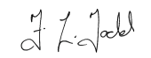 | 
18/12/2019
04/10/2020 | 
30/09/2022

Persons Responsible for Policy: | Executive Headteacher RCSAT
Approval Date | 01/04/2017
Signed: | Director RCSAT
Signed: | Executive Headteacher RCSAT

Contents
Introduction and rationale 2
What is this procedure for? 4
Addition 5
Subtraction 21
Multplication 37
Division 52

Introduction and Rationale

‘To believe in fixed ability is to believe in fixed futures…To believe in the transformability of learning capacity is to embrace the convictions…that human development is not predictable, the children’s futures are unknowable, that education has the chance to enhance the lives of all. ‘
Swann, Peacock, Hart and Drummond (2012), Creating Learning Without Limits, p.127

This calculation procedure sets out expectations for the mastery of addition, subtraction, multiplication and division as written in the National Curriculum 2014 as well as the progression of written methods as used at The Rural Church Schools Academy Trust. It is vital that pupils are taught according to the stage at which they are currently working, being moved onto mastery at greater depth as soon as they are ready, or working at a lower stage until they are secure enough to move on. Children should not be discouraged from using previously taught methods in which they are secure while new concepts are becoming embedded. Children will not be moved on to the next year group’s curriculum but moved onto solving more complex mathematical concepts for their current year group that require mastery at greater depth.

The expectation is that every child will reach MASTERY of the mathematics curriculum for their respective year group. A number of the high achieving (gifted) mathematicians in each year group will reach mastery at greater depth. Every attempt has to be made and every opportunity taken allow the children to demonstrate mastery and mastery at greater depth through a regular diet of fluency, problem solving and reasoning (FRP) activities. This not only allows the children to practice methods and calculations but also to apply them in and out of contexts and make links between mathematics and the wider curriculum. Under the National Curriculum 2014 (NC14) there is greater emphasis placed on children being able to solve problems and make connections by solving real life problems. This is an element that should be clear in most mathematics sessions taught.

Although this procedure focuses largely on written calculation methods it is important to recognise that the ability to calculate mentally lies at the heart of numeracy; in every written method there is an element of mental processing and children need to develop the mental skills and methods to allow them to do this efficiently. However, written recording can help children to clarify their thinking and supports and extends the development of more fluent and sophisticated strategies.

What is this procedure for?
This procedure is intended to demonstrate how we teach different forms of calculation at RCSAT schools. It is organised by year groups although some higher ability children may use methods from later year groups. In the KS2 tests at the end of Year 6, children are expected to use written formal methods for all four operations (addition, subtraction, multiplication and division).
This procedure is designed to help teachers and TAs at the school ensure that calculation is taught consistently across the school and to aid them in helping children who may need extra support or challenges.
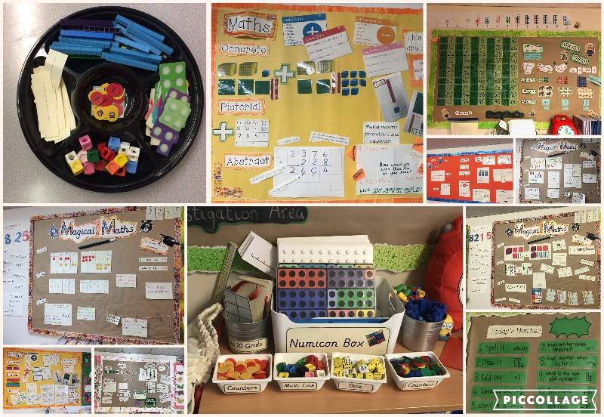
This procedure is also designed to help parents, carers and other family members support children’s learning by letting them know the expectations for their child’s year group and by providing an explanation of the methods used in our school.

The teaching of Maths in Foundation Stage:
The teaching of mathematics in the Foundation Stage consists of daily maths workshops that focus on specific areas of the subject. These sessions focus on counting, using number names in the correct order and recognising numbers in the environment. The children learn through a range of practical contexts using images, objects, stories, rhymes and songs to engage and promote the importance of number. The children are introduced to the language of ‘more or less’ and start to recognise simple shapes from everyday objects. They begin to develop early problem-solving skills to encourage them to use maths outside of the classroom. In Reception, maths teaching is based on the EYFS curriculum and supported by the use of White Rose 'Mastery Maths' resources. Whilst lessons are conducted in a Maths No Problem format (due to a lack of EYFS MNP resources) to ensure whole school consistency.



National Curriculum Objectives: Addition objectives from Addition  and Subtraction Strand | Key Skills/ other linked NC Objectives (Place Value) | Key Vocabulary
- Read. Write and interpret mathematical symbols involving addition (+) and equals (=) signs.  - Represent and use number bonds within 20.  - Add one-digit and two-digit numbers to 20, including 0.  - Solve one step problems that involve addition, using concrete objects and pictorial representations and missing  number problems. | - Count forwards to and across 100, beginning with 0 or 1, or from any given number.  - Count, read and write numbers to 100 in numerals.  - Given a number, identify one more.  - Identify and represent numbers using objects and pictorial representations including the number line.  - Read and write numbers from 1-20  in numerals and words. | Addition, add, altogether, put together, sum, and, plus, total  Equals, equal to, makes  more than, less than, fewer, most, least
Children should:
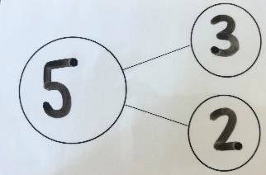
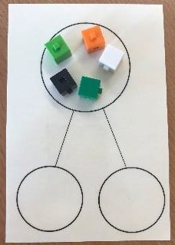
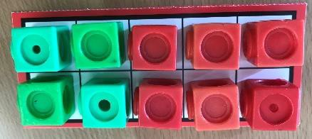
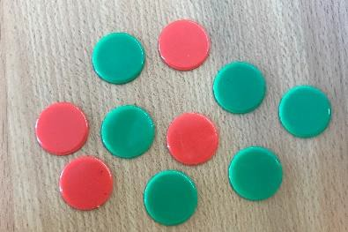
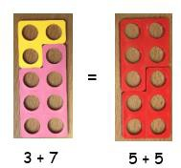
- Have access to a wide range of counting equipment, everyday objects, number tracks and number lines, and be shown numbers in different contexts. They should explore number and the different ways the numbers can be partitioned (representing and using number bonds within 20).
- Read and write the addition (+) and equals (=) signs within number sentences. Specific learning should take place, through exploration of number, around the equals sign, ensuring children understand it’s role within a number sentence and that it does not always just indicate where the answer goes.

- Interpret addition number sentences and solve missing box problems, using concrete objects and number line addition to solve them: 8 + 3 = , = 15 + 4 and
14 = + 9.
- Where children are not yet secure in their Early Learning Goals, they should be given the opportunity to consolidate these foundations.
Mental Methods- The children should be taught to use the following mental strategies, and to use jottings to support their methods:
- Counting on in ones
- Re-ordering the numbers when adding e.g. put the larger number first
- Counting on and back in ones, twos and tens
- Looking for pairs of numbers that equal 10
- Partitioning small numbers to bridge tens e.g. 8+3 = 8+2+1
- Partitioning using known facts e.g. double and adjust 5+6 = 5+5+1
- Adding 9 to a number by adding 10 and then subtracting 1
- Recalling number bonds to 10 and 20 in several different forms (e.g. 9+7 = 16, 16-7=9 and 7=16-9)
Written Methods: Building on the prior learning, and exploration of number outlined above, children should:
- Use numbered number lines to add, by counting on in ones. Children should be encouraged to start with the larger number.
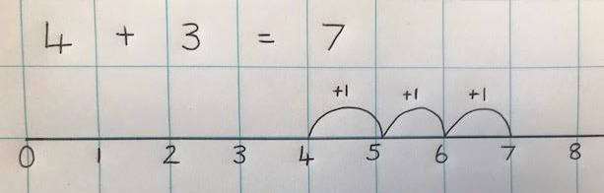
- Once confident using a number line for addition, children should be taught to use their understanding of partitioning numbers and number bonds to bridge tens.
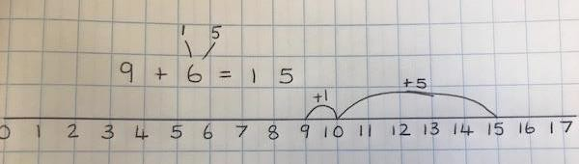



National Curriculum Objectives: Addition objectives from Addition and Subtraction Strand | Key Skills/ other linked NC Objectives (Place  Value) | Key Vocabulary
Solve problems with addition  - Using concrete objects and pictorial representations, including those involving numbers, quantities and measures.  - Apply their increasing knowledge of mental and written methods.  Add numbers using concrete objects, pictorial representations and mentally:  - Add two-digit numbers and ones.  - Add two-digit numbers and tens.  - Add two, two-digit numbers.  - Add three one-digit numbers.  - Recall and use addition facts up to 20 fluently and derive and use related facts up to 100.  - Show that addition can be done in any order.  - Recognise and use the inverse relationship between addition and subtraction and use this to check calculations and solve missing box  number problems. | - Count in steps of 2, 3 and 5 and count in tens from any number  - Understand the place value of 2-digit numbers (tens, ones)  - Compare and order numbers to 100 and use  <, > and = signs.  - Read and write numbers to at least 100 in numerals and words.  - Identify, represent and estimate numbers using different representations, including the number line. | Addition, add, altogether, put together, sum, and, plus, total  Equals, equal to, makes  more than, less than, fewer, most, least, double  N.B: Same vocabulary as Year 1, to be consolidated and extended in different contexts.

Children should:
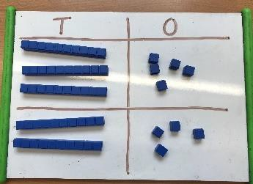
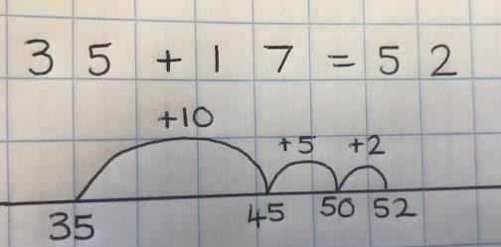
- Have access to a wide range of practical resources and equipment, counting materials, models and images and should be given the opportunity to use these to support their understanding of mental and written methods at all stages.
- Spend time learning and practising mental methods for addition, starting with questions which do not cross boundaries and progressing to those that do. This will include exploring number and different ways to partition number, to support addition strategies as well as adding the nearest multiple of 10 and adjusting (e.g. to add 9, 19 etc.), using near doubles and partitioning and recombining.

Mental Methods: The children should be taught to use the following mental strategies, and to use jottings to support their methods:

- Reordering numbers when adding
- Count on in tens or ones
- Using knowledge of pairs making 10 and place value
- Compensating: add 9, 19, 11 or 21 by rounding and adjusting
- Compensating: doubling and adjusting.
- Partitioning: Bridge through 10 when adding.
- Partition and combine multiples of tens and ones.
- Looking for number bonds/known facts when adding 3 one-digit numbers.

Steps for Written Methods:
All steps to be supported by concrete and pictorial, with a focus on Year 2 children becoming confident in using a blank number line as a jotting for their mental method as well as a pictorial representation to prepare them for more formal written methods in the future.

Step 1: Adding two, two-digit numbers and tens

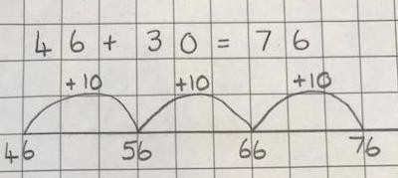
Children build on their previous learning and progress from adding one-digit numbers to adding multiples of 10.

Step 2: Adding two, two-digit numbers
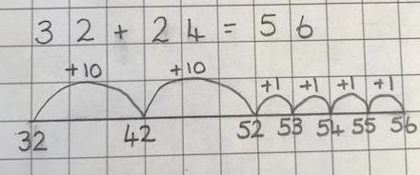
Once confident with the above, and using their ability to partition two- digit numbers into tens and ones, children add two two-digit numbers on a number line.
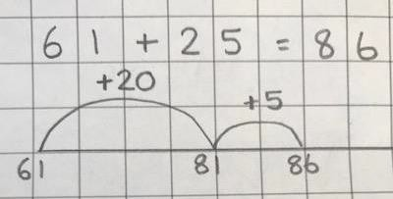
Step 3: Using number lines efficiently
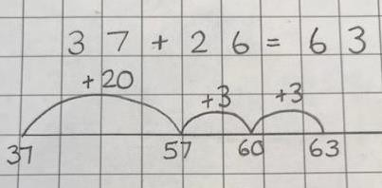
When children are showing a secure understanding of the above steps, they should be taught to use number lines to calculate in the most efficient way. This will include partitioning numbers to bridge tens, as in the second example.

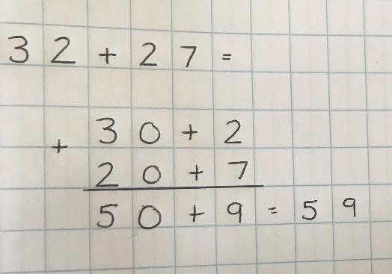
Step 4: Partitioned Column Method
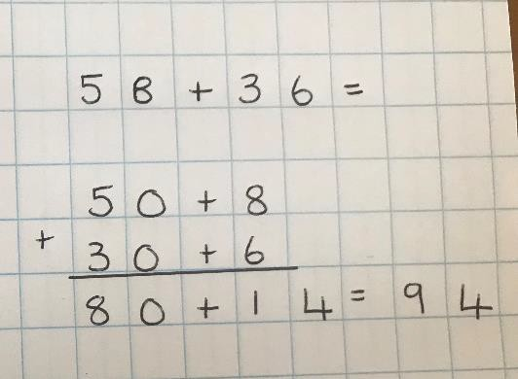
Those children who are ready, may progress to a partitioned column method. Children to progress only when they have really mastered the previous steps and have shown understanding through their mental methods. Children to work with examples which do not cross boundaries first, before progressing (if they are ready) to those which do.



National Curriculum Objectives: Addition objectives from Addition and  Subtraction Strand | Key Skills/ other linked NC Objectives (Place Value) | Key Vocabulary
- Add numbers mentally, including three-digit numbers and ones.  - Add numbers mentally, including three-digit numbers and tens.  - Add numbers mentally, including three-digit numbers and hundreds.  - Add numbers with up to 3 digits, using formal written method of columnar addition.  - Estimate the answer to a calculation and use inverse operations to check answers.  - Solve problems including missing number problems, using number  facts, place value, and more complex addition. | - Find 10 or 100 more than a given number.  - Recognise the place value of each digit in a three-digit number.  - Identify, represent and estimate numbers using different representations.  - Read and write numbers up to 1000 in numerals in words.  - Compare and order numbers up to 1000. | KS1 Vocab plus:  Combined, more, column, carrying, expanded, compact

Children should:
- Have access to a wide range of practical resources and equipment, counting materials, models and images and should be given the opportunity to use these to support their understanding of mental and written methods at all stages.

- Spend time learning and practising mental methods for addition, starting with questions which do not cross boundaries and progressing to those that do. This will include exploring number and different ways to partition number, to support addition strategies as well as adding the nearest multiple of 10 and adjusting (e.g. to add 9, 99 etc.), using near doubles and partitioning and recombining.
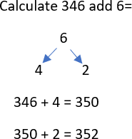
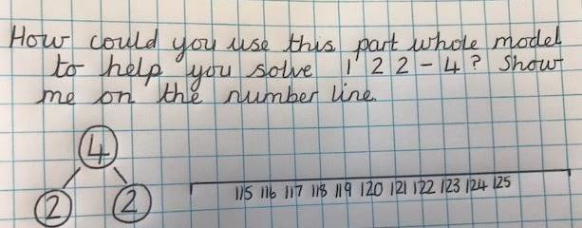

Mental Methods: The children should be taught to use the following mental strategies, and to use jottings to support their methods, where appropriate:

  - Counting on in hundreds, tens and ones to find the total.
  - Partitioning into hundreds, tens, and ones in different ways, then recombine (824= 800+ 20 + 4, 824=700 + 110 +14).
  - Reorder the numbers when adding.
  - Bridge through a multiple of 10, then adjust.
  - Use known facts and place value to add
  - Use patterns of similar calculations
  - Compensating: add or subtract 10, 20 or 100 and adjust.

Steps for Written Methods:

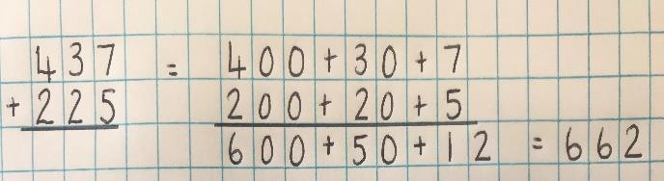
Step 1: To apply expanded column methods from Y2 when adding three- digit numbers. This may be new teaching for the children, depending on whether they were ready for this in Year 2.
Therefore, they may need to track back.

Step 2: Introduce the expanded column method.

Step 2 and Step 3 can be taught alongside each other to ensure the children understand the value of the numbers they are adding in the compact method.

Step 3: Move to the compact column addition, first without carrying and then with.

Ensure correct use of vocabulary throughout.
E.g. we are adding 3 tens and 7 tens (30 and
70) to make 10 tens or 100, as opposed to 3 and 7 equals 10.
Add the ones column first, in preparation for the compact method.

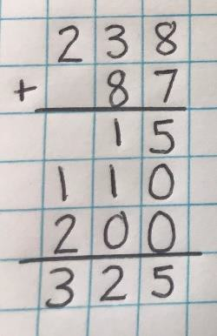
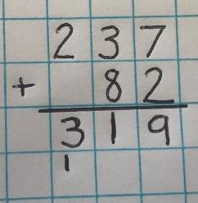
Add the ones first.
Carry numbers underneath the bottom line.



National Curriculum Objectives: Addition objectives from Addition and  Subtraction Strand | Key Skills/ other linked NC Objectives (Place Value) | Key Vocabulary
- Add numbers with up to 4 digits using the formal methods of columnar addition where appropriate.  - Estimate and use the inverse operations to check answers to a calculation.  - Solve two-step addition problems in contexts, deciding which operations to use and why. | - Find 1,000 more than a given number.  - Recognise the place value of each digit in a four-digit number.  - Identify, represent and estimate numbers using different representations.  - Compare and order numbers  beyond 1000. | All previously taught vocabulary, plus:  Inverse, operation, opposite, increase

Children should:
- Have access to a wide range of practical resources and equipment, counting materials, models and images and should be given the opportunity to use these to support their understanding of mental and written methods at all stages.
- Be given time to extend their previous work on adding multiples of 10 and 100 to adding 1000s too.
- Spend time learning and practising mental methods for addition. This will include exploring number and different ways to partition number, to support addition strategies as well as adding the nearest multiple of 10, 100 and 1000 and adjusting (e.g. to add 9, 49, 99 999 etc), using near doubles and partitioning and recombining.
Mental Methods: The children should be taught to use the following mental strategies, and to use jottings to support their methods, where appropriate:

  - Count in steps of thousands, hundreds, tens and ones.
  - Reorder numbers in a calculation
  - Add 3 or 4 small numbers
  - Partition: adding the most significant digit first
  - Compensating: doubling and adjusting
  - Compensating: Adding the nearest multiple of 10 or 100 and then adjust
  - Using knowledge of place value and related calculations e.g. working out 150 +140 = 290 by using 15 + 14 = 29.

Written Methods:
Recap the children’s understanding of Year 3 calculation strategy, moving to the compact column method adding the ones first and carrying numbers underneath the calculation.

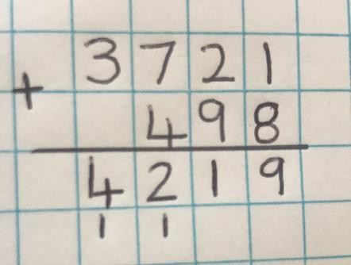

Ensure correct use of vocabulary throughout. E.g. we are adding 5 hundreds and 3 hundreds, not 5 add 3 for example.

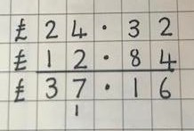
Teach children to apply their use of the column methods to decimal numbers.

Apply column method to money and measurement values.
The decimal point should be aligned in the same way as the other place value columns and must be in the same column in the answer.



National Curriculum Objectives: Addition objectives from Addition and  Subtraction Strand | Key Skills/ other linked NC Objectives (Place Value) | Key Vocabulary
- Add whole numbers with more than 4 digits, including using formal written methods (columnar addition).  - Add increasingly large numbers mentally.  - Solve addition multi-step problems in contexts, deciding which operations  and methods to use and why. | - Read, write and compare numbers to at least 1,000,000 and determine the value of each digit.  - Count forwards in steps of powers of ten for any given number up to 1,000,000. | All previously taught vocabulary, plus  Tenths, hundredths, thousandths, decimal places, decimal point

Children should:
- Have access to a wide range of practical resources and equipment, counting materials, models and images and should be given the opportunity to use these to support their understanding of mental and written methods at all stages.
- Spend time learning and practising mental methods for addition. This will include exploring number and different ways to partition number, to support addition strategies as well as adding the nearest multiple of 10, 100 and 1000 and adjusting (e.g. to add 9, 49, 99 999 etc.); using near doubles; partitioning and recombining; inverse and using number bonds.

Mental Methods: The children should be taught to use the following mental strategies, and to use jottings to support their methods, where appropriate:
  - Counting on in steps of 0.1, 1, 10, 100 or 1,000
  - Reorder the numbers in a calculation
  - Partitioning, adding the most significant digit first
  - Compensating: Add a multiple of 10, 100 or 1,000 and adjust.
  - Compensating: Double and adjust.
  - Use knowledge of place value and related calculations e.g.6.3 + 4.8 using 63 + 48

Written Methods:
To include money, measures and decimals with different numbers of decimal places.

The decimal point should be aligned in the same way as their other place value columns and must be in the same column in the answer.

Numbers should exceed 4 digits.

Pupils should be able to add more than two values, carefully aligning place value columns.
Children should understand the place value of tenths and hundredths and use this to align numbers with different numbers of decimal places.

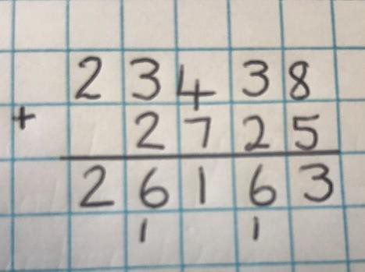
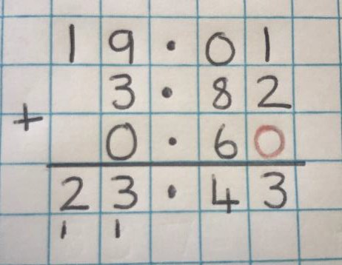

Empty decimal places should be filled with zero to show the place value of the column.
Ensure correct vocabulary is used throughout. E.g. 6 tenths and 7 tenths equals 13 tenths.



National Curriculum Objectives: Addition objectives from Addition, subtraction,  multiplication and division strand. | Key Skills/ other linked NC Objectives (Place Value) | Key Vocabulary
- Perform mental calculations, including with mixed operations and large numbers.  - Use their knowledge of the order of operations to carry out calculations involving the four operations.  - Solve addition multi-step problems in contexts, deciding which operations and methods to use and why.  - Solve problems involving four- operations.  - Use estimation to check answers to calculations. | - Read, write, order and compare numbers up to 10,000,000 and determine the value of each digit. | Consolidate use of all previously taught vocabulary.
Children should:
- Have access to a wide range of practical resources and equipment, counting materials, models and images and should be given the opportunity to use these to support their understanding of mental and written methods at all stages.
- Spend time learning and practising mental methods for addition. This will include exploring number and different ways to partition number, to support addition strategies as well as adding the nearest multiple of 10, 100 and 1000 and adjusting (e.g. to add 9, 49, 99 999 etc.); using near doubles; partitioning and recombining; inverse and using number bonds.
Mental Methods: The children should be taught to use the following mental strategies, and to use jottings to support their methods, where appropriate.
- Consolidate all strategies from previous years
- Partition, adding the most significant digit first
- Compensating: adding a whole number, multiple of 10 or double and adjust.
- Use knowledge of place value and related calculations e.g. 680 + 430, 6.8 + 4.3, 0.68 +
0.43 can all be worked out using the related calculation 68 + 43.

Written Methods:
Written method of column addition should be used in a variety of contexts and with numbers of increasing size and complexity.

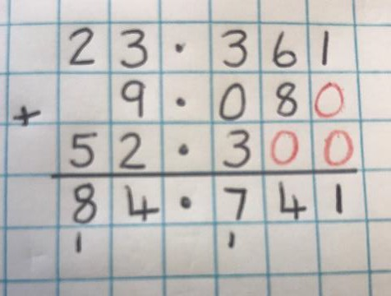
This should include addition several numbers with different numbers of decimal places (including in the context of measures and money).
Tenths, hundredths and thousandths should be correctly aligned, with the decimal place lined up vertically, including in the answer row.
Zeros should be added into empty decimals places to show there is no value to add.

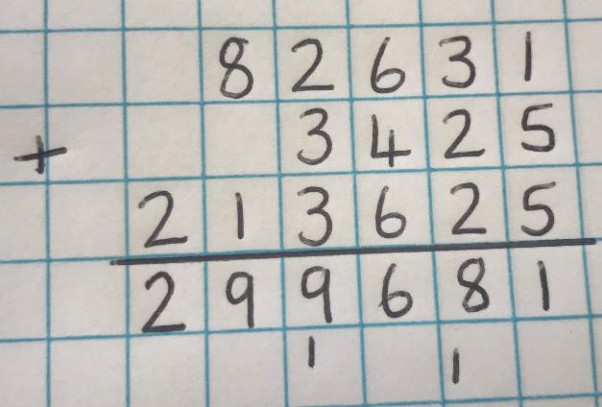
Adding several numbers with more than four- digits.



National Curriculum Objectives: Subtraction objectives from Addition and Subtraction  Strand | Key Skills/ other linked NC Objectives (Place Value) | Key Vocabulary
- Read. Write and interpret mathematical symbols involving subtraction (-) and equals (=) signs.  - Represent and use related subtraction facts within 20.  - Subtract one-digit and two-digit numbers to within 20, including 0  - Solve one step problems that involve subtraction, using concrete objects and pictorial representations and missing number problems. | - Count backwards from and across 100, beginning from any given number.  - Count, read and write numbers to 100 in numerals.  - Given a number, identify one less.  - Identify and represent numbers using objects and pictorial representations including the number line.  - Read and write numbers from 1-20 in numerals and  words. | Subtraction, subtract, take away, minus  Halve, half,  Difference, distance between  Less, least, few, fewest

Children should:
- Have access to a wide range of counting equipment, everyday objects, number tracks and number lines, and be shown numbers in different contexts.


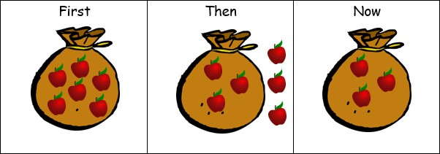
- Consolidate their understanding of subtraction practically, showing subtraction on bead strings, using cubes etc. They should then use practical resources alongside pictures to make the link between concrete and pictorial representations.
- Read and write the subtraction (-) and equals (=) signs within number sentences. Specific learning should continue, through exploration of number and use of practical resources, around the equals sign, ensuring children understand it’s role within a number sentence and that it does not always just indicate where the answer goes.
- Interpret addition number sentences and solve missing box problems, using concrete objects and number line subtraction to solve them: 8 - 3 = 15 - =10 and 9 = 14 -
5
.
- Be introduced to finding the difference. This will be introduced practically, using the language
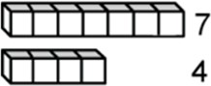
‘find the distance between’ and ‘How many more?’
7 is 3 more
than 4

Mental Methods- The children should be taught to use the following mental strategies, and to use jottings to support their methods:
- Count back in ones
- Find one less than a number
- Find 10 less than a multiple of 10
- Take away a small number by counting back
- Find a small difference by counting on (using equipment)
- Begin to bridge through 10 when subtracting a one-digit number
- Start to recall subtraction facts up to and within 10 and 20 and understand subtracting 0.
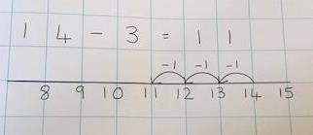
Written Methods: Building on the prior learning, and exploration of number outlined above, children should

Use numbered number lines to subtract, by counting back in ones, marking the jumps on a number line or number track

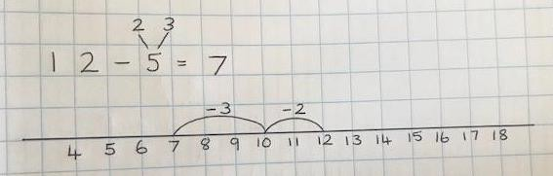
Once confident using a number line for subtraction, children should be taught to use their understanding of partitioning numbers and number bonds to bridge tens.



National Curriculum Objectives: Subtraction  objectives from Addition and Subtraction Strand | Key Skills/ other linked NC  Objectives (Place Value) | Key Vocabulary
Solve problems with subtraction  - Using concrete objects and pictorial representations, including those involving numbers, quantities and measures.  - Apply their increasing knowledge of mental and written methods.  Add numbers using concrete objects, pictorial representations and mentally:  - Subtract two-digit numbers and ones.  - Subtract two-digit numbers and tens.  - Subtract two, two-digit numbers.  - Recall and use subtraction facts within 20 fluently and derive and use related facts up to 100.  - Show that subtraction cannot be done in any order.  - Recognise and use the inverse relationship between addition and subtraction and use this to check calculations and solve missing box  number problems. | - Count in steps of 2, 3 and 5 and count in tens from any number  - Understand the place value of 2-digit numbers (tens, ones)  - Compare and order numbers to 100 and use <, > and = signs.  - Read and write numbers to at least 100 in numerals and words.  - Identify, represent and estimate numbers using different representations, including the number line. | Subtraction, subtract, take away, minus  Halve, half,  Difference, distance between  Less, least, few, fewest  N.B: Same vocabulary as Year 1, to be consolidated and extended in different contexts.

Children should:
- Continue to have access to a wide range of counting equipment, everyday objects, number tracks and number lines, and be shown numbers in different contexts.
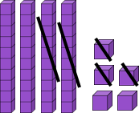

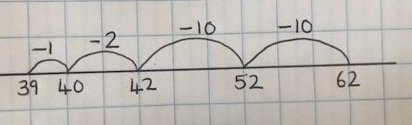
- Consolidate their understanding of subtraction practically, showing subtraction on bead strings, using cubes etc. They should then use practical resources alongside pictures to make the link between concrete and pictorial representations.

- Read and write the subtraction (-) and equals (=) signs within number sentences. Specific learning should continue, through exploration of number and use of practical resources, around the equals sign, ensuring children understand it’s role within a number sentence and that it does not always just indicate where the answer goes.

- Interpret addition number sentences and solve missing box problems, using concrete objects and number line subtraction to solve them: E.g 28 - 3 = 35 - = 21 and = 24 - 9 .
5
- Be introduced to finding the difference, continuing to develop understanding of this e.g. find the distance, how many more, how many less etc. Children to start to develop an understanding of the different methods that can be used for this (counting back, counting on) and when we might use each.

Mental Methods:
  - Counting back in tens and ones.
  - Subtract mentally a ‘near multiple of 10’ by subtracting and adjusting
  - Subtract a small number by counting back.
  - Find a small difference by counting up from the smaller to the larger number (on a number line)
  - Recalling subtraction facts for numbers to 20 and using these to derive the related facts up to 100.
  - Subtract by partitioning the second number and subtracting tens then ones.
  - Use patterns of similar calculations.

Steps for Written Methods.
All steps to be supported by concrete and pictorial, with a focus on Year 2 children becoming confident in using a blank number line as a jotting for their mental method as well as a pictorial representation to prepare them for more formal written methods in the future.

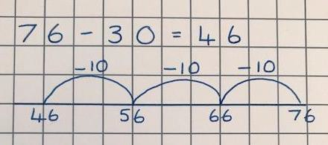
Step 1: Subtracting two-digit numbers and tens.

Children build on their previous learning and progress from subtracting one-digit numbers to subtracting multiples of 10.

Step 2: Subtracting two, two-digit numbers.
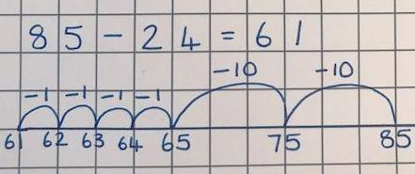
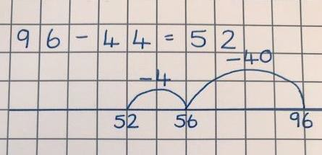
Once confident with the above, and using their ability to partition two-digit numbers into tens and ones, children subtract a two-digit number from a larger two-digit number on a number line.

Step 3: More efficient methods for subtraction.
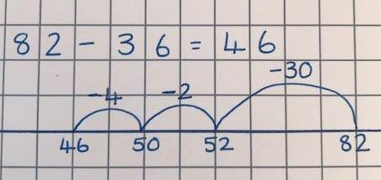
When children are showing a secure understanding of the above steps, they should be taught to use number lines to calculate in the most efficient way. This will include partitioning numbers to bridge tens, as in the second example.



National Curriculum Objectives: Subtraction objectives from Addition and Subtraction  Strand | Key Skills/ other linked NC Objectives (Place Value) | Key Vocabulary
- Subtract numbers mentally, including three-digit numbers and ones.  - Subtract numbers mentally, including three-digit numbers and tens.  - Subtract numbers mentally, including three-digit numbers and hundreds.  - Subtract numbers with up to 3 digits, using formal written method of columnar subtraction.  - Estimate the answer to a calculation and use inverse operations to check answers.  - Solve problems including missing number problems, using number facts,  place value, and more complex subtraction. | - Find 10 or 100 more than a given number.  - Recognise the place value of each digit in a three-digit number.  - Identify, represent and estimate numbers using different representations.  - Read and write numbers up to 1000 in numerals in words.  - Compare and order numbers up to 1000. | KS1 Vocab plus:  Fewer, less, reduce, how many less? How many remain?  Exchange, decrease, value, digit, hundreds

Children should:
- Continue to use practical resources alongside the developing calculation strategies. These will include dienes, place value counters, place value charts, digit cards etc and will be appropriate for support children’s subtraction with three-digit numbers.

- Apply their understanding of using concrete resources to using pictorial representations alongside their abstract calculations.
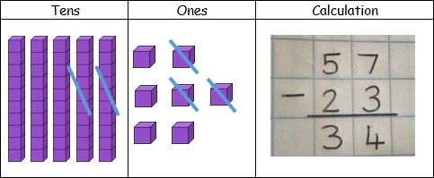
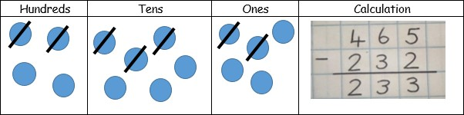

- Continue to develop their understanding of finding the difference. They should experience difference contexts and representations for doing this and start to become more secure with choosing the most effective strategy to do this.

Mental Methods:
  - Counting back in hundreds, tens and ones.
  - Counting on as a mental strategy for subtraction when the numbers are close together (e.g. 131-129), and for finding a small difference.
  - Compensating: subtract mentally a near multiple of 10 then adjust.
  - Bridging through a multiple of 10
  - Use knowledge of number facts and place value to subtract pairs of numbers
  - Subtract a two-digit number by partitioning it then subtracting tens and ones.
  - Use patterns of similar calculations
  - Use the relationship between addition and subtraction.

Written Methods:
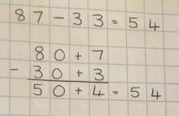
Step 1:
Introduce this method with examples where no exchanging is required. Use this as an opportunity to reinforce place value and check children’s understanding before moving on.
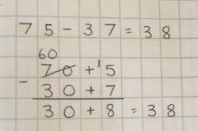
Step 2:
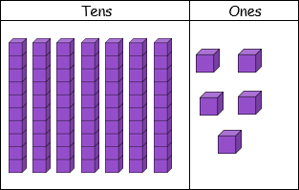
Introduce exchanging through practical subtraction. Make the larger number with dienes and then physically exchange a row of 10 for ten ones. Model how to record this.
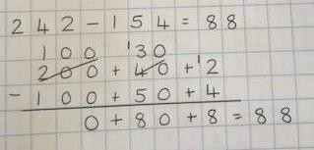
Step 3:
Once the children are secure with the ‘exchanging’ method, they can use this to subtract two and three-digit numbers in a variety of contexts.
Step 4:
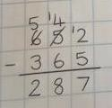
If children are ready, and have a secure understanding of the maths involved, they may use compact column subtraction for three-digit numbers. However, children must not be moved onto this stage too soon.



National Curriculum Objectives: Subtraction objectives from Addition and Subtraction  Strand | Key Skills/ other linked NC Objectives (Place Value) | Key Vocabulary
- Subtract numbers with up to 4 digits using the formal methods of columnar addition where appropriate.  - Estimate and use the inverse operations to check answers to a calculation.  - Solve two-step addition problems in contexts, deciding which operations to  use and why. | - Find 1,000 more than a given number.  - Recognise the place value of each digit in a four-digit number.  - Identify, represent and estimate numbers using  different representations. | All previously taught vocabulary, plus  Reverse, backwards, remove, decrease, inverse

Children should:
    - Continue to use concrete and pictorial resources to build their understanding as they apply their previous learning to subtracting four-digit numbers.
    - Be given the opportunity to explore and use different written and mental strategies in a range of contexts, discussing how effective the strategies are and why. Children should start to select the most effective strategies.
    - Continue to develop their understanding of finding the difference, choosing the most appropriate strategies to do so.

Mental Methods
    - Counting on and back in thousands, hundreds, tens, ones.
    - Use known facts and place value to subtract
    - Counting on to subtract when the numbers are close together.
    - Find a different by counting up through the next multiple of 10, 100 and 1,000
    - Compensating: Subtracting the nearest multiple of 1, 10, 100 or 1,000 and adjust.

Written Methods:

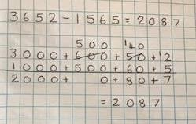
Step 1:
Return to the expanded column method and use practical resources and pictures to reinforce previous learning and extend to subtracting four-digit numbers.

Step 2:
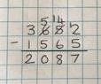
Compact column subtraction. Ensure children have the opportunity to apply this method to a variety of different contexts, including money and measures.

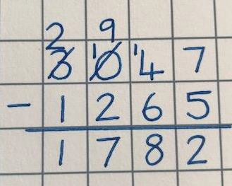
Ensure children have experience of using this method for subtraction where there is a 0 in the column they need to exchange from, and that they understand, through clear modelling (using practical resources) how to move to the next column and exchange then ‘move’ the value along.



National Curriculum Objectives: Subtraction objectives from Addition and Subtraction  Strand | Key Skills/ other linked NC Objectives (Place Value) | Key Vocabulary
- Subtract whole numbers with more than 4 digits, including using formal written methods (columnar subtraction).  - Subtract increasingly large numbers mentally.  - Solve subtraction multi-step problems in contexts, deciding which operations  and methods to use and why. | - Read, write and compare numbers to at least 1,000,000 and determine the value of each digit.  - Count backwards in steps of powers of ten  for any given number up to 1,000,000. | All previously taught vocabulary, plus  Tenths, hundredths, decimal, decimal point

Children should:
- Continue to be given the opportunity to work with practical resources and pictorial representations in order to consolidate and extend their understanding of the maths which underpins the methods. They should be interpreting pictorial representations as part of their varied fluency, reasoning and problem solving.
- Be becoming, through regular practise, discussion and modelling, more independent in their ability to select the most efficient methods. They should be given regular opportunities to solve the same problem in several different ways and discuss their findings (this includes finding the difference).

Mental Methods:
- Counting back steps of 0.1, 1, 10, 100 or 1000
- Use known facts and place value to subtract
- Find a difference by counting on through the next multiple of 10, 100 or 1,000
- Subtract by counting up from the smaller to the larger number where this is the most efficient method
- Subtract the nearest multiple of 1, 10 or 100 then adjust
- Use knowledge of place value and related calculations e.g. 4.5 - 3.6 using 45-36
- Use the relationship between addition and subtraction

Written Methods: Compact Column Subtraction
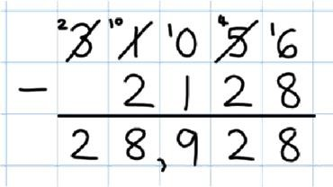
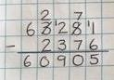
Children use this method to subtract increasingly large and complex numbers, in a range of contexts.
Those children who are not ready for this, should become confident with the expanded column method first.

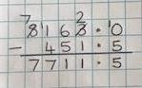
Children should be taught to use this method to subtract decimals, including mixtures of whole numbers and decimals, ensuring they align the decimal point correctly.
Children should be taught to add a zero in any empty decimal places to aid understanding of what to subtract in that column.

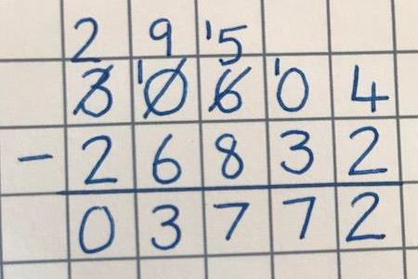
Ensure children have experience of using this method for subtraction where there is a 0 in the column they need to exchange from, and that they understand, through clear modelling (using practical resources) how to move to the next column and exchange then ‘move’ the value along.
Children to have lots of opportunities for subtracting and finding the differences with money and measures.



National Curriculum Objectives: Subtraction objectives from Addition, Subtraction,  Multiplication and Division Strand | Key Skills/ other linked NC Objectives (Place Value) | Key Vocabulary
- Perform mental calculations, including with mixed operations and large numbers.  - Use their knowledge of the order of operations to carry out calculations involving the four operations.  - Solve subtraction multi-step problems in contexts, deciding which operations and methods to use and why.  - Solve problems involving four- operations.  - Use estimation to check answers to  calculations. | - Read, write, order and compare numbers up to 10,000,000 and determine the value of each digit. | Consolidate use of all previously taught vocabulary.

Children should:
- Be given the opportunity to apply their previous learning into new contexts and use it to solve problems in different ways.
- Where children are not confident with previous learning or do not have a solid understanding of the place value and maths underpinning the strategies, they should have the opportunity to track back and fill these gaps in their learning.
- Children should be given the opportunity to regularly and independently select the most effective method from their repertoire.
- Children should be given the opportunity to interpret and use mathematical pictures and practical resources as part of their varied fluency, reasoning and problem solving.

Mental Methods:
- Consolidate all mental strategies from previous year groups.
- Counting back in powers of tens, including tenths, hundredths and thousandths.
- Use knowledge of place value and related calculations
- Subtract a power of ten, or a whole number and adjust.
- Find the difference by counting up through the nearest multiple of 0,1, 10, 100 or 1,000 then adjust.
- Continue to use the relationship between addition and subtraction.

Written Methods:

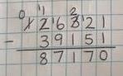
Step 1: Using the compact column method to subtract more complex numbers.

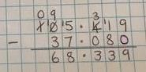
Step 2: Use the compact column method to subtract money and measures, including decimals with different numbers of decimal places. Children can fill empty decimal places with zeros to show the place value in each column.

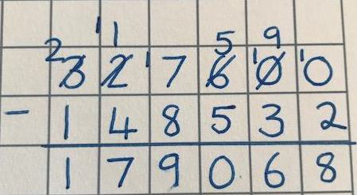
Ensure children have experience of using this method for subtraction where there is a 0 in the column they need to exchange from, and that they understand, through clear modelling (using practical resources) how to move to the next column and exchange then ‘move’ the value along.



National Curriculum Objectives: Multiplication objectives from  Multiplication and Division Strand | Key Skills/ other linked NC Objectives (Place Value) | Key Vocabulary
- Solve one-step problems involving multiplication, by calculating the answer using concrete objects, pictorial representations and arrays, with support from the teacher. | - Count in multiple of 2,5 and 10. | groups of, lots of, sets of  times, altogether, multiply, count,

Children should:
- Begin to understand multiplication by multiplying with concrete objects, arrays and pictorial representations.
- Experience counting equal groups of objects in 2s, 5s and 10s.
- Experience practical problem-solving activities in various contexts.
- Make connections between concrete resources and pictorial representations, number patterns, arrays and counting in 2, 5 and 10s.
- Be given the opportunity to explore and understand the vocabulary of early multiplication
e.g. lots of, how many altogether etc.

Mental Methods
- Counting in multiples of 2, 5, and 10s.
- Spotting number patterns when counting in 2, 5 and 10s.
- Repeated addition
- Links to doubling
- Use of arrays

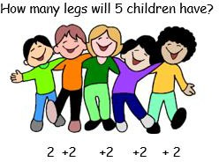
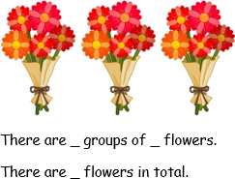



National Curriculum Objectives: Multiplication objectives from  Multiplication and Division Strand | Key Skills/ other linked NC Objectives (Place Value) | Key Vocabulary
- Recall and use multiplication facts for the 2, 5 and 10 times tables.  - Calculate mathematical statements for multiplication within the multiplication tables and write them using the multiplication signs and equals signs.  - Show that the multiplication of two numbers can be done in any order.  - Solve problems involving multiplication and division, using materials, arrays, repeated addition, mental methods and multiplication facts, including  problems in context. | - Recognise odd and even numbers.  - Count in steps of 2,3 and 5 from zero and in 10s from any number. | Year 1 vocab plus  Array, multiplied by, repeated addition,  Two times, three times, five times, ten times

Children should:
  - Develop their understanding of multiplication through the use of practical resources and pictorial representations.
  - Multiply using arrays and repeated addition.

Mental Methods:
  - Counting in twos, fives and tens
  - Repeated addition
  - Use of arrays
  - Children should recall multiplication facts for the 2, 5 and 10 times tables through practising counting and understanding of the operation and number patterns.
  - Using doubling and understanding that this is the same as multiplying by 2.
  - Reordering a calculation, knowing that multiplication can be done in any order.

Written Methods:
Step 1: Practical Apparatus
Children continue to explore multiplication through use of real- life problems using a range of practical equipment.


3 x 5 = 5 + 5 + 5

Step 2: Arrays
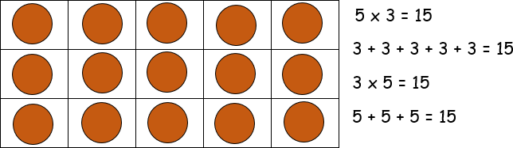
Use arrays to help teach the children that multiplication can be done in any order and explore examples such as
3 X ... = 6

Step 3: Repeated Addition on a number line.

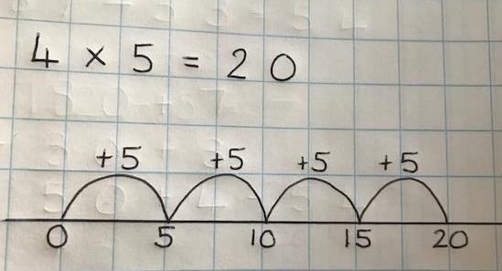
Children start from 0 and make equal jumps on a number line in order to work our multiplication facts and write multiplication statements using X and = symbols.



National Curriculum Objectives: Multiplication objectives from Multiplication  and Division Strand | Key Skills/ other linked NC Objectives (Place  Value) | Key Vocabulary
- Recall and use multiplication and division facts for the 3,4 and 8 times tables.  - Write and calculate multiplication using the multiplication tables they know, including for two-digit numbers times one-digit numbers, suing mental methods and progressing to formal written methods.  - Solve problems, including missing number problems, involving multiplication, including positive integer scaling problems and corresponding problems in which n objects are connected to m  objects. | - Count from 0 in multiples of 4 and 8. | All previous vocabulary, plus:  Product, multiple

Children should:
- Continue to develop their understanding of multiplication through use of practical resources and pictorial representations. Year 2 multiplication must be consolidated for those children who do not have a secure understanding.
- Be given the opportunity to practise their recall of the 2,5 and 10 times tables from the start of Year 3, before any new multiplication objectives are introduced.
- Start to be introduced to the grid method for multiplication. However, in order to do this, children need secure understanding of the maths which will underpin this.

Mental Methods:
- Counting in 2s, 5s, 10s, 3s, 4s and 8s.
- Repeated addition
- Recall multiplication facts for 2, 5 and 10 times tables (from Year 2)
- Recall multiplication facts for 3, 4 and 8 times tables
- Use known facts and place value to multiply by 2,3,4,5,8 and 10.
- Use doubles to link to x2, x4 and x8.
- Reorder a calculation, understanding that multiplication can be done in any order.

Written Methods for multiplying a two-digit number by a one-digit number.
Step 1: Arrays
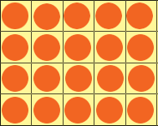

Reinforce Year 2 work on arrays, ensuring children have a secure understanding and can apply these to calculate facts for the 3, 4 and 8 times tables.
4 + 4 + 4 + 4 + 4 = 20
5 + 5 + 5 + 5 = 20
4 x 5 = 20
5 x 4 = 20

Step 2: Introducing the grid method using arrays
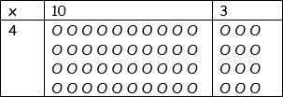
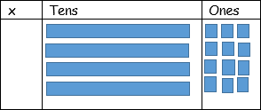
Introduce the grid method to the children by making the arrays to represent the multiplication statement. E.g. “We need 4 rows of 10 and 4 rows of 3”.
Then move onto using dienes, as a progression towards a more compact method.
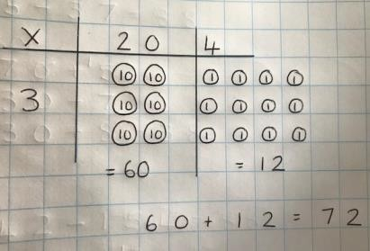
Children can then represent the work they have done with the practical resources, in a way in which they understand, after modelling by the teacher.

Step 3: Grid method
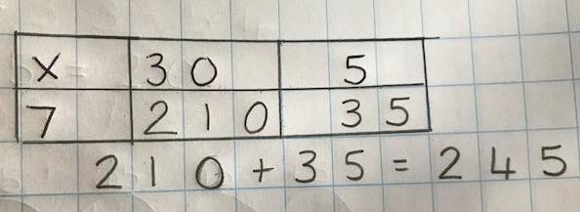
Once the children have a secure understanding of the above steps, the grid method can be introduced, alongside a pictorial representation to start with, then the children practise and use this in a variety of different contexts.
Step 4: Short multiplication
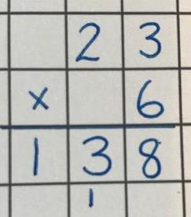
For those children who show a secure understanding of the previous steps and can use these in a variety of contexts, they may be shown how to record this as a short multiplication method. This should be done alongside the grid method so that children are clear on the link between the two.



National Curriculum Objectives: Multiplication objectives from  Multiplication and Division Strand | Key Skills/ other linked NC Objectives (Place Value) | Key Vocabulary
- Recall multiplication facts for multiplication tables up to 12 X 12.  - Use place value, known and derived number facts to multiply mentally including multiplying by 0 and 1.  - Multiply 3 numbers together  - Multiply two-digit and three-digit numbers by a one-digit number using formal written layout.  - Solve problems involving multiplication | - Count in multiples of 6, 7, and 9 | All previous vocabulary, plus:  inverse

Children should:
- Be taught specifically, through exploration of place value, to multiply by 10, 100 and 1,000. Children should be confident in discussing the place value of each digit and how these change.
- Have the opportunity to apply their known number facts to solve other calculations. E.g. if 7 + 4 = 11, then 70 + 40 =, 700 + 400 = etc.
- Be given the opportunity to consolidate and practise their previous learning on multiplication before new content is introduced.
- Be practising their recall of their previously learnt times tables (2,5,10,3,4 and 8) from the start of year 4, before any new times tables are introduced.
- Be given regular opportunity to approximate before they calculate and use this to check the accuracy of their calculations.

Mental Methods:
- Counting in 6s, 7s, 9s, 25s and 100s
- Recall previously learnt multiplication facts with increasing confidence (2, 5, 10, 3, 4 and 8 times tables).
- Recall multiplication facts for the 6,7,9, 11 and 12 times tables.
- Partitioning: multiplying hundreds, tens and ones separately and then recombining.
- Using understanding of when a number is multiplied by 10, 100 or 1,000.
- Using knowledge of number facts and place value e.g. 7 X 8 = 56 to find 70 X 8, 7 X 80 etc.

Written Methods:
Step 1: Grid method for multiplying two and three-digit numbers by a one-digit number.
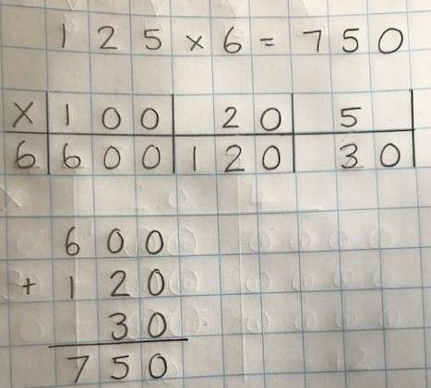
Recap previous multiplication using the grid method and extend this to multiplying two-digit and three-digit numbers by a one-digit number. Track back for any children who are not confident.
\

Step 2: Short multiplication for multiplying by a one-digit number.
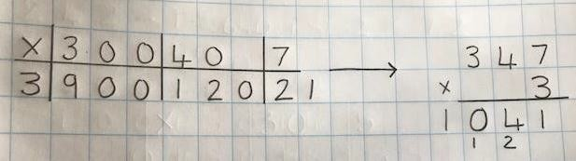
Pupils can be asked to work out a calculation using the grid method, and then compare to ‘your’ column method. What are the similarities and differences? Unpick the steps together and show how it reduces the steps.

Children start by completing a short multiplication method alongside the grid method until they are secure and able to see and understand the links between the two.



National Curriculum Objectives: Multiplication objectives from Multiplication and Division  Strand | Key Skills/ other linked NC Objectives (Place  Value) | Key Vocabulary
- Multiply numbers up to 4 digits by a one-digit or two-digit number including long multiplication for multiplying by two-digit numbers.  - Identify multiples and factors  - Multiply mentally, drawing upon known facts.  - Multiply whole numbers and those involving decimals by 10, 100 and 1,000.  - Recognise and use square and cube numbers.  - Solve problems using the 4 operations, and a combination of these, including understanding the meaning of the equals sign.  - Solve problems involving multiplication and division, including scaling by simple fractions  and problems involving simple rates. | - Count forwards in steps of powers of 10 for any given number up to 1,000,000. | All previous vocabulary, plus:  Square number, cube number integer, short multiplication, long multiplication

Children should:
- Now be able to recall the multiplication facts for ALL their times tables up to 12 X 12. Children need to be given regular opportunities to increase their speed and confidence with this, as well as apply these facts to other calculations.
- Be taught specifically, through exploration of place value, to multiply by 10, 100 and 1,000. Children should be confident in discussing the place value of each digit and how these change.
- Have the opportunity to apply their known number facts to solve other calculations. E.g. if 7 + 4 = 11, then 70 + 40 =, 700 + 400 = etc.
- Be given regular opportunity to approximate before they calculate and use this to check the accuracy of their calculations.

Mental Methods:
- Counting in steps of powers of 10
- Use commutativity and tables to multiply
- Use known facts and place value to multiply
- Use related facts to multiply
- Scaling up using known facts to multiply
- Recall of all times tables up to 12 X 12
- Using times table facts to recognise and use square and cube numbers.

- Use understanding of multiplying by 10, 100 or 1,00 and how the digits change in their place value.
- Use the relationship between multiplication and division.

Written Methods:
Step 1: Short multiplication for multiplying by a one-digit number

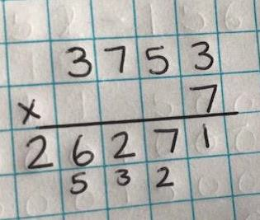
Children use this method to multiply four-digit numbers by a one-digit number, in a range of contexts and units.

Step 2: Introduce long multiplication for multiplying by two-digits.

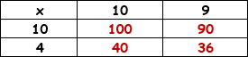
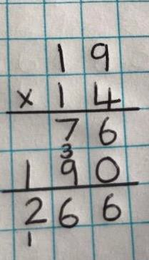
The grid method can be used to introduce long multiplication as this method not only shows each row clearly but will be a familiar method to the children.
Children when multiplying by the tens number, children should be taught to put the ‘0’
in the ones column then think
‘1 times 8, 1 times 1’ etc., as 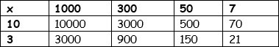
long as they understand the
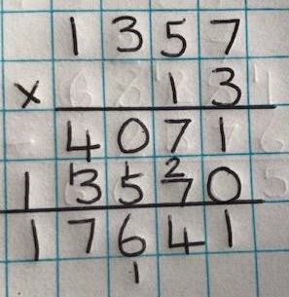
place value involved.



National Curriculum Objectives: Multiplication objectives from Addition, subtraction, multiplication and division  strand. | Key Skills/ other linked NC Objectives (Place Value) | Key Vocabulary
- Multiply numbers up to 4-digits by 2- digit numbers using long multiplication.  - Perform mental calculations, including with mixed operations and large numbers.  - Identify common factors and common multiples.  - Use their knowledge of the other of operations to carry out calculations involving the four operations.  - Solve problems involving the four operations.  - Use estimation to check answers to calculations. | - Understanding place value in large numbers | All previous vocabulary, plus:  Tenths, hundredths, decimals

Children should:
- Have the opportunity to consolidate previous multiplication work and track back if they are not secure.
- Have the opportunity to apply short and long division to various contexts and use it as part of their varied fluency, reasoning and problem solving.
- Be given regular opportunity to approximate before they calculate and use this to check the accuracy of their calculations.

Mental Methods:
- Rapid recall of all times tables up to 12X12 - as in Year 4 and Year 5
- Recalling square and cubed numbers
- Use known facts and place value to multiply.
- Use related facts to multiply.
- Scaling up using known facts.
- Use the relationship between multiplication and division.

Written Methods: Short and long Multiplication

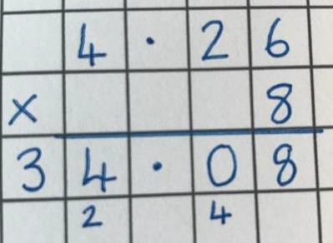
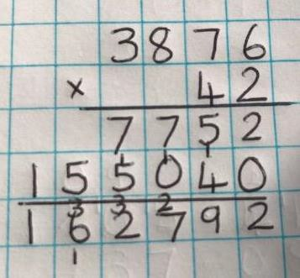
Children will use short multiplication to multiply numbers with more than 4 digits by a one-digit number, to multiply money and measures and to multiply decimals with up to 2 decimal places by a single digit.

Children will use long division to multiply numbers with up to 4-digits by two-digit numbers.



National Curriculum Objectives: Division objectives from Multiplication and  Division Strand | Key Skills/ other linked NC Objectives (Place Value) | Key Vocabulary
- Solve one-step problems involving division, by calculating the answer using concrete objects, pictorial representations and arrays, with support from the teacher. | - Counting in 2s, 5s and 10s | share, share equally, one each, two each…, group, groups of, lots of, array

Children should:
- Be given lots of opportunity to explore division as both grouping and sharing, using practical resources and pictorial representations to solve simple problems.
- Be taught to understanding the difference between grouping objects (How many groups of 2 can you make?) and sharing objects (Share these sweets between two people).
- Be taught to find half of a group of objects by sharing into 2 equal groups.
- Children should be taught to interpret and use pictures to support their grouping and sharing, alongside the use of practical objects and resources.

Mental Methods:
- Counting in twos, fives and tens
- Links to halving
- Use arrays

- Through grouping and sharing small quantities, children will begin to understand division and finding simple fractions of objects, numbers and quantities:
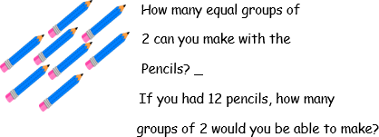
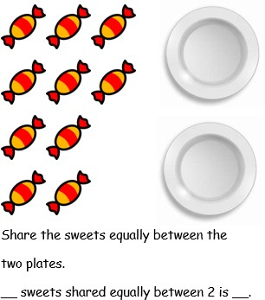



National Curriculum Objectives: Division objectives from Multiplication and  Division Strand | Key Skills/ other linked NC Objectives (Place Value) | Key Vocabulary
- Recall and use division facts for the 2, 5 and 10 times tables.  - Calculate mathematical statements for division within the multiplication tables and write them using the multiplication signs and equals signs.  - Show that the division of two numbers cannot be done in any order.  - Solve problems involving division, using materials, arrays, repeated addition, mental methods and multiplication  facts, including problems in context. | - Counting in 2s, 5s, 10s and 3s. | Year 1 vocabulary plus:  Division, divided by, shared by,  Grouping, sharing, left, left over

Children should:
- Have plenty of opportunities to use objects, arrays and pictorial representations to group and share.
- Develop their understanding of the divide and equals signs through recording their practical activities and exploration.

Mental Methods:
- Counting in 2s, 5s, 10s and 3s
- Links to arrays
- Recalling the division facts for the 2,5 and 10 times tables
- Using knowledge that halving is in the inverse of doubling and the same as dividing by 2.
- Use known facts and place value to divide.

Written Methods:
Step 1: Understanding Arrays and the link between multiplication and division Children should be taught to interpret
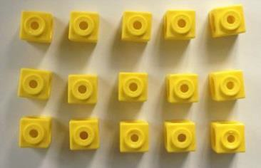
arrays and use these to understand the link
between multiplication and division. For example, by being able to generate the 4 linked multiplication and division sentences.
Eg 15 ÷ 3 = 5 5 x 3 = 15
15 ÷ 5 = 3 3 x 5 = 15

Step 2: Practical problem solving with a focus on recognising grouping and sharing.
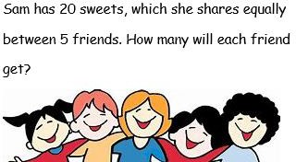
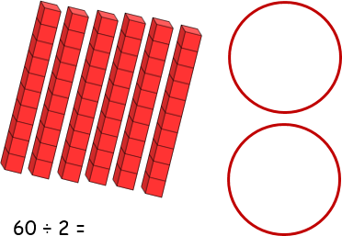
Children should be given the opportunity to recap their practical work on sharing and grouping, with a focus on understanding the difference and being taught to recognise whether problems involve grouping or sharing.
Children can use pictures or shapes to divide quantities and start to record the division number sentence alongside these.

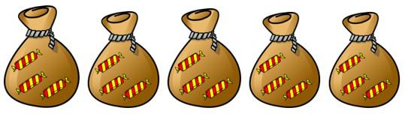
Children to experience grouping in various different contexts, to ensure they are confident with the concept before looking at grouping using a number line.

Step 3: Subtracting groups of a number, using a Number line


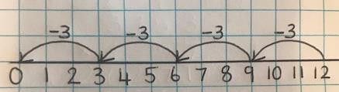
Children use a number line, by jumping back equal amounts from 12 to find out for example, how many groups of 3 there are in 12, as a response to questions such as: A toy costs £3, how many toys can I buy with £12?



National Curriculum Objectives: Division objectives from Multiplication and  Division Strand | Key Skills/ other linked NC Objectives (Place Value) | Key Vocabulary
- Recall the division facts for the 3, 4 and 8 times tables.  - Write and calculate division statements using the multiplication tables they know.  - Solve problems, including missing  number problems, involving division. | - Count in multiples of 4, 8, 50 and 100. | Previous vocabulary, plus:  Inverse, short division, carry, remainder, multiple

Children should:
- Be given the opportunity to explore division in a range of real-life contexts to enable them to start to build a secure understanding of division and recognise when they should use this operation.

Mental Methods:
- Counting in 2s, 5s, 10s, 3s, 4s and 8s
- Recalling the division facts for the 2,5 and 10 times tables- from Year 2
- Recalling the division facts for the 3, 4 and 8 times tables.
- Use known facts and place value to divide be 2, 3, 4, 5, 8 or 10
- Using knowledge that halving is in the inverse of doubling and the same as dividing by 2. Use this to link to ÷ 2, ÷ 4 & ÷ 8.
- Using known facts/partition in different ways to become more efficient in mental calculations: e.g. 39÷3 by taking 3 lots of 10 away mentally, then 3 lots of 3 to get 13 as the answer.
- Use the relationship between multiplication and division.
- Scaling down using known facts.

Written Methods:

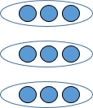
Step 1: Developing understanding of grouping, using a number line and introducing remainders.
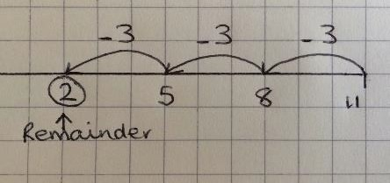
Children explore, through the continued use of practical equipment, pictures and number lines, the concept of remainders, how many are left etc. This is preparation for carry remainders across within short division.
Children also continue to develop their understanding of using grouping on a number line to divide, and also to find remainders.

Step 2: Introducing short division (no remainders and no numbers carried)
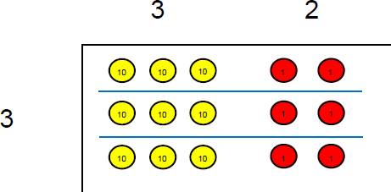
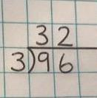
Once children are secure with division as grouping and sharing, using number lines, arrays etc. short division for larger two-digit numbers can be introduced. To start with, this should be introduced with numbers that have no remainders within, or at the end of the calculation.

Step 3: Short division, with no remainders in the final answer

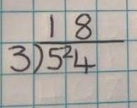
Once children have shown a secure understanding of the above 2 steps, they should be taught how to use short division when remainders occur within the calculation and be shown how to carry the remainder onto the next digit.



National Curriculum Objectives: Division objectives from Multiplication and  Division Strand | Key Skills/ other linked NC Objectives (Place Value) | Key Vocabulary
- Recall division facts for multiplication tables up to 12X12  - Use place value, known and derived facts to divide mentally- including dividing by 1.  - Recognise and use factor pairs and commutativity in mental calculations. | - Counting in 6s, 7s, 9s, 25s and 1000s | Previous vocabulary, plus:  Divisible by, factor

Children should:
- Continue to develop their understanding of division and extend their previous learning to dividing 3-digit numbers by a single digit.
- Be given a wide variety of real-life contexts to work with and problem solve to help develop a secure understanding of division and how to apply it to problems.

Mental Methods:
- Counting in 6s, 7s, 9s, 25s and 1000s.
- Recall division facts for all the times tables, up to 12X12
- Use understanding of place value and what happens to the value of each digit when it is divided by 10, 100 or 1,000.
- Use known facts and place value to solve calculations and to become more efficient in mental calculations e.g 92÷4 by taking away 4 lots of 20, to be left with 12, then taking away 3x4 to get the answer of 23.
- Use related facts to divide
- Use factor pairs to divide
- Scaling down using known facts
- Use the relationship between multiplication and division

Written Methods: Dividing numbers with up to 3-digits by a one-digit number.
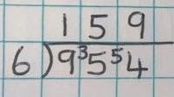
Children move into dividing numbers with up to 3 digits by a one-digit number in a wide range of contexts. At this stage this will not include calculations which result in a final answer with a remainder. However, this could be taught as an extension for children who have exceeded this objective (see Year 5).
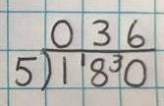
Where the answer to the first column is 0, children should initially write 0 above to acknowledge this, then carry to number over to the next digit as a remainder.



National Curriculum Objectives: Division objectives from Multiplication and  Division Strand | Key Skills/ other linked NC Objectives | Key Vocabulary
- Divide numbers mentally, drawing upon known facts.  - Divide numbers up to 4 digits by a one-digit number using short division and interpret remainders appropriately for the context.  - Divide whole number and those involving decimals by 10, 100 and 1,000.  - Solve problems using division and a combination of the four operations. | - Identifying all factor pairs of a number and common factors of 2 numbers.  - Know and use vocabulary of prime numbers, prime factors and composite (non-prime) numbers.  - Establish whether a number up to 100 is prime and recall prime  numbers up to 19. | Previous vocabulary, plus:  Quotient, prime number, prime factors, common factor, composite (non- prime) number

Children should:
- Be given the opportunity to continue to explore division in an increasingly wide range of real-life problems.
- They should consolidate and extend their use of short division, to include those calculations with remainders in their final answers.
- Significant time and teaching should be spend considering the meaning of those remainders and how they should be presented and interpreted, as this will enable children to have a more secure understanding in preparation for more complex problem solving in Year 6.

Mental Methods:
- Counting in steps of powers of 10.
- Recall division facts for all the times tables, up to 12X12
- Use understanding of place value and what happens to the value of each digit when it is divided by 10, 100 or 1,000.
- Use known facts and place value to solve calculations.
- Use related facts to divide
- Use factor pairs to divide
- Scaling down using known facts
- Use knowledge of division facts e.g. when carrying out a division to find a remainder.
- Use the relationship between multiplication and division.

Written Methods:

Step 1: Short division with no remainder in the final answer.
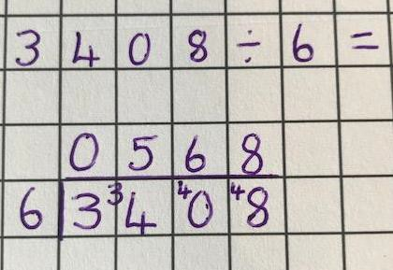
Children should recap their previous work on short division- at this stage with no final remainder, but with remainders which need carrying within the calculation.
This will now be extended to include four-digit numbers divided by a one-digit number.

Step 2: Short division with remainders.
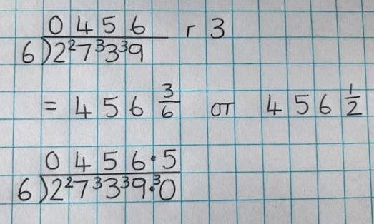
Children are introduced to examples that have remainders within the final answer. Children should be given the opportunity, through specific teaching and modelling, to consider the meaning of the remainder and how it should be expressed (i.e. as a fraction, a decimal, or as a rounded number, depending on the context of the problem).



National Curriculum Objectives: Division objectives from Multiplication and Division Strand | Key Skills/ other linked NC  Objectives | Key Vocabulary
- Divide numbers up to 4 digits by a two-digit whole number using long division and interpret remainders as whole number remainders, fractions, or by rounding as appropriate for the context.  - Divide numbers up to 4 digits by a two-digit whole number using short division where appropriate, interpreting remainders as appropriate to the context.  - Perform mental calculations including with mixed operations and large numbers.  - Use estimation to check answers to calculations.  - Solve problems involving addition.  - Use knowledge of order of operations to carry out calculations involving the four operations. | - Identify common factors and prime numbers.  - Use estimation to check answers to calculations. | Consolidate all previous vocabulary.

Children should:
- Be given the opportunity to develop their division skills in a range of contexts, with a focus on presenting their remainders appropriately for the context.
- Learn to use long division to divide by two-digit numbers, and use these methods efficiently.

Mental Methods:
- Counting in steps of powers of 10.
- Recall division facts for all the times tables, up to 12X12
- Use understanding of place value and what happens to the value of each digit when it is divided by 10, 100 or 1,000.
- Use known facts and place value to solve calculations.
- Use knowledge of division facts e.g. when carrying out a division to find a remainder.
- Use factor pairs to divide
- Use the relationship between multiplication and division
- Consolidate all previously taught strategies.

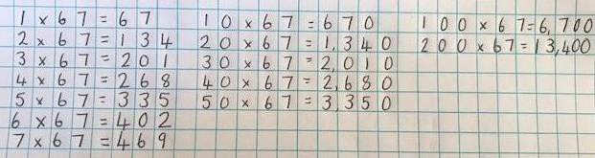
Written Methods:
Step 1: Extend use of short division for dividing by one-digit numbers.

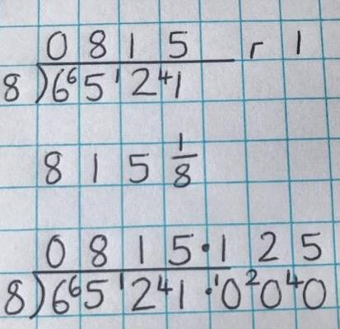
Children continue to develop their use of short division and how to express remainders as whole numbers, fractions, rounded numbers and decimals. Specific teaching to take place to support children in understanding each of these and when they should be

Step 2: Dividing by two-digit numbers

Long Division - ‘Chunking Method’
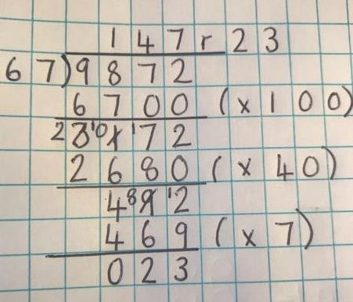
Supported by their secure understanding of the division learning done previously, children should be introduced to long division by chunking.
Children should be taught how to set this out clearly, including noting down multiples of the number to support this process. They should be encouraged to take away the largest ‘chunk’ they can each time to limit the number of steps and therefore likely errors. Children should aim to get to the answer in a maximum of 3 steps.

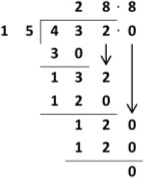
Formal Method for Long Division
Divide Multiply Subtract
When the children have a clear understanding of the place value within their division calculations, they can move onto a formal method for long division.
This reduces the amount of related facts that they need to use, and therefore will improve their efficiency.

Step 2: Using Short Division to divide by two-digit numbers
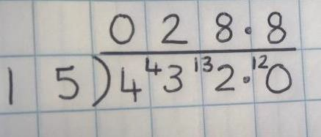
When children are fully secure with long division for dividing by a two- digit number, they may progress to a short division method. Be aware that there are multiple parts to each step and therefore children may make errors if they rush or if their understanding is not yet secure

