Being online, staying safe and social media in EYFS
Curriculum links – EYFS  playing and exploring - children investigate and experience things, and ‘have a go’; | Understanding the world involves guiding children to make sense of their physical world and their community through opportunities to explore, observe and find out about people, places, technology and the environment.  Technology: children recognise that a range of technology is used in places such as homes and schools. They select and use technology for particular purposes.  Expressive arts and design involves enabling children to explore and play with a wide range of media and materials, as well as providing opportunities and encouragement for sharing their thoughts, ideas and feelings through a variety of activities in art, music, movement, dance, role-play, and design and technology.  Communication and language development involves giving children opportunities to experience a rich language environment; to develop their confidence and skills in expressing themselves; and to speak and listen in a range of situations.  Physical development: Moving and handling: children show good control and co-ordination in large and small movements. They move confidently in a range of ways, safely negotiating space. They handle equipment and tools effectively, including pencils for writing.  • Personal, social and emotional development involves helping children to develop a positive sense of themselves, and others; to form positive relationships and develop respect for others; to develop social skills and learn how to manage their feelings; to understand appropriate behaviour in groups; and to have confidence in their own abilities.

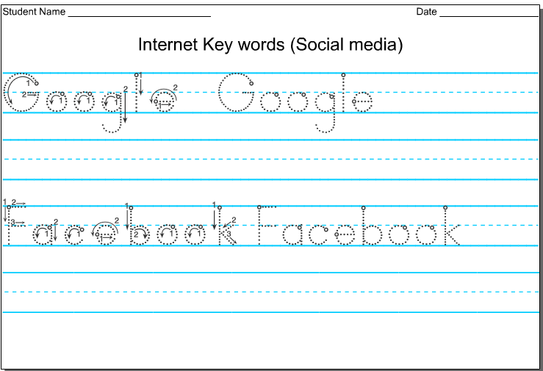

Mouse motor skills: http://www.happyclicks.net/toddler-games/toddlers_games_dolls2.php - these activities can be completed in two ways – first with a mouse and secondly with a touchpad.



