Literacy |  | Maths | PSED
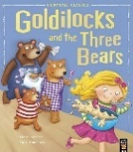  Texts and outcome  Goldilocks and the Three Bears – ordering the story  We’re Going on a Bear hunt – describing the bear  Word Focus  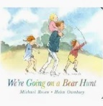  I  Handwriting:  Fine motor focus – threading, pegs and peg boards, tweezers  Dough Disco |  | NCETM  Subitising, counting and comparison | Self-Regulation: How can I do it?  Zones of regulation  Exploring our different emotions and how they make us feel.
Shape, space and Measure

2D shapes
Autumn 1: My Family and People Who Help Us
Physical Development | Understanding the World | Expressive arts and design | RE
Fundamental movement skills, moving safely and developing our spatial awareness.  Learning different bean bag games  Squiggle while you wiggle | Theme day: Languages Day  Understand that different communities celebrate different festivals and traditions.  Who are the people who help us?  Exploring different families as well as our own. | Nursery Rhymes – getting to know them and performing them.  Identify primary colours and experiment with mixing colours to create new shades. | What makes people special.
Foundational Skills
Using a knife and fork, getting dressed, cutting, pencil control, writing and recognising my name, washing our hands

What I may already know: | Key Vocabulary:
- I can tell you my name.  - I can tell you how old I am and how old I will be on my next birthday.  - I can tell you member of my family.  - I can tell you some different occupations | family |  | A group of people that are special to you.
 | emotions |  | How you are feeling. (happy, sad, angry)
 | occupation |  | What a person does for a job.
 | uniform |  | Distinctive clothing
 | favourite |  | Prefer to all others.
 | neighbour |  | someone who lives close to your home and is part of your local community.
 | community |  | people who belong together and care for one another.
 | emergency |  | is a time when we need to get help fast to keep people safe
Autumn 1: My Family and People Who Help Us knowledge organiser
Key Knowledge |  | 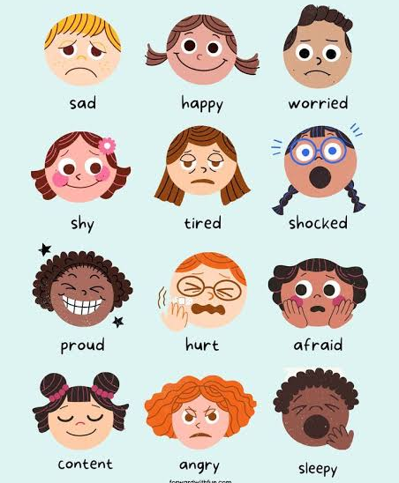  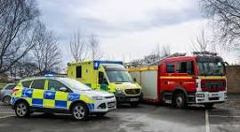
People will do different jobs.
Some people will wear uniforms for their jobs.
There are different people in each family and families can all look different.
There are different emotions and I will feel these in different situations.
I can call 999 if I have an emergency and people will come to help me.
My community is the people around me.
