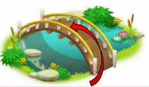
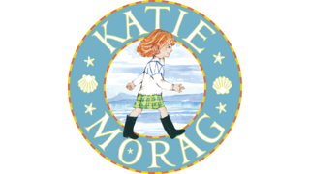
Prior Knowledge
Our school and homes are in England.
Be able to discuss countries or places that pupils may have visited in the United Kingdom.
Island Life

Knowledge Organiser: Autumn 1
Key Vocabulary |  | Key Locations
Capital City | The location of a country’s government. | England
City | A big, busy place where many people live. | Scotland
Coast | Where the land meets the sea. | Wales
Country | A part of the world with its own people and laws. | Northern Island
Country | A part of the world with its own people and laws. | Key Maps/Symbols
Countryside | The land outside towns and cities where there are fields, woods or farms.
  UK map showing regions and capitals | UK map showing seas
  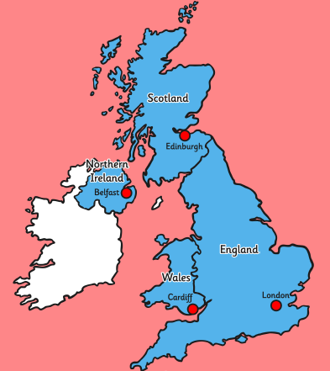 | 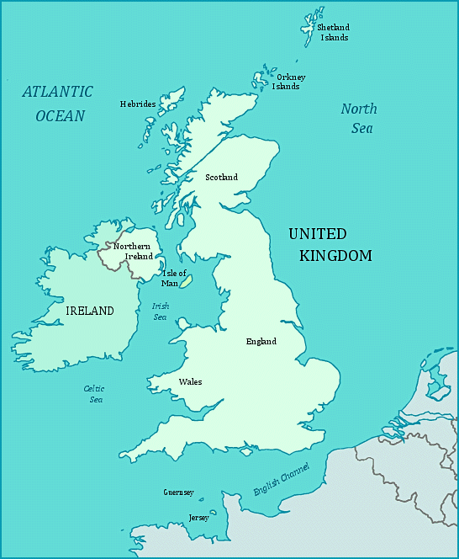
Sea | A large area of salty water.
Town | A place in which people live that is larger than a village but smaller than a city.
Village | A small place where people live in a countryside area.
Key Knowledge
Capital cities | England – London  Northern Ireland – Belfast  Scotland – Edinburgh  Wales - Cardiff
Parts of the United Kingdom | 3 countries (England, Scotland and Wales) and 1 ‘region’ (Northern Ireland), together making up 1 country.
Seas of the United Kingdom | Atlantic Ocean, English Channel, Irish Sea, North Sea
UK | Short for United Kingdom.

