
Year 5 Roots & Routes Enrichment Activities
Create a wordsearch using scientific words to do with lifecycles | Create a presentation about something you have grown, explaining the different stages. | 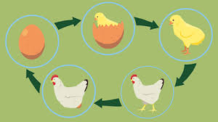  Create a model of a flower showing the reproductive organs.
Learn a nature poem about an animal to recite off-by-heart to the class | Research & present the life spans of 10 different animals | Create a piece of artwork showing a life cycle of your choice.
Discover as many collective nouns for animals. Create booklet/poster. | 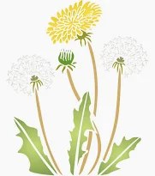  Find out about and produce a visual diagram of the life cycle of a dandelion | 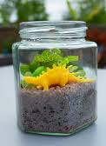  Create a jam jar bean or seed garden

