Geography Knowledge Organiser – Year 2 – Summer 2 Would You Like To Be A Botanist?
What should I already know? |  | Key Vocabulary  Key Maps – our school
  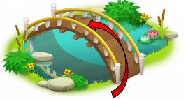
  • Know the compass points are North, South, East and West
  • Know that a map shows a representation of a real place, including some of the key details of that place.
  • Be able to describe maps.
  • Distinguish between a range human and physical features.
  Landscape | The visible features of an area of land, like hills, rivers, and buildings.
  Vegetation | Plants, trees, and bushes in an area.
  Season | One of the four times of the year with different weather: Spring, Summer, Autumn, Winter.
  Weather | The conditions outside, like sunny, rainy or snowy.
  Landmark | An important or famous place or building.
  Human Features | Things made by people, like buildings, roads and bridges.
  Physical Features | Natural parts of the land, like mountains, rivers and beaches.
  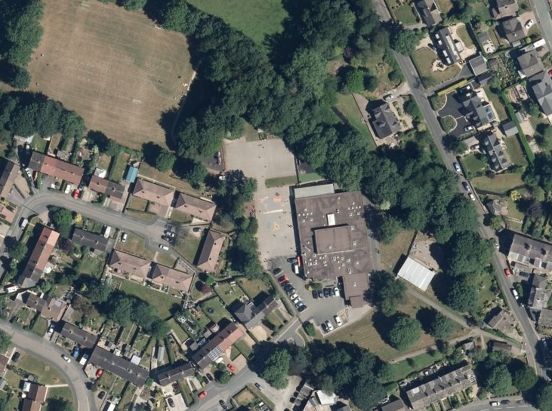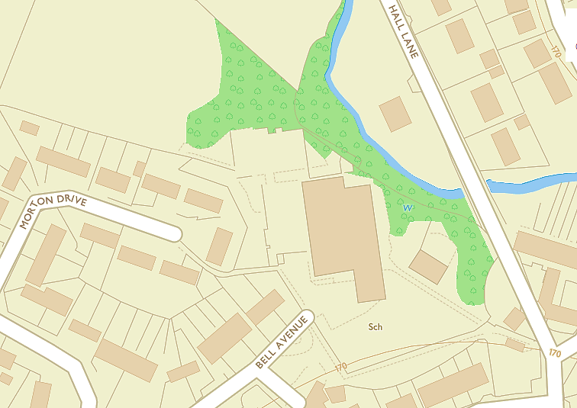
Key Component Knowledge

Know and use accurately the points of the compass for North, South, East and West. Know the terms: NE, NW, SE, SW.
When using coordinates, know that bottom comes before side.
How to draw a simple picture map.
How to match aerial and plan views of buildings or features.

How to draw a simple plan with objects relative to each other in position and size.
How to add labels and a couple of features given to a field sketch.
Know the difference between human and physical features and basic features of maps, aerial photographs and plan perspectives.

Science Knowledge Organiser – Year 2 – Summer 2 Would You Like To Be A Botanist?
What should I already know? |  | Key Vocabulary  Key Diagrams  Bean life cycle Daffodil life cycle  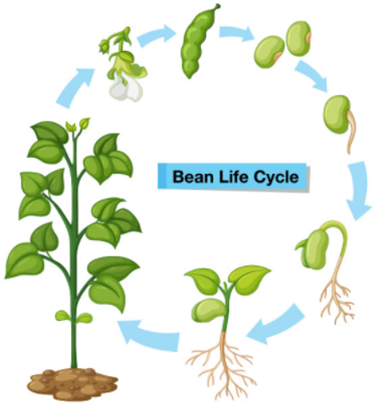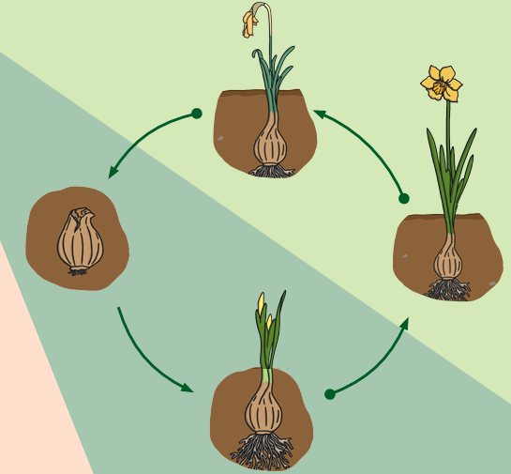
  Identify and name a variety of common wild and garden plants, including
  deciduous and evergreen trees. (Y1 - Plants)
  Identify and describe the basic structure of a variety of common flowering plants, including trees. (Y1 - Plants)
  Flower | The colourful part of a plant that makes seeds and can grow into fruit.
  Leaf | The flat, green part of a plant that catches sunlight to help the plant make food.
  Light | Brightness from the sun or a lamp.
  Root | The part of the plant that grows underground and takes in water and nutrients.
  Seed | A small part of a plant that can grow into a new plant.
  Shade | A cool, dark area where the sun's light is blocked.
  Stem | The part of a plant that holds it up and carries water and food.
  Sun | The big star that gives us light and warmth.
  Warm | A comfortable, gentle heat.
  Cool | Slightly cold, but not too much.
  Water | The liquid we drink and use to grow plants.
  Grow | To get bigger or taller.
  Healthy | Being well and strong.
Key Knowledge

Plants may grow from either seeds or bulbs.

These then germinate and grow into seedlings which then continue to grow into mature plants.
These mature plants may have flowers which then develop into seeds, berries, fruits etc.
Seeds and bulbs need to be planted outside at particular times of year and they will germinate and grow at different rates.
Some plants are better suited to growing in full sun and some grow better in partial or full shade.
Plants also need different amounts of water and space to grow well and stay healthy.

