Key Vocabulary
holiday | A day/ period of time when people do not work or go to school.
transport | How people move from one place to another.
family | A group of people who love care a support one another.
seaside | Where the land and the sea meet.
journey | a big adventure, a long trip, or a special quest.
motorway | a fast, wide road built for cars and trucks to travel long distances between cities without stopping.
city | a large, busy place where many people live and work.
accommodation | A place to stay
What I should already know
- People often go on holiday to the seaside.
- I can identify sea and land on a map.
- I can tell you ways to travel to go on a holiday.

Key Knowledge
There are different ways to travel to go on a holiday.
People often go on holidays with their families.
The beach is a popular place to go on holiday
People might visit a city for a holiday.
People often fly on a plane to go on a holiday as they go to a different country.
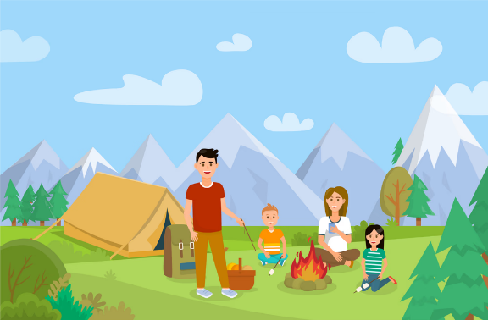
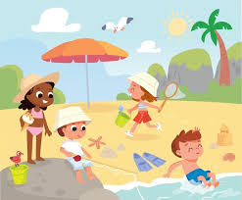


Holiday Adventure - Quiz
- What is a holiday? |  | - Can you name three types of accommodation?
Start | End | Start | End
- How might I get on holiday? |  | - What is the role of a lifeguard?
Start | End | Start | End
