- | Literacy | Maths | Wider
  Launch  Drawing self portraits  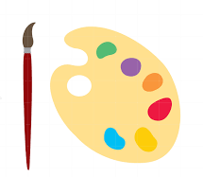  Celebration  Baby pictures quiz   | Goldilocks and the Three Bears  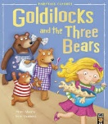  Use images to sequence the story of Goldilocks and the Three Bears  Orally describe the Goldilocks and the three bears.    Focus Books:  The Colour Monster  The Colour Monster goes to school  Only One You | Shape and space  Understanding The World    History  Talk about the lives of the people around them and their roles in society.  People Who Help Us  Understanding different people’s jobs and how they help us. How can we recognise someone by their uniform?  Geography/ Science  Understand that we do things at different times of the year and that the weather and the world can look different during these events. | Physical Development:    Fundamental movement skills and exploring the space around us  Beanbag Games  PSED:  What is self-regulation and how do I do it?  Music:  Nursery Rhymes  Computing:  Interactive games  Expressive Art & Design:  Explore different colours and colour mixing  RE:  What makes people special?  PSHE Day:  Languages Day
History
Geography
Science
Autumn Term 1
What makes me, me?

All About Me


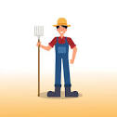
History
Geography
Science
What type of animals would you see on a farm?
Autumn Term 2


 | Literacy | Maths | Wider
Launch  What is life like on a Farm?  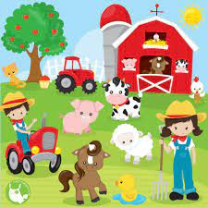  Celebration  Big Art: Designing and creating our very own farm   | The Little Red Hen  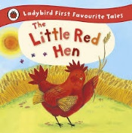  Create a list of characters from the story.  Writing or drawing words that rhyme with HEN.  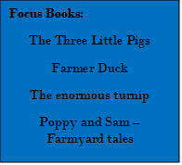  Word Focus  Go  I To ToTTo  No  Thee | Measures  Understanding The World  Geography:  I can find where animals live on a farm using a simple map.  I can describe my immediate environment using knowledge and observation.  Science:  To recognise animals, including humans, and understand how to care for them.   |   Physical Development:  Focusing on co-ordination, throwing, catching and aiming.  Expressive Art & Design:  Exploring Colour Mixing and learning about the Primary Colours  PSED:  What are our class rules?    Music:  The Love Music Trust – Celebrations unit    Computing:  Interactive games, including iPads  RE:  What makes people special? What do religious people learn from stories?  Why do Christians perform special nativity plays at Christmas?

Spring term 1 - Traditional Tales History and Science
Question:    What character would you be in a traditional tale?  Literacy  The Gingerbread Man  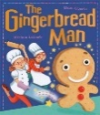  Who else could The Gingerbread Man run away from?  How to catch The Gingerbread Man | Maths  Pattern  Science  Floating and sinking – offering explanations of what is happening    Experiment:  Could the gingerbread man be made out of a different biscuit?  History  Understanding the past through settings, characters and events encountered in books read in class and storytelling | Wider  Computing  Using Microsoft Word to write CVC words  Physical Development  Developing balance, co-ordination and core strength.  Rugby (coach)  PSED:  How can I look after myself?  RE:  How do people describe God?  How do Christians describe God?  Art & DT  Puppet making - making use of props and materials when in role.  Music:  The Love Music Trust – Friends unit | Launch  Designing our own gingerbread men  End of topic celebration  Making/ decorating Gingerbread men  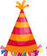  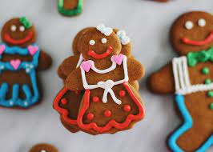


Spring Term 2 - Our Wonderful World
Science History Geography

Question  Do you want to be an animal, plant or a human? | Maths  Shape and Space | Understanding the world  Science  Understanding some important processes and changes in the natural world around us.  Geography  Explain similarities and difference in the natural world around us. | Wider Curriculum  PSED:  How can I build positive relationships?  Physical development:  Different rolls, jumps and balances.  Music:  BBC 10 pieces – Lark Ascending  RE:  How do celebrations bring Christians together?  Art:  Using different art materials.  Computing:  Purple Mash
Launch  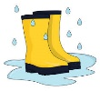  Welly walks | Literacy  Handa’s Surprise  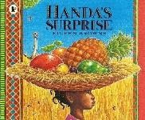  What fruit did Handa take to her friend?  What is happening at this part of the story?
Celebration

Fruit Tasting
PSED day  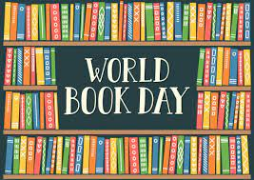  World Book Day | Books to support  Here we are  Only one You | Trip  Local Walk and Garden Centre

History
Geography
Science
The Very Hungry Caterpillar

Summer Term 1
Question:
What is the life cycle of a butterfly?
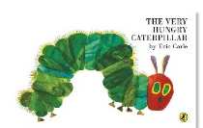

 | Literacy | Maths | Wider
Launch  Meeting our very own “hungry caterpillars”  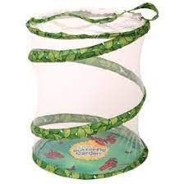  Celebration:  Releasing the butterflies  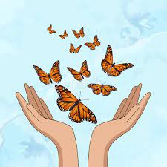  Text: The Very Hungry Caterpillar  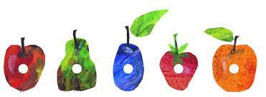 | The Very Hungry Caterpillar  Innovate the story, The Very Hungry…  What did I eat? Written as if I were The Very Hungry Caterpillar. | Measure  Understanding the World  Science: Explore the natural world around them, making observations and drawing pictures of animals and plants.  Geography: Describe what the Hungry Caterpillar might see and think when they turn into a butterfly  PSHE Day:  My Money Day | Physical Development:  Gymnastics  PSED:  How are people different?  Expressive Art & Design:  Tunnicliffe: Making observations and drawing pictures of animals and plants.  Computing:  Mini Mash  Music:  The Love Music Trust – Animals Unit  RE:  How do Christians look after the world?


Where would you like to go on holiday?

Summer 2 – Holiday Adventure Geography and Science
 | Literacy | Maths | Wider
Launch  Sandcastle Building    Celebration  A Beach Party    Texts:  Winnie & Wilbur at the Seaside  Commotion in the Ocean  Co  C | Harry the Happy Mouse  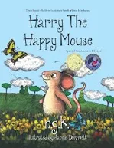  Innovating the nursery rhyme: Hickory, Dickory, Dock.  Making predictions  Describing Harry the Mouse  Who might Harry meet on his journey? | Pattern  Understanding the World  Geography  Recognise and understand similarities and differences between the natural world around them and contrasting environments.  To know that not all places we visit look the same.  Science:  Light and Sound  To understand what a shadow is and to recognise the term `sound`.  Sports Week  Trip: Manchester Runway Par | Physical Development:  Athletics  Forest School  PSED:  What are my learning powers?  Expressive Art & Design:  Drawing for accuracy  Sharing creations and explaining the process they have used.  Computing  Exploring `Word` and beginning to type using the keyboard.  Music:  The Love Music Trust – Weather unit  RE:  Why should we look after the world?  How do Christians, Jews & Muslims say we should look after the world?

