Year 1 – Enrichment Activities Big City v Little Village
Look at pictures/photographs of London and draw some of the architecture.   | Go on a walk in the local area and note down all the amenities.   | Draw a map of the local area and include any special places of interest.  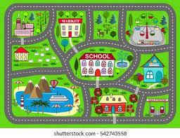
Create a quiz all about London or Sutton.   | 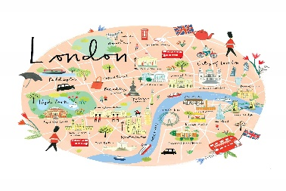  Draw a map of London and include all of the landmarks which you would see. | Create a piece of artwork of Sutton or London.  
Write an adventure story based on ‘Katie in London’.  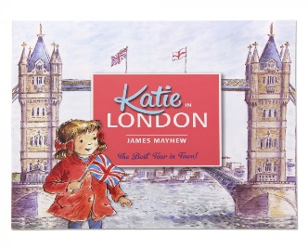 | 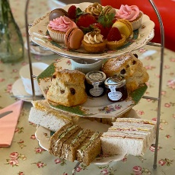  Invite your family/toys for afternoon tea or a picnic. Create a menu. | Imagine you are a Tour guide. Create a booklet about London or Sutton.  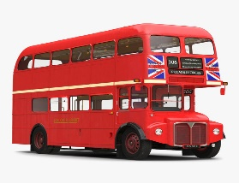
Weekly phonics homework will continue to be set on Spelling Shed and an additional weekly sheet of either English or Maths.

