Geography Knowledge Organiser: Summer 2
Big City v Little Village
Key Images: | Key Vocab
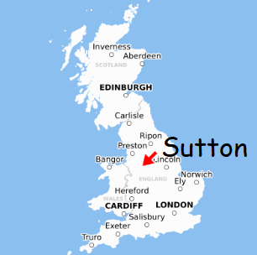 | Village – A group of houses and other buildings.  Town – A place with many houses and buildings, where people live and work. It is larger than a village.  City – A big, busy place with lots of people, shops, businesses and homes. It is bigger than a town and much bigger than a village.  Physical features- things in a village, city or town that are there naturally.  Human features - things in a village, city or town that are put there or made by humans.  Map – a drawing of part of the earth, used to show where things are.
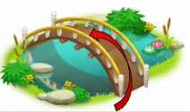
Prior Knowledge:

- Know the countries of the UK.
- Know that our school and homes are in England, which is part of the UK.
- Know that the capital city of England and the UK is London.
- Be able to locate England on a map.
Key Knowledge:
- Sutton and London are both places in England, which is part of the United Kingdom.
- Sutton is a village in which our school is located. Sutton is on the outskirts of Macclesfield, our nearest town.
- London is the capital city of England. London is much bigger than Sutton.
- Key physical features of Sutton are: hills, countryside, stream.
- Key human features of Sutton are: our school, the church, pub, village shop and post office and playground.
- A plan is a bird’s-eye view.

