Here We Grow!
Optional Enrichment Activities
If you would like to choose activities from this menu, this work will be celebrated in a ‘Show and Tell’ style throughout the term.
Plant bulbs or seeds at home and watch them grow. Bring in your plants at the end of term or show photographs of them. Write a diary explaining how you cared for your plants and observe the changes. | 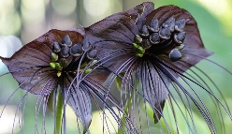  With an adult, search the web for examples of amazing plants and make your own weird and wonderful plant book. | 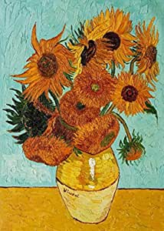  Attempt a piece of flower artwork based on a famous artist, such as Van Gogh’s Sunflowers.
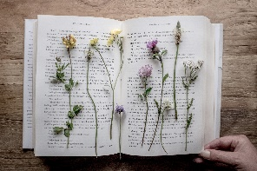  Press flowers between the pages of a book and use them to make cards or artwork for family or friends. Show us your creations! | On a visit to the supermarket, find plants you can eat, including herbs, vegetables and fruit. Which part of the plant are they? The roots, leaves? Flower? Stem? Present your findings either on paper or a PowerPoint. | Recite a poem for the class about flowers or plants
  Create a plant-based meal at home and explain to the class where the ingredients came from. |   Visit the local library and find books about plants and flowers and share your favourite parts with the class. | 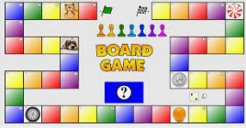  Create a board game or card game about plants

